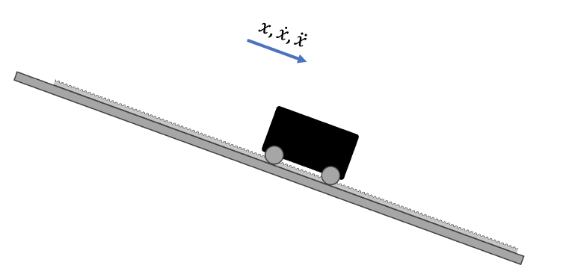

FG

FN

FR

FAntr

FLuft

FH

FTr