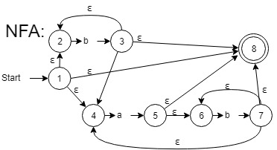3.2

* 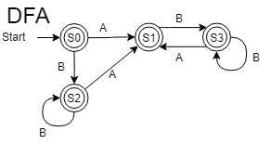Regular expression: b*a?(bb*a)*b*

|  |  |  |  |
| --- | --- | --- | --- |
| NFA | | | |
|  | Move(a) | Move(b) | ε* |
| 1 | - | - | 1,2,4,8 |
| 2 | - | 3 | 2 |
| 3 | - | - | 2,3,4,8 |
| 4 | 5 | - | 4 |
| 5 | - | - | 5,6,8 |
| 6 | - | 7 | 6 |
| 7 | - | - | 4,6,7,8 |
| **8** | - | - | 8 |

|  |  |  |  |  |
| --- | --- | --- | --- | --- |
| dFA | | | | |
| State: | a | b | NFA states | Accepting |
| S0 | S1 | S2 | 1,2,4,8 | Y |
| S1 | - | S3 | 5,6,8 | Y |
| S2 | S1 | S2 | 2,3,4,8 | Y |
| S3 | S1 | S3 | 4,6,7,8 | Y |

3.3)

* let z = (17) in z + 2 * 3 end EOF
* Converting to EXPR:

(E to convert Let, B to convert names, C to convert ints, G to convert times, H for plus, E for parentheses)

LET (NAME “z”) EQ ( LPAR (CSTINT 17) RPAR)

IN (

((NAME “z”) PLUS (CSTINT 2))

TIMES (CSTINT 3)

)

END EOF

3.4) Draw the above derivation as a tree.

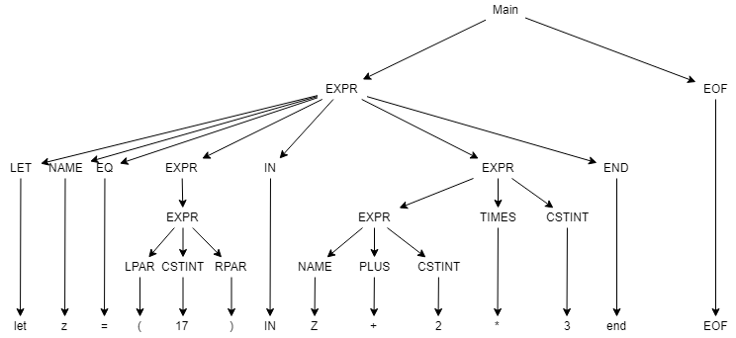

3.5

Loading expression abstract syntax, the lexer and parser modules, and expression interpreter and compilers into an interactive F# session:

fslex --unicode ExprLex.fsl

fsyacc --module ExprPar ExprPar.fsy

fsi -r bin/FsLexYacc.Runtime.dll Absyn.fs Expr.fs ExprPar.fs ExprLex.fs Parse.fs

build bat

run.bat

open Parse;;

fromString "1 + 2 * 3";;

val it : Absyn.expr = Prim ("+",CstI 1,Prim ("*",CstI 2,CstI 3))

fromString "1 - 2 - 3";;

val it : Absyn.expr = Prim ("-",Prim ("-",CstI 1,CstI 2),CstI 3)

fromString "1 + -2";;

val it : Absyn.expr = Prim ("+",CstI 1,CstI -2)

fromString "x++";;

System.Exception: parse error near line 1, column 3

fromString "1 + 1.2";;

System.Exception: Lexer error: illegal symbol near line 1, column 6

fromString "1 + ";;

System.Exception: parse error near line 1, column 4

fromString "let z = (17) in z + 2 * 3 end";;

val it : Absyn.expr = Let ("z",CstI 17,Prim ("+",Var "z",Prim ("*",CstI 2,CstI 3)))

fromString "let z = 17) in z + 2 * 3 end";;

System.Exception: parse error near line 1, column 11

fromString "let in = (17) in z + 2 * 3 end";;

System.Exception: parse error near line 1, column 6

fromString "1 + let x=5 in let y=7+x in y+y end + x end";;

val it : Absyn.expr =

Prim

("+",CstI 1,

Let

("x",CstI 5,

Prim

("+",Let ("y",Prim ("+",CstI 7,Var "x"),Prim ("+",Var "y",Var "y")),

Var "x")))

3.6

Use the expression parser from Parse.fs and the compiler scomp

(from expressions to stack machine instructions) and the associated datatypes from

Expr.fs, to define a function compString : string -> sinstr list

that parses a string as an expression and compiles it to stack machine code.

open Parse;;

compString "1 + let x=5 in let y=7+x in y+y end + x end";;

val it : Expr.sinstr list =[SCstI 1; SCstI 5; SCstI 7; SVar 1; SAdd; SVar 0; SVar 1; SAdd; SSwap; SPop; SVar 1; SAdd; SSwap; SPop; SAdd]

3.7

* add IfElse
* Not needed to fix eval