Montreal Scenic Tours (MST) – A database team project:  
Team members: Sabrina Robinson, Selihom Efrem Ogbe, Abdulmajeed Kakar and Jonas Faes de Almeida.

## Crow’s Foot ERDs (Designs from Deliverable 1): Initial concept and Initial relationship maps:

Recap:   
   
  
Deliverable 1 - Teamwork summary:

Each member of our team was tasked with creating their own version of the diagram. We then came together as a group and discussed which elements of each diagram should be included in the final version. For example, a few of use had included a table for qualifications and transactions while others had not. Ultimately, we decided that it would be a good idea to include both.

Deliverable 1 - Difficulties that the team faced:

We ran into some confusion about how to go about the qualifications table, and what attributes it would need to function in the way that we wanted it to. We wanted to store a boolean value to determine whether the guide was in fact qualified or not. Since SQL does not have such a value, we used a bit in its place (1 bit to represent true, and 0 bit to represent false). Other than that, our team worked well together and did not face any other hardships. Our communication was clear and concise, and we understood the assignment well. Ultimately, we have no complaints regarding this project thus far.

Logical Schema:   
Reworked original map:

## Crow’s Foot ERDs (Designs from Deliverable 2):

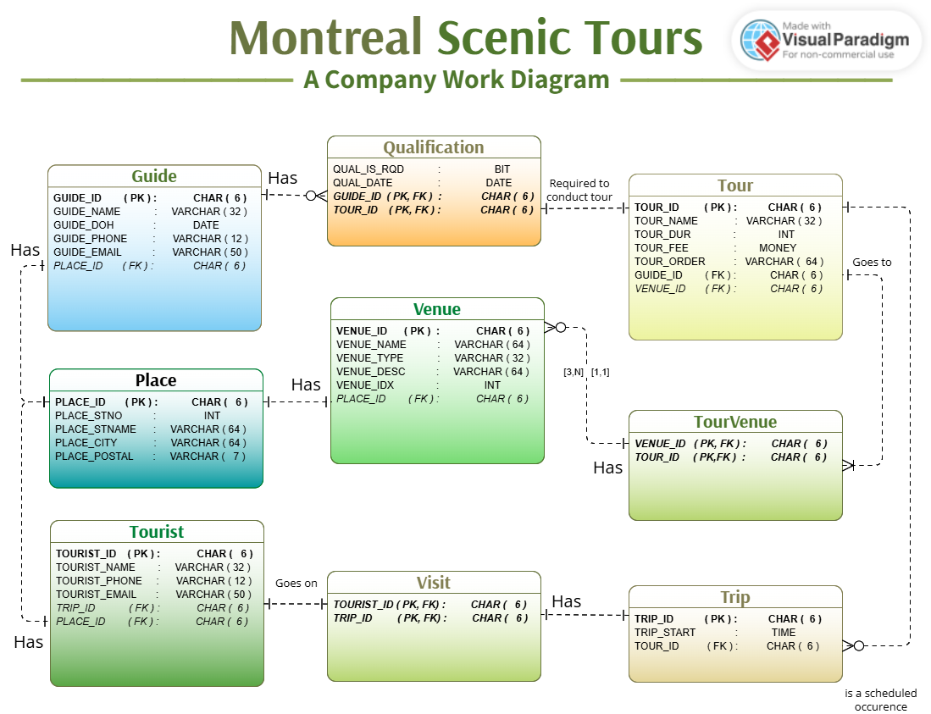Reworked relationship map:



+



+



|  |  |  |
| --- | --- | --- |
|  | Changes made to the diagram: | |
|  | | Changed name of Location table to something that wouldn’t conflict with any SQL keywords. |
|  | | Added phone and email attributes to both the guide table and the tourist table. |
|  | | Changed primary keys to INT values for sequences, CHAR values for identities. |
|  | | Increase quantity of characters in VARCHAR values to accommodate longer pieces of data. |
|  | | Added QUAL_DATE to track the date in which the guide obtained their qualifications, and TOUR_QUAL_RQD to check whether a qualification was required. |
| + | | New classes created to solve many-to-many relationships. |
|  | |  |

Some changes that can’t be seen on the new diagram is that we removed one of the tables from the initial design. Originally, we had included a table called ‘Transaction’ that later changed to ‘Invoice’. At first, we thought it would be useful to keep track of a tourists purchases (trips that they went on) but saw that wasn’t needed for the project. Ultimately, we decided to remove it to relieve any unnecessary confusion. Normalization:

Click the link to go to image’s url (to better view the text, and gain ability to zoom in)!  
https://i.imgur.com/tE6gou6.png

Teamwork Summary:

We came together as a group to discuss what tasks we would have to do to complete the second deliverable. Each task was given to a single team member and worked on individually. This way we could achieve our goal within the time frame we were allotted. Tasks will be explained in order of what needed to be realized first.

Sabrina’s task:

They were tasked with reworking the diagrams. The completely remade the logical schema, starting from scratch to better show the rows, and their relationships to each other. The relationship ERD diagram took a little bit more work. First, changes were made to the quantity of characters that would be stored in any varchar attributes. Secondly, additional attributes (email and phone number) were provided for the Guide and Tourist class so we would have a way to reach out to them. And lastly, changes were made to the relationships between the different classes. Sabrina was also responsible for writing and formatting the document. Additionally, they also provided help and feedback to the other team members as they worked on their own tasks.

Majeed’s task:

He was tasked with creating the schema to demonstrate our process for the project’s normalization. He would have to take a series of steps to convert our 1NF relationships to 3NF relations. The first step he took was to display all the columns that contained atomic values in a single row. In the second step, he abolished any partial dependencies in that row. To do so, he divided the list of records into two. The first row containing all records relating to the guide_ID, and the second containing all those that related to the tour_ID. During this step, an additional row called ‘qualification’ was created to represent the qualification table as it utilises both guide_ID and tour_ID. After these steps were taken, the schema relations should be in 2NF. To move from 2NF to 3NF he took one final step. That step being to get rid of all the transitive dependencies. Further explanation for the normalization process can be viewed directly on the schema.

Jonas’ task:

He was tasked with creating a github repository for the team to work on. This allowed us all to work on the same script file and keep track of who added what. Once github was set up, He would start to convert the ERD diagram’s data into an actual sql script. He was responsible for creating the tables and double checking that the information given to said tables was correct and depicted the attribute they were meant to represent accurately. After the basic structure was set up, he reinforced the integrity of each class by adding primary keys and foreign keys where necessary. Since he was responsible for the creation of the classes, he was also responsible for the upkeep of said tables and would make changes to them as changes were made in the ERD diagrams.

Selihom’s task:

The final task and one of the most important was given to selihom. She was responsible for finding bugs in the code and making corrections where she saw fit. Her job was to ensure that there would be no errors upon compilation of our group’s script. Additionally, she had altered tables to give them additional constraints and change their id attributes to something more suitable. After a discussion with the group, and some judgement of her own, she converted the ids of each table to a sequence of an identity depending on their importance. Finally, she and Jonas added insert statements to give data to each table we had created.

Finally once all of our individual tasks were completed, we came together as a team to polish the project and ensure that everything is correct; making last minute changes to fix minor errors and simple mistakes.

Difficulties faced as a team:

Asides from the initial confusion surrounding the feedback of our previous deliverable, we didn’t seem to face many difficulties. Each team member chose to work on something that they were confident they could do well. We also made sure to explain our process to the other team members and make sure that everyone knew why we made the decisions that we did. The team communicated effectively and efficiently, giving constant feedback throughout the completion of our project. The most notable difficulty we saw was in depicting the 3NF relationships needed for the second deliverable. At first, we were confused as to how to solve the many-to-many relationships but after seeking counsel from the teacher that confusion was alleviated. Other than that, we had small errors inside of the code but those too were quickly resolved. The biggest frustration is that we constantly changed between different value types for our diagrams/classes and had to keep altering them to match said changes.