# **Railpican P1A errata**

1. The CANBUS controller “u1 - MCP2515-I/P” interrupt is not connected to the raspberry pi interrupt pin. A patch-wire is required between pinhead connector pin 22 and u1 pin 12.
2. The voltage regulator to feed the Raspberry pi from the 12V CANBUS terminal screw connector is becoming way to hot. Don’t connect the 12 V terminal, and feed the Raspberry pi separately from USB or similar.

Interrupt patch needed

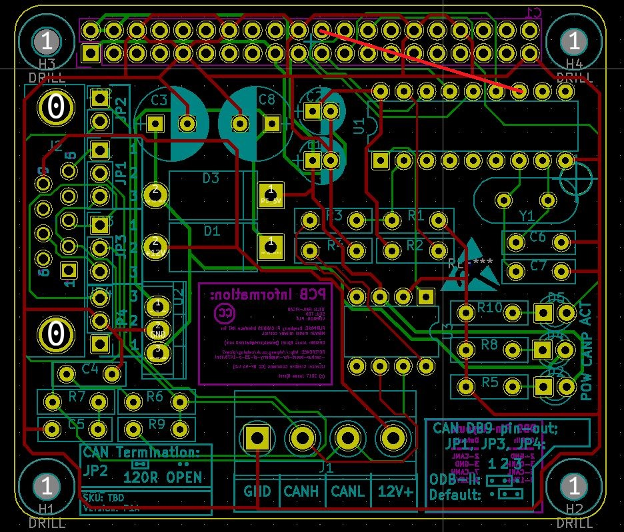

Don’t connect – use separate Raspi power feed

Figure 1: Needed patches

Figure 2: Real life patch – but the yellow patch wire broke away from u1 pin 12

Figure 3: Gnd, CanL & CanH (but not 12V) being patched into the almost non existent DIN connector SKU of Merklin control head end. I have not found a single supplier for this connector.