Databases Project – Spring 2021

Team No:

Members:

# **Contents**

Contents 1

Deliverable 1 2

Assumptions 2

Entity Relationship Schema 2

Schema 2

Description 2

Relational Schema 2

ER schema to Relational schema 2

DDL 2

General Comments 2

Deliverable 2 3

Assumptions 3

Data Loading/Cleaning 3

Query Implementation 3

General Comments 3

Deliverable 3 4

Assumptions 4

Query Implementation 4

Query Performance Analysis – Indexing 4

General Comments 4

# **Deliverable 1**

## **Assumptions**

**On Identification:**

* Every party number should be unique within a collision. Every party_id, victim_id, case_id should be unique by its own within the corresponding .csv files.

**On data:**

* We assumed that in the .csv files every field would be represented by its key or that we would make it so during the data cleaning phase.
* We assumed that every description could fit in 150 char.
* For the id (case_id for example), we assumed that the leadings 0 were important to differentiate two different cases and therefore we decided to use CHAR(64).

**On integrity:**

* Every victim should be associated with an unique party. Every party should be implicated in a unique collision.

**Entity Relationship Schema**

<In this section you should have figure of the ER schema as well as descriptions about entities and relations>

### **Schema**

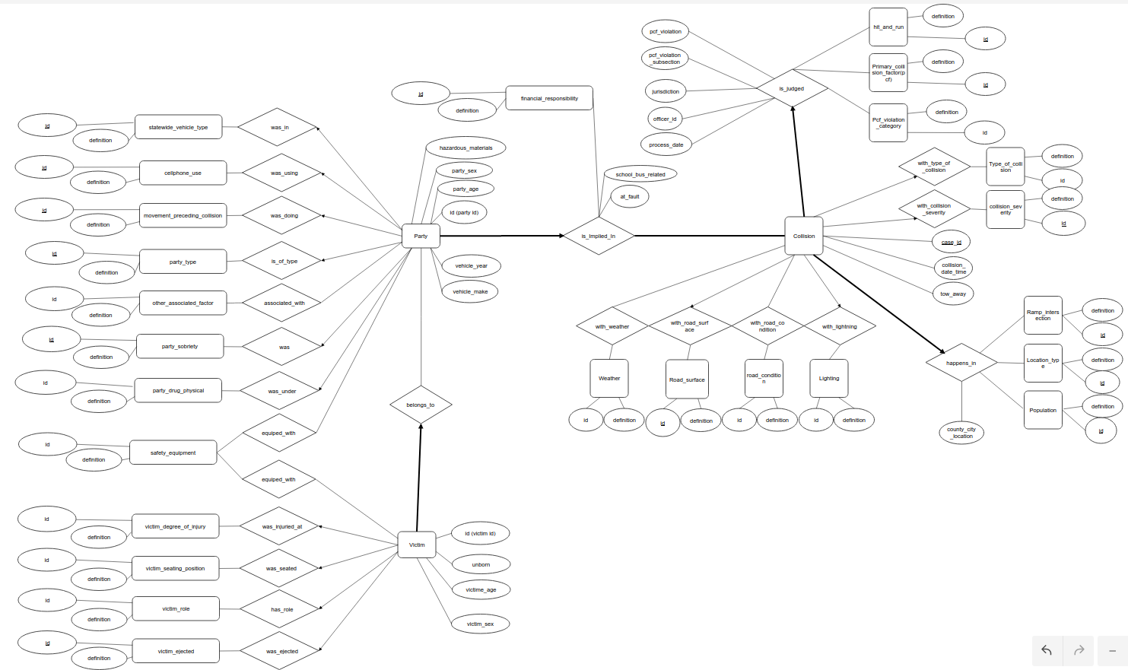

### **Description**

<Describe all the choices you made for Entities and Relationships>

For the ER diagram, we first decided to divide the attributes into 3 main entities called Victim, Party and Collision, because it seemed to us that they were the main actors in the model.

Then, we saw that it didn't make much sense to have only these 3 entities, because some attributes wouldn't be logically attributed to them. For example, it wouldn't make sense that a collision has an attribute population, because they are not directly correlated. Therefore, we tried to group attributes that logically belonged to a common idea together (star schema). For the collisions, we saw that there were many attributes related to the location of the collision, the conditions under which the collision happened and the legal part related to the collision. For the parties, many attributes were related to the vehicle. Hence, we wanted to add these 4 entities to our diagram (but finally modified it slightly, see below).

Also, after we spoke with some assistants, we realised that it would be a good idea to create entities for attributes that are lists with some finite non-logically predefined values (A:..., B:...). The reasons are the following: it would be easier to enforce the data we store to be cleaned and in the same format (it avoids to have one time 'a' and one time 'A' referencing to the same value) and it would make it more modulable and easier to change (if we realize that we would like to add/remove an option, we could simply add/remove one row in the table of the entity and add/invalidate these entries in the other table).

When there were many times the same attribute in the csv files (...\_1 and ...\_2), we also decided to create an entity. This has the advantage to be more modulable, since we could decide to add a third (...\_3) attribute or even more of them in the future if we would like to slightly change the model. For that, we simply allowed the relation to have many of these new entities.

Finally, when we wanted to merge all our previous ideas together to construct the diagram, we found that creating the 4 entities mentioned above was not really practical because we would have to create these entities which now have no (or not many) attributes (since their corresponding attributes were often lists which we now model with an entity and bind through a relation), which makes them almost useless and increases the complexity of the diagram. Therefore, we decided to create N-ary relations directly to group the collision and all the attributes related to a given theme. This seems easier to understand and will create the same result in the database (since every attribute will finally be stored in the Collision table after the merging due to the many-to-one relation) when we translate it from the ER model to the SQL DDL commands.

After the first milestone, we also decided to remove the condition table which we had kept, because we found it easier to implement in the data cleaning process and because our associated TA advised us to do so. Indeed, on our older schema, we had to create a custom key for condition and bind it through a relation which was more complicated and didn’t bring much. The only utility of the condition table was to make the star schema easier to understand, but in practice it didn’t bring much.

## **Relational Schema**

### **ER schema to Relational schema**

<Describe the transition from ER schema to Relational schema>

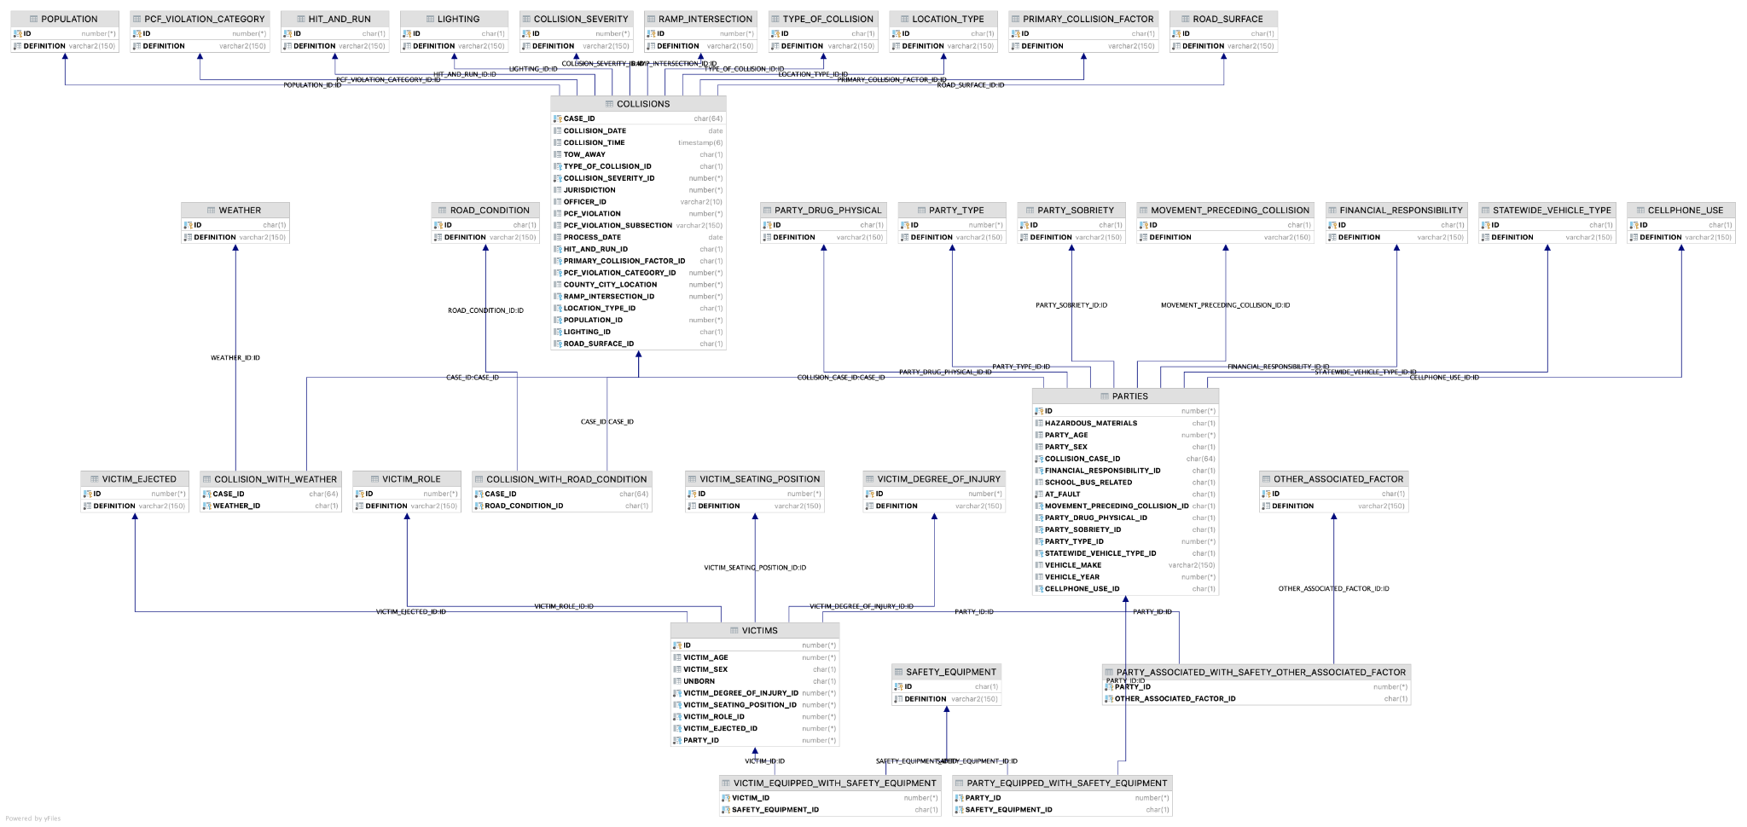

### **DDL**

|  |
| --- |
| *---Design implementations---*  *-- Boolean => char(1)*  *-- definition => varchar(150)*  *-- Table_name (First letter upper case then underscores)*  *-- One-to-Many (Store key in one)*  *-- No state is null, set key to null*  *-- In an entity: id is id of current entity, create new attribute table_id for referenced id*  *---Collisions start---*  **CREATE TABLE** Weather  (  **id char**(1), *-- check if if is one of letter*  **definition varchar**(150) **not null**,  **PRIMARY KEY** (**id**)  );  **CREATE TABLE** Road_surface  (  **id char**(1), *-- check if if is one of letter*  **definition varchar**(150) **not null**,  **PRIMARY KEY** (**id**)  );  **CREATE TABLE** Road_condition  (  **id char**(1), *-- check if if is one of letter*  **definition varchar**(150) **not null**,  **PRIMARY KEY** (**id**)  );  **CREATE TABLE** Lighting  (  **id char**(1), *-- check if if is one of letter*  **definition varchar**(150) **not null**,  **PRIMARY KEY** (**id**)  );  **CREATE TABLE** Type_of_collision  (  **id char**(1), *--check char between a & h*  **definition varchar**(150) **not null**,  **PRIMARY KEY** (**id**)  );  **CREATE TABLE** Collision_severity  (  **id int CHECK** (0 <= **id and id** <= 4),  **definition varchar**(150) **not null**,  **PRIMARY KEY** (**id**)  );  **CREATE TABLE** Hit_and_run  (  **id char**(1),  **definition varchar**(150) **not null**,  **PRIMARY KEY** (**id**)  );  **CREATE TABLE** Primary_collision_factor  (  **id char**(1),  **definition varchar**(150) **not null**,  **PRIMARY KEY** (**id**)  );  **CREATE TABLE** Pcf_violation_category  (  **id int CHECK** ((0 <= **id and id** <= 24)),  **definition varchar**(150) **not null**,  **PRIMARY KEY** (**id**)  );  **CREATE TABLE** Ramp_intersection  (  **id int CHECK** (1 <= **id and id** <= 8),  **definition varchar**(150) **not null**,  **PRIMARY KEY** (**id**)  );  **CREATE TABLE** Location_type  (  **id char**(1),  **definition varchar**(150) **not null**,  **PRIMARY KEY** (**id**)  );  **CREATE TABLE** Population  (  **id int CHECK** (0 <= **id and id** <= 9),  **definition varchar**(150) **not null**,  **PRIMARY KEY** (**id**)  );  **CREATE TABLE** Collisions  (  **case_id char**(64),  **collision_date date**,  **collision_time timestamp**(6),  **tow_away char**(1) **CHECK** (**tow_away** = **'T' or tow_away** = **'F'**),  **type_of_collision_id char**(1) **references** Type_of_collision (**id**),  **collision_severity_id int not null references** Collision_severity (**id**),  *-- Relations is_judged*  **jurisdiction int CHECK** (0 <= **jurisdiction and jurisdiction** <= 9999),  **officer_id varchar**(10),  **pcf_violation int**,  **pcf_violation_subsection varchar**(150),  **process_date date**,  **hit_and_run_id char**(1) **references** Hit_and_run (**id**),  **primary_collision_factor_id char**(1) **references** Primary_collision_factor (**id**),  **pcf_violation_category_id int references** Pcf_violation_category (**id**),  *-- Relations happens_in*  **county_city_location int**,  **ramp_intersection_id int references** Ramp_intersection (**id**),  **location_type_id char**(1) **references** Location_type (**id**),  **population_id int references** Population (**id**),  *-- Relations happens_under*  **lighting_id char**(1) **references** Lighting (**id**),  **road_surface_id char**(1) **references** Road_surface (**id**),  **PRIMARY KEY** (**case_id**)  );  **CREATE TABLE** Collision_with_weather  (  **case_id char**(64) **references** Collisions (**case_id**) **on delete cascade**,  **weather_id char**(1) **references** Weather (**id**) **on delete cascade**,  **PRIMARY KEY** (**case_id**, **weather_id**)  );  **CREATE TABLE** Collision_with_road_condition  (  **case_id char**(64) **references** Collisions (**case_id**) **on delete cascade**,  **road_condition_id char**(1) **references** Road_condition (**id**) **on delete cascade**,  **PRIMARY KEY** (**case_id**, **road_condition_id**)  );  *---Collisions end---*  **CREATE TABLE** Safety_equipment  (  **id char**(1),  **definition varchar**(150) **not null**,  **PRIMARY KEY** (**id**)  );  *---Parties start---*  *-- Related entities with party: one to many*  **CREATE TABLE** Movement_preceding_collision  (  **id char**(1),  **definition varchar**(150) **not null**,  **PRIMARY KEY** (**id**)  );  **CREATE TABLE** Party_drug_physical  (  **id char**(1),  **definition varchar**(150) **not null**,  **PRIMARY KEY** (**id**)  );  **CREATE TABLE** Party_sobriety  (  **id char**(1),  **definition varchar**(150) **not null**,  **PRIMARY KEY** (**id**)  );  **CREATE TABLE** Party_type  (  **id int**,  **definition varchar**(150) **not null**,  **PRIMARY KEY** (**id**)  );  **CREATE TABLE** Statewide_vehicle_type  (  **id char**(1),  **definition varchar**(150) **not null**,  **PRIMARY KEY** (**id**)  );  **CREATE TABLE** Cellphone_use  (  **id char**(1),  **definition varchar**(150) **not null**,  **PRIMARY KEY** (**id**)  );  *-- Relations with party: Many to many*  **CREATE TABLE** Other_associated_factor  (  **id char**(1),  **definition varchar**(150) **not null**,  **PRIMARY KEY** (**id**)  );  **CREATE TABLE** Financial_responsibility  (  **id char**(1),  **definition varchar**(150) **not null**,  **PRIMARY KEY** (**id**)  );  *-- Parties*  **CREATE TABLE** Parties  (  **id int**,  *-- Attributes*  **hazardous_materials char**(1),  **party_age int**,  **party_sex char**(1),  *-- relation to collision*  **collision_case_id char**(64) **not null references** Collisions (**case_id**),  **financial_responsibility_id char**(1) **references** Financial_responsibility (**id**),  **school_bus_related char**(1),  **at_fault char**(1) **not null**,  *-- referenced ids*  **movement_preceding_collision_id char**(1) **references** Movement_preceding_collision (**id**),  **party_drug_physical_id char**(1) **references** Party_drug_physical (**id**),  **party_sobriety_id char**(1) **references** Party_sobriety (**id**),  **party_type_id int references** Party_type (**id**),  **statewide_vehicle_type_id char**(1) **references** Statewide_vehicle_type (**id**),  **vehicle_make varchar**(150),  **vehicle_year int**,  **cellphone_use_id char**(1) **default 'D' references** Cellphone_use (**id**), *--default 'D' makes it faster*  *-- key*  **PRIMARY KEY** (**id**)  );  **CREATE TABLE** Party_equipped_with_safety_equipment  (  **party_id int not null references** Parties (**id**) **on delete cascade**,  **safety_equipment_id char**(1) **not null references** Safety_equipment (**id**) **on delete cascade**,  **PRIMARY KEY** (**party_id**, **safety_equipment_id**)  );  **CREATE TABLE** Party_associated_with_safety_other_associated_factor  (  **party_id int not null references** Parties (**id**) **on delete cascade**,  **other_associated_factor_id char**(1) **not null references** Other_associated_factor (**id**) **on delete cascade**,  **PRIMARY KEY** (**party_id**, **other_associated_factor_id**)  );  *---Parties end---*  *---Victims start---*  **CREATE TABLE** Victim_degree_of_injury  (  **id int CHECK** (0 <= **id and id** <= 7), *-- can we make sure id and def are consistent*  **definition varchar**(150) **not null**,  **PRIMARY KEY** (**id**)  );  **CREATE TABLE** Victim_seating_position  (  **id int**, *--can we check if id is number or char?*  **definition varchar**(150) **not null**,  **PRIMARY KEY** (**id**)  );  **CREATE TABLE** Victim_role  (  **id int CHECK** (1 <= **id and id** <= 6),  **definition varchar**(150) **not null**,  **PRIMARY KEY** (**id**)  );  **CREATE TABLE** Victim_ejected  (  **id int CHECK** (0 <= **id and id** <= 3), *--make sure entity is still created if id is null*  **definition varchar**(150) **not null**,  **PRIMARY KEY** (**id**)  );  **CREATE TABLE** Victims  (  **id int**,  **victim_age int**,  **victim_sex char**(1),  **unborn char**(1),  *--- referenced ids--*  **victim_degree_of_injury_id int not null references** Victim_degree_of_injury (**id**),  **victim_seating_position_id int references** Victim_seating_position (**id**),  **victim_role_id int not null references** Victim_role (**id**),  **victim_ejected_id int references** Victim_ejected (**id**),  **party_id int not null REFERENCES** Parties (**id**),  **PRIMARY KEY** (**id**)  );  **CREATE TABLE** Victim_equipped_with_safety_equipment  (  **victim_id int not null references** Victims (**id**) **on delete cascade**,  **safety_equipment_id char**(1) **not null references** Safety_equipment (**id**) **on delete cascade**,  **PRIMARY KEY** (**victim_id**, **safety_equipment_id**)  );  *---Victims end---* |

## **General Comments**

In general, we found it pretty hard to create the ER diagram at first because there were a lot of attributes to proceed and understand and also because we didn’t have much experience with this kind of work. But after having spent some time, we think that our implementation is now logical and should allow us to retrieve the information without having too many problems.

The allocation between the members was good, since we almost always worked together as a team. We first all took part in the elaboration of the ER diagram by concentrating us each on a CSV file and then talking with each other to see which attributes could belong together.  
We then all wrote some of the SQL DDL commands to create the tables and wrote the report together.

# **Deliverable 2**

## **Assumptions**

## **Data Loading/Cleaning**

We decided to clean the data in jupyter notebooks using pandas. We processed the data CSV by CSV then transferred the data using pickles for example to infer party_id from case_id and party_number. We used translation tables (python dictionary) to translate from description to id where it was needed, since we decided to create small entities for each for attributes that are lists with some finite non-logically predefined values. We generated the tables for such small entities by copying the data from the handout pdf file. For the relations with entities representing multiple attributes with the same mapping (with _1 and _2) we concatenate all the non null rows and drop the duplicates since they don't add any information.

**Collisions.csv:**

No major assumptions were needed to clean the collisions data. We chose to use timestamp as a type for all the date and time attributes. We first wanted to use a specific type for date only and one for time only, but we didn’t see any such data type available with Oracle DB, therefore we chose timestamp which is not ideal for our use case. For the collision_date the time is automatically set to 00:00. For the collision_time field we chose to set a fixed default date (2000-01-01) . We couldn’t merge both date and time in a single field because when one of them is missing, setting it to a default value would compromise the integrity of the data.

officer_id:

We decided to change the officer id ",66" to None because we had problems inserting it in the database due to the ','. We could have changed it to "66" (which is a valid value in the dataset), but since we were not sure that it was a typo, we found this assumption too strong and therefore we prefered to remove it.

**Parties.csv**

The data from parties had more dirty values. Here are the choices we did:

cellphone_use:

We realised that the values that are stored in the cellphone_use column {'1', '2', '3', 'B', 'C', 'D', nan} are different to the ones on the handout {'B', 'C', 'D', nan}. The values that are in the data but not in the handout {'1', '2', '3'} appear 2’636’894 times. We decided not to drop these values because they are a big chunk of the data (56%).

We needed to find a plausible mapping between the numbers and the letters. We opted to do it by doing a frequency analysis.

1 : 24787 in % : 0.009 B : 38932 in % : 0.018

2 : 39114 in % : 0.015 C : 795475 in % : 0.377

3 : 2572993 in % : 0.976 D : 1274423 in % : 0.604

As you can see, it is clear that 1 and B are those that appear the least, and 3 and D are those that appear most frequently.

Therefore, we concluded that the correct mapping is: 1 -> B, 2 -> C, 3 -> D

As we imported the data in the database we chose to replace the None value by "D" since D already means "No Cell Phone/Unknown" which is equal to "no value".

vehicle_make:

Since vehicle_make is an open field there are a lot of errors and inconsistency. We corrected the most obvious typos (see below) and made some brands consistent. We chose not to modify this field too much since we are not experts in vehicle_make and that's error prone to modify it manually. For example we decided not to remove values with "OTHER - ..." since they add information compared to a "None". Here are the typos and inconsistencies we corrected and:

"AMERICAN MOTORS" => "AMERICAN MOTORS (AMC)"

"DODG" => "DODGE"

"HOND" => "HONDA"

"MERCEDES BENZ" => "MERCEDES-BENZ"

"MAZD" => "MAZDA"

"TOYTA" => "TOYOTA"

"MISCELLANEOUS" , "NOT STATED" => None

party_drug_physical:

We noticed 585’062 rows of party_drug_physical with value "G" which is not a valid key. We decided to replace it by None since we had no way to guess what the correct value was.

**Victims**:

victim_age and pregnancy:

In order to clean the data and make querying easier, we decided to create a new field: unborn which is a boolean telling if the victim was born or not. We set unborn from the convention saying that if the age is a 999 then the victim is the fetus of a pregnant woman. Then we replaced the age 999 by None. We chose to replace it by None and not 0 because we thought it would make more sense and that it would be weird if the mean of age of a 30 years old pregnant woman is 15 years.

## **Assumptions For Queries**

For the queries, we had the assumption that we could use all available built-in functions for Oracle database systems. These functions are EXTRACT, COUNT, MEDIAN, FETCH, TO_CHAR, LOWER and DUAL.

## **Query Implementation**

**Query 1:**

***Description of logic:***

This query should retrieve the number of collisions per year. Therefore, we first group by the year that we extract with the built-in function “EXTRACT(YEAR from …)”. We then count the number of entries per year. We decided to order it by year, ascending to make it clearer.

***SQL statement***

|  |
| --- |
| SELECT EXTRACT(YEAR FROM C.COLLISION_DATE) AS YEAR, COUNT(*) AS NUMBER_COLLISIONS  FROM COLLISIONS C  GROUP BY EXTRACT(YEAR FROM C.COLLISION_DATE)  ORDER BY EXTRACT(YEAR FROM C.COLLISION_DATE) ASC; |

***Query result (if the result is big, just a snippet)***

|  |  |
| --- | --- |
| YEAR | NUMBER_COLLISIONS |
| 2001 | 522562 |
| 2002 | 544741 |
| 2003 | 538954 |
| 2004 | 538295 |
| 2005 | 532725 |
| 2006 | 498850 |
| 2007 | 501908 |
| 2017 | 7 |
| 2018 | 21 |

**Query 2:**

***Description of logic:***

This query should retrieve the most popular vehicle make and the number of vehicles for this make. We do this by first grouping by make and sorting it by the number of vehicles for each make. To retrieve the most popular make only, we use the “FETCH FIRST 1 ROW ONLY“ built-in function (which is equivalent to limit in MySQL).

***SQL statement***

|  |
| --- |
| SELECT P.VEHICLE_MAKE, COUNT(*) AS NUMBER_VEHICLE  FROM PARTIES P  GROUP BY P.VEHICLE_MAKE  ORDER BY COUNT(*) DESC  FETCH FIRST 1 ROW ONLY; |

***Query result (if the result is big, just a snippet)***

|  |  |
| --- | --- |
| VEHICLE_MAKE | NUMBER_VEHICLE |
| FORD | 1129701 |

**Query 3:**

***Description of logic:***

This query should retrieve the fraction of collisions which happen under dark lighting. For that, we first query the lightning that contains “dark” in their definition (note that we could directly use the ID since we know it, but we found clearer and more robust to query it using the definition if we would like to use the same query later on, when the table could be modified and more than one field could be about dark weather). We then bind it to the lighting id stored in the collisions to count all the collisions with this weather type. We finally divide by the total number of collisions to have a fraction. We also decided to round the result to avoid having many useless digits.

***SQL statement***

|  |
| --- |
| SELECT ROUND(A.NUMBER_COLLISIONS_UNDER_DARK/A.TOTAL_NUMBER_COLLISIONS, 3) AS FRACTION_UNDER_DARK  FROM(  SELECT  (SELECT COUNT(*)  FROM COLLISIONS C  WHERE C.LIGHTING_ID IN  ( SELECT L.ID  FROM LIGHTING L  WHERE LOWER(L.DEFINITION) LIKE '%dark%')) AS NUMBER_COLLISIONS_UNDER_DARK,  (SELECT COUNT(*) FROM COLLISIONS) AS TOTAL_NUMBER_COLLISIONS  FROM DUAL  )A; |

***Query result (if the result is big, just a snippet)***

|  |
| --- |
| FRACTION_DARK |
| 0.28 |

**Query 4:**

***Description of logic:***

This query should retrieve the number of collisions which happen under snowy weather. Just like before, we just query the ids in weather which contain “snow” in their definition and count all the entries of the relation which have this id.

***SQL statement***

|  |
| --- |
| SELECT COUNT(*) AS NUMBER_COLLISIONS_SNOWY_WEATHER  FROM COLLISION_WITH_WEATHER CWW  WHERE CWW.WEATHER_ID IN  ( SELECT W.ID  FROM WEATHER W  WHERE LOWER(W.DEFINITION) LIKE '%snow%'); |

***Query result (if the result is big, just a snippet)***

|  |
| --- |
| NUMBER_COLLISIONS_SNOWY_WEATHER |
| 8530 |

**Query 5:**

***Description of logic:***

This query should retrieve the number of collisions that happen every day of the week. For that, we first groupy by the day using the built-in function “TO_CHAR(date, ‘DAY’)” and count the number of entries.

***SQL statement***

|  |
| --- |
| SELECT TO_CHAR(C.COLLISION_DATE, 'DAY') AS WEEKDAY, COUNT(*) AS NUMBER_COLLISIONS  FROM COLLISIONS C  GROUP BY TO_CHAR(C.COLLISION_DATE, 'DAY'); |

***Query result (if the result is big, just a snippet)***

|  |  |
| --- | --- |
| WEEKDAY | NUMBER_COLLISIONS |
| MONDAY | 516799 |
| TUESDAY | 535743 |
| SUNDAY | 428289 |
| WEDNESDAY | 536068 |
| FRIDAY | 614853 |
| SATURDAY | 509498 |
| THURSDAY | 536813 |

**Query 6:**

***Description of logic:***

This query should retrieve all the types of weather and their corresponding number of collisions, sorted in descending order. For that, we simply join the tables weather and collisions with weather, then group by the definition and count all the entries.

***SQL statement***

|  |
| --- |
| SELECT W.DEFINITION, COUNT(*) AS NUMBER_COLLISIONS  FROM WEATHER W, COLLISION_WITH_WEATHER CWW  WHERE W.ID=CWW.WEATHER_ID  GROUP BY W.DEFINITION  ORDER BY COUNT(*) DESC; |

***Query result (if the result is big, just a snippet)***

|  |  |
| --- | --- |
| DEFINITION | NUMBER_COLLISIONS |
| Clear | 2941042 |
| Cloudy | 548250 |
| Raining | 223752 |
| Fog | 21259 |
| Wind | 13952 |
| Snowing | 8530 |
| Other | 6960 |

**Query 7:**

***Description of logic:***

This query should retrieve all the at-fault collision parties with financial responsibility and loose material. For that, we had to check if the party is at fault in the table party and then check for the financial responsibility by using the id and extracting the ones having “yes” in their description and finally check the loose material by using the case id to retrieve the collision, then the road condition id from the relation table and finally take only the definition having “loose material” in it.

***SQL statement***

|  |
| --- |
| SELECT COUNT(*) AS NUMBER_AT_FAULT_WITH_FIN_REP_LOOSE_MAT  FROM PARTIES P  WHERE P.AT_FAULT='T'  AND P.FINANCIAL_RESPONSIBILITY_ID IN  ( SELECT FR.ID  FROM FINANCIAL_RESPONSIBILITY FR  WHERE LOWER(FR.DEFINITION) LIKE '%yes%')  AND P.COLLISION_CASE_ID IN  ( SELECT COL.CASE_ID  FROM COLLISIONS COL  WHERE COL.CASE_ID IN  ( SELECT CWRC.CASE_ID  FROM COLLISION_WITH_ROAD_CONDITION CWRC  WHERE CWRC.ROAD_CONDITION_ID IN  ( SELECT RC.ID  FROM ROAD_CONDITION RC  WHERE LOWER(RC.DEFINITION) LIKE '%loose material%'))); |

***Query result (if the result is big, just a snippet)***

|  |
| --- |
| NUMBER_AT_FAULT_WITH_FIN_REP_LOOSE_MAT |
| 4608 |

**Query 8:**

***Description of logic:***

This query should retrieve the median age and the most common victim seating position. Since these 2 informations have not much to do with each other, we first wrote them individually and then used dual to write them together.

For the median age, we just used the built-in “MEDIAN” function.

For the most common victim seating position, we used the same trick as in query 2 which is to group by the seating position, sort by the number and keep the top row only.

***SQL statement***

|  |
| --- |
| SELECT  A.VICTIM_AGE_MEDIAN, A.MOST_COMMON_VICTIM_SEATING_POSITION  FROM  (  SELECT  ( SELECT MEDIAN(V.VICTIM_AGE)  FROM VICTIMS V) AS VICTIM_AGE_MEDIAN,  ( SELECT VSP.DEFINITION  FROM VICTIM_SEATING_POSITION VSP  WHERE VSP.ID IN  ( SELECT V.VICTIM_SEATING_POSITION_ID  FROM VICTIMS V  GROUP BY V.VICTIM_SEATING_POSITION_ID  ORDER BY COUNT(*) DESC  FETCH FIRST 1 ROW ONLY)) AS MOST_COMMON_VICTIM_SEATING_POSITION  FROM DUAL  )A; |

***Query result (if the result is big, just a snippet)***

|  |  |
| --- | --- |
| VICTIM_AGE_MEDIAN | MOST_COMMON_VICTIM_SEATING_POSITION |
| 25 | Passengers |

**Query 9:**

***Description of logic:***

This query should retrieve the fraction of victims who were using a belt along all the participants. For that, we first count all victims which have a belt and divide by the total number of victims and participants using DUAL to be able to divide them. We also decided to round the result to make it more readable.

***Remarks***

We found this query not very logical since a party represents a group of people and that a party could be already counted in the victim table, but not necessarily since we have no way to be sure whether a party only has victims or not. At first, we had only counted the total number of victims (instead of victims + parties), but after seeing this post <https://moodle.epfl.ch/mod/forum/discuss.php?d=56137>, point3, we decided to use the query shown below.

***SQL statement***

|  |
| --- |
| SELECT ROUND(A.NUMBER_VICTIM_WITH_BELT / (A.TOTAL_VICTIM + A.TOTAL_PARTIES), 3) AS FRACTION_WITH_BELT  FROM  (  SELECT  (SELECT COUNT(*)  FROM VICTIMS V  WHERE V.ID IN  ( SELECT VEWSE.VICTIM_ID  FROM VICTIM_EQUIPPED_WITH_SAFETY_EQUIPMENT VEWSE  WHERE VEWSE.SAFETY_EQUIPMENT_ID IN  ( SELECT SE.ID  FROM SAFETY_EQUIPMENT SE  WHERE LOWER(SE.DEFINITION) LIKE '%belt use%'))) AS NUMBER_VICTIM_WITH_BELT,  (SELECT COUNT(*) FROM VICTIMS) AS TOTAL_VICTIM,  (SELECT COUNT(*) FROM PARTIES) AS TOTAL_PARTIES  FROM DUAL  )A; |

***Query result (if the result is big, just a snippet)***

|  |
| --- |
| FRACTION_WITH_BELT |
| 0.011 |

**Query 10:**

***Description of logic:***

This query should retrieve the fraction of collisions that happen each hour of the day. For that, we simply group by the hour that we extract from the time using the EXTRACT(HOUR, time) built-in function, count the number of entries for each hour and divide by the total number of collisions.

***Remark:***

We decided to keep an entry when the hour was not specified with the fraction of accidents when the hour was unknown because we found it clearer this way.

We only showed the first 20 entries in the result as asked in the question.

***SQL statement***

|  |
| --- |
| SELECT EXTRACT(HOUR FROM C.COLLISION_TIME) AS HOUR, ROUND(COUNT(*)/( SELECT COUNT(*) FROM COLLISIONS), 3) AS FRACTION_COLLISIONS  FROM COLLISIONS C  GROUP BY EXTRACT(HOUR FROM C.COLLISION_TIME)  ORDER BY EXTRACT(HOUR FROM C.COLLISION_TIME) ASC; |

***Query result (if the result is big, just a snippet)***

|  |  |
| --- | --- |
| HOUR | FRACTION_COLLISIONS |
| 0 | 0.019 |
| 1 | 0.018 |
| 2 | 0.018 |
| 3 | 0.012 |
| 4 | 0.01 |
| 5 | 0.014 |
| 6 | 0.026 |
| 7 | 0.052 |
| 8 | 0.052 |
| 9 | 0.041 |
| 10 | 0.042 |
| 11 | 0.049 |
| 12 | 0.058 |
| 13 | 0.058 |
| 14 | 0.065 |
| 15 | 0.077 |
| 16 | 0.073 |
| 17 | 0.079 |
| 18 | 0.063 |
| 19 | 0.044 |

## **General Comments**

We didn’t have to change our previous work on the ER diagram in part 1 too much and we were able to write the queries quite easily. However, it took us a lot of time to clean the data and we had some problems when we tried to import the data in the database.

We decided to work all together on the different tasks, each team member spent an equal amount of time.

# **Deliverable 3**

# **Assumptions**

<In this section write down the assumptions you made about the data. Write a sentence for each assumption you made>

## **Query Implementation**

<For each query>

**Query a:**

***Description of logic:***

<What does the query do and how do I decide to solve it>

***SQL statement***

<The SQL statement>

***Query result (if the result is big, just a snippet)***

<The SQL statement result>

## **Query Performance Analysis – Indexing**

<In this section, for 6 selected queries explain in detail why do you see given improvements (or not). For example, why building an index on certain field changed the plan and IO.>

**Query 1**

<Initial Running time/IO:

Optimized Running time/IO:

Explain the improvement:

Initial plan

Improved plan>

**Query 2**

<Initial Running time/IO:

Optimized Running time/IO:

Explain the improvement:

Initial plan

Improved plan>

# **General Comments**

<In this section write general comments about your deliverable (comments and work allocation between team members>