Exercise – 12 Task 2

**Task**

Hacker101 complete the “Hello World” native binary challenge

**Tools**

Ghidra, Burp Suit and Firefox´s inspect element functions

**Answer**

**Step 0:** I ran the command ‘file vulnerable’ in the terminal and found out that the binary file is ELF 64bit LSB executable.

**Step 1**: I tried to insert 50 chars as input. This led to segmentation fault. Segmentation fault means that I try to access memory which do not belong to me.

Input: “01234567890123456789012345678901234567890123456789”

Output: “Segmentation fault (core dump)”

**Step 2:** I found the amount of chars possible to insert without receiving segmentation fault. 40 chars were the limit. In the end of the output we also received some weird characters “á¢¥÷ÿ!”. I suspect this is a pointer, pointing to an address.

Input: “0123456789012345678901234567890123456789”

Output: “Hello 0123456789012345678901234567890123456789á¢¥÷ÿ!”

**Step 3:** Used Ghidra to find the memory address to the flag. In Ghidra the memory addresses are stored backwards, after the Little Indian standard.

Address:

The address is therefor: ee064000.

In step 0 we found out that the file, vulnerable, is ELF 64bit LSB executable. Therefor we rewrite the address to 64 bit format: %ee%06%40%00%00%00%00%00

**Step 4:** Sent 40 chars + the flags memory address as input. The secret flag apers as the output.

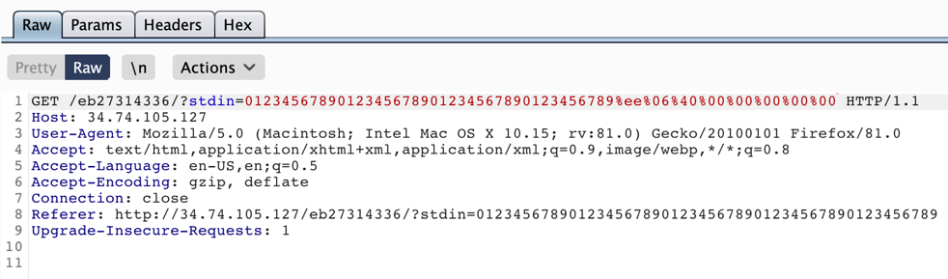Input: “0123456789012345678901234567890123456789%ee%06%40%00%00%00”

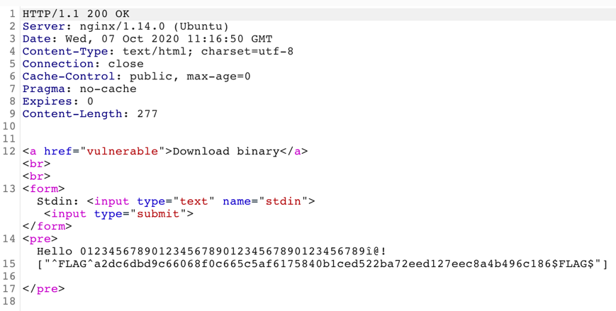Output:

**Submitted the flag**: 