STUDENT(S) DETAILS
 |  | Student 1 |  | Student 2 |  |  | Student 3 |  |  |  |  | Student 4 |  |  | Student 5
Student ID Number(s) |  | 700513X
Family Name(s) |  | Bunawan
Given name (s) |  | Jonas
SUBJECT DETAILS
Subject Code |  | INF30010 |  | Subject Title |  |  | Database Administration
Lecturer’s/Supervisor’s Name |  | Mohamed Abdelrazek |  |  |  |  | Tute/Lab day & time |  |  |  |  | Lab 1 (1) | Tuesday, 11:30 – 12:30
ASSIGNMENT DETAILS
Title or Topic Addressed |  | Assignment2 – Database Design (ACE Horizons - Cloud Based Computing)
Due Date | Monday, 19th October 2015 @10 PM AEDST |  |  |  |  |  |  |  | Date Received |  | Sunday, 8 November 2026 1:07:05 AM
DECLARATION
- I/We hold a photocopy or electronic copy of this assignment which can be produced if the original is lost/damaged;
- To the best of my/our belief, no part of this assignment has been copied from any other student’s work or from any other source except where acknowledgement is made in the text;
- No part of this assignment has been written for me/us by any other person except where such collaboration has been authorised by the lecturer concerned and where acknowledgement is made in the text;
- No part of this assignment has been previously submitted as an assessable item, except where authorised by the lecturer concerned and where acknowledgement is made in the text;
- SAFE ASSIGN: For units where Safe Assign facility is available in the Blackboard site
1/we declare that this assignment has been submitted to Safe Assign (as specified in the unit outline) and all identified matches and referencing have been checked and corrected.

X I / We accept that electronic submission of this cover sheet will be taken as consent to the terms outlined in Points 1 to 5 of the above declaration by the student/s submitting this assignment.

Student Signature(s)
MARKER’S MAIN COMMENTS
Marker’s Signature |  |  |  |  |  | Date |  |  |  | Grade/Mark


Faculty of Business And Enterprise
INF300010 Database Administration
Assignment 2 – Database Design

Database Design
ACE HORIZONS – Cloud Based Computing Solution
INF30010_A03_T006

Author:

Jonas Bunawan – BICT (Business Systems) – 700513X

I hold a copy of this assignment that can be produced if the original is lost/damaged. To the best of my belief, no part of this assignment has been copied from any other student’s work or from any other source except where due acknowledgement is made in the text. No part has been written for me/us by any other person, except where such collaboration has been authorised by the lecturer concerned.

Executive Summary
This report is made as part of the requirements in passing INF30010 Database Administration subject at Swinburne University of Technology. I did the assignment all by myself by hoping that I could learn more since I could go through every single task that is required in this assignment 2. I am actually aiming for a higher grade than Credit (since I got credit for Assignment 1) for this subject, albeit I have never really had in my mind to take this subject as part of my degree at the early stage. However, since I like database and want to know more about it, I chose this subject so that I could get more technical knowledge which is believed to be a good start to be engaged in real IT industry.
I was enrolled for Database Implementation in last semester, but due to certain condition that required me to withdraw the subject, I had to choose another database related unit to take in this semester (since it’s not offered in last semester of my degree studies). I have tried to finish all of the required sections thus giving me the chance to get higher grade. However, since I know that my knowledge is still limited, I hope that this report can at least be a proof that I have done my learning. At last, I hope that I still have the chance to get higher grade through my work on this assignment. Thank you.

Table of Contents
Executive Summary i
Table of Contents ii
1. Database Design 3
2. Hardware Support 5
3. Intra-site Resilience 7
3.1 Conventional Way 7
3.2 Replicated Database 7
4. Resilience against Catastrophes 8
5. Replication 9
6. Data Warehouse 10
7. Conclusions 12
8. Assertions Justified by Calculations & Explanation 13
9. References 15

Database Design
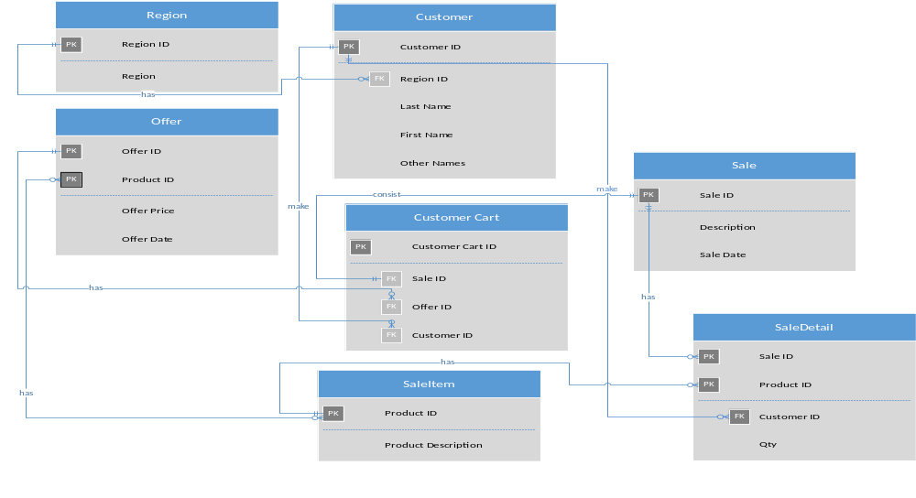
Figure 1 AceHorizons Database Design - ERD
The provided ERD outlines entities that will exist in ACE Horizons Cloud Based Computing System, the explanation are as following:
- Customer Table: containing customer record
- Region Table: acting as lookup table for customer table which contain region details(to make up default choices for Customer’ Region without having random input, i.e: VIC instead of Victoria, or the other way around)
- Sale Table: containing Sale record
- SaleDetail Table: containing Sale record in details(with the list of Product(s) that are being sold and number of quantity that are purchased by Customer which is represented by Customer ID in the table)
- SaleItem Table: containing list of Product that are being sold by the organisation
- CustomerCart Table: containing customers’ shopping cart details. (Transaction table)
- Offer Table: containing offer(s)/deal(s) that are being offered to customer

SaleDetail Table has a composite primary key that is made up by Sale ID and Product ID so that there’s no duplicated data and details for each sale record can be stored in the table precisely where as Sale Item Table, which contains list of products, does not need a Sale ID column since it is referred by Sale Detail and relation between Product and Sale can be achieved by having a query to joint those tables through Sale Detail.
Region Table exists to supplement the Region data of each Customer. The purpose of having that table is so that Customer Table has a lookup table for region data to ensure that data consistency is achieved and to save data storage capacity (instead of having Region in text which might drain more space in the server, Region ID would only take a few bits of space which then can be referred to Region Table for a description of what Region a customer belongs to).

Hardware Support
It is mentioned in the requirements that ACE Horizons has standardised their database management system to use ORACLE RDBMS. Therefore, to achieve compatibility purpose between software and hardware in their expected cloud based system, ACES Horizons is recommended to have a set of hardware which fully supports the database management system, which in this case is most likely, be provided by Sun Microsystems their server.
Client hardware requirements should not be a big issue for ACE Horizons intended system since the database management system would be interrelated with client system via a web application which would be hosted in the cloud and could be accessed by the user remotely (which is one of the objectives in producing Cloud Based system) via users’ own PC/laptop web browser without any specific preferred system.
Furthermore, there is no specified data storage size for the required server since data will be growing rapidly with vast amount. By having a consideration of 500K users to process 50 transactions each day, ACE Horizons is suggested to have server with their own preferred data storage size which then the resource allocation can be taken care by Virtualisation technique. There are number of options which are offered by Sun Microsystems/Oracle for their hardware virtualization capability that can be applied in ACE Horizons case, such as:
- Oracle Secure Global Desktop
- Oracle VM Server for x86
- Oracle VM Server for SPARC
Moreover, since Ace Horizons have some existing hardware that is used to support its current systems, they can be used to support intended secondary site, which is most likely to be had for a backup, that is with the subject of compatibility review on its capability to upkeep the new RDBMS, ORACLE, prior to the application. In that way, there would be more savings in term of cost.
Provided following is the illustration of how the hardware architecture will look like by using preferred storage method, SAN, with the support of RAID and use of dual multi-core multi-threaded processors will be applied in the hardware architecture.
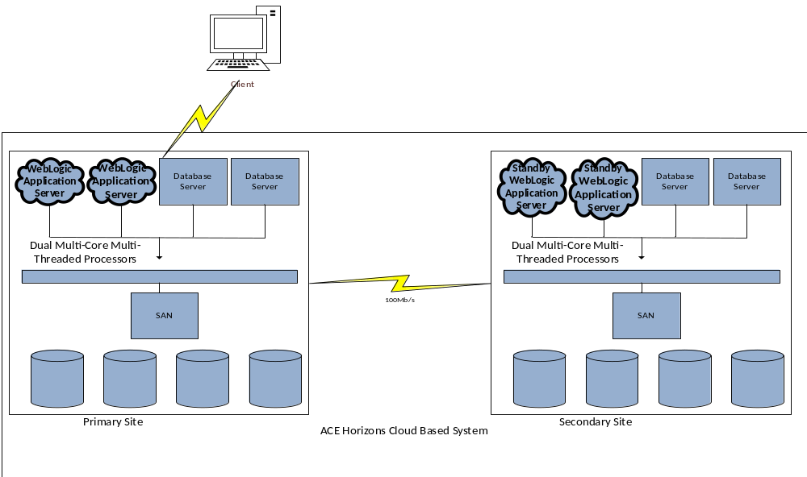
Figure 2 ACE Horizons Cloud Based System - Hardware Architecture

Intra-site Resilience
It is obvious that almost nothing will always run smoothly as what we expect. There may be loss of data that is unpredictable or hardware failure that we cannot avoid. In that case, resiliency of the system within the ACE Horizons site can be achieved by several ways of applicable techniques.

Conventional Way
This method is a manual resiliency model where every step that is involved in the backing up and recovering the database are done manually by an operator/database administrator. Backup process is done regularly (usually overnights so that no interruption is caused by the backup process in the database server) and recovery is done based on existing backup which usually take long time to be done. This method will be the least preference method to be applied in expected ACE Horizons Cloud Based System considering the quick failover time that is needed to get the system back up and running again in case of the system malfunctions to happen.
However, manual backup may still be conducted minimally within the database on a single site to ensure that there is security copy available for each individual database.

Replicated Database
By having a replicated database, it means that there is an exact copy of the database available to be used depending on the model that is being applied. Backup and Recovery process will mostly be done automatically by the system (although in some cases, recovery requires some sort of trigger to be done prior to database recovery, so there is still need to have a database administrator to take care of the system). This method will likely to be used in ACE Horizons case where the system is having a failure; it will still have a next available clustered system to be run so that customers will not be faced up by any interruption/delay during their transactions process.
Furthermore, in regards to hardware failure, dual multi-core multi-threaded processors will be implemented in the primary site as well as in secondary site where SAN is used for data storage method to minimise the risk of single hardware failure.

Resilience against Catastrophes
For an online cloud-based system like the one that is tried to be achieved in ACE Horizons case, it is always a priority to ensure that the system will be up and running without any unnecessary interruption, such as: Hardware Failure, loss of data, etc. Hence, that is why it is mentioned on the previous section that Replicated database would be a good option for ACE Horizons to apply in their database solution.
Replication will also take over the role of conventional periodic back up which is generally used in industry. With the replicated database, we can save up some space by having a backup at one place at a time instead of multiple backups which require huge amount of data storage. Moreover, since dual multi-core multi-threaded processors will be used in both sites, secondary site can take over primary site functionality thus allowing customers to proceed along with their transactions in timely manner if any catastrophe happens. In the case of catastrophe, secondary site will be configured as master database and primary site will act temporarily as slave which then the roles will be configured back to what their previous roles are.
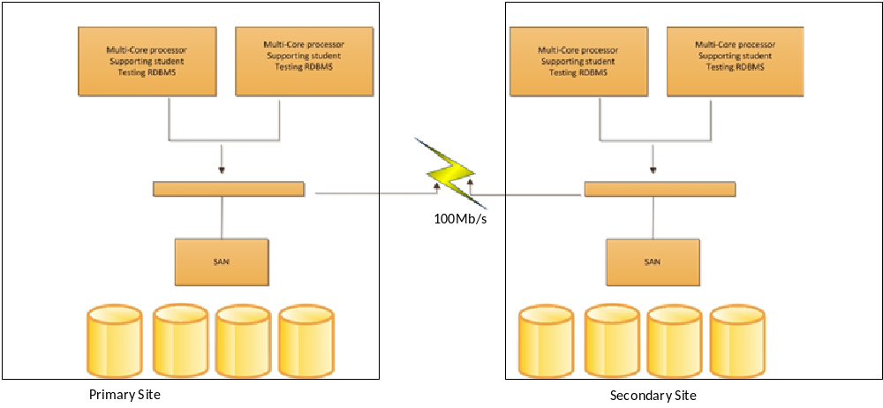
Figure 3 ACE Horizons – Catastrophe Resiliency by Replication

P.S.:More explanation on relevant replication model will be explained on next section

Replication
Since replication is highly preferred to be implemented for resiliency of ACE Horizons Cloud based system, there are certain models that can be options for its application in the database system design; Logical & Physical Principle with their own advantages and disadvantages.
By having consideration of fast failover and/or failback that is needed between the primary and secondary site (quickly change the role of master/slave database on each site), Physical Replication model will be preferred because of its quick time response for the needed recovery. Physical replication model is also a good choice since there will be not much difference between the primary and secondary database schema which is one of the Physical replication requirements.
Furthermore, it is also considered to be the most appropriate solution since it offers the capability to minimise delay to transaction update on slave which is needed in ACE Horizons Cloud based system to process the huge amount of transactions that will occur in the transactional database (primary database). Additionally, there is 2 minutes response time that needs to be taken into account, so Physical Replication model that can minimise the data processing time will be considered the most to be applied as ACE Horizons replication method.
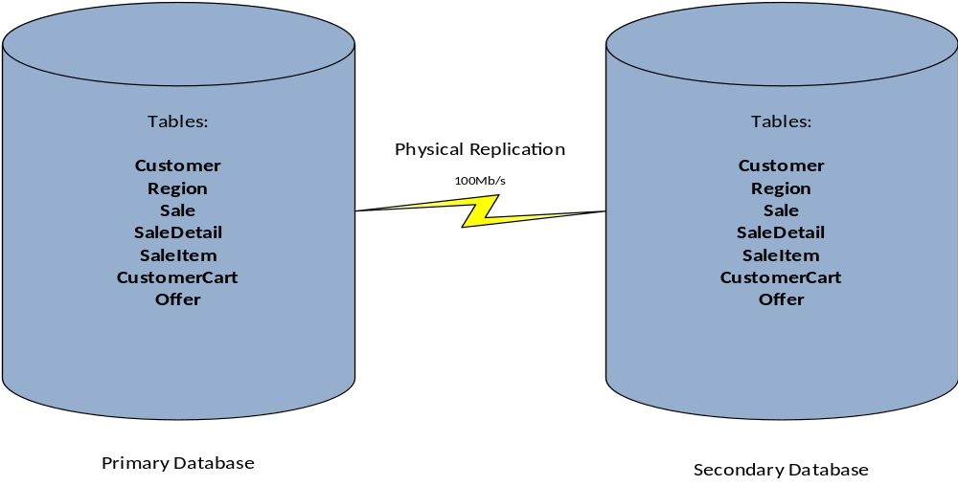
Figure 4 ACE Horizons - Replication Model
However, with that being said, it does not mean Logical Principle will not be useful in ACE Horizons database replication model. Logical Principle will be useful for ACE Horizons datawarehouse replicated database.

Data Warehouse
Data Warehouse of ACE Horizons Cloud Based Computing system will be stored in separate database instance at secondary site. The reason of having data warehouse in secondary site is to avoid using resource on primary site where the transactional database resides which may require much resource for its transactions with quick turnovers and data warehouse itself requires much resource for its database itself. Moreover, there are several processes that need to be done for Data Warehouse, which is Extract, Transform, & Load; or well known as ETL. These processes require extra resource to product data warehouse which will be used to generate reports.
Triggers, which is best data extract technique so far, will be implemented to log changes in database, so when it comes to data extract for Data Warehouse, RDBMS does not need to run full table scan thus allowing us to save some time in ETL process. In companion of triggers to log change for data extract, distributed database technique will also be used to intermediate data transform as working database which then the results of transformation will be loaded to data warehouse. Data Marts can also be produced to easily generate requested reports, albeit at this stage data marts will not be a priority.
For a security purpose, Data Warehouse can also be replicated so that backup exists in case of any failure occurs during ETL or errors in existing Data Warehouse itself. In this case Logical Replication model which ensures the copy of data accuracy by executing two-phase commit between master & slave database will be a preferred model, albeit it takes longer time than Physical Replication model to replicate database. Logical Replication is considered to be chosen principle to replicate ACE Horizons Data Warehouse since there is no real-live transaction which requires the process to be done quickly, in Data Warehouse(Data Warehouse will mainly be used for analytical purpose only), whereas simultaneous transactions will occur in Transactional Database.
The following diagram is an illustration of ACE Horizons Data architecture which describes database relations structure and data warehouse process.
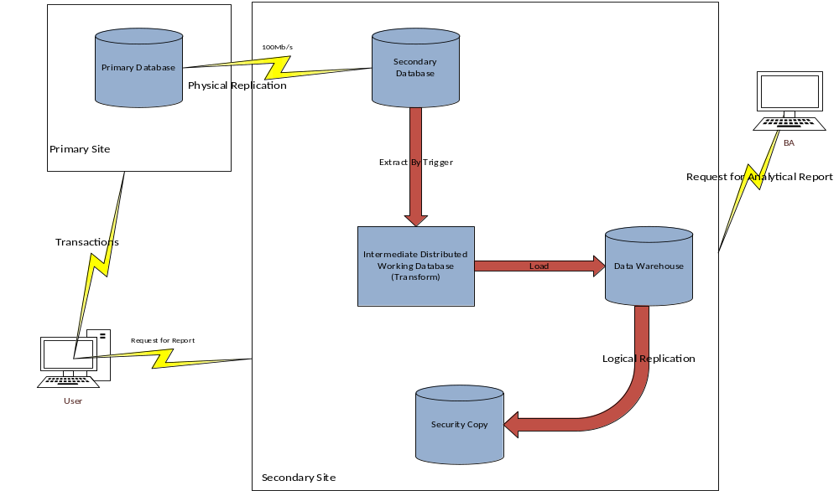
Figure 5 ACE Horizons Cloud Based System- Data Architecture

Conclusions
To conclude all of the findings and proposed solution for ACE Horizons in achieving its expected Cloud Based System, there are several key points that can be taken into account. First of all, ACE Horizons database will consist of 7 tables which are: Customer, Region, CustomerCart, Offer, Sale, SaleDetail, SaleItem; in its primary data center as well as secondary data center. Moreover, SAN model with RAID technique will be used to store the data and Dual Multi-Core Multi-Threaded Processors will be implemented for its Hardware support.
In regards of ACE Horizons Hardware Support, Virtualisation is also strongly recommended to reduce waste of server resource, albeit it is not a major requirement of the newly structured system. By implementing virtualisation technique within the system, ACE Horizons could save cost not only by re-using the re-usable existing hardware for its current systems, but also by using the most of new hardware for the new system in its optimum performance.
Secondary data center will not only be used to store ACE Horizons customer data, but to support intra-site resiliency as well as system resiliency against catastrophe where much resource is required to be used for physical replication between primary and secondary data center to support quick failover/failback. That is also one of the reasons why dual multi-core multi-threaded processors are implemented in both sites.
In regards of its Data Warehouse, ACE Horizons will use secondary data center as well to support its Data Warehouse existence within the system. The purpose of having Data Warehouse is to quickly generate report to customer which requires the history of their accepted offers and/or declined offers and for its Business Analyst to make new offers for customer (Business Forecast). Heavy loaded performance of ETL is also one of the reasons why Data Warehouse is likely to be stored in secondary site thus the performance of primary data center, transactional database (OLTP), will not be interrupted by any other processes.
ACE Horizons Data Warehouse will also be replicated to ensure the security of data in case if data loss occurs. The kind of replication that will be implemented for its Data Warehouse is Logical Replication which two-phase commit will ensure that replicated data is exactly the same as master data, which in this case is the Data Warehouse. Logical Replication is also chosen to be the replication model for ACE Horizons Data Warehouse since there is no time urgency in its replication process to be done. (Data Warehouse is OLAP database)

Assertions Justified by Calculations & Explanation
Transaction Log Estimations
Assumption: Data Size: 2 KB/offer (based on database design, data size for each column and fact-based data: 64-bit INT, 64-bit NUMERIC, 255 VARCHAR, & +/- 255 TEXT)
Transaction rate: (50tns X 500,000) / (4hrs X 60 X 60) = 1737 tns/sec
Transaction log volume: rate * volume = 1737 * 2 = 3.5 MB/sec

Number of blocks to be read/write for required transactions:
(50tns X 500K X 200B)/4096B=1,220,704 blocks

Time for SAN to process transactions:
1,220,704 blocks X 26msec/block = 31,738 seconds = 8.9 hrs

Based on the above calculation, dual multi-threaded multi-core processors will likely be able to process transactions within the required time, which is 4 hrs:
8.9hrs / 2: +/- 4hrs

Replication Time: time to transfer data between servers + time to read/write blocks in servers

Communications Link
Link Capacity: 100Mb/sec = 12.5MB/sec
Utilisation: 3.5 / 12.5 = 28%

Time for replicating database only:
50X50,000X200=500MB
500MB/12.5MB/sec = 40 secs

Total Replication Time: (2 X Data processing in each server for transactions) + Replicating Time
(2 x 4 hrs) + 40 secs = +/- 8 hrs and 1 mins

Therefore, to achieve the best performance of database, physical replication on primary to secondary site is preferred so that delays that may occur will still be able to be taken care of by the system by giving buffering time where logical replication can be applied on data warehouse replication for security copy which only be occurring overnight (8 hrs of replication time over the night).

P.S.: Calculation is made based on basic formulas and logical assumption.

References
Abdelrazek, M 2015, ‘Lecture 8 – Replicated Databases’, INF30010 Database Administration, Learning Materials on Blackboard, Swinburne University of Technology, 29th September 2015, viewed 15th October 2015.
Abdelrazek, M 2015, ‘Lecture 10 – Case Study’, INF30010 Database Administration, Learning Materials on Blackboard, Swinburne University of Technology, 13th October 2015, viewed 15th October 2015.
Dbvisit Database Replication 2015, Physical or Logical Replication?, Dbvisit, viewed 15th October 2015, http://www.dbvisit.com/physical-vs-logical-replication/.
Mohanasundaram, V & Vijayaraghavan, G 2013, ‘VicED Student Testing Database Design Architecture’, Swinburne University of Technology, 27th October 2013, viewed on 15th October 2015.

