

Faculty of Information and Communication Technologies
HIT 1402/6402 Database Analysis and Design
Assignment 3 (Group HIT1402_A03_T001)

Aussie Wine Tour

Version 1.0

Author
Kyle Ding – MIT(Software Development) – 1779133
Jonas Bunawan – BICT(Business Systems) – 700513X
Aaron Long – BICT(Networking) – 1799452
Michael Andrew Apostolopoulos – Bachelor of Computer Science – 9991417

Executive Summary
This report is made to fulfil the requirements of passing HIT 1402/6402 Database Analysis and Design subject in Swinburne University of Technology. It is a solution of Aussie Wine Tour case study. There are 3 main sections in this report, which are ERD, Relational Schema, Network Diagram. The diagrams were made by the help of using other diagramming tool (Microsoft Visio), so they meet the standard requirements of HIT 1402/6402 Assignment 3.
Table of Contents
Executive Summary 1
1. ERD 1
2. Relational Schema 2
3. Network Diagram 2

1. ERD
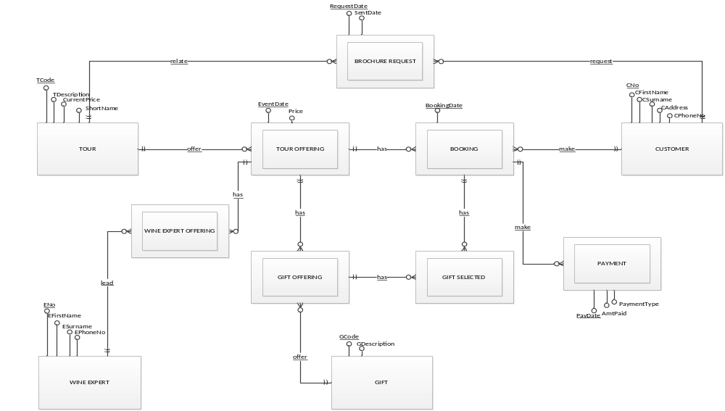

2. Relational Schema

TOUR(TCode, CurrentPrice, TDescription, ShortName)
CUSTOMER(CNo, CFirstName, CSurname, CAddress, CPhoneNo)
GIFT(GCode, GDescription)
WINE EXPERT(ENo, EFirstName, ESurname, EPhoneNo)
TOUR OFFERING(TCode, EventDate, Price)
FK: (TCode) REFERENCES TOUR
WINE EXPERT OFFERING(ENo, TCode, EventDate)
FK: ENo REFERENCES WINE EXPERT
FK: (TCode, EventDate) REFERENCES TOUR OFFERING
GIFT OFFERING(TCode, EventDate, GCode)
FK: (TCode, EventDate) REFERENCES TOUR OFFERING
FK: GCode REFERENCES GIFT
BOOKING(CNo, BookingDate, TCode, EventDate)
FK: (TCode, EventDate) REFERENCES TOUR OFFERING
FK: CNo REFERENCES CUSTOMER
GIFT SELECTED(CNo, BookingDate, TCode, EventDate, GCode)
FK: (CNo, BookingDate) REFERENCES BOOKING
FK: (GCode, TCode, EventDate) REFERENCES GIFT OFFERING
PAYMENT(PayDate, CNo, BookingDate, AmtPaid, PaymentType)
FK: (CNo, BookingDate) REFERENCES BOOKING
BROCHURE REQUEST(CNo, TCode, RequestDate, SentDate)
FK: CNo REFERENCES CUSTOMER
FK: TCode REFERENCES TOUR

3. Network Diagram
