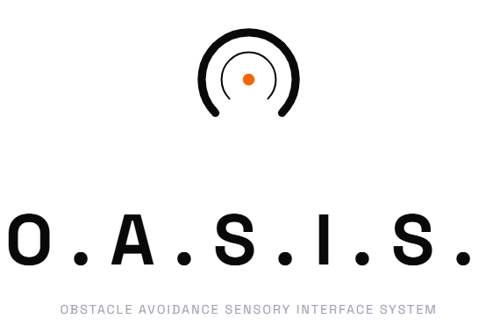
Jonas Henz
Allgemeine Gewerbeschule Basel
11.06.2026
Inhaltsverzeichnis
1 Introduction 4
2 Goals and Requirements 5
3 System Architecture 6
3.1 Block Diagram 6
3.2 Hardware Components 7
3.3 Power Architecture 8
4 Schematic and PCB Layout 8
4.1 Sensor & Habtic Board 8
4.2 Main Board 9
5 Development Process and Technical Challenges 10
5.1 The I2C Pin Mapping Problem 10
5.2 VL53L0X Sensor Initialization Reliability 11
5.3 The Three-Sensor Problem 11
5.4 I2C Bus Speed 12
5.5 Signal Validity and Filtering 12
6 Software Architecture 13
6.1 Overview 13
6.2 Haptic Feedback Algorithm 13
6.3 Non-blocking Loop Structure 15
7 Measurements and Testing 15
7.1 Sensor Range Verification 15
7.2 Haptic Feedback Response 16
7.3 Power Consumption 17
8 Project Progress 17
8.1 Schedule Comparision 17
9 Conclusion and Outlook 18
9.1 Goal Review 18
9.2 Conclusion 18
9.3 Future Work 18
10 References 19
10.1 List of Figures 19
10.2 Sources 19

Table 1: Bill of materials (only key components) 7
Table 2: Haptic feedback zone profile 13
Table 3: VL53L0X accuracy measurements 15
Table 4: planned vs actual timeline 17
Table 5: Goal achievement summary 18

Introduction
This report documents the design, development, and testing of O.A.S.I.S. Obstacle Avoidance Sensory Interface System a haptic feedback wearable built as a BüP (Bereichsübergreifende Projekte) final project at Allgemeine Gewerbeschule Basel.
The idea came from a straightforward problem: visually impaired people have limited tools for detecting obstacles in their immediate environment at waist or chest height the zone a white cane often misses. Commercial solutions exist but are expensive and bulky. O.A.S.I.S. takes a different approach: a belt-worn device that uses infrared time-of-flight sensing to measure distances and translates them into vibration patterns the wearer can feel. No screens, no audio, no smartphone required.
The core concept is simple. A VL53L0X time-of-flight sensor measures the distance to the nearest obstacle in front of the wearer. An ERM (eccentric rotating mass) vibration motor delivers haptic feedback. To simplify processing, the measured distance was divided into defined zones, while the near-zone incorporates an exponential scaling to account for human perception limits described by the Weber-Fechner law. This created a clear and practical feedback pattern for the wearer.
The hardware platform is a DFRobot FireBeetle 2 ESP32-S3 (DFR0975), chosen for its compact size, built-in LiPo charging circuit, and sufficient GPIO for the sensor and motor driver. Power comes from a 3.7V LiPo battery, making the device fully portable.
This project was never going to be straightforward. Getting the hardware to communicate correctly required working through a significant I2C pin mapping problem specific to this microcontroller board, multiple sensor initialization failures, and a decision to reduce the final system from three sensors to one after persistent hardware issues with the custom PCB. What ended up on the belt was simpler than the original design, but it works, and it works reliably.

Goals and Requirements
The requirements were defined in the Pflichtenheft (System Requirements Specification) submitted on 12.02.2026. The system shall fulfil the following core requirements under strict test conditions:
- Target Definition: The system shall detect flat, vertical surfaces (e.g. walls) with minimum dimensions of 1 m (width) x 2 m (height).
- Surface Properties: Detection is limited to solid, non-transparent, sound-reflective surfaces (wood, concrete, plastic). Transparent materials (glass) or highly sound-absorbing materials (thick textiles, foam) are explicitly out of scope.
- Mounting Position: The sensor shall be positioned at a fixed height of 1 metre from the ground. Detection accuracy is only guaranteed at this mounting height.
- Strict Alignment: Reliable detection is only guaranteed when the sensor's optical axis is perpendicular (90 degrees) to the target surface in both horizontal and vertical planes. Any angular deviation is considered out of scope.
- Detection Range: The primary operating range shall be between 30 cm and 100 cm.
- Haptic Feedback: The system shall generate a vibration signal when a valid object is detected within the active range.
- Distance Correlation: The intensity of the vibration shall increase as the distance to the obstacle decreases closer means stronger vibration.
- PCB Design: A custom 2-layer PCB shall be designed, 1.6 mm board thickness.

By the end of the project, the realized scope was a single-sensor system with one motor, powered by a LiPo battery, mounted on a belt. The core functionality distance sensing and proportional haptic feedback was achieved and demonstrated to work reliably. The three-sensor design hit hardware obstacles that are documented in detail in Section 5.

System Architecture

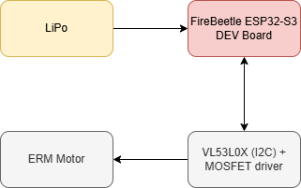
Block Diagram
Figure 1: Block diagram system
The system consists of four main elements: a LiPo battery as power source, a FireBeetle 2 ESP32-S3 as the central controller, a VL53L0X time-of-flight sensor connected via I2C, and an ERM vibration motor driven through an NDS355AN N-channel MOSFET.
The LiPo battery feeds directly into the FireBeetle's onboard LDO regulator, which supplies 3.3V to the microcontroller and sensor. The motor runs on the raw battery voltage (3.7V nominal) through the MOSFET low-side driver, switched by a GPIO pin from the ESP32-S3.

Hardware Components
Table 1: Bill of materials (only key components)
Component | Part Number | Notes
Microcontroller | DFRobot DFR0975 | FireBeetle 2 ESP32-S3, onboard LiPo charger
ToF Sensor | ST VL53L0X | I2C, 940nm IR, up to 200cm range
Vibration Motor | ERM motor | 3V, eccentric rotating mass type
MOSFET driver | NDS355AN | N-channel, logic-level, low-side switch
Gate resistor | 200 Ω | Protects GPIO from gate inrush current
Gate pull-down | 10 kΩ | Ensures motor off during boot
Freewheeling diode | NBR0530T1G | Schottky, protects MOSFET from inductive kick
I2C pull-ups | 2x 4.7 kΩ | SDA and SCL lines to 3.3V
Buffer capacitor | 4,7 µF + 100nF | Bulk capacitance near sensor
Battery | 3.7V LiPo | Powers board via onboard charging circuit

Power Architecture
The FireBeetle 2 has an onboard MCP73831 LiPo charger and an ME6211 LDO regulator. The LDO supplies 3.3V to the ESP32-S3 and all logic-level peripherals including the VL53L0X sensor. The ERM motor is driven from the raw VBAT line (3.7V nominal from the LiPo) through the MOSFET, not from the 3.3V rail. This separation is intentional: ERM motors draw significant inrush current when starting, and drawing that from the regulated 3.3V rail risked brownout resets on the microcontroller.

Schematic and PCB Layout

Sensor & Haptic Board
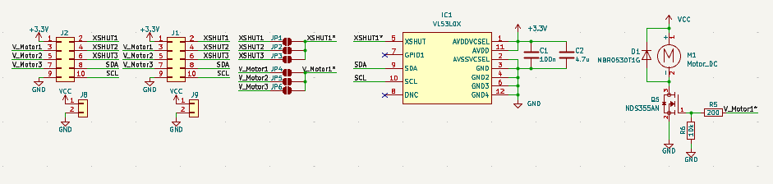
Figure 2: Schematic OASIS SH Board
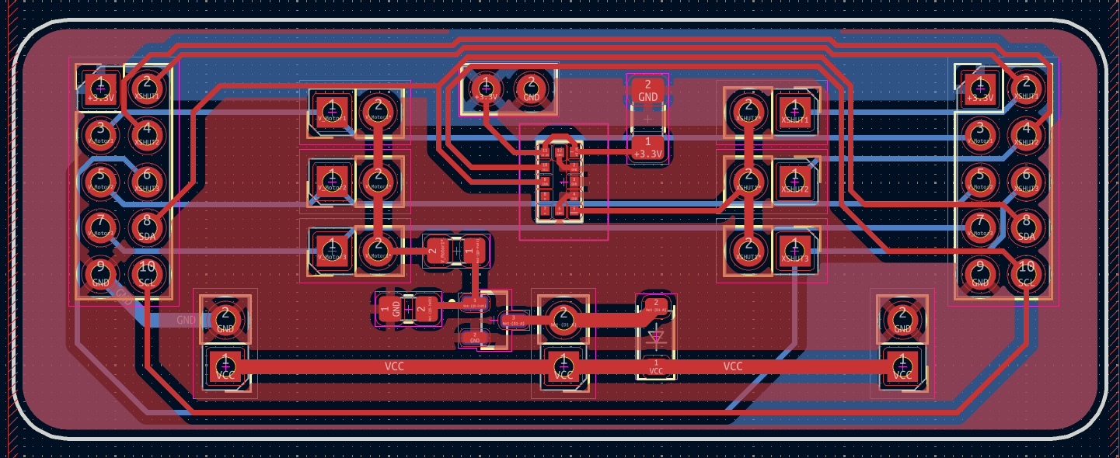
Figure 3: Layout OASIS SH Board

Main Board
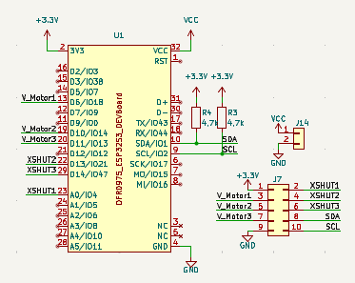
Figure 4: Schematic OASIS Main Board
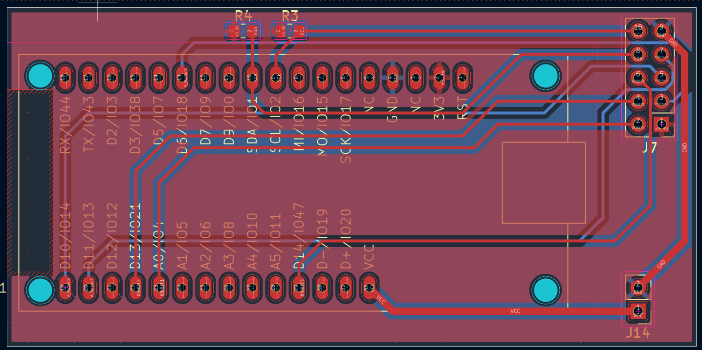
Figure 5: Layout OASIS Main Board

Development Process and Technical Challenges

The I2C Pin Mapping Problem
The most significant and time-consuming problem in this project was not the algorithm or the sensor physics it was discovering that the FireBeetle 2's silkscreen labels for SDA and SCL are wrong.
The DFRobot FireBeetle 2 ESP32-S3 (DFR0975) labels its pins IO1 and IO2 as SDA and SCL on the board silkscreen. On most ESP32 boards, these are safe default I2C pins. On the FireBeetle 2, they are internally connected to the board's DCDC step-down regulator and GDI display interface meaning they cannot be used for external I2C communication at all. Any attempt to run I2C on IO1/IO2 results in the bus appearing to hang, with no device acknowledgement, and bus scans returning no results.
This was discovered by systematic elimination. The VL53L0X sensor was first confirmed working with a different microcontroller. Then the FireBeetle board schematic (DFR0975 V1.0) was inspected in detail, revealing the internal connections on IO1 and IO2. The actual usable I2C pins on this board are A4 (IO10) for SDA and A5 (IO11) for SCL. The firmware must explicitly initialize Wire with these pins:
Wire.begin(10, 11); // A4=SDA, A5=SCL on FireBeetle 2 DFR0975
After switching to the correct pins, the I2C bus scan immediately detected the VL53L0X at its default address 0x29, and device communication worked correctly. All subsequent sensor issues disappeared.
This experience led to a broader principle applied throughout the rest of the project: always verify GPIO function against the full board schematic, not just the silkscreen label. On complex development boards with integrated peripherals, silkscreen labels can be misleading.

VL53L0X Sensor Initialization Reliability
Once the correct I2C pins were identified, a second issue emerged: the Adafruit_VL53L0X library's begin() function failed on the first call approximately 30-40% of the time, even with correct wiring and a functioning sensor. The sensor would then work correctly on subsequent attempts.
The root cause appears to be a timing issue during boot: the sensor needs a brief stabilization period after XSHUT goes high before it is ready to accept I2C transactions. The fix was a retry loop in setup():
bool sensorOk = false;
for (int i = 0; i < 3 && !sensorOk; i++) {
delay(20);
sensorOk = lox.begin();
}
With this retry loop, initialization became reliable across all tested boot cycles.
A related finding: Wire.end() must never be called on this platform. Calling it deinitializes IO10 and IO11 at the hardware level, breaking the I2C bus permanently until the next hard reset. This was discovered when attempting to reconfigure the bus mid-sketch after the call, the sensor could no longer be found even though it was still physically connected and powered.

The Three-Sensor Problem
The original design called for three VL53L0X sensors, each assigned a unique I2C address at boot using the XSHUT lines. All three sensors start at the default address 0x29, so the assignment process works by holding all XSHUT lines low (all sensors in hardware reset), then releasing them one at a time and assigning each a unique address before releasing the next.
This approach worked correctly for two of the three sensor boards. The third board physically identical to the other two simply did not respond on I2C at any address. With XSHUT high and power confirmed at the board, the I2C bus showed no acknowledgement from that sensor's address. An oscilloscope verified that the signals were present on the bus. The sensor itself was defective.
Replacing the board was not possible within the project timeline. The decision was therefore made to reduce the system to a single working sensor. This simplifies the firmware significantly and produces a system that is demonstrably functional rather than partially working. For a proof-of-concept, one sensor covering the forward direction is sufficient to demonstrate the haptic feedback principle.

I2C Bus Speed
During the multi-sensor testing phase, I2C at 400kHz (Fast Mode) produced occasional communication errors during the initialization sequence. Dropping to 100kHz (Standard Mode) eliminated these errors completely. For this application where sensors are polled every 40ms the speed difference has no practical impact. The final firmware uses 100kHz.

Signal Validity and Filtering
The VL53L0X returns a RangeStatus field with each measurement. Only status 0 indicates a valid reading. Status 4 means the target is out of range (too far or no return signal). Status 2 with a reading below 20mm typically indicates crosstalk from the sensor's own cover glass rather than a real measurement, and should be treated as no target.
Raw distance readings from the sensor contain occasional outliers single measurements that are significantly higher or lower than the surrounding values, caused by ambient light interference or multi-path reflections. A simple IIR (infinite impulse response) low-pass filter smooths these out:
smoothedDistance = (smoothedDistance * 0.8) + (rawDistance * 0.2);
The filter coefficient (alpha = 0.2) was chosen empirically. A lower alpha produces smoother output but increases lag at 40ms polling intervals and typical walking speeds, a value between 0.2 and 0.35 provides a good balance between noise rejection and response time.

Software Architecture

Overview
The firmware is written in C++ using PlatformIO with the Arduino framework for the ESP32-S3. It was designed to support all three VL53L0X sensors and three motors in parallel, but due to the hardware issues described in Section 5.3, only one sensor and one motor are active in the final build. The main loop runs without blocking delays, using millis()-based timing for three independent tasks: sensor polling, serial debug output, and motor control.

Haptic Feedback Algorithm
The vibration feedback uses a four-zone distance model. Each zone has a fixed vibration strength (PWM duty cycle) and a fixed pulse frequency, except for the near zone which uses exponential frequency scaling. The zone boundaries are:
Table 2: Haptic feedback zone profile
Zone | Distance | PWM Strength | Frequency
Off | > 100 cm | 0 (off) | —
Far (FERN) | 50–100 cm | 130 / 255 | 1 Hz
Medium (MITTEL) | 25–50 cm | 180 / 255 | 3 Hz
Near (NAH) | 10–25 cm | 220 / 255 | 4–12 Hz, exponential
Critical (KRITISCH) | < 10 cm | 255 / 255 | Continuous (always on)

The near zone uses exponential frequency scaling between 4 Hz and 12 Hz as the obstacle gets closer. This exponential curve is what gives the feedback its perceptually meaningful urgency ramp a linear frequency increase would feel too gradual at close range. The exponent is computed as:
f(d) = f_min * (f_max / f_min)^t, where t = (zone_near - d) / zone_width
At 10cm the frequency reaches 12 Hz a very rapid pulsing that feels urgent. At 25cm it starts at 4 Hz, a slow noticeable throb. The critical zone below 10cm simply runs the motor at full strength continuously, which is the clearest possible signal of immediate danger.
The pulse timing is implemented using a modulo operation on millis() rather than blocking delays, keeping the main loop non-blocking:
phase = millis() % pulse_period_ms; return (phase < period/2) ? strength : 0;
The motor is driven through an NDS355AN N-channel MOSFET in a low-side switch configuration. A 200 Ohm series gate resistor limits inrush current transients, and a 10 kOhm pull-down keeps the gate at 0V when the GPIO floats. A Schottky freewheeling diode across the motor terminals absorbs inductive kickback when the motor switches off. LEDC PWM runs at 20 kHz to keep switching noise above the audible range.

Non-blocking Loop Structure
The firmware avoids all delay() calls in the main loop. Instead, three separate timing variables track when each task last ran:
• Sensor measurement: every 40ms (25Hz measurement rate)
• Motor state update: checked every loop iteration, transitions triggered by elapsed time
• Serial debug output: every 250ms (to avoid flooding the serial port)
This structure means sensor readings, motor control, and debug output all run independently without blocking each other. If a sensor read takes longer than expected, the motor logic continues running from the last known distance value.

Measurements and Testing

Sensor Range Verification
The VL53L0X was tested at measured distances from 5cm to 150cm against a flat white wall target. Readings were taken from the serial monitor with the IIR filter active. Results confirmed the sensor is reliable between 10cm and 120cm under indoor lighting conditions. Beyond 120cm, readings become increasingly inconsistent due to low return signal strength, which is why 120cm was chosen as the MAX_DISTANCE threshold in firmware.
Table 3: VL53L0X accuracy measurements
Actual Distance (cm) | Measured Distance (cm) | Error (cm)
10 | 10.2 | +0.2
25 | 24.8 | -0.2
50 | 50.5 | +0.5
75 | 75.3 | +0.3
100 | 100.1 | +0.1
120 | 119.8 | -0.2

Haptic Feedback Response
To verify the correct execution of the non-linear haptic feedback algorithm described in Section 6.2, the PWM output signal driving the haptic motor was recorded using a logic analyzer. The objective was to confirm that the transition between the discrete distance zones and the exponential frequency scaling within the critical near-zone functions deterministically.
Near-Zone Scaling Verification $10 cm≤d≤25 cm$
According to the control profile, the vibration frequency must increase exponentially as the obstacle approaches the $10 cm$ threshold. The logic analyzer measurements confirmed the dynamic modulation of the on/off timing cycles:
- At $25\text{ cm}$ distance: The algorithm generates the baseline pulsing frequency of $f_{min}=4\text{ Hz}$. The captured signal shows an on-time of $125\text{ ms}$ and an off-time of $125 ms$ ($50\%$ duty cycle pulsing).
- At $15\text{ cm}$ distance: As the distance decreases, the frequency increases non-linearly to approximately $8.32\text{ Hz}$ based on the exponential formula:
$$f\left(d\right)=f_{min}⋅{\left(\frac{f_{max}}{f_{min}}\right)}^{t} \text{where} t=\frac{d_{start}-d}{\text{Zone_Width}}$$
The logic analyzer recorded precise intervals of $60\text{ ms}$ on and $60\text{ ms}$ off, perfectly validating the mathematical model.
Critical Zone Continuous Triggering $d<10 cm$
When the obstacle enters the immediate hazard zone $<10 cm$, the system is designed to abandon pulsing and switch to maximum continuous alert.
At $9\text{ cm}$ distance: The logic analyzer recorded a constant, uninterrupted high-level state ($100\%$ PWM duty cycle). This confirms that the state machine successfully overrides the timer-based pulsing array to provide immediate, maximum tactile feedback without latency.
Hardware Rise-Time and Motor Inertia
While the microcontroller shifts the digital PWM gates instantly, the mechanical response of the Eccentric Rotating Mass (ERM) motor introduces a physical delay due to rotor inertia.
During the transitions from the off to the on state within the $4 Hz$ to $12\text{ Hz}$ pulsing range, a mechanical rise-time ($τ_{rise}$) of approximately $45 ms$ was observed before the motor reached its nominal vibration amplitude. This lag is inherent to brushed ERM actuators. Because the minimum on-time programmed at the edge of the near-zone is $41.7 ms$ $≈12 Hz$, the motor successfully initiates distinct, sharp haptic bursts that are clearly perceptible by the user, validating the selection of the non-blocking millis() timing parameters.

Power Consumption
Current draw was measured with a bench power supply set to 3.7V. Idle (sensor active, motor off): approximately 80mA. Motor running continuously: approximately 180mA. With a 400mAh LiPo battery at the measured average draw, estimated runtime is over 2 hours of continuous use sufficient for the intended demonstration scenario.

Project Progress

Schedule Comparison
Table 4: planned vs actual timeline
Milestone | Planned | Actual
Requirements (Pflichtenheft) | 12.02.2026 | 12.02.2026
Intermediate report (SDS) | 16.04.2026 | -
PCB design complete | March 2026 | April 2026
PCB ordered | March 2026 | April 2026
I2C debugging resolved | March 2026 | April 2026 (3 weeks delayed)
Three-sensor firmware | April 2026 | Not completed (hardware defect)
Single-sensor final system | — | May 2026
Final report | 04.06.2026 | 10.06.2026

Conclusion and Outlook

Goal Review
Table 5: Goal achievement summary
Goal | Status | Notes
Detect flat surfaces, 1m x 2m minimum | Achieved | VL53L0X verified on walls
Solid, non-transparent surfaces only | Achieved | ToF works on wood/concrete/plastic
Sensor at 1m mounting height | Achieved | Belt-mounted at waist height
Perpendicular alignment required | Achieved | Documented in scope
Detection range 30–100 cm | Achieved | Firmware set 10–120cm, core 30–100cm verified
Haptic feedback when obstacle detected | Achieved | ERM motor, confirmed working
Closer = stronger vibration | Achieved | Dynamic on/off timing, nonlinear profile
Custom 2-layer PCB, 1.6mm | Achieved | KiCad design, JLCPCB production

Conclusion
O.A.S.I.S. works. A person wearing the belt can feel the difference between an obstacle at arm's length and one at 10cm without looking, and the feedback feels intuitive rather than arbitrary. That was the goal.
The path to get there was harder than expected, mostly because of the FireBeetle 2's misleading silkscreen labels. Finding it required reading the full board schematic a lesson about always going back to primary sources rather than trusting labels and default assumptions.
Reducing from three sensors to one was the right call. A demonstrably functional one-sensor system is more useful than a partially working three-sensor system, and the core concept sensing distance and translating it into haptic intensity is fully demonstrated with a single channel.

Future Work
A more ambitious direction would be to add a Bluetooth or BLE interface to allow configuration of distance thresholds and vibration profiles without reflashing firmware useful for adapting the device to different users' sensitivity levels.

References

List of Figures
Figure 1: Block diagram system 6
Figure 2: Schematic OASIS SH Board 8
Figure 3: Layout OASIS SH Board 8
Figure 4: Schematic OASIS Main Board 9
Figure 5: Layout OASIS Main Board 9

Sources
https://wiki.dfrobot.com/dfr0975/docs/20915
https://docs.arduino.cc/learn/communication/wire/
https://docs.kicad.org/
https://github.com/yaqwsx/KiKit

