Chapter 6

Individual Deductions

SOLUTIONS MANUAL

Discussion Questions

1. [LO 1] It has been suggested that tax policy favors deductions for AGI compared to itemized deductions. Describe two ways in which deductions for AGI are treated more favorably than itemized deductions.

Itemized deductions must exceed the standard deduction before taxpayers receive any tax benefit from the deductions (this is equivalent to an overall floor limit). In contrast, business deductions that are deductible for AGI (above the line) reduce taxable income without being subject to an overall floor limit. Also, itemized deductions are subject to many mechanical limitations including ceilings, floors, and phase-outs whereas business deductions are generally not subject to these limits (there are limits on certain specific deductions, but this will be described in greater detail in chapter 9).

2. [LO 1] How is a business activity distinguished from an investment activity? Why is this distinction important for the purpose of calculating federal income taxes?

Both business and investment activities are motivated primarily by profit intent, but they can be distinguished by the level of profit-seeking activity. A business activity is commonly described as a sustained, continuous, high level of profit-seeking activity, whereas investment activities don’t require a high level of involvement. The distinction can be important for the location of deductions, because business deductions are claimed above the line (for AGI on Schedule C) while investment deductions are generally itemized or from AGI deductions (with the exception of rent and royalty expenses which are deductible for AGI on Schedule E).

3. [LO 1] Describe how a business element is reflected in the requirements to deduct moving expenses and how Congress limited this deduction to substantial moves.

A business element is reflected in both the distance test and time test associated with the move. To satisfy the distance test, the distance from the taxpayer’s old residence to the new place of work (business element) must be at least 50 miles more than the distance from the old residence to the old place of work (business element). The time test for a moving expense deduction requires the taxpayer to be employed full time 39 of the first 52 weeks (or self-employed for 78 of the first 104 weeks) after the move (obviously reflecting a business element).

4. [LO 1] Explain why Congress allows self-employed taxpayers to deduct the cost of health insurance above the line (for AGI) when employees can only itemize this cost as a medical expense. Would a self-employed taxpayer ever prefer to claim health insurance premiums as an itemized deductions rather than a deduction for AGI? Explain.

This deduction provides a measure of equity between employees and the self-employed. The cost of health insurance is essentially a personal expense. However, employees typically aren’t required to pay insurance premiums because their employers pay the premiums for them as a form of compensation. The employer is allowed to deduct the premium as a compensation expense, and the employee is allowed to exclude from taxable income the value of the premiums paid on his behalf. Thus, from the employee’s perspective, this arrangement has the same effect as if (1) the employer pays the employee cash compensation in the amount of the premium and (2) the employee pays the premium and deducts the expense for AGI (completely offsetting the compensation income). In contrast to employees, self-employed taxpayers pay their own health insurance costs, because they don’t have an employer to pay these costs for them. Absent a rule to the contrary, self-employed taxpayers would deduct their medical expenses as itemized deductions subject to strict limitations, because the cost of the health insurance is a personal expense rather than a business expense. To treat employees and self-employed taxpayers similarly, Congress allows self-employed taxpayers to deduct personal health insurance premiums as for AGI rather than itemized deductions. Thus, self-employed taxpayers are able to (1) receive business income and (2) use the business income to pay their health insurance premiums and deduct the premiums as a for AGI deduction (completely offsetting the business income they used to pay the premium). Given the preferential treatment of for AGI deductions relative to itemized deductions, a self-employed taxpayer should never prefer to claim health insurance premiums as an itemized deduction rather than a deduction for AGI.

5. [LO 1] Explain why Congress allows self-employed taxpayers to deduct the employer portion of their self-employment tax.

To put self-employed individuals on somewhat equal footing with other employers that are allowed to deduct the employer’s share of the social security and Medicare tax. Hence, self-employed taxpayers are allowed to deduct the employer’s share of the self-employment tax.

6. [LO 1] {Research} Using the Internal Revenue Code, describe two deductions for AGI that are not discussed in this chapter.

§62 is the quickest way to identify deductions for AGI, but several can also be identified from the front of form 1040. Examples include the performing artist deduction, deductions of business expenses for state and local officials, reforestation expenses, and remitted jury duty pay.

7. [LO 1] Explain why Congress allows taxpayers to deduct interest forfeited as a penalty on the premature withdrawal from a certificate of deposit.

The full amount of the interest income is included in gross income, and this deduction reduces the net interest income to the amount actually received by the individual.

8. [LO 1] Describe the mechanical limitation on the deduction for interest on qualified educational loans.

The maximum deduction for interest expense on qualified education loans is the amount of interest expense paid up to $2,500. However, the deduction is reduced (phased-out) for taxpayers depending on the taxpayer’s filing status and modified AGI. Specifically, the deduction for interest on educational loans is subject to proportional phase-out over a range of $15,000 ($30,000 for married filing jointly). The range begins for taxpayers at $65,000 of modified AGI ($130,000 for MFJ) and ends at $80,000 of modified AGI ($160,000 for married filing jointly). Modified AGI for this purpose is AGI before deducting interest expense on the qualified education loans and before deducting qualified education expenses. Married individuals who file separately are not allowed to deduct this expense under any circumstance.

9. [LO 2] Explain why the medical expense and casualty loss provisions are sometimes referred to as “wherewithal” deductions and how this rationale is reflected in the limits on these deductions.

These deductions are designed to reduce the tax burden on taxpayers whose circumstances have involuntarily reduced their ability to pay. Both deductions are restricted to expenses that exceed insurance reimbursements and a floor limit based upon AGI. These limits ensure that taxpayers claiming the deduction have exceedingly large involuntary expenditures as measured by their ability to pay.

10. [LO 2] Describe the type of medical expenditures that qualify for the medical expense deduction. Does the cost of meals consumed while hospitalized qualify for the deduction? Do over-the-counter drugs and medicines qualify for the deduction?

Medical expenses include any payments for the care, prevention, diagnosis, or cure of injury, disease, or bodily function that are not reimbursed by health insurance. Included are the costs of prescription medicine, insulin, and payments to doctors, dentists, and the like incurred by the taxpayer, taxpayer’s spouse, and dependents. Over-the-counter drugs and medicines do not qualify for the deduction. Besides direct medical expenses, the deduction includes the cost of health insurance (if not already deducted above the line by self-employed taxpayers or if not offset by a premium tax credit under IRC Sec. 36B). Medical expenses also include long-term care services for disabled spouses and dependents to the extent the costs (including meals and lodging) are attributable to medical care. The cost of elective cosmetic surgery and over-the-counter drugs is not deductible. The cost of meals and lodging qualify if incurred at a medical-care facility or hospital and are incident to the care of the patient, but the cost of lodging is limited to $50 per eligible person per night. The cost of travel for and essential to medical care, including lodging (still limited to $50 per eligible person per night) is also deductible if the expense is not extravagant and the travel has no significant element of personal pleasure.

11. [LO 2] Under what circumstances can a taxpayer deduct medical expenses paid for a member of his family? Does it matter if the family member reports significant amounts of gross income and cannot be claimed as a dependent?

A taxpayer can deduct medical expenses incurred for members of his family if they are dependents (i.e., either qualified children or qualified relatives). For purposes of deducting medical expenses, a dependent need not meet the gross income test (§213(a)).

12. [LO 2] What types of taxes qualify to be deducted as itemized deductions? Would a vehicle registration fee qualify as a deductible tax?

Taxes qualifying for this deduction include state, local, and foreign income taxes, real estate taxes, and personal property taxes. State and local sales taxes may also be deducted but only in lieu of state and local income taxes. The deduction for sales tax can be based upon either the amount paid or the amount published in the IRS tables (IRS Publication 600). Vehicle registration fees are not deductible (unless calculated based on the value of the vehicle rather than its weight).

13. [LO 2] Compare and contrast the limits on the deduction of interest on home acquisition indebtedness versus home equity loans. Are these limits consistent with horizontal equity? Explain.

Taxpayers can deduct qualified residence interest defined as either (1) interest paid on a loan to purchase or improve a residence (acquisition indebtedness) or (2) interest paid on a loan secured by the residence but not used to purchase or improve the residence (home equity loan). Interest paid can be deducted on $1 million of acquisition indebtedness and $100,000 of home equity debt regardless of the rate of interest on the loan. These limits are consistent with horizontal equity inasmuch as the limits treat taxpayers consistently across loan amounts. However, the deduction for interest on acquisition indebtedness and home equity loans is definitely not consistent with providing horizontal equity across homeowners and non-homeowners.

14. [LO 2] Explain the argument that the deductions for charitable contributions and home mortgage interest represent indirect subsidies for these activities.

In each case, the deduction reduces the after-tax cost of the activity, making it more likely that taxpayers will engage in the activity. For example, contributions to charity reduce the cost of giving thereby indirectly encouraging donations to charitable organizations.

15. [LO 2] {Research} Cash donations to charity are subject to a number of very specific substantiation requirements. Describe these requirements and how charitable gifts can be substantiated. Describe the substantiation requirements for property donations.

Charitable contributions are only deductible if substantiated with written records such as a cancelled check, bank record, or a written communication from the charity showing the name of the charity and the date and amount of the contribution. § 170(a)(1) and Reg § 1.170A-13(a)(1). Additional substantiation is required for: contributions of $250 or more (§ 170(f)(8)), non-cash contributions exceeding $500 (§170(f)(11)(B)), and contributions of cars, boats and planes (§ 170(f)(12)). For donations of property, including clothing and household items, taxpayers should keep a written record of the donation that includes a description of the property and its condition. Deductions are not allowed for used property unless the property is in good condition. Taxpayers must keep a contemporaneous, written acknowledgement from a charity for each deductible donation (either money or property) of $250 or more. For contributions of property in excess of $500, a description of the property must be attached to the tax return. A qualified appraisal of the property must be attached with the return for donations of property with a value in excess of $5,000.

16. [LO 2] Describe the conditions in which a donation of property to a charity will result in a charitable contribution deduction of fair market value and when it will result in a deduction of the tax basis of the property.

Taxpayers deduct the fair market value of property (noncash) donations when they donate:
(1) a capital asset that has appreciated in value (the value is greater than the basis of the property) and the taxpayer has owned the asset for more than a year before donating it (but see exceptions below), or
(2) appreciated business assets (value greater than basis) the taxpayer owned for more than a year before donating but only to the extent that the gain on the asset would not be treated as ordinary income if it had been sold.

However, the deduction for an appreciated capital asset that is tangible, personal property is limited to the adjusted basis of the property if the charity uses the property for a purpose unrelated to its charitable purpose.

Taxpayers donating ordinary income property (or capital loss property) deduct the lesser of (1) the fair market value of the property and (2) the adjusted basis of the property. Thus when the value of ordinary income property (or capital loss property) is less than the basis, taxpayers deduct the value.

Thus, taxpayers deduct the basis of the property when they contribute:
ordinary income property that has appreciated in value.
capital gain property donated to private nonoperating foundations (other than stock).
capital gain property consisting of tangible personal property and the charity uses the property (and the taxpayer should have reasonably expected that) for a purpose unrelated to the reason it is a charity.
appreciated business assets held more than a year to the extent that the gain would be recaptured as ordinary income under the depreciation recapture rules.

17. [LO 2] Describe the type of event that qualifies as a casualty for tax purposes.

A casualty is defined as an unexpected, unforeseen, or unusual event such as a “fire, storm, or shipwreck” or loss from theft.

18. [LO 2] A casualty loss from the complete destruction of a personal asset is limited to the lesser of fair market value or the property’s adjusted basis. Explain the rationale for this rule as opposed to just allowing a deduction for the basis of the asset.

The loss from any specific event is limited to the lesser of the economic loss or the tax basis (cost) of the asset to prevent the deduction of otherwise nondeductible personal losses. If the basis (cost) of the asset was always allowed for a personal casualty loss deduction, then this would have the effect of allowing a deduction for the decline in the value of the asset prior to the casualty (assuming that original cost exceeds the value of the asset).

19. [LO 2] {Research} This week Jim’s residence was heavily damaged by a storm system that spread destruction throughout the region. While Jim’s property insurance covers some of the damage, there is a significant amount of uninsured loss. The governor of Jim’s state has requested that the president declare the region a federal disaster area and provide federal disaster assistance. Explain to Jim the income tax implications of such a declaration and any associated tax planning possibilities.

Under IRC §165(i), individuals who incur a disaster loss are subject to the regular casualty loss floor limits ($100/10 percent of AGI), but they may elect to claim a disaster loss for the tax year before the loss occurred (e.g., by filing an amended return if the original return has been filed). This deduction could accelerate the tax benefit of the loss (and any attendant refund), but also allow the taxpayer to choose the year with the most attractive tax outcome (in terms of AGI limits, other casualty losses (or gains), and marginal tax rate).

20. [LO 2] Describe the types of expenses that constitute miscellaneous itemized deductions and explain why these expenses rarely produce any tax benefits.

Miscellaneous itemized deductions consist of employee business expenses (not reimbursed under an accountable plan), investment expenses (not related to rental or royalty activities), and tax preparation fees. These deductions must be reduced by two percent of AGI before the deductions can be combined with other itemized deductions. This floor limit makes it unlikely these itemized deductions will generate any tax benefit.

21. [LO 2] Explain why the cost of commuting from home to work is not deductible as a business expense.

The cost of commuting is almost entirely dictated by the location of an individual’s residence. This is a personal (rather than business decision), and Congress likely did not want to be seen as subsidizing individuals who wished to live a substantial distance from their business location.

22. [LO 2] When is the cost of education deductible as an employee business expense?
The cost of education is deductible as an employee business expense if the education maintains or improves the employee’s skill in the business, but not if the education is required to qualify a taxpayer for a new business or profession. For example, an IRS agent could not deduct the cost of a legal education even though the education would maintain or improve his skill as a tax auditor. This is because a law degree would also qualify the agent for a new profession (lawyer).

23. [LO2] How might the reimbursement of a portion of an employee expense influence the deductibility of the expense for the employee?

Employee expenses are deducted as miscellaneous itemized deductions subject to the 2% of AGI floor limit. A reimbursement of a portion of an employee business expense would normally be included in the employee’s gross income and would have no effect on the deductibility of the expense. An important exception to this rule is for employee expenses reimbursed under an “accountable” plan. Among other things, an accountable plan requires that employees provide substantiation for reimbursement and that employers only reimburse legitimate deductible expenses. Reimbursements from an accountable plan are not required to be included in income, but the reimbursed expenses are not deductible, either. In essence, the reimbursements and expenses offset each other, and both are ignored for tax purposes. If the expense exceeds the reimbursement, the excess (unreimbursed) portion of each expense can be deducted as a miscellaneous itemized deduction subject to the 2% of AGI floor limit.

24. [LO 2] Explain why an employee should be concerned about whether his employer reimburses business expenses using an “accountable” plan?

The employee should be concerned because absent an accountable plan, reimbursements are reported as income to the employee and the expense is reported as a miscellaneous itemized deduction subject to the 2% AGI floor. Thus, the reimbursements would be treated as “wages” for purposes of withholding and employment taxes, and the deduction would be unlikely to generate any reduction in taxable income (e.g., because of the 2% AGI floor). On the other hand, if the plan qualifies as an accountable plan, reimbursements from the plan are not required to be included in income, but the reimbursed expenses are not deductible, either. If, however, the expense exceeds the reimbursement, the excess (unreimbursed) portion of each expense can be deducted as a miscellaneous itemized deduction subject to the 2% of AGI floor limit.

25. [LO 2] Jake is a retired jockey who takes monthly trips to Las Vegas to gamble on horse races. Jake also trains race horses part time at his Louisville ranch. So far this year, Jake has won almost $47,500 during his trips to Las Vegas while spending $27,250 on travel expenses and incurring $62,400 of gambling losses. Jake also received $60,000 in revenue from his training activities and he incurred $72,000 of associated costs. Explain how Jake’s gambling winnings and related costs will be treated for tax purposes. Describe the factors that will influence how Jake’s ranch expenses are treated for tax purposes.

Jake’s $47,500 of gambling winnings is included in his gross income. The gambling losses are (total of $62,400) are only deductible as miscellaneous itemized deductions (not subject to the 2% of AGI floor) to the extent of the gambling winnings (thus, only $47,500 will be deductible). His travel costs are personal expenditures and are nondeductible. Likewise, the $60,000 revenues from Jake’s training activities are included in Jake’s gross income. The expenses associated with the ranch (assuming the expenses are ordinary and necessary and not capitalized) should be deductible as itemized deductions (mortgage interest, real estate taxes, and as miscellaneous itemized deductions subject to the 2% floor) to the extent of the related gross income if this activity is treated as a hobby. The factors in the regulations would likely dictate whether the activity is a hobby or a business. For example, how much time does Jake spend at the ranch—a few hours each week or does he work full time? It is unclear if he operates the ranch in a professional manner, takes the advice of professionals, or whether his success as a jockey would lead to success in training horses. Of course, his financial status (retired) and personal pleasure would likely count against business treatment.

26. [LO 2] {Research} Frank paid $3,700 in fees for an accountant to tabulate business information (Frank operates as a self-employed contractor and files a Schedule C). The accountant also spent time tabulating Frank’s income from his investments and determining Frank’s personal itemized deductions. Explain to Frank whether or not he can deduct the $3,700 as a business expense or as an itemized deduction, and provide a citation to an authority that supports your conclusion.

Under Reg §1.67-1T(c), expenditures that relate to both a business activity (not subject to the 2% floor) and the production of income or tax preparation (both subject to the 2% floor) must be allocated between the activities on a reasonable basis. It would seem that billable hours would provide just such a basis.

27. [LO 2] Contrast ceiling and floor limitations, and give an example of each.

A ceiling is a maximum amount for an exclusion or deduction. In contrast to a ceiling, a floor limitation eliminates any deduction for amounts below the minimum amount (i.e., the floor). Ceiling limitations may provide that amounts above the ceiling limit are lost (disallowed) or could be used in other years (carryover). Like a ceiling, a floor can be structured as either a fixed amount or a floating constraint based upon some intermediate number. Unlike ceilings, floor limits eliminate any amounts below the minimum thereby limiting the number of taxpayers who qualify for any adjustment to income. While there are many examples of ceiling and floor limits, two common examples are the personal casualty loss deduction (which contains two floors) and the charitable contribution deduction (which contains several ceilings). The $100 per casualty limit on personal casualty loss deductions is a floor limit placed on each casualty, and the 10 percent of AGI limit is an aggregate floor limit placed on the sum of all casualty losses in a particular year. If the casualty loss does not exceed both floors, then no deduction can be claimed. In contrast, the charitable contribution deduction contains ceiling limits—such as, cash deductions cannot exceed 50 percent of AGI. To the extent that contributions exceed the ceiling, the deductions carryover into the subsequent year.

28. [LO 2] Identify which itemized deductions are subject to floor limitations, ceiling limitations, or some combination of these limits.

Charitable contributions and home mortgage interest are subject to ceiling limits (based on a percentage of AGI and on the amount of debt, respectively) whereas aggregate casualty losses, medical expenses, and miscellaneous deductions are subject to separate floor limits (based upon percentages of AGI) and each casualty loss is subject to a $100 flat floor limit. All itemized deductions are subject to the standard deduction which is a flat floor limitation.

29. [LO 3] Describe the tax benefits from “bunching” itemized deductions in one year. Describe the characteristics of the taxpayers who are most likely to benefit from using bunching and explain why this is so.

The strategy of bunching itemized deductions (a cash-basis taxpayer paying two years’ worth of deductible expenses in one year to the extent possible) makes it more likely that deductions will exceed a floor limit. This strategy can be effective for generating some incremental tax benefits from total itemized deductions and miscellaneous itemized deductions. Taxpayers are likely to benefit from bunching if (1) they are unlikely to have sufficient itemized deductions in any one year to easily exceed the standard deduction, but can easily exceed the standard deduction by summing itemized deductions for two consecutive years, (2) report on the cash-basis and (3) are able to time payments around year-end (to minimize the loss of present value). Charitable deductions and real estate taxes (due at year-end) can often be easily bunched into one year or another.

30. [LO 3] Explain how the standard deduction is rationalized and why the standard deduction might be viewed as a floor limit on itemized deductions.

From the government’s standpoint, the standard deduction serves two purposes. First, to help taxpayers with lower income, it automatically provides a minimum amount of income that is not subject to taxation. Second, it eliminates the need for the IRS to verify and audit itemized deductions for those taxpayers who chose to deduct the standard deduction. From the taxpayers’ perspective, the standard deduction allows them to avoid taxation on a portion of their income, and for those not planning to itemize deductions, it eliminates the need to substantiate and collect information about them. The standard deduction essentially eliminates the tax benefits of itemized deductions up to the amount of the standard deduction and thus may be viewed as a floor limit on itemized deductions because most taxpayers will not elect to itemize if the standard deduction exceeds itemized deductions.

31. [LO 3] Explain how the calculation of the standard deduction limits the ability to shift income to a dependent.

The standard deduction for a taxpayer who is claimed as a dependent on another’s tax return (such as a child) is limited to the greater of (1) $1,050 or (2) $350 plus the dependent’s earned income (not to exceed the dependent’s normal standard deduction of $6,300). This limits the amount that can be shifted without being taxed because it does not allow the dependent child to offset unearned income with the full standard deduction amount.

32. [LO 3] Explain why the overall phase-out of itemized deductions has been described as a “haircut” of itemized deductions. Explain whether it is possible for a taxpayer to lose all their itemized deductions under the phase-out rules.

The itemized deduction phase-out provision provides that when an individual’s AGI exceeds a threshold amount, itemized deductions are reduced by 3% of the excess AGI above the threshold. The phase-out of itemized deductions is sometimes referred to as a cutback, or haircut, because itemized deductions can only be reduced, but not completely eliminated. This is because the maximum amount of the cutback is 80 percent of certain itemized deductions. Medical expenses, casualty losses, investment interest expense, and gambling losses are not subject to the phase-out.

33. [LO 3] Describe the mechanism for phasing out exemptions. Can a taxpayer lose the benefit of all of her personal and dependency exemptions?

The phase-out is triggered at relatively high levels of adjusted gross income, and it is done in increments. The process of determining the amount of the phase-out involves the following five steps:
Step 1: Subtract the taxpayer’s AGI from the AGI threshold based on the taxpayer’s filing status. If the threshold equals or exceeds the taxpayer’s AGI, the taxpayer deducts her full personal and dependency exemption.
Step 2: Divide the excess AGI (the amount from Step 1) by 2,500. If the result is not a whole number (i.e., the excess AGI is not evenly divisible by 2,500), round up to the next whole number. [For married filing separate taxpayers, replace the 2,500 amount with 1,250).
Step 3: Multiply the outcome of Step 2 by 2 percent, but limit the product to 100 percent.
Step 4: Multiply the percentage determined in Step 3 by the taxpayer’s total personal and dependency exemptions (i.e., number of personal and dependency exemptions times $4,050 in 2016). The product is the amount of personal and dependency exemption that is phased-out (i.e., the taxpayer is not allowed to deduct this amount).
Step 5: Subtract the Step 4 result from the taxpayer’s total personal and dependency exemptions that would be deductible without any phase-out (i.e., number of personal and dependency exemptions times $4,050 in 2016).

34. [LO 3] {Research} Determine whether a taxpayer can change his or her election to itemize deductions once a return is filed. (Hint: Read about itemization under Reg. §1.63-1.)

The election to itemize is made on the return and, Reg.§1.63-1 specifies that the election can be changed by filing an amended return any time within the statute of limitations (except for taxpayers filing married-separately both of whom must file consistently).

35. [LO 3] {Research} Determine whether a taxpayer who is claimed as a dependent on another return is entitled to an addition to the standard deduction for age or blindness. (Hint: Read the calculation of the standard deduction under IRC §63.)

Under §63(c), standard deduction is defined as the “basic” standard deduction plus an “additional” standard deduction for age and sight. However, §63(c)(2) only limits the “basic” standard deduction for a taxpayer claimed as a dependent on another’s return to $1,050 or $350 plus the individual's earned income, whichever is greater. Hence, it would appear that a taxpayer claimed as a dependent on another’s return could claim an addition to the standard deduction for age and sight.

Problems

36. [LO 1] Clem is married and is a skilled carpenter. Clem’s wife, Wanda, works part-time as a substitute grade school teacher. Determine the amount of Clem’s expenses that are deductible for AGI this year (if any) under the following independent circumstances:
a. Clem is self-employed and this year he incurred $525 in expenses for tools and supplies related to his job. Since neither were covered by a qualified health plan, Wanda paid health insurance premiums of $3,600 to provide coverage for herself and Clem (not through an exchange).
b. Clem and Wanda own a garage downtown that they rent to a local business for storage. This year they incurred expenses of $1,250 in utilities and $780 of depreciation.
c. Clem paid self-employment tax of $15,300 (the employer portion is $7,650) and Wanda had $3,000 of Social Security taxes withheld from her pay.
d. Clem paid $45 to rent a safe deposit box to store his coin collection. Clem has collected coins intermittently since he was a boy and he expects to sell his collection when he retires.

a. $4,125 – The tools and supplies and the health insurance are deductible for AGI.
b. $2,030 – The utilities and depreciation are deductible for AGI (rental activity).
c. $7,650 –The employer portion of the self-employment tax is deductible for AGI but the Social Security tax is not deductible.
d. $0 – The safe deposit fee is an itemized deduction (it appears that Clem is investing in rare coins rather than a dealer in coins – a business).

37. [LO 1] Clyde currently commutes 55 miles to work in the city. He is considering a new assignment in the suburbs on the other side of the city that would increase his commute considerably. He would like to accept the assignment, but he thinks it might require that he move to the other side of the city. Assume that Clyde is employed for 39 of the next 52 weeks. Determine if Clyde’s move qualifies for a moving expense deduction and calculate the amount (if any) under the following circumstances:
a. Clyde estimates that unless he moves across town, his new commute would be almost 70 miles. He also estimates the costs of a move as follows:
Lodging while searching for an apartment $ 126
Transportation – auto (100 miles @ 19 cents/mile, rounded) 19
Mover’s fee (furniture and possessions) 1,500
Meals while en route 35
b. Same as part (a) above, except Clyde estimates that unless he moves across town, his new commute would be almost 115 miles.
c. Same as part (a) above, except Clyde’s new commute would be almost 150 miles and the mover’s intend to impose a $450 surcharge on the moving fee for the additional distance.

a. Zero. Clyde would not qualify for a moving expense deduction. To qualify for a moving expense deduction the new commute from Clyde’s current residence would need to be a minimum of 105 miles. That is, his commute from his old residence to the new job must be more than 50 miles longer than his current commute.
b. Clyde now qualifies for a moving expense deduction (assuming he is employed for 39 of the next 52 weeks). Estimated costs of $1,519 are deductible for AGI. This excludes the cost for lodging while searching for an apartment and the meals en route.
c. Clyde qualifies for a moving expense deduction (assuming he is employed for 39 of the next 52 weeks). Estimated costs of moving increase to $1,969, and this total is deductible for AGI.

38. [LO 1] Smithers is a self-employed individual who earns $30,000 per year in self-employment income. Smithers pays $2,200 in annual health insurance premiums (not through an exchange) for his own medical care. In each of the following situations, determine the amount of the deductible health insurance premium for Smithers before any AGI limitation.
a. Smithers is single, and the self-employment income is his only source of income.
b. Smithers is single, but besides being self-employed, Smithers is also employed part-time by SF Power Corporation. This year Smithers elected not to participate in SF’s health plan.
c. Smithers is self-employed, and he is also married. Smithers’ spouse, Samantha, is employed full-time by SF Power Corporation and is covered by SF’s health plan. Smithers is not eligible to participate in SF’s health plan.
d. Smithers is self-employed, and he is also married. Smithers’ spouse, Samantha, is employed full-time by SF Power Corporation and is covered by SF’s health plan. Smithers elected not to participate in SF’s health plan.

a. Smithers can deduct $2,200 either as a deduction for AGI or claim $2,200 as an itemized medical expense.
b. Smithers can claim only $2,200 as an itemized medical expense. Even though he is self-employed, he is not eligible to deduct the health insurance premiums as a for AGI deduction because he is eligible to participate in his employer’s plan (even though he did not actually participate).
c. Smithers can deduct $2,200 either as a deduction for AGI or claim $2,200 as an itemized medical expense.
d. Smithers can claim only $2,200 as an itemized medical expense. Even though he is self-employed, he is not eligible to deduct the health insurance premiums as a for AGI deduction because he is eligible to participate in his spouse’s employer’s plan (even though he did not actually participate in her plan).

39. [LO 1] Hardaway earned $100,000 of compensation this year. He also paid (or had paid for him) $3,000 of health insurance. What is Hardaway’s AGI in each of the following situations (ignore the effects of Social Security and self-employment taxes)?
a. Hardaway is an employee, and his employer paid Hardaway’s $3,000 of health insurance for him as a nontaxable fringe benefit. Consequently, Hardaway received $97,000 of taxable compensation and $3,000 of nontaxable compensation.
b. Hardaway is a self-employed taxpayer, and he paid $3,000 of health insurance himself. He is not eligible to participate in an employer-sponsored plan.

a. Hardaway’s AGI is $97,000, consisting of the $97,000 of taxable compensation he received from his employer.
b. Hardaway’s AGI is $97,000 (the same as in part a), consisting of $100,000 of taxable earnings minus $3,000 for AGI deduction for the health insurance.

40. [LO 1] {Tax Forms} Betty operates a beauty salon as a sole proprietorship. Betty also owns and rents an apartment building. This year Betty had the following income and expenses. Determine Betty’s AGI and complete page 1 of Form 1040 for Betty. You may assume that Betty will owe $2,502 in self-employment tax on her salon income.

Interest income $ 11,255
Salon sales and revenue 86,360
Salaries paid to beauticians 45,250
Beauty salon supplies 23,400
Alimony paid to her ex-husband, Rocky 6,000
Rental revenue from apartment building 31,220
Depreciation on apartment building 12,900
Real estate taxes paid on apartment building 11,100
Real estate taxes paid on personal residence 6,241
Contributions to charity 4,237

The beauty parlor salaries and expenses are deductible on Schedule C as business expenses and the depreciation and real estate taxes for the apartment building are deductible for AGI as rental/royalty related deductions. The interest income is included in AGI, and the alimony expense is deductible for AGI. Note that this solution assumes that the apartment building amounts represent Betty’s interest and not the total. The residential real estate taxes and the charitable contributions are itemized deductions.

Interest income $ 11,255
Salon revenue $ 86,360
Less: Salaries - 45,250
Supplies - 23,400
Operating income from salon 17,710
Apartment building revenue $ 31,220
Less: Depreciation - 12,900
Taxes on apartment building - 11,100
Apartment building income 7,220
Less: Employer share of self-employment taxes* -1,251
Alimony deduction -6,000
AGI $ 28,934

*Betty would owe $2,502 in self-employment tax ($17,710 salon income × 92.35% × 15.3% = $2,502). Of the $2,502, $1,251 ($17,710 × 92.35% × 7.65%) would be deductible as a for AGI deduction.

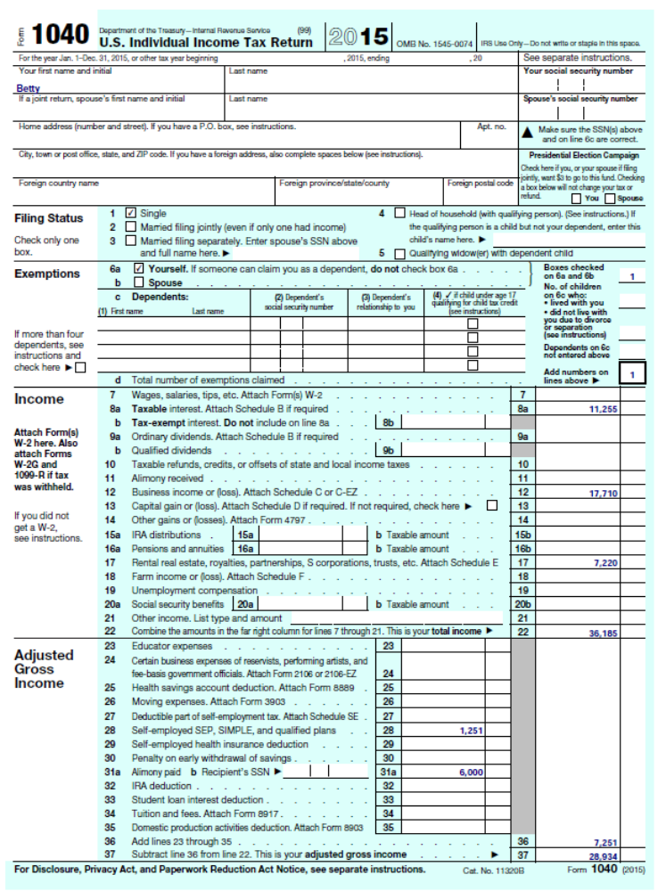
41. [LO 1] Lionel is an unmarried law student at State University Law School, a qualified educational institution. This year Lionel borrowed $24,000 from County Bank and paid interest of $1,440. Lionel used the loan proceeds to pay his law school tuition. Calculate the amounts Lionel can deduct for higher education expenses and interest on higher education loans under the following circumstances:
a. Lionel’s AGI before deducting interest on higher education loans is $50,000.
b. Lionel’s AGI before deducting interest on higher education loans is $74,000.
c. Lionel’s AGI before deducting interest on higher education loans is $90,000.

a. The maximum interest deduction is the amount paid up to $2,500. The deduction is phased out as AGI exceeds $65,000 (before applying the interest deduction). Consequently, because his AGI is below the trigger amount for the phase-out, Lionel can deduct $1,440, which is the lesser of (1) $2,500 or (2) $1,440 (the amount of interest expense he paid). Lionel paid $24,000 of qualified educational expenses. Because his modified AGI ($50,000 – $1,440 deduction for interest on higher education loan = $48,560) is less than the trigger for the deduction for qualified education expense phase-out ($65,000), Lionel can deduct $4,000 for qualified education expenses, which is the lesser of (1) $4,000 or (2) $24,000 (qualified education expenses paid).
b. Lionel can deduct $576 of qualified educational interest expense computed as follows:

Description | Amount | Explanation
(1) Modified AGI | $74,000
(2) Amount of interest paid up to $2,500 | 1,440 | Lesser of amount paid or $2,500
(3) Phase-out (reduction) percentage | 60% | [(1) – 65,000] / 15,000, limited to 100 percent
(4) Phase-out amount (reduction in maximum) | 864 | (2) × (3)
Deductible interest expense | $576 | (2) – (4)

Since Lionel’s modified AGI (($74,000 – $576 deduction for interest on higher education loan = $73,424) exceeds $65,000 but is less than or equal to $80,000, Lionel can also deduct $2,000 of qualified education expenses, which is the lesser of (1) $2,000 or (2) $24,000 (qualified education expenses paid).

c. Lionel is not allowed to deduct any qualified educational interest expense computed as follows:

Description | Amount | Explanation
(1) Modified AGI | $90,000
(2) Amount of interest paid up to $2,500 | 1,440 | Lesser of amount paid or $2,500
(3) Phase-out (reduction) percentage | 100% | [(1) – 65,000] / 15,000, limited to 100 percent
(4) Phase-out amount (reduction in maximum) | 1,440 | (2) × (3)
Deductible interest expense | $0 | (2) – (4)

Lionel is also not allowed to deduct any qualified education expenses because his modified AGI ($90,000) exceeds $80,000.

42. [LO 1] {Planning} This year Jack intends to file a married-joint return with two dependents. Jack received $162,500 of salary, and paid $5,000 of interest on loans used to pay qualified tuition costs for his dependent daughter, Deb. This year Jack has also paid qualified moving expenses of $4,300 and $24,000 of alimony.
a. What is Jack’s adjusted gross income? Assume that Jack will opt to treat tax items in a manner to minimize his AGI.
b. Suppose that Jack also reported income of $8,800 from a half share of profits from a partnership. Disregard any potential self-employment taxes on this income. What AGI would Jack report under these circumstances? Again, assume that Jack will opt to treat tax items in a manner to minimize his AGI.

a. AGI is $132,050. Jack’s modified AGI calculated without adjustment for educational interest expense is 134,200. He is allowed to deduct part of his student loan interest because his modified AGI is not above $160,000. Jack’s maximum deduction before the phase-out is $2,500 (the amount of interest paid up to $2,500). The maximum deduction of $2,500 is phased-out ratably over a $30,000 range beginning with modified AGI over $130,000. Consequently, Jack’s education interest expense deduction is $2,150 = ($2,500 – $2,500 × [($134,200-130,000)/30,000]). Jack’s AGI is computed as follows:
Salary and gross income $ 162,500
Less: Alimony - 24,000
Moving Expense Deduction - 4,300
Modified AGI $ 134,200
Student Loan Interest Deduction - 2,150
AGI $ 132,050

b. AGI is $141,583. Jack’s modified AGI calculated without adjustment for educational interest expense is 143,000. He is allowed to deduct part of his student loan interest because his modified AGI is not above $160,000. Jack’s maximum deduction before the phase-out is $2,500 (the amount of interest paid up to $2,500). The maximum deduction of $2,500 is phased-out ratably over a $30,000 range beginning with modified AGI over $130,000. Consequently, Jack’s education interest expense deduction is $1,417 = ($2,500 – $2,500 × [($143,000-130,000)/30,000]).
Jack’s AGI is computed as follows:
Salary $ 162,500
Partnership income + 8,800
Less: Alimony - 24,000
Moving Expense Deduction - 4,300
Modified AGI $ 143,000
Student Loan Interest Deduction - 1,417
AGI $ 141,583

43. [LO 1, LO 2] In each of the following independent cases, indicate the amount (1) deductible for AGI, (2) deductible from AGI, and (3) neither deductible for nor deductible from AGI before considering income limitations or the standard deduction.
a. Ted paid $8 rent on a safety deposit box at the bank. In this box he kept the few shares of stock that he owned.
b. Tyler paid $85 for minor repairs to the fence at a rental house he owned.
c. Timmy paid $545 for health insurance premiums this year (not through an exchange and not with pre-tax dollars). Timmy is employed full-time and his employer paid the remaining premiums as a qualified fringe benefit.
d. Tess paid $1,150 of state income taxes on her consulting income.

a. Deduction from AGI – investment expense deducted as a miscellaneous itemized deduction
b. Deduction for AGI – rental/royalty expense
c. The health insurance is from AGI – medical itemized deduction but subject to an AGI floor limitation.
d. The state income taxes are deductible from AGI (an itemized deduction).

44. [LO 1, LO 2] In each of the following independent cases, indicate the amount (1) deductible for AGI, (2) deductible from AGI, and (3) neither deductible for nor deductible from AGI before considering income limitations or the standard deduction.
a. Fran spent $90 for uniforms for use on her job. Her employer reimbursed her for $75 of this amount under an accountable plan (and did not report the reimbursement as wages).
b. Timothy, a plumber employed by ACE Plumbing, spent $65 for small tools to be used on his job, but he was not reimbursed by ACE.
c. Jake is a perfume salesperson. Because of his high pay, he receives no allowance or reimbursement from his employer for advertising expenses even though his position requires him to advertise frequently. During the year, he spent $2,200 on legitimate business advertisements.
d. Trey is a self-employed special-duty nurse. He spent $120 for uniforms.
e. Mary, a professor at a community college, spent $340 for magazine subscriptions. The magazines were helpful for her research activities but she was not reimbursed for the expenditures.
f. Wayne lost $325 on the bets he made at the race track, but he won $57 playing slot machines.

a. $0 for AGI. $15 from AGI (miscellaneous itemized deduction as unreimbursed employee business expense). Income and expenses associated with the $75 reimbursement completely offset each other and are ignored. Note that the accountable plan only reimburses deductible expenses.
b. from—miscellaneous itemized deduction as employee business expense
c. from—miscellaneous itemized deduction as employee business expense
d. for—trade expense assuming that the special duty uniforms cannot be adapted to normal use.
e. $340 from AGI as miscellaneous itemized deduction as employee business expenses
f. $57 from AGI as a miscellaneous itemized deduction not subject to 2% floor. Wayne’s gambling loss deduction is limited to his winnings.

45. [LO 2] Ted is a successful attorney, but when he turned 50 years old he decided to retire from his law practice and become a professional golfer. Ted has been a very successful amateur golfer, so beginning this year Ted began competing in professional golf tournaments. At year-end, Ted reported the following expenses associated with competing in 15 professional events:
Transportation from his home to various tournaments $ 25,000
Lodging for the 15 weeks on the road 18,200
Meals while traveling and during golf tournaments 5,200
Entry fees 7,500
Lessons from various golf teachers 12,500
Golf supplies (balls, tees, etc.) 783
Total expenses $ 69,183

a. Suppose that Ted reports $175,000 in gross income from his pension and various investments. Describe the various considerations that will dictate the extent to which Ted can deduct the expenses associated with professional golf.
b. Calculate Ted’s deduction for golf expenses assuming that the IRS and the courts are convinced that Ted engages in competitive golf primarily for enjoyment rather than the expectation of making a profit. Assume Ted wins $10,000 this year and his AGI is $185,000 (including the golf revenues).

a. The factors in the regulation would likely be whether Ted competes in a professional manner, takes the advice of professionals (lessons), works full time (versus 15 weeks), success in similar activities (amateur golf?), financial status (he has a significant amount of income from other sources), and personal pleasure (some enjoy playing golf).
b. Ted must include the $10,000 of hobby revenue in gross income but hobby expenses are deductible only as miscellaneous itemized deductions subject to the 2% of AGI floor. Assuming that the meals have not already been reduced by 50 percent, Ted’s hobby expenses are $66,583 ($69,183 – 2,600 for the nondeductible portion of the meals). However, Ted’s deductible expenses are further limited to his hobby revenue and by the 2% of AGI floor. Since his revenues are only $10,000, Ted’s maximum deduction for his hobby is $6,300, calculated as the expenses deductible up to the hobby revenue ($10,000), reduced by the 2% of AGI floor for miscellaneous itemized deductions as follows: $10,000 – (2% × $185,000).

46. [LO 2] Penny, a full-time biochemist, loves stock car racing. To feed her passion, she bought a used dirt-track car and has started entering some local dirt-track races. The prize money is pretty small ($1,000 for the winner), but she really is not in it for the money. Penny reported the following income and expenses from her nights at the track:
Prize Money $2,500
Expenses:
Transportation from her home to the races 1,000
Depreciation on the dirt-track car 4,000
Entry fees 3,500
Oil, gas, supplies, repairs for the dirt track car 2,050
Calculate Penny’s deduction for the racing expenses assuming that the racing activity is a hobby, and Penny’s AGI is $97,500 before considering the prize money.

Penny must include the $2,500 of hobby revenue in gross income, but hobby expenses are deductible only as miscellaneous itemized deductions subject to the 2% of AGI floor. Penny’s hobby expenses are $10,550. However, Penny’s deductible expenses are limited to her hobby revenue and by the 2% of AGI floor. Since her revenues are only $2,500, Penny’s maximum deduction for her hobby is $500, calculated as the expenses deductible up to the hobby revenue ($2,500), reduced by the 2% of AGI floor for miscellaneous itemized deductions as follows: $2,500 – (2% × ($97,500 AGI before the hobby revenue + $2,500 hobby revenue)).

47. [LO 2] Simpson is a single individual who is employed full-time by Duff Corporation. This year Simpson reports AGI of $50,000 and has incurred the following medical expenses:
Dentist charges $ 900
Physician's charges 1,800
Optical charges 500
Cost of eyeglasses 300
Hospital charges 2,100
Prescription drugs 250
Over-the-counter drugs 450
Medical insurance premiums (not through an exchange) 775
a. Calculate the amount of medical expenses that will be included with Simpson’s itemized deductions after any applicable limitations.
b. Suppose that Simpson was reimbursed for $250 of the physician's charges and $1,200 for the hospital costs. Calculate the amount of medical expenses that will be included with Simpson’s itemized deductions after any applicable limitations.

a. All expenses are qualified medical expenses except for the over-the-counter drugs. Hence, Simpson’s medical expense deduction is $6,625 less $5,000 (10 percent × 50,000) = $1,625 and this amount is included with Simpson’s other itemized deductions.
b. Same as a. except Simpson’s medical expenses are first reduced by reimbursements $6,625 less $1,450 then reduced by the floor limit $5,000 (10 percent × 50,000) = $175 and this amount is included with Simpson’s other itemized deductions.

48. [LO 2] {Research} This year Tim is age 45 and is considering enrolling in an insurance program that provides for long-term care insurance. He is curious about whether the insurance premiums are deductible as a medical expense and, if so, what the maximum amount is that can be deducted in any year.

§213(d)(10)(A) limits the deduction depending upon the age of the insured. The amounts listed are indexed for inflation under §213(d)(10), so reference needs to be made to the inflation adjusted amounts listed in a current Revenue Procedure. For 2016, Rev Proc 2015-53, provides that for taxpayers over age 40 but not yet over age 50, the maximum deduction is $730.

49. [LO 2] {Research} Doctor Bones prescribed physical therapy in a pool to treat Jack’s broken back. In response to this advice (and for no other reason), Jack built a swimming pool in his backyard and strictly limited use of the pool to physical therapy. Jack paid $25,000 to build the pool, but he wondered if this amount could be deducted as a medical expense. Determine if a capital expenditure such as the cost of a swimming pool qualifies for the medical expense deduction.

Under Reg 1.213-1(e)(1)(iii) capital expenditures that are medical necessities are deductible to the extent the expenditure exceeds the increase in the value of the underlying property. No deduction is allowed for the cost of making the architectural changes for aesthetic purposes. Hence, the taxpayer could likely deduct some part of the $25,000 expenditure depending upon the extent of any increase in the value of the residence. The IRS will not issue advance rulings on this issue (Rev Proc 87-3, 1987-1 CB 523), so the taxpayer should expect some interaction with the service if the deduction is large. Rev Rul 87-106, 1987-2 CB 67, lists other types of capital expenditures that may be acceptable as medical expenses.

50. [LO 1, LO 2] Charles has AGI of $50,000 and has made the following payments related to (1) land he inherited from his deceased aunt and (2) a personal vacation taken last year. Calculate the amount of taxes Charles may include in his itemized deductions for the year under the following circumstances:
State inheritance tax on the land $ 1,200
County real estate tax on the land 1,500
School district tax on the land 690
City special assessment on the land (new curbs and gutters) 700
State tax on airline tickets (paid on vacation) 125
Local hotel tax (paid during vacation) 195
a. Suppose that Charles holds the land for appreciation.
b. Suppose that Charles holds the land for rent.
c. Suppose that Charles holds the land for appreciation and that the vacation was actually a business trip.

a. Deductible taxes = $2,190. The inheritance tax, the airline tax, and the hotel tax are nondeductible personal expenses. The special assessment is also not deductible because it is capitalized to the value of the property.
b. The $2,190 of taxes are deductions for AGI associated with rental property.
c. The inheritance tax and the special assessment are still not deductible (as in a. above). However, now the airline tax and the hotel tax are deductible unreimbursed business expenses (miscellaneous itemized deduction subject to 2% AGI floor).

51. [LO 2] Dan has AGI of $50,000 and paid the following taxes during this tax year. Calculate the amount of taxes Dan may include in his itemized deductions for the year.
State income tax withholding $ 1,400
State income tax estimated payments 750
Federal income tax withholding 3,000
Social Security tax withheld from wages 2,100
State excise tax on liquor 400
Automobile license (based on the car’s weight) 300
State sales tax paid 475

Deductible taxes = $2,150 (only the state income taxes paid and withheld will be deductible) The $300 fee for the auto license is not deductible as property tax since the fee is based on weight, not value. Dan could opt to deduct state sales tax in lieu of state income taxes.

52. [LO 1, LO 2] Tim is a single, cash-method taxpayer with one personal exemption and an AGI of $50,000. In April of this year Tim paid $1,020 with his state income tax return for the previous year. During the year, Tim had $5,400 of state income tax and $18,250 of federal income tax withheld from his salary. In addition, Tim made estimated payments of $1,360 and $1,900 of state and federal income taxes, respectively. Finally, Tim expects to receive a refund of $500 for state income taxes when he files his state tax return for this year in April next year. What is the amount of taxes that Tim can deduct as an itemized deduction?

Tim can deduct the state taxes paid with last year’s return, state tax withheld during the year, and estimated payments of state tax, a total of $7,780. The expected refund next year will not affect the deductions for this year, but may be taxable next year under the tax benefit rule.

53. [LO 2] This year Randy paid $28,000 of interest (Randy borrowed $450,000 to buy his residence, and it is currently worth $500,000). Randy also paid $2,500 of interest on his car loan and $4,200 of margin interest to his stockbroker (investment interest expense). How much of this interest expense can Randy deduct as an itemized deduction under the following circumstances?
a. Randy received $2,200 of interest this year and no other investment income or expenses. His AGI is $75,000.
b. Randy had no investment income this year, and his AGI is $75,000.

a. Randy can deduct $30,200. The interest on the car loan is nondeductible personal interest but Randy may deduct all $28,000 of his interest on the home loan as an itemized deduction. The $4,200 of margin interest is likely investment interest, and this itemized deduction is limited to net investment income. Because the $2,200 of interest income qualifies as investment income and Randy apparently has no other investment expenses, the investment interest expense would be limited to his $2,200 in net investment income.
b. Randy may deduct all $28,000 of his interest on the home loan as an itemized deduction. Randy apparently has no net investment income. Hence, the investment interest would not be deductible this year and would carry forward to next year.

54. [LO 2] This year, Major Healy paid $40,000 of interest on a mortgage on his home (Major Healy borrowed $800,000 to buy the residence; $900,000 original purchase price and value at purchase; $1,000,000 current worth), $6,000 of interest on a $120,000 home equity loan on his home (loan proceeds were used to buy antique cars), and $10,000 of interest on a mortgage on his vacation home (loan of $200,000; home purchased for $500,000). Major Healy’s AGI is $220,000.
a. How much interest expense can Major Healy deduct as an itemized deduction?
b. Assume the original facts, except that Major Healy’s home had a fair market value of $1,000,000 when he purchased the home and took out the home equity debt, but now the home is worth $500,000. How much interest expense can Major Healy deduct as an itemized deduction?

- $55,000. Major Healy’s acquisition debt on his home and vacation home does not exceed $1,000,000. Thus, he can deduct the $40,000 mortgage interest on his home and $10,000 of mortgage interest on his vacation home. Because his home equity debt exceeds $100,000, he can only deduct a portion of the interest on the $120,000 home equity debt (i.e., the portion attributable to $100,000 of debt). Thus, Major Healy can also deduct $5,000 of home equity interest ($6,000 interest expense × ($100,000 home equity debt limit/ $120,000 home equity debt amount) = $5,000).
- $55,000. Same as in a. The fair market value limitation for home equity debt is determined at the date the debt is executed. Thus, the lower fair market value does not impact Major Healy’s interest deduction

55. [LO 2] Ray Ray made the following contributions this year.

Charity Property Cost FMV
Athens Academy School cash $ 5,000 $5,000
United Way cash 4,000 4,000
American Heart Association Antique painting 15,000 75,000
First Methodist Church Coca Cola stock 12,000 20,000

Determine the maximum amount of charitable deduction for each of these contributions ignoring the AGI ceiling on charitable contributions and assuming that the American Heart Association plans to sell the antique painting to fund its operations. Ray Ray has owned the painting and Coca-Cola stock since 1990.

The maximum amount is $9,000 for the cash contributions and $35,000 for the property donations. Because Ray Ray has reason to expect that the American Heart Association will sell the antique painting, the antique is used for a purpose unrelated to the American Heart Association’s charitable purpose. Thus, Ray Ray’s deduction for the painting is limited to his basis in the painting ($15,000). The amount of the deduction for the Coca Cola stock is its fair market value ($20,000) because the stock is considered intangible, appreciated long-term capital gain property.

56. [LO 2] Calvin reviewed his canceled checks and receipts this year for charitable contributions. He has owned the IBM stock and painting since 2005. Calculate Calvin’s charitable contribution deduction and carryover (if any) under the following circumstances.
Donee Item Cost FMV
Hobbs Medical Center IBM stock $ 5,000 $ 22,000
State Museum painting 5,000 3,000
A needy family food and clothes 400 250
United Way cash 8,000 8,000

a. Calvin’s AGI is $100,000.
b. Calvin’s AGI is $100,000 but the State Museum told Calvin that it plans to sell the painting.
c. Calvin’s AGI is $50,000.
d. Calvin’s AGI is $100,000 and Hobbs is a nonoperating private foundation.
e. Calvin’s AGI is $100,000 but the painting is worth $10,000.

a. Calvin can deduct $33,000. All the contributions are deductible except the donation to the needy family. This donation will not qualify for a charitable deduction because the family is not a qualified charity (in contrast, a donation of food and clothes to a qualifying organization, such as the Red Cross, would qualify). The IBM stock is long-term capital gain property, so Calvin can deduct the FMV of the stock ($22,000) subject to a 30 percent of AGI ($30,000) ceiling. The painting is not capital gain property because it has not appreciated in value. Hence, Calvin can only deduct the value of the painting subject to the 50 percent of AGI ceiling ($50,000). Calvin’s cumulative donations are $33,000, which does not approach the 50 percent limit, calculated as follows:

50 percent AGI limit $ 50,000
50 percent Contributions – cash $ 8,000
50 percent Contributions – painting + 3,000
Total 50 percent contributions - 11,000
Maximum remaining contribution to reach 50 percent $ 39,000

b. No difference with a. because the painting is not capital gain property.
c. The IBM stock is long-term capital gain property and the painting is not capital gain property. Hence, Calvin can only deduct the value of the stock subject to the lesser of (1) the value of the stock up to the 30 percent AGI limit ($15,000) or (2) the remaining amount of deduction to reach the 50 percent limit ($14,000 calculated below). Hence, Calvin can deduct $25,000 this year consisting of cash of $8,000, painting of $3,000, and the stock of $14,000. The remaining value of the stock $8,000 ($22,000 – $14,000) is carried over to next year subject to the 30 percent of AGI limit.
50 percent AGI limit $ 25,000
50 percent Contributions – cash $ 8,000
50 percent Contributions – painting + 3,000
Total 50 percent contributions - 11,000
Maximum remaining contribution to reach 50 percent $ 14,000

d. The IBM stock is long-term capital gain property but because the donee is a private nonoperating foundation, the deduction for the value of the stock is subject to a 20 percent of AGI limitation. Hence, Calvin can deduct the lesser of (1) the value of the stock up to the 20 percent AGI limit ($20,000) or (2) the remaining amount of deduction to reach the 50 percent limit ($39,000 calculated in a. above). Hence, Calvin can deduct $31,000 this year consisting of cash of $8,000, painting of $3,000, and the stock of $20,000. The remaining value of the stock $2,000 ($22,000 – $20,000) is carried over to next year subject to the 20 percent of AGI limit.
e. Now both the IBM stock and the painting are capital gain properties. Hence, Calvin can only deduct the aggregate value of the stock and painting ($22,000 plus $10,000) subject to the 30 percent AGI limit ($30,000). This assumes that the painting will be used for the state museum’s charitable purposes. The $30,000 limit is less than the remaining amount of deduction to reach the 50 percent limit $42,000 ($50,000 less $8,000). Hence, Calvin can deduct $38,000 this year consisting of cash of $8,000, and the $30,000 of combined value of the painting and the stock ($32,000). The remaining value of the capital gain property $2,000 ($32,000 – $30,000) is carried over to next year subject to the 30 percent of AGI limit.

57. [LO 2] In addition to cash contributions to charity, Dean decided to donate shares of stock and a portrait painted during the earlier part of the last century. Dean purchased the stock and portrait many years ago as investments. Dean reported the following recipients:

Charity Property Cost FMV
State University cash $ 15,000 $15,000
Red Cross cash 14,500 14,500
State History Museum Antique painting 5,000 82,000
City Medical Center Dell stock 28,000 17,000

a. Determine the maximum amount of charitable deduction for each of these contributions ignoring the AGI ceiling on charitable contributions.
b. Assume that Dean’s AGI this year is $150,000. Determine Dean’s itemized deduction for his charitable contributions this year and any carryover.
c. Assume that Dean’s AGI this year is $240,000. Determine Dean’s itemized deduction for his charitable contributions this year and any carryover.
d. Suppose Dean is a dealer in antique paintings, and he held the painting for sale before the contribution. What is Dean’s charitable contribution deduction for the painting in this situation (ignoring AGI limitations)?
e. Suppose that Dean’s objective with the donation to the museum was to finance expansion of the historical collection. Hence, Dean was not surprised when the museum announced the sale of the portrait because of its limited historical value. What is Dean’s charitable contribution deduction for the painting in this situation (ignoring AGI limitations)?

a. The maximum amount is $29,500 for the cash contributions and $99,000 for the property donations. The amount of the deduction for property is fair market value if the property is long-term capital gain property and either intangible (the stock) or related to the charity’s exempt function (the antique to a museum). Hence, the value of the antique is deductible. Because the stock has declined in value it is not considered to be capital gain property so, the deduction for this donation is the lesser of fair market value or basis. In this case, the deductible amount is the $17,000 fair market value.
b. In this situation, Dean has contributed to public charities and he can deduct all of his cash contributions and the value of the stock because the total does not exceed the 50 percent AGI limit. Note that the stock is subject to the 50 percent of AGI limit and not the 30 percent AGI limit because it is ordinary income due to the fact its basis exceeds its value (it is not capital gain property). Thus, Dean can deduct the lesser of (1) the value of the antique up to the 30 percent AGI limit ($45,000) or (2) the remaining amount of deduction to reach the 50 percent limit ($28,500 calculated below). Hence, Dean can deduct $75,000 this year consisting of cash of $29,500, stock of $17,000, and the antique of $28,500. The remaining value of the antique $53,500 ($82,000 – $28,500) is carried over to next year subject to the 30 percent of AGI limit.

50 percent AGI limit $ 75,000
50 percent Contributions – cash $ 29,500
50 percent Contributions – stock + 17,000
Total 50 percent contributions - 46,500
Maximum remaining contribution to reach 50 percent $ 28,500

c. Again, Dean can deduct all of his cash contributions and the value of the stock because the total does not exceed the 50 percent AGI limit. Dean can deduct the lesser of (1) the value of the antique up to the 30 percent AGI limit ($72,000) or (2) the remaining amount of deduction to reach the 50 percent limit ($73,500 calculated below). Hence, Dean can deduct $118,500 this year consisting of cash of $29,500, stock of $17,000, and the antique of $72,000. The remaining value of the antique $10,000 ($82,000 – $72,000) is carried over to next year subject to the 30 percent of AGI limit.

50 percent AGI limit $ 120,000
50 percent Contributions – cash $ 29,500
50 percent Contributions – stock + 17,000
Total 50 percent contributions - 46,500
Maximum remaining contribution to reach 50 percent $ 73,500

d. Because Dean is an antique dealer, the antique painting is ordinary income property, not capital gain property. Thus, Dean may deduct only the basis of the painting, $5,000, and this deduction is subject to the 50 percent AGI limit, not the 30 percent AGI limit.
e. Because Dean had reason to expect the Museum would sell the antique, the antique is used for a purpose unrelated to the museum’s charitable purposes. Thus, Dean may deduct only the basis of the antique, $5,000, but this deduction is subject to the 50 percent AGI limit, not the 30 percent AGI limit.

58. [LO 2] Tim suffered greatly this year. In January a freak storm damaged his sailboat and in July Tim’s motorcycle was stolen from his vacation home. Tim originally paid $27,000 for the boat, but he was able to repair the damage for $6,200. Tim paid $15,500 for the motorcycle, but it was worth $17,000 before it was stolen. Insurance reimbursed $1,000 for the boat repairs and the cycle was uninsured.
a. Calculate Tim’s deductible casualty loss if his AGI is $50,000.
b. Calculate Tim’s deductible casualty loss if his AGI is $150,000.
c. How would you answer a. if Tim received an additional $65,000 in interest from municipal bonds this year?

a. The aggregate loss is $20,500 calculated as the sum of the losses from the boat and cycle as follows:
Boat Cycle
Decline in value or repair cost $ 6,200 $ 17,000
Adjusted basis 27,000 15,500
Lesser of basis or value $ 6,200 $ 15,500
less insurance proceeds - 1,000
uninsured loss $ 5,200 $ 15,500
Per casualty floor - 100 - 100
Casualty Loss $ 5,100 $ 15,400

Tim must reduce this by 10 percent of his AGI which is $5,000. Hence, Tim can claim a $15,500 casualty loss deduction this year ($20,500-$5,000).
b. Tim must reduce his $20,500 loss by 10 percent of his AGI which is $15,000. Hence, Tim can claim a $5,500 casualty loss deduction this year.
c. The interest on municipal bonds is excluded from gross income so this income would not affect Tim’s AGI and would not, therefore, have any effect on the casualty loss deduction. Tim’s deductible casualty loss deduction would still be $15,500.

59. [LO 2]{Planning} Trevor is a single individual who is a cash method, calendar-year taxpayer. For each of the next two years (year 1 and year 2), Trevor expects to report AGI of $80,000, contribute $3,500 to charity, and pay $2,500 in state income taxes.
a. Estimate Trevor’s taxable income for year 1 and year 2 using 2016 amounts for the standard deduction and personal exemption for both years.
b. Now assume that Trevor combines his anticipated charitable contributions for the next two years and makes the combined contribution in December of year 1. Estimate Trevor’s taxable income for each of the next two years using the 2016 amounts for the standard deduction and personal exemption. Reconcile the total taxable income to your solution to part (a).
c. Trevor plans to purchase a residence next year, and he estimates that additional property taxes and residential interest will each cost $4,000 annually ($8,000 in total annually). Estimate Trevor’s taxable income for each of the next two years (year 1 and year 2) using the 2016 amounts for the standard deduction and personal exemption and also assuming Trevor makes the charitable contribution of $3,500 and state tax payments of $2,500 in each year.
d. Assume that Trevor makes the charitable contribution for year 2 and pays the real estate taxes for year 2 in December of year 1. Estimate Trevor’s taxable income for year 1 and year 2 using the 2016 amounts for the standard deduction and personal exemption. Reconcile the total taxable income to your solution to part (c).
e. Explain the conditions in which the bunching strategy in part (d) will generate tax savings for Trevor.

a. Trevor will elect the standard deduction of $6,300 (rather than itemized deductions of $6,000) and after deducting his personal exemption of $4,050 report taxable income of $69,650. His total taxable income for the two years will be $139,300 ($69,650 + $69,650) calculated as follows.
Year 1 Year 2
AGI $ 80,000 $ 80,000
Standard deduction - 6,300 - 6,300
Personal exemption - 4,050 - 4,050
Taxable income $ 69,650 $ 69,650

b. Trevor can now itemize his deductions in year 1, because the total $9,500 itemized deductions ($3,500 + $3,500 +$2,500) now exceed the standard deduction. He will report lower total taxable income ($136,100 calculated below) over the two years because $3,200 of his itemized deductions now reduce taxable income.
Year 1 Year 2
AGI $ 80,000 $ 80,000
Itemized deductions - 9,500
Standard deduction - 6,300
Personal exemption - 4,050 - 4,050
Taxable income $ 66,450 $ 69,650

c. Now Trevor can itemize his deductions so he reports taxable income of $61,950 ($80,000-14,000-4,050 for both years).
Year 1 Year 2
AGI $ 80,000 $ 80,000
Itemized deductions - 14,000 - 14,000
Personal exemption - 4,050 - 4,050
Taxable income $ 61,950 $ 61,950

d. Itemized deductions in year 1 will be $8,000 (real estate taxes) + $4,000 (residential interest) + $7,000 (charitable contribution) + $2,500 (state tax deduction) = $21,500. Itemized deductions in year 2 are $4,000 (residential interest) + $2,500 (state tax deduction) = $6,500. Trevor reports the same total of taxable income, $123,900 for the two years, but the timing of the taxable income differs as follows:
Year 1 Year 2
AGI $ 80,000 $ 80,000
Itemized deductions - 21,500 - 6,500
Personal exemption - 4,050 - 4,050
Taxable income $ 54,450 $ 69,450

e. By bunching his deductions in part d. Trevor will not reduce his taxable income because he is already itemizing in both years. However, Trevor can save the time value of taxes as he has deferred $7,500 of his taxable income into year 2 (accelerated real property taxes of $4,000 and charitable contribution of $3,500 into year 1). Also Trevor may save taxes using this strategy if his tax rate is higher in year 1 than year 2.

60. [LO 2] Baker paid $775 for the preparation of his tax return and incurred $375 of employee business expenses of which $60 was reimbursed by his employer through an accountable plan. Baker also paid a $100 fee for investment advice. Calculate the amount of these expenses that Baker is able to deduct assuming he itemizes his deductions in each of the following situations:
a. Baker’s AGI is $50,000.
b. Baker’s AGI is $100,000.

a. All $1,190 of expenses are miscellaneous itemized deductions subject to the 2% of AGI floor ($775+$315+$100=$1,190).
The deductible amount in excess of the 2% floor is $190 {1,190-(2% × 50,000)}
b. All $1,190 of expenses are miscellaneous itemized deductions subject to the 2% AGI floor. However because 2% of AGI is $2,000 ($100,000 × 2%), Baker won’t be allowed to deduct any of the expenses.

61. [LO 2] Simon lost $5,000 gambling this year on a trip to Las Vegas. In addition, he paid $2,000 to his broker for managing his $200,000 portfolio, and $1,500 to his accountant for preparing his tax return. In addition, Simon incurred $2,500 in transportation costs commuting back and forth from his home to his employer’s office, which were not reimbursed. Calculate the amount of these expenses that Simon is able to deduct assuming he itemizes his deductions in each of the following situations:
a. Simon’s AGI is $40,000.
b. Simon’s AGI is $200,000.

a. $2,700. Gambling losses are only deductible to the extent of gambling winnings. Thus, Simon cannot deduct any of the $5,000 gambling losses. The $2,500 commuting expenses are also nondeductible as they are deemed to be personal expenses. The $2,000 broker management fees are deductible as investment fees (miscellaneous itemized deductions subject to the 2% AGI floor), and the $1,500 tax return fees are also deductible as miscellaneous itemized deductions subject to the 2% AGI floor. Thus, Simon may deduct $2,700 of these expenses ($2,000 + $1,500 – (2% × $40,000 AGI) = $2,700).
b. $0. Gambling losses are only deductible to the extent of gambling winnings. Thus, Simon cannot deduct any of the $5,000 gambling losses. The $2,500 commuting expenses are also nondeductible as they are deemed to be personal expenses. The $2,000 broker management fees are deductible as investment fees (miscellaneous itemized deductions subject to the 2% AGI floor), and the $1,500 tax return fees are also deductible as miscellaneous itemized deductions subject to the 2% AGI floor. However, because the 2% AGI floor (2% × $200,000 AGI = $4,000) exceeds the sum of the broker management fees ($2,000) and the tax return fees ($1,500), Simon will not be able to deduct either expense.
62. [LO 2] Zack is employed as a full-time airport security guard. This year Zack’s employer transferred him from Dallas to Houston. At year-end, Zack discovered a number of unreimbursed expenses related to his employment in Dallas prior to his move to Houston. Identify which expenses are deductible and whether the deductions are for or from AGI.
Cost of bus transportation from his home to the airport $ 150
Subscription to Journal of Security Guards 52
Lunch with colleagues 195
Cost of self-defense course at local community center 500
Cost of lunch with supervisor during evaluations 383
Total $ 1,280

The cost of bus transportation and the lunch with colleagues are nondeductible personal expenses, but the cost of the subscription and half the cost of the supervisor lunches (assuming Zack has sufficient substantiation) will be deductible as miscellaneous itemized deductions subject to the 2% floor (from AGI). The cost of the course is also deductible as a miscellaneous itemized deduction subject to the 2% of AGI floor, because it appears to maintain or improve Zack’s skills in the business.

63. [LO 3] Stephanie is a 12-year-old who often assists neighbors on weekends by babysitting their children. Calculate the 2016 standard deduction Stephanie will claim under the following independent circumstances (assume that Stephanie’s parents will claim her as a dependent).
a. Stephanie reported $850 of earnings from her babysitting.
b. Stephanie reported $1,500 of earnings from her babysitting.
c. Stephanie reported $8,000 of earnings from her babysitting.

a. Stephanie can claim a standard deduction of $1,200, the greater of the minimum standard deduction ($1,050) or $350 plus her earned income ($850).
b. Stephanie can claim a standard deduction of $1,850, the greater of the minimum standard deduction ($1,050 ) or $350 plus her earned income ($1,500).
c. Stephanie can claim a standard deduction of $6,300, the greater of the minimum standard deduction ($1,050) or $350 plus her earned income but limited to the maximum standard deduction for her filing status, (single is $6,300 for 2016).

64. [LO 1, LO 2, LO 3] {Research} Tammy teaches elementary school history for the Metro School District. In 2016 she has incurred the following expenses associated with her job:

Noncredit correspondence course on history $ 900
Teaching cases for classroom use 1,800
Tuition for university graduate course in physics 1,200
Transportation between school and home 750
Photocopying class materials 100
Transportation from school to extracurricular activities 110
Cost of lunches eaten during study halls 540

Tammy’s base salary is $45,000, and she receives a $200 salary supplement to help her cover expenses associated with her school extracurricular activities.
a. Identify the amount and type (for AGI or from AGI) of deductible expenses.
b. Calculate Tammy’s AGI and taxable income for 2016 assuming she files single with one personal exemption.

a. The commuting expense and lunches are personal and not deductible. The tuition for the university graduate course is eligible for the qualified education expense deduction (IRC Sec. 222(d) and IRC Sec. 25A(f)), but the correspondence course is not likely to qualify as a qualified education deduction, because it is not for credit. $250 of the publications would qualify for the educator’s deduction (IRC Sec. 62(d)). The remaining expenses are deductible as unreimbursed employee business expenses under miscellaneous itemized deductions.

Noncredit correspondence course $ 900 From
Teaching cases for classroom use 1,550 From
250 For
Tuition for university graduate course in physics 1,200 For
Transportation between school and home 750 Not
Photocopying class materials 100 From
Transportation to extracurricular activities 110 From Cost of lunches eaten during study halls 540 Not

b. Tammy’s taxable income is $33,400. Tammy would elect the standard deduction in lieu of itemizing.
Salary and supplement $ 45,200 Qualified education expense (graduate tuition) - 1,200
Educator’s Deduction 250
AGI $ 43,750
Standard deduction - 6,300
Personal exemption - 4,050
Taxable income $ 33,400

65. [LO 3] In 2016, Jeff, who is single, is entitled to the following deductions before phase-outs:
State income taxes $7,850
Real estate taxes 1,900
Home mortgage interest 8,200
Charitable contributions 1,700
a. Assume that Jeff’s AGI is $280,000. Calculate Jeff’s itemized deductions after considering the overall phase-out of itemized deductions.
b. Suppose that Jeff’s AGI increases to $1,280,000. Calculate Jeff’s itemized deductions after considering the overall phase-out of itemized deductions.

a. Jeff’s itemized deductions are $19,032 calculated as follows:

Description | Amount
Taxes (state taxes and real estate) | $9,750
Interest on loans secured by residence | 8,200
Charitable contributions | 1,700
Total itemized deductions subject to phase-out | $19,650
Less phase-out of itemized deductions (See below) | −618
Total itemized deductions | $19,032

Calculation of the phase-out:
Lesser of :
- 3 percent $×$ (AGI minus $259,400) = 3 percent $×$ ($280,000 – $259,400) = $618 or
- 80 percent of the total itemized deductions subject to phase-out ($19,650) = $15,720

b. Jeff’s itemized deductions are $3,930 calculated as follows:

Description | Amount
Taxes | $9,750
Interest on loans secured by residence | 8,200
Charitable contributions | 1,700
Total itemized deductions subject to phase-out | $19,650
Less phase-out of itemized deductions (See below) | −15,720
Total itemized deductions | $3,930

Calculation of the phase-out:
Lesser of :
- 3 percent $×$ (AGI minus $259,400) = 3 percent $×$ ($1,280,000 – $259,400) = $30,618 or
- 80 percent of the total itemized deductions subject to phase-out ($19,650) = $15,720

66. [LO 3] Jim files single and has three dependent children. Calculate his deductible total personal and dependency exemptions under the following independent conditions:
a. Jim has AGI of $150,000.
b. Jim has AGI of $303,000.
c. Jim has AGI of $450,000.

a. Jim’s AGI is below the exemption phase-out threshold ($259,400 for single taxpayers). Thus, he will be able to deduct $16,200 of personal and dependent exemptions (4 $×$ 4,050).
b. $10,368, computed as follows:

 | Amount | Explanation
Step 1: | $43,600 | $303,000 – 259,400 (Excess AGI).
Step 2: | 20 | Divide $43,600 by 2,500 and round up to nearest whole number $43,600/2,500 = 17.4 → 18.
Step 3: | 36% | Multiply the amount in Step 2 by 2% (i.e., 18 $×$ 2%).
Step 4: | $5,832 | Multiply the Step 3 result by the total exemption amount (i.e., $16,200 $×$ 36%). This is the amount of the phase-out.
Step 5: | $10,368 | Subtract the Step 4 result from the total exemption amount (i.e., $16,200 − $5,832). This is the deductible exemption amount.

c. Jim’s AGI exceeds the point at which exemptions are completely phased-out for single taxpayers ($381,901). Thus, he will not be able to deduct any personal or dependency exemption this year.

Comprehensive Problems

67. This year Evan graduated from college, and took a job as a deliveryman in the city. Evan was paid a salary of $68,500 and he received $700 in hourly pay for part-time work over the weekends. Evan summarized his expenses below.
Cost of moving his possessions to the city (125 miles away) $ 1,200
Interest paid on accumulated student loans 2,800
Cost of purchasing a delivery uniform 1,400
Contribution to State University deliveryman program 1,300
Calculate Evan’s AGI and taxable income if he files single with one personal exemption. Assume that interest payments were initially required on Evan’s student loans this year.

AGI is $66,000; Taxable income is $55,650, computed as follows:

Salary $ 68,500
Part-Time Hourly Pay + 700
Gross Income $ 69,200
Less Moving Expense Deduction - 1,200
Modified AGI (for student interest) $ 68,000
Student Loan Interest Deduction - 2,000
AGI $ 66,000
Standard Deduction - 6,300
Personal Exemption - 4,050
Taxable Income $ 55,650

Evan’s modified AGI for determining the deductibility of his educational loan interest is $3,000 beyond the threshold amount of $65,000, and hence his deduction for educational loan interest is subject to a phase-out. Evan’s maximum deduction before the phase-out is $2,500 (the amount of interest paid ($2,800) up to $2,500). The ratio is $3,000/$15,000 resulting in a phase-out of 20% percent of the maximum deduction of $2,500. Hence, Evan can only deduct $2,000 of the student loan interest ($2,500-$500). Hence, Evan’s AGI is $66,000. The uniform would qualify as an employee business deduction, but would be reduced by the 2% floor on miscellaneous itemized deductions (by 2% of $66,000 = $1,320). The charitable contribution would be deductible as an itemized deduction, but Evan would choose his standard deduction instead of itemizing (because the standard deduction ($6,300) exceeds the sum of his itemized deductions ($1,380 = $80 employee business expense after the 2% floor + $1,300 charitable contributions).

68. {Tax Forms} Read the following letter and help Shady Slim with his tax situation. Please assume that gross income is $172,900 (which consists only of salary) for purposes of this problem.
December 31, 2016
To the friendly student tax preparer:
Hi, it’s Shady Slim again. I just got back from my 55th birthday party, and I’m told that you need some more information from me in order to complete my tax return. I’m an open book! I’ll tell you whatever I think you need to know.
Let me tell you a few more things about my life. As you may recall, I am divorced from my wife, Alice. I know that it’s unusual, but I have custody of my son, Shady, Jr. The judge owed me a few favors and I really love the kid. He lives with me full-time and my wife gets him every other weekend. I pay the vast majority of my son’s expenses. I think Alice should have to pay some child support, but she doesn’t have to pay a dime. The judge didn’t owe me that much, I guess.
I had to move this year after getting my job at Roca Cola. We moved on February 3 of this year, and I worked my job at Roca Cola for the rest of the year. I still live in the same state, but I moved 500 miles away from my old house. I left a little bit early to go on a house-hunting trip that cost me a total of $450. I hired a moving company to move our stuff at a cost of $2,300, and I drove Junior in my car. Junior and I got a hotel room along the way that cost us $65 (I love Super 8!). We spent $35 on meals on the way to our new home. Oh yeah, I took Junior to a movie on the way and that cost $20.
Can you believe I’m still paying off my student loans, even after 15 years? I paid a total of $900 in interest on my old student loans this year.
Remember when I told you about that guy that hit me with his car? I had a bunch of medical expenses that were not reimbursed by the lawsuit or by my insurance. I incurred a total of $20,000 in medical expenses, and I was only reimbursed for $11,000. Good thing I can write off medical expenses, right?
I contributed a lot of money to charity this year (and have receipt documentation for all contributions). I’m such a nice guy! I gave $1,000 in cash to the March of Dimes. I contributed some of my old furniture to the church. It was some good stuff! I contributed a red velvet couch and my old recliner. The furniture is considered vintage and is worth $5,000 today (the appraiser surprised me!), even though I only paid $1,000 for it back in the day. When I contributed the furniture, the pastor said he didn’t like the fabric and was going to sell the furniture to pay for some more pews in the church. Some people just have no taste, right? Roca Cola had a charity drive for the United Way this year and I contributed $90. Turns out, I barely even miss it, because Roca Cola takes it right off my paycheck every month…$15 a month starting in July. My pay stub verifies that I contributed the $90 to the United Way. Oh, one other bit of charity from me this year. An old buddy of mine was down on his luck. He lost his job and his house. I gave him $500 to help him out.
I paid a lot of money in interest this year. I paid a total of $950 in personal credit card interest. I also paid $13,000 in interest on my home mortgage. I also paid $2,000 in real estate taxes for my new house.
A few other things I want to tell you about this year. Someone broke into my house and stole my kid’s brand new bicycle and my set of golf clubs. The total loss from theft was $900. I paid $125 in union dues this year. I had to pay $1,200 for new suits for my job. Roca Cola requires its managers to wear suits every day on the job. I spent a total of $1,300 to pay for gas to commute to my job this year.
Oh, this is pretty cool. I’ve always wanted to be a firefighter. I spent $1,400 in tuition to go to the local firefighter’s school. I did this because someone told me that I can deduct the tuition as an itemized deduction, so the money would be coming back to me.
That should be all the information you need right now. Please calculate my taxable income and complete pages 1 and 2 of Form 1040 (through taxable income, line 43) and Schedule A. You’re still doing this for free, right?

Taxable income is $145,250, computed as follows:

Gross Income $ 172,900
Less Moving Expenses:
Mileage (500 × 19¢) $ 95
Moving company 2,300
Lodging 65 - 2,460
AGI $ 170,440
Itemized Deductions:
Medical Expenses 0
Mortgage Interest 13,000
Real Estate Taxes 2,000
Charitable Contributions 2,090
Misc. Itemized Deductions 0 - 17,090
Taxable income before exemptions $ 153,350
Personal & Dependency exemptions - 8,100
Taxable Income $ 145,250
Notes:
1. House-hunting trip, meals, and movie are not deductible moving expenses.
2. Student loan interest is not deductible because Slim’s AGI exceeds the threshold amount of income.
3. Medical expenses do not exceed the floor limitation of 10 percent of AGI so are non-deductible.
4. Personal credit card interest is not deductible.
5. Slim can deduct the $1,000 cash donation, the $90 payroll deduction and the basis of the furniture he contributed (capital gain property put to unrelated use).
6. Casualty losses do not exceed floor limitations ($100 and 10 percent of AGI) thus, they are not deductible.
7. Miscellaneous itemized deductions: union dues of $125 don't exceed the 2% threshold.
8. Other non-deductible items: clothing for work, commuting expenses, firefighter education expenses.
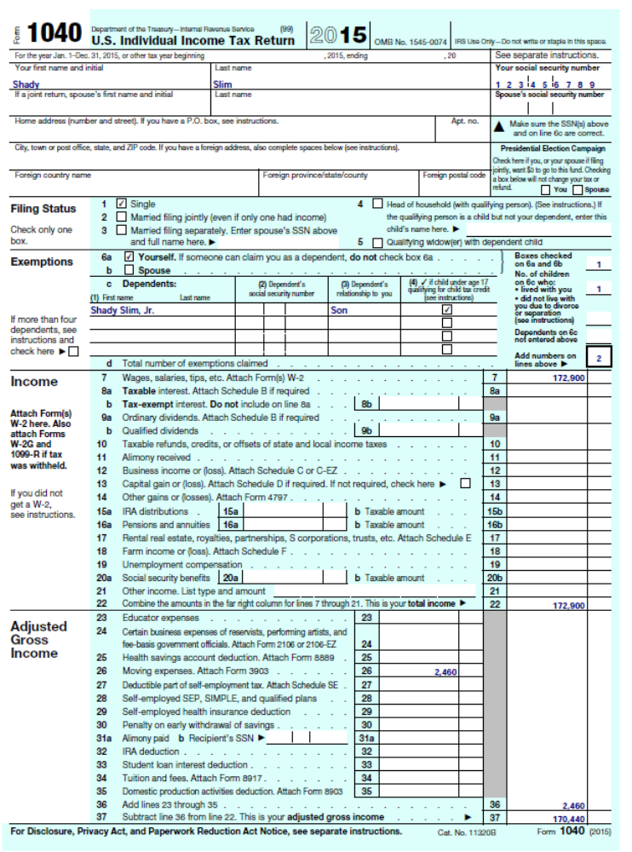
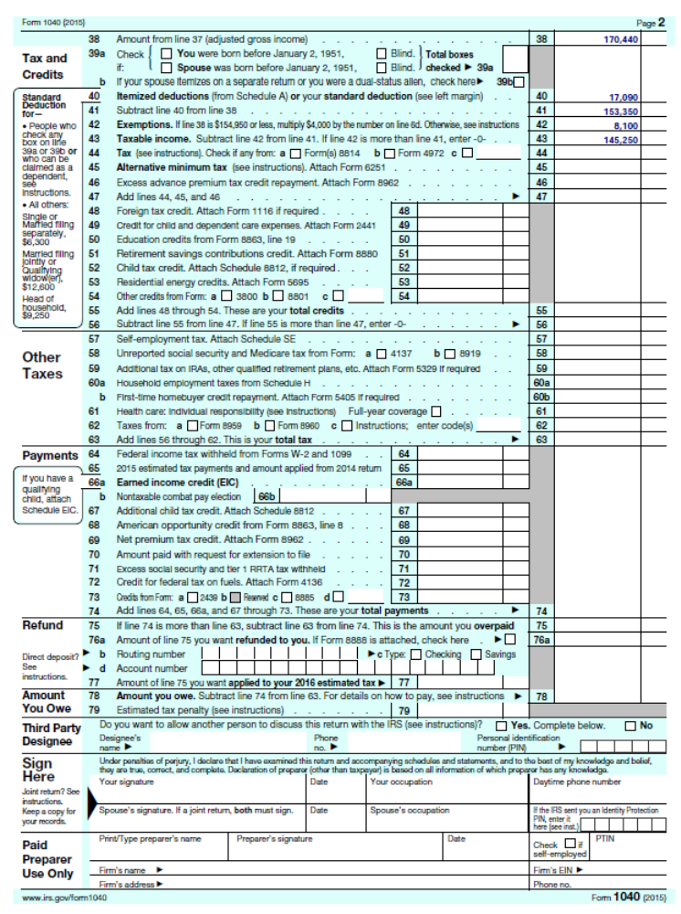
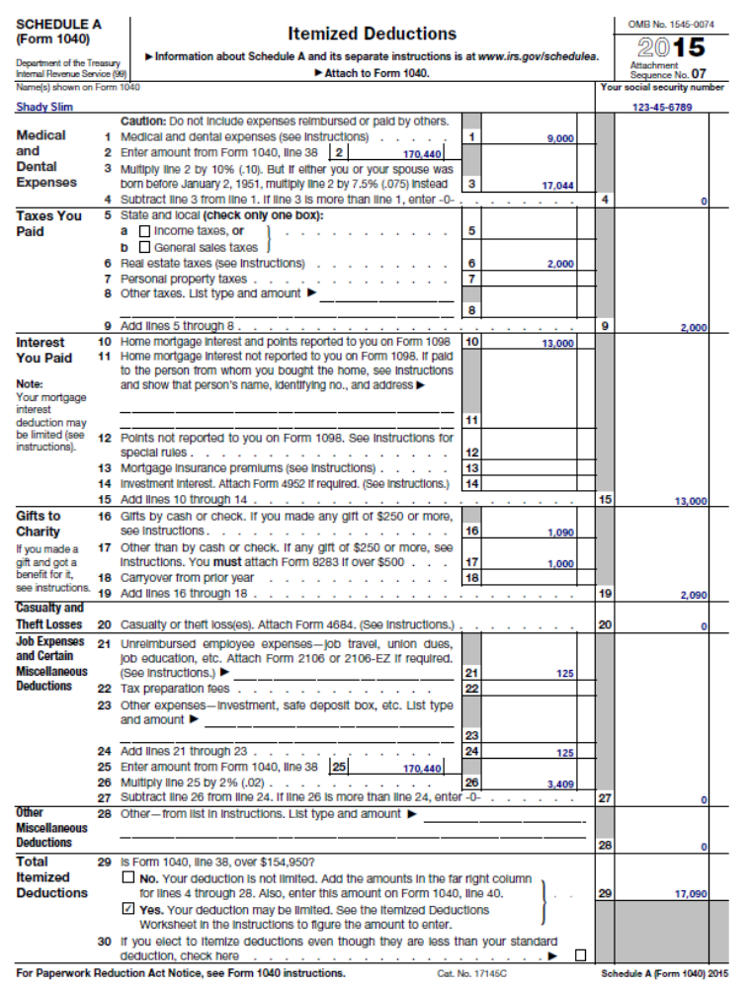

69. Jeremy and Alyssa Johnson have been married for five years and do not have any children. Jeremy was married previously and has one child from the prior marriage. He is self-employed and operates his own computer repair store. For the first two months of this year, Alyssa worked for Office Depot as an employee. In March, Alyssa accepted a new job with Super Toys, Inc. (ST) where she worked for the remainder of the year. This year the Johnsons received $255,000 of gross income. Determine the Johnson’s AGI given the following information:
a. Expenses associated with Jeremy’s store include $40,000 in salary (and employment taxes) to employees, $45,000 of supplies, and $18,000 in rent and other administrative expenses.
b. As a salesperson, Alyssa incurred $2,000 in travel expenses related to her employment that were not reimbursed by her employer.
c. The Johnsons own a piece of raw land held as an investment. They paid $500 of real property taxes on the property and they incurred $200 of expenses in travel costs to see the property and to evaluate other similar potential investment properties.
d. The Johnsons own a rental home. They incurred $8,500 of expenses associated with the property.
e. The Johnson’s home was only five miles from the Office Depot store where Alyssa worked in January and February. The ST store was 60 miles from their home, so the Johnsons decided to move to make the commute easier for Alyssa. The Johnson’s new home was only ten miles from the ST store. However, their new home was 50 miles from their former residence. The Johnsons paid a moving company $2,002 to move their possessions to the new location. They also drove the 50 miles to their new residence. They stopped along the way for lunch and spent $60 eating at Denny’s. None of the moving expenses were reimbursed by ST.
f. Jeremy paid $4,500 for health insurance coverage for himself (not through an exchange). Alyssa was covered by health plans provided by her employer, but Jeremy is not eligible for the plan until next year.
g. Jeremy paid $2,500 in self-employment taxes ($1,250 represents the employer portion of the self-employment taxes).
h. Jeremy paid $5,000 in alimony and $3,000 in child support from his prior marriage.
i. Alyssa paid $3,100 of tuition and fees to attend night classes at a local university. The Johnsons would like to deduct as much of this expenditure as possible rather than claim a credit.
j. The Johnsons donated $2,000 to their favorite charity.

Answer: $128,738, computed as follows:

Johnson’s AGI
Description | Amount | Explanation
Gross income | $255,000
a Ordinary and necessary business expenses | 103,000 | Ordinary expenses associated with Jeremy’s business
b Unreimbursed employment expenses | - | Unreimbursed employee business expenses are deductible from AGI not for AGI
c Real property taxes and investment expenses. | - | Taxes and investment expenses are deductible from AGI not for AGI.
d Rental expenses | 8,500 | Rental expenses are deductible for AGI even though they are technically investment or “production of income expenses.”
e Moving expenses | 2,012 | Her old residence to new place of employment is more than 50 miles farther than her old residence to her old place of employment (60 – 5 = 55). The location of her new residence is irrelevant. The Johnsons are allowed to deduct costs of moving ($2,002 movers including 19 cents a mile for driving themselves (50 × 23¢ =$10, rounded)). Meals are an indirect cost of moving and are not deductible.
f Self-employed health insurance | 4,500 | Jeremy may deduct all the costs of his health insurance because he is not eligible for ST’s health plan.
g Self-employment taxes | 1,250 | The employer portion of self-employment taxes are allowed as for AGI deduction
h Alimony | 5,000 | Alimony allowed as for AGI deduction
i Education expenses | 2,000 | See Note A below
j Charitable contributions | - | Charitable contributions are from AGI deductions, not for AGI deductions
Total for AGI deductions | 126,262
AGI | $128,738 | AGI

Note A: Qualifying education expenses are deductible up to a maximum of $4,000. Since the Johnson’s modified AGI of $130,738 (AGI without deducting education expenses) exceeds $130,000, the Johnsons are allowed to deduct the lesser of their actual qualified expenditures of $3,100 or $2,000.

70. {Tax Forms} Shauna Coleman is single. She is employed as an architectural designer for Streamline Design (SD). Shauna wanted to determine her taxable income. She correctly calculated her AGI. However, she wasn’t sure how to compute the rest of her taxable income. She provided the following information with hopes that you could use it to determine her taxable income.
a. Shauna paid $4,680 for medical expenses for care from a broken ankle. Also, Shauna’s boyfriend, Blake, drove Shauna (in her car) a total of 115 miles to the doctor’s office so she could receive care for her broken ankle.
b. Shauna paid a total of $3,400 in health insurance premiums during the year (not through an exchange). SD did not reimburse any of this expense. Besides the health insurance premiums and the medical expenses for her broken ankle, Shauna had Lasik eye surgery last year and she paid $3,000 for the surgery (she received no insurance reimbursement). She also incurred $450 of other medical expenses for the year.
c. SD withheld $1,800 of state income tax, $7,495 of Social Security tax, and $14,500 of federal income tax from Shauna’s paychecks throughout the year.
d. In 2016, Shauna was due a refund of $250 for overpaying her 2015 state taxes. On her 2015 state tax return that she filed in April of 2016, she applied the overpayment towards her 2016 state tax liability. She estimated that her state tax liability for 2016 will be $2,300.
e. Shauna paid $3,200 of property taxes on her personal residence. She also paid $500 to the developer of her subdivision, because he had to replace the sidewalk in certain areas of the subdivision.
f. Shauna paid a $200 property tax based on the state’s estimate of the value of her car.
g. Shauna has a home mortgage loan in the amount of $220,000 that she secured when she purchased the home. The home is worth about $400,000. Shauna paid interest of $12,300 in interest on the loan this year.
h. Shauna made several charitable contributions throughout the year. She contributed stock in ZYX Corp. to the Red Cross. On the date of the contribution, the FMV of the donated shares was $1,000 and her basis in the shares was $400. Shauna originally bought the ZYX Corp. stock in 2008. Shauna also contributed $300 cash to State University and religious artifacts she has held for several years to her church. The artifacts were valued at $500 and Shauna’s basis in the items was $300. Shauna had every reason to believe the church would keep them on display indefinitely. Shauna also drove 200 miles doing church-related errands for her minister. Finally, Shauna contributed $1,200 of services to her church last year.
i. Shauna’s car was totaled in a wreck in January. The car was worth $14,000 and her cost basis in the car was $16,000. The car was a complete loss. Shauna received $2,000 in insurance reimbursements for the loss.
j. Shauna paid $300 for architectural design publications, $100 for continuing education courses to keep her up to date on the latest design technology, and $200 for professional dues to maintain her status in a professional designer’s organization.
k. Shauna paid $250 in investment advisory fees and another $150 to have her tax return prepared (that is, she paid $150 in 2016 to have her 2015 tax return prepared).
l. Shauna is involved in horse racing as a hobby. During the year, she won $2,500 in prize money and incurred $10,000 in expenses. She has never had a profitable year with her horse racing activities, so she acknowledges that this is a hobby for federal income tax purposes.
m. Shauna sustained $2,000 in gambling losses over the year (mostly horse-racing bets) and only had $200 in winnings.
Required:
A. Determine Shauna’s taxable income and complete page 2 of Form 1040 (through taxable income, line 43) and Schedule A assuming her AGI is $107,000.
B. Determine Shauna’s taxable income and complete page 2 of Form 1040 (through taxable income, line 43) and Schedule A assuming her AGI is $207,000

Part A: $79,760, computed as follows:

Description | Amount | Explanation
(1) AGI | $107,000
From AGI deductions:
a) and b) Medical expenses | $ 852 | Medical expenses in excess of 10 percent of AGI are deductible. See Note A below.
c) and d) State taxes | 2,050 | State income taxes paid are deductible $1,800 withheld and 250 overpayment applied on last year’s return treated as paid last year).
e) Real property taxes | 3,200 | Real property taxes deductible from AGI. Payment to developer is not a tax.
f) Personal property taxes | 200 | Property tax on personal property based on value deductible from AGI
g) Interest on loans secured by her home | 12,300 | Primary home loan interest deductible from AGI
h) Charitable contributions | 1,828 | See Note B below
i) Casualty loss | 1,200 | See Note C below
j) – l) Itemized deductions subject to 2% AGI floor | 1,360 | See Note D below
m) Gambling losses | 200 | Gambling losses are limited to earnings from gambling deductible as a miscellaneous itemized deduction but not subject to 2% of AGI floor.
(2) Total itemized deductions | 23,190
(3) Standard deduction | 6,300 | Single taxpayer
(4) Greater of Itemized deductions or standard deduction | 23,190 | Greater of (2) or (3). Shauna should choose to itemize deductions.
(5) Personal exemption amount | 4,050 | One exemption
(6) Total From AGI deductions | 27,240 | (4) + (5)
Taxable income | $79,760 | (1) – (6)

Note A: $852. Medical expenses = $4,680 (medical expenses for broken ankle), + $22 (115 miles × 19¢ per mile) + 3,400 (unreimbursed health insurance premiums) + 3,000 (Lasik eye surgery) + 450 (other medical expenses) – $10,700 (AGI of 107,000 × 10 percent) = $852.
Note B: $1,828. Capital gain property generally in the form of stock deductible at FMV; Thus, Shauna can deduct $1,000 for her ZYX stock donation to the Red Cross. Cash contributions of $300 are fully deductible. Religious artifacts are used by church in its normal function as a non-profit organization and thus are deductible at FMV of $500. Finally, Shauna may deduct $28 (as a cash donation) expense for her charitable mileage (200 miles × 14¢ per mile). Note that the value of services donated is not deductible. Accordingly, Shauna’s charitable contribution deduction is $1,828 (1,000 + 300 + 500 + 28) = $1,828. Shauna need not be concerned about the AGI-based limitations on her contributions because her AGI is relatively high and her contributions are relatively low.
Note C: $1,200. The amount of the loss is the lesser of (1) the reduction in value of the car ($14,000) or (2) the taxpayer’s basis in the car ($16,000). This $14,000 loss is reduced by the $2,000 insurance proceeds. Thus, before applying limitations, the amount of her loss is $12,000 ($14,000 – 2,000). To determine the deductible amount, the loss must be reduced by $100 and then by 10 percent of AGI ($10,700). So, her deductible loss is $1,200 ($12,000 – 100 – 10,700).
Note D:
j) Employee business expenses | $600 | 300 + 100 + 200. All items deductible as miscellaneous itemized deductions subject to the 2% of AGI floor.
k) Investment expense and tax preparation fees | 400 | 250 + 150. Both items deductible as miscellaneous itemized deductions subject to the 2% of AGI floor
l) Hobby losses | 2,500 | Hobby losses limited to income generated from the activity. In this case $2,500. These are miscellaneous itemized deductions subject to the 2% of AGI floor.
(1) Total Itemized deductions subject to 2% floor | 3,500
(2) 2% × AGI floor | -2,140 | $107,000 AGI × 2%
Amount in excess of floor | 1,360 | (1) – (2)

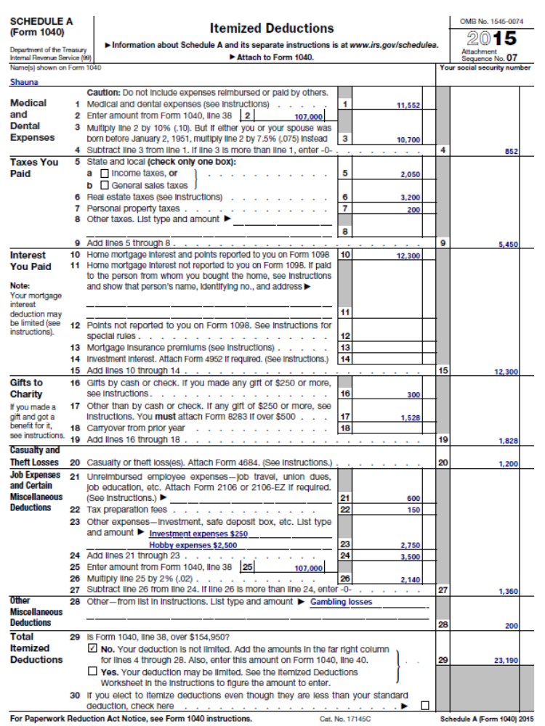

Part B: $183,172 computed as follows:

Description | Amount | Explanation
(1) AGI | $207,000
From AGI deductions:
a) and b) Medical expenses | 0 | Medical expenses in excess of 10 percent of AGI are deductible. See note A below.
c and d State taxes | 2,050 | State income taxes paid last year are deductible ($1,800 withheld and 250 overpayment applied on last year’s return treated as paid last year.
e Real property taxes | 3,200 | Real property taxes deductible from AGI. Payment to developer is not a tax.
f Personal property taxes | 200 | Property tax on personal property based on value deductible from AGI
g Interest on loans secured by her home | 12,300 | Primary home loan and home equity loan deductible from AGI
h Charitable contributions | 1,828 | See note B below
i Casualty loss | - | See note C below
j – l Itemized deductions subject to 2% AGI floor | - | See note D below
m) Gambling losses | 200 | Gambling losses are limited to earnings from gambling deductible as a miscellaneous itemized deduction but not subject to 2% of AGI floor or phase out.
(4) Total itemized deductions | 19,778
(5) Standard deduction | 6,300 | Single taxpayer
(6) Greater of Itemized deductions or standard deduction | 19,778 | Greater of (4) or (5). Shauna should choose to itemize deductions.
(7) Personal exemption amount | 4,050 | One exemption.
(8) Total From AGI deductions | 23,828 | (6) + (7)
Taxable income | $183,172 | (1) – (8)

Note A: $0. Medical expenses = $4,680 (medical expenses for broken ankle), + $22 (115 miles × 19¢ per mile) + 3,400 (unreimbursed health insurance premiums) + 3,000 (Lasik eye surgery) + 450 (other medical expenses) – $20,700 (AGI of 207,000 × 10 percent) < $0. Because 10 percent of Shauna’s AGI exceeds her total medical expenses, Shauna is unable to deduct any medical expenses.
Note B: $1,828. Capital gain property generally in the form of stock is deductible at FMV; Thus, Shauna can deduct $1,000 for her ZYX stock donation to the Red Cross. Cash contributions of $300 are fully deductible. Religious artifacts are used by church in its normal function as a non-profit organization and thus are deductible at FMV of $500. Finally Shauna may deduct $28 (as a cash donation) expense for her charitable mileage (200 miles × 14¢ per mile). Note that the value of services donated is not deductible. Accordingly, Shauna’s charitable contribution deduction is $1,828 (1,000 + 300 + 500 + 28) = $1,828. Shauna need not be concerned about the AGI-based limitations on her contributions because her AGI is relatively high and her contributions are relatively low.
Note C: $0. The amount of the loss is the lesser of (1) the reduction in value of the car ($14,000) or (2) the taxpayer’s basis in the car ($16,000). This $14,000 loss is reduced by the $2,000 insurance proceeds. Thus, before applying limitations, the amount of her loss is $12,000 ($14,000 – 2,000). To determine the deductible amount, the loss must be reduced by $100 and then by 10 percent of AGI ($20,700). So, her deductible loss is $0 (12,000 – 100 – 20,700).
Note D:
j) Employee business expenses | $600 | 300 + 100 + 200. All items deductible as miscellaneous itemized deductions subject to the 2% of AGI floor.
k) Investment expense and tax preparation fees | 400 | 250 + 150. Both items deductible as miscellaneous itemized deductions subject to the 2% of AGI floor
l) Hobby losses | 2,500 | Hobby losses limited to income generated from the activity. In this case $2,500. These are miscellaneous itemized deductions subject to the 2% of AGI floor.
(1) Total Itemized deductions subject to 2% floor | 3,500
(2) 2% × AGI floor | (4,140) | $207,000 AGI × 2%
Amount in excess of floor | 0 | (1) + (2), limited to $0.

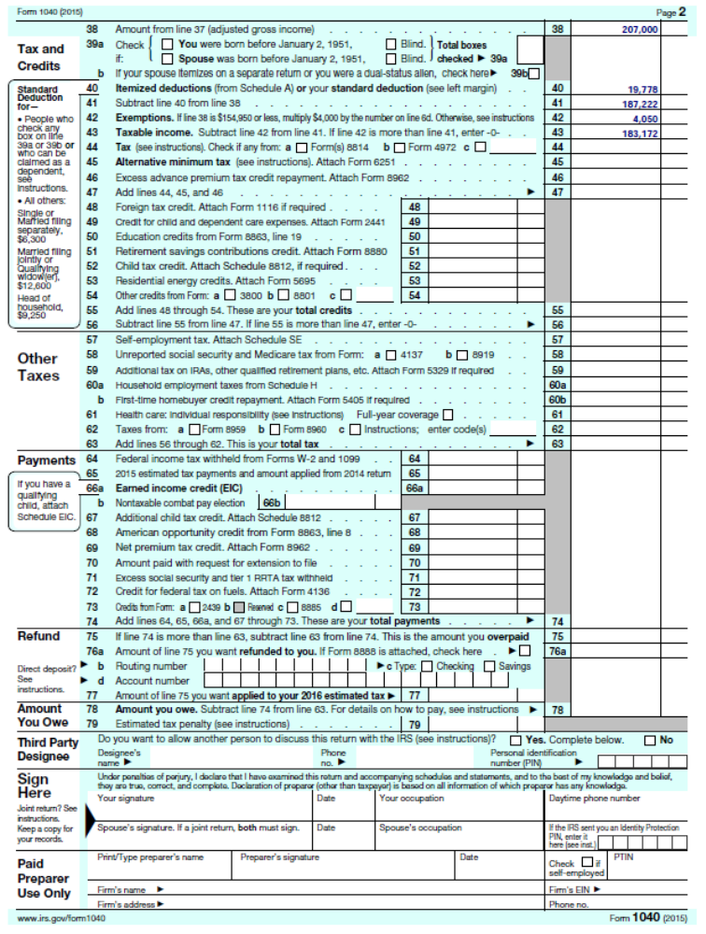

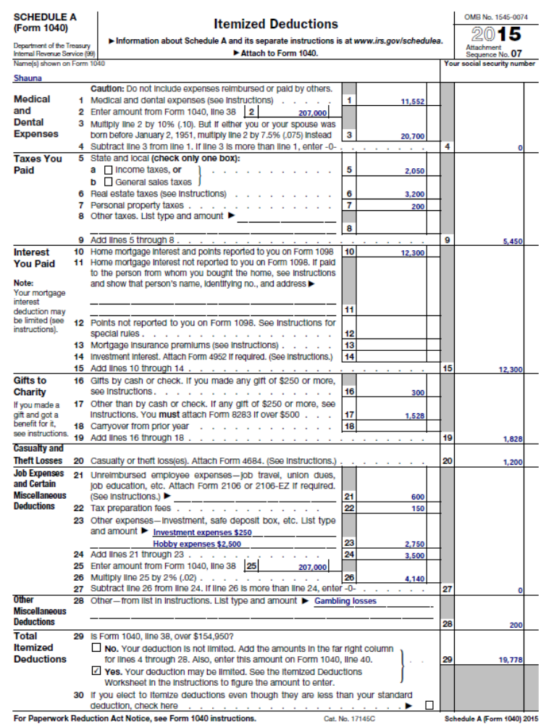
71. {Tax Forms} Joe and Jessie are married and have one dependent child, Lizzie. Lizzie is currently in college at State University. Joe works as a design engineer for a manufacturing firm while Jessie runs a craft business from their home. Jessie’s craft business consists of making craft items for sale at craft shows that are held periodically at various locations. Jessie spends considerable time and effort on her craft business and it has been consistently profitable over the years. Joe and Jessie own a home and pay interest on their home loan (balance of $220,000) and a personal loan to pay for Lizzie’s college expenses (balance of $35,000).
Neither Joe nor Jessie is blind or over age 65, and they plan to file as married-joint. Based on their estimates, determine Joe and Jessie’s AGI and taxable income for the year and complete pages 1 and 2 of Form 1040 (through taxable income, line 43) and Schedule A. Assume that the employer portion of the self-employment tax on Jessie’s income is $808. Joe and Jessie have summarized the income and expenses they expect to report this year as follows:
Income:
Joe’s salary $ 119,100
Jessie’s craft sales 18,400
Interest from certificate of deposit 1,650
Interest from Treasury bond funds 727
Interest from municipal bond funds 920
Expenditures:
Federal income tax withheld from Joe’s wages $ 13,700
State income tax withheld from Joe’s wages 6,400
Social Security tax withheld from Joe’s wages 7,482
Real estate taxes on residence 6,200
Automobile licenses (based on weight) 310
State sales tax paid 1,150
Home mortgage interest 14,000
Interest on Masterdebt credit card 2,300
Medical expenses (unreimbursed) 1,690
Joe’s employee expenses (unreimbursed) 2,400
Cost of Jessie’s craft supplies 4,260
Postage for mailing crafts 145
Travel and lodging for craft shows 2,230
Meals during craft shows 670
Self-employment tax on Jessie’s craft income 1,615
College tuition paid for Lizzie 5,780
Interest on loans to pay Lizzie’s tuition 3,200
Lizzie’s room and board at college 12,620
Cash contributions to Red Cross 525

Salary $ 119,100
Interest (taxable) + 2,377
Craft revenue $ 18,400
less cost of goods - 4,260
less travel & postage - 2,375
less 50 percent of meals - 335
Income from craft business + 11,430
Total Income $ 132,907
Less Employer portion of SE taxes - 808
Modified AGI (for student loan interest deduction) $ 132,099
Student loan interest deduction - 2,325
Modified AGI (for qualified education expenses) $129,774
Tuition deduction - 4,000 AGI $ 125,774

Joe and Jessie’s maximum deduction for the educational interest deduction before the phase-out is $2,500 (the amount of interest paid ($3,200) up to $2,500). Joe and Jessie’s modified AGI of $132,099 (for the student loan interest deduction) is above the phase-out trigger for student loan interest in 2016, $130,000 for MJ. Hence, the maximum deduction for the educational loan interest ($2,500) is reduced by the excess AGI over the threshold ($132,099-$130,000) divided by the phase-out range ($2,099/30,000) or 7 percent. Thus, their deduction for student loan interest is $2,325 ($2,500 – $175 [7 percent of $2,500]). Their modified AGI of $129,774 (for the qualified education expense deduction) is less than the $130,000 phase-out trigger. Thus, they may deduct the lesser of the $5,780 tuition they paid for Lizzie or $4,000 (the maximum deduction allowed).

Itemized deductions:
Medical expenses $ 1,690
less 10 percent AGI Floor - 12,577 $ 0
Taxes: State income tax $ 6,400
Real estate taxes + 6,200 + 12,600
Interest – QRI + 14,000
Charitable contributions + 525
Miscellaneous itemized:
Employee business expenses $ 2,400
less 2% AGI floor - 2,515 + 0
Total itemized deductions $ 27,125
AGI $ 125,774
Standard Deduction $ 12,600
Itemized deductions - 27,125
Exemptions (3 × $4,050) - 12,150
Taxable Income $ 86,499

