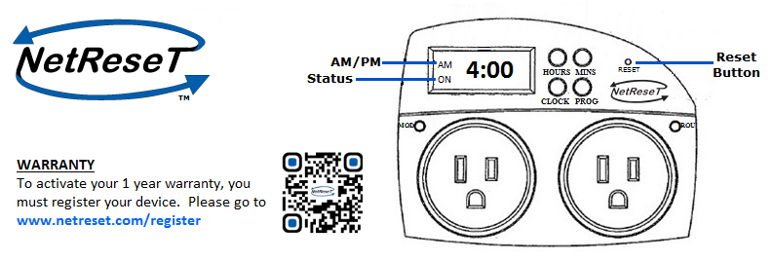

Thank you for purchasing your NetReseT device. Welcome to the strongest and most reliable Internet possible. Before using your NetReseT unit please read the following product instructions carefully.

**Setting your NetReseT**

After unboxing, if clock display does not appear, plug the unit into the wall outlet to charge. After 1 hour of charge remove unit from wall outlet to set time..

**Step 1: Set the current time**

1. Press and hold the CLOCK button on the NetReseT unit.
2. While holding the CLOCK button, tap the HOUR and MIN button to set the current minute. AM and PM is indicated on the left of the time.

**Step 2: Set the reset time**

Your “reset time” is the time you wish for the NetReseT unit to power cycle your modem and router.

1. Press the PROG button. This will change the Current Time to Programmed Time. DO NOT HOLD THE PROG BUTTON.
2. Tap the HOUR and MIN button until you reach the desired time for reset.
3. After the reset time has been reached, push the CLOCK button. This will activate NetReseT.

**Installing your NetReseT**

**Option 1: Standalone - modem and router are two separate devices**

Note: If your modem has a battery back-up it must be removed for NetReseT to work properly.

1. On the NetReseT unit, plug your modem into the outlet labeled “MOD.” Plug your router into the outlet labeled “ROU”. Plug the NetReseT unit into the wall.

**Option 2: All in one/combo - modem and router are both in one device**

Note: If your combo device has a battery back-up it must be removed for NetReseT to work properly.

1. On the NetReseT unit, plug your combo modem/router into the outlet labeled “MOD”. Plug the NetReseT unit into the wall.

**How to reset your NetReseT**

To reset unit to factory default settings, press the RESET button using a pen for 5 to 10 seconds.

**Specifications**

Output-Max: MOD 7.5A/120VAC, ROU 7.5A/120VAC

Input- AC120V/60 Hz/15 Amps

Operating temperature: 0° to 40° C

Battery backup: rechargeable NiMH 2.4VDC

**Contact**

If further assistance is required please email: [support@netreset.com](mailto:support@netreset.com)

  

Facebook: NetReseT Instagram: netreset_ Twitter: @NetReseT