**Pseudo-Flipping Assignment on Chp 9: Models Of Chemical Bonding**

Here are the key principles you will be expected to know (and will be tested on) from Chp 9 in your text.

{ ***Chapter 9*: Models of Chemical Bonding****(*Sec 9.1 - 9.3, 9.5*)**

* know the meaning of and/or be able to identify the **Key Terms** from sec. **9.1 - 9.3 & 9.5** on pg. 298.
* know the definition of a chemical bond
* know that there are three major types of chemical bonds (**covalent, ionic, metallic**) and how each is formed
* know that covalent bonds can be single, double, or triple bonds and the number of electrons constituting each kind of bond
* know how to identify the type of bond in a compound by the type of elements in the compound
* know how to draw the Lewis electron dot symbol for an element
* know where metals and non-metals are located in the periodic table.
* know how to determine the charge on ion (*metals: charge = group #; non-metals: charge = group # - 8 )*.
* be able to explain properties of ionic compounds using the ionic bonding model
* know what electronegativity is & its trends in the periodic table
* know how to show *polar* bonds using polarity arrows and delta (δ) symbols
* know how to calculate electronegativity differences (ΔEN) and determine the **ionic character** of a chemical bond
* know the bond properties (bond order, bond length and bond energy) and the factors influencing them
* be aware of the interrelationship among the bond properties
* be able to explain the properties of covalent compounds using the covalent model [*intermolecular forces breaking (not the covalent bonds) in some liquids; covalent bonds breaking in network covalent solids*] }

Read the chapter pages 277 - 289 & 293 - 297 (**secs 9.1 - 9.3 & 9.5**) or my PowerPoint notes on Chp 9 on Blackboard and then answer the following questions.

**Part I on Chp 9**

1. State the type of bonding --ionic, covalent, or metallic and then give a reason.

|  |  |  |
| --- | --- | --- |
| **Substance** | **Type of bonding** | **Simple reason** |
| ICl3(g) |  |  |
| Cu(s) |  |  |
| LiCl(s) |  |  |
| O2(g) |  |  |

2. Draw the Lewis electron dot structure for (a) Ba, (b) Xe, (c) Cl, (d) Si

3. a) In general, how does the lattice energy of an ionic compound depend on the charges and sizes of the ions?

b) Ion arrangement of three general compounds are shown below. Rank them in order of *increasing* lattice energy.

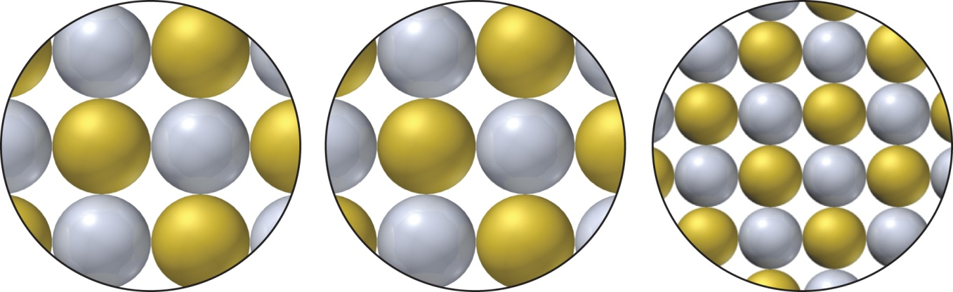

**A**: balls have 1+ & 1- charges **B**: balls have 2- & 2+ charges **C**: balls have 2- & 2+ charges

4. For each ionic compound formula, identify the main or A group in the periodic table (1A - 7A) to which X belongs: (a) SrX2 ; (b) XPO4 ; (c) AlX; (d) X2O

5. For single bonds between similar types of atoms, how does the strength of the bond relate to the sizes of the atoms? Explain.

6. How does the energy of the bond between a given pair of atoms relate to the bond order? Why?

7. When liquid methanol (CH3OH) boils, does the gas consist of molecules, ions, or separate atoms? Use the covalent bonding model to explain.