**TM/FTS**

Input from RCC Department

1. The intercom. expected to used in Panga Site in Oct.16 is 5.8 GHz.
2. The Satellite Link DTI has already procured for use in Pangna Site is as follows:

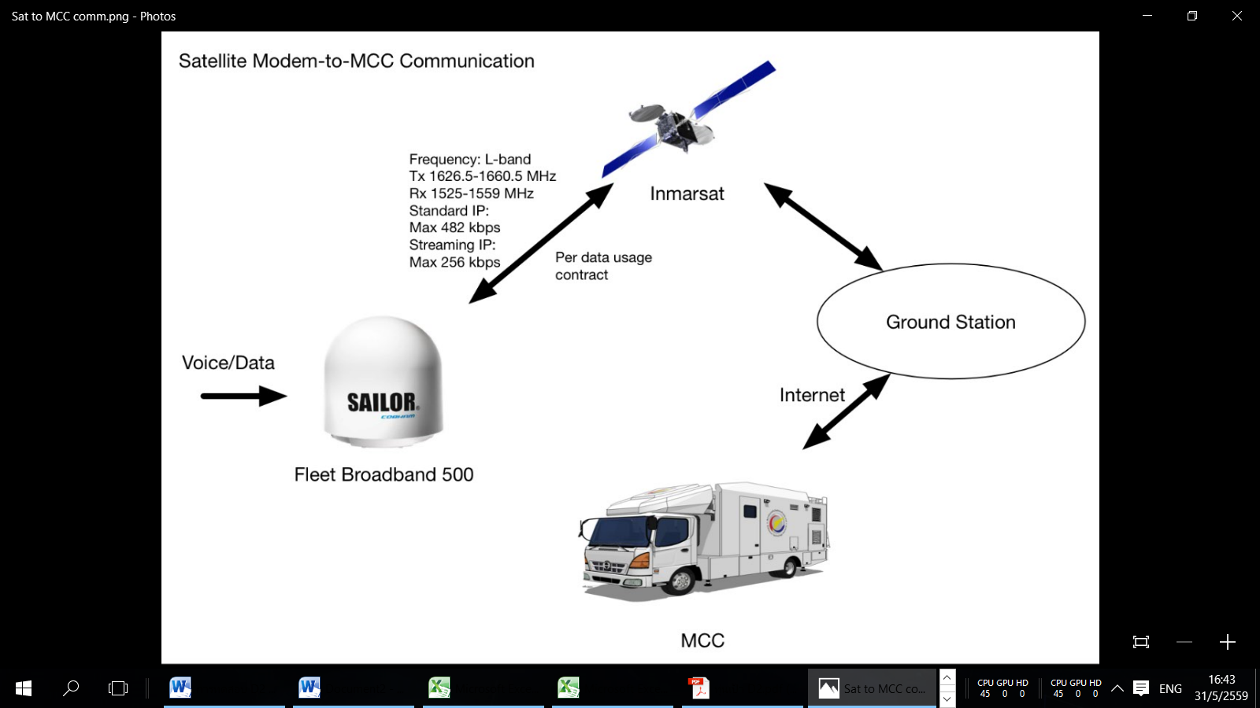

1. The company providing “GPS Simulator” and test: REPCO (Thailand)

http://www.repco.co.th/gnss-test-and-simulator/

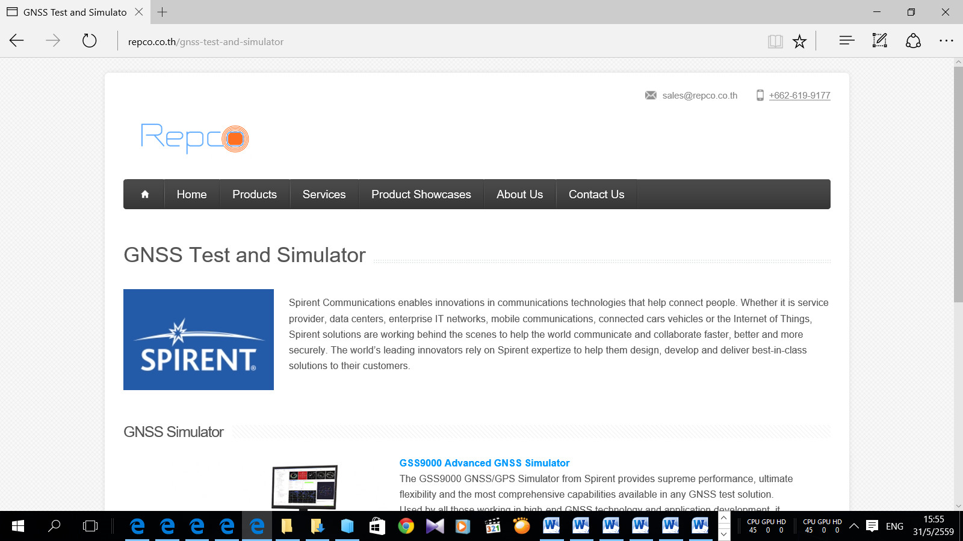

Contact: Dr.Nikorn - 086 701 1125

Repco is DTI’s contractor for the procurement of 3-axis Turntable and GPS simulator. Repco provided RCC Department a lecture on GPS Receiving System and conducted a test of >5mach and >18km altitude on K-500 GPS receiver board.

1. Information of sensor used in DTI’s 122mm program:

* “Sensonor” IMU (options: high rate & +- 80g)

<http://www.sensonor.com/gyro-products/inertial-measurement-units/stim300.aspx>

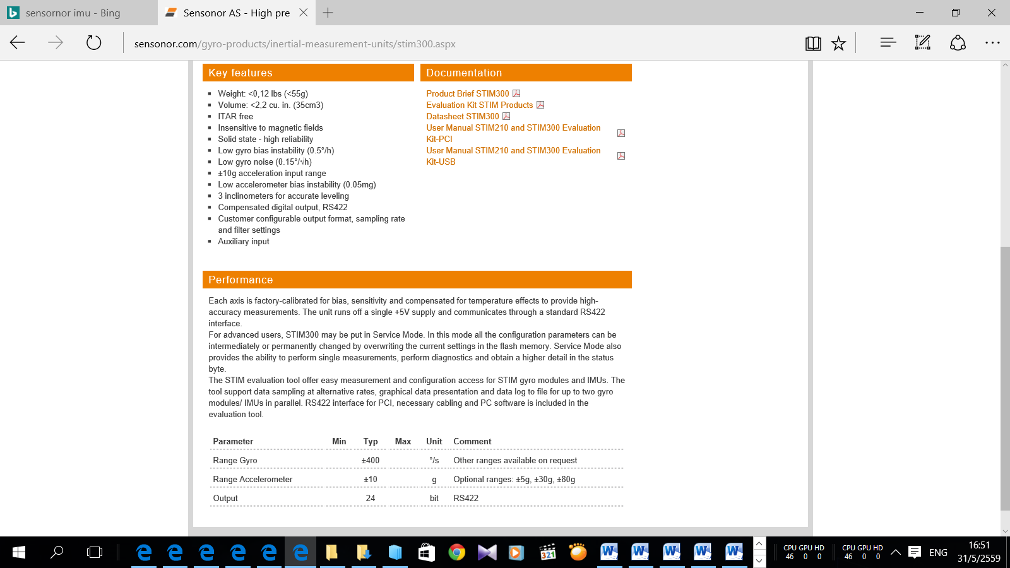

* K-500 (GPS) or K-700 (GPS + GNSS) from ComNav

<http://www.comnavtech.com/index.asp?sw=1280&sh=720>

