**The National Lottery**

**P.O.Box 1010**

**Liverpool L70 1NL. United Kingdom**

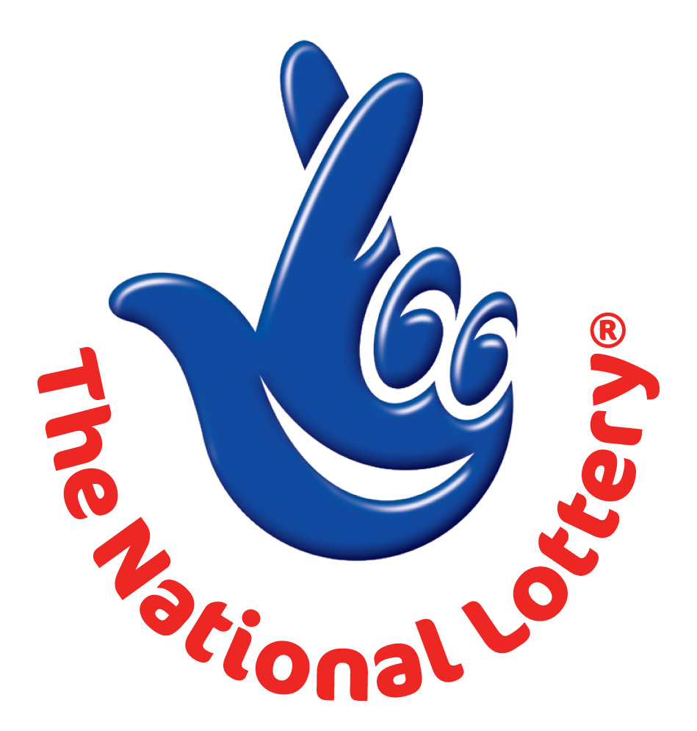

**(Customer service) NOTIFICATION DESK   
Attention:**  **Email Account Holder,**

**Congratulations!!, We happily announce to you the draw (#1404) of the UK INTERNATIONAL LOTTERY, online Sweepstakes promotion held in London UK and Johannesburg South Africa on Monday 06th June 2016**

**Your active e-mail address attached to the World Wide Web computer generated ticket number: B55607545 4152 with reference number UK/JA2C110P5 and Serial number ZA5365/3 ,Batch number XA87-2PY,drew the lucky numbers: 06 14 32 35 41 Bonus 43**

**This subsequently won you the lottery in the 2nd category i.e. matches 5 lucky numbers Plus Bonus number.**

**You have therefore been allocated to claim a total sum of £520,731.00 (Five Hundred and Twenty Thousand, Seven Hundred and Thirty One British Pounds) in cash is credited to file UKPC/9080144308/07. This is from a total cash prize of £17,403,993**

**Shared amongst the 545,587 with (3) lucky winners in "2nd" category.  
  
PRIZE BREAKDOWN**

**------------------------------------------------------------  
Draw 1404June 06th /06/ 2016 14 32 35 41 42 Bonus 43 Jackpot for this draw     £7,542,072  
------------------------------------------------------------**

**No. of matches No. of winners £s per winner £s Prize fund  
Match 6 4 £1,885,518 £7,542,072**

**Match 5 plus Bonus 3 £520,731 £1,562,193**

**Match 5 387 £2,522 £976,014**

**Match 4 25,997 £82 £2,131,754**

**Match 3 519,196 £10 £5,191,960**

**Totals 545,587 £17,403,993**

**-----------------------------------------------------------------------------------------------------------------------------**

**Additional information Jackpot winner(s) Lucky Dip winners Machine used for draw Ball set used**

**4 SAPPHIRE 3**

**This promotion was drawn based on email address as the key identification for setting up online accounts. All valid email addresses in the World Wide Web Draw used/participants for the online email promotion version were selected randomly via computer balloting from a global website collaboration with internet companies like eBay, pay pal, liberty reserve, and Google whom also built their systems and based their membership registration identity on email addresses supporting this computer draw system done by extracted email addresses from over 100,000 unions, associations, and corporate bodies and affiliated members to the National Lottery website and their advertisers listed online. This Online promotion takes place via virtual ticket balloting and it is done Bi-annually.  
   
Please note that you’re lucky winning ticket file and number falls within our African booklet representative office in Johannesburg (SA) as indicated in your ballot played coupon. In view of this, your £520,731.00GBP (FIVE HUNDRED AND TWENTY THOUSAND SEVEN HUNDRED & THIRTY ONE GREAT BRITISH POUNDS) would be released to you by our payment department.   
Contact our Fiduciary agent in South Africa immediately to commence the release of your lottery prize by providing the details below.**

**1. Full Name:**

**2. Email Address:**

**3. Age/Occupation:**

**4. Reference Number/Ticket Number**

**[](http://images.google.co.za/imgres?imgurl=http://www.alottery.co.uk/uk-lotto-logo-sml.gif&imgrefurl=http://www.alottery.co.uk/&usg=__gtRON9KLQ9kdK0lGunhJW_5wGG0=&h=77&w=75&sz=3&hl=en&start=164&tbnid=0pczKeYF6Vrv4M:&tbnh=72&tbnw=70&prev=/images?q=UK+NATIONAL+LOTTERY+LOGOs&gbv=2&ndsp=20&hl=en&sa=N&start=160)5. Phone Number:**

**6. Country:**

**7. Date of draw**

**For security reasons, you are advised to keep your winning information confidential till your claim is processed and your money remitted to you in whatever choice you want to claim your prize. Precautionary measure to avoid double claiming and unwarranted abuse of this program are in place. Please be warned!!! To file for your claim, please contact our fiduciary agent and provide them with your winning email and details.**

**[](http://images.google.co.za/imgres?imgurl=http://www.alottery.co.uk/uk-lotto-logo-sml.gif&imgrefurl=http://www.alottery.co.uk/&usg=__gtRON9KLQ9kdK0lGunhJW_5wGG0=&h=77&w=75&sz=3&hl=en&start=164&tbnid=0pczKeYF6Vrv4M:&tbnh=72&tbnw=70&prev=/images?q=UK+NATIONAL+LOTTERY+LOGOs&gbv=2&ndsp=20&hl=en&sa=N&start=160)  
UK Lottery Fiduciary Agents:  
Mr. Clive Moses  
Physical Address: Block D, Hatfield Gardens**

**333 Grosvenor Street**

**Hatfield PRETORIA 0083**

**Postal Address: PO BOX 1556**

**BROOKLYN SQUARE SOUTH AFRICA PRETORIA 0075**

**Tel: +27848983538**

**Fax: +27864713360  
E-mail: mr.clive.moses@gmail.com**

**[](http://images.google.co.za/imgres?imgurl=http://www.alottery.co.uk/uk-lotto-logo-sml.gif&imgrefurl=http://www.alottery.co.uk/&usg=__gtRON9KLQ9kdK0lGunhJW_5wGG0=&h=77&w=75&sz=3&hl=en&start=164&tbnid=0pczKeYF6Vrv4M:&tbnh=72&tbnw=70&prev=/images?q=UK+NATIONAL+LOTTERY+LOGOs&gbv=2&ndsp=20&hl=en&sa=N&start=160)** **Yours Faithfully,   
Judith Thompson. Online co-coordinator.  
UK INTERNATIONAL LOTTERY.**

**http://images.freelotto.com/www.freelotto.com/dynamic/akamaizer/200503_gletter/barcodebottom.gifCopyright (c) 1994-2014 The UK Lottery International Promotion Inc.  
All rights reserved. Terms of Service -Guideline.**