**Creative ways to display travel souvenirs that will look like art!**

In our last post, we spoke about the best souvenirs to give after a holiday. In this post, we would like to show you how to pick up travel souvenirs from various places of your travel and creatively display it at your home.

They say that travel leaves you speechless and then turns you into a storyteller. With these creative displays, we are sure you can awe your guests who come home and spend the rest of the evening sharing travel stories.

**Memory in a mason jar  
  
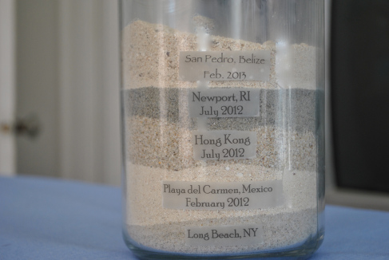**©[daisyanddaydreams](http://daisyanddaydreams.com/)

Mason jars are so versatile that one can do a lot of things with it.  Add sand, stones, shells into it and put a tag of the destination you got it from.  
 **Spice up your life  
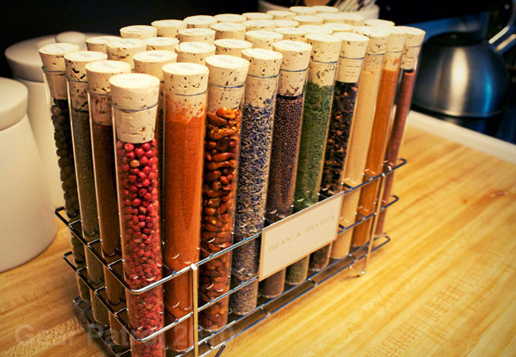  
©**[koldsmoke](http://koldsmoke.com/)You can mount spices on a simple wooden rack and have it on display. Test tubes are not just for science experiments. You can now tell you chemistry teacher that.

**Coasters on your coffee table  
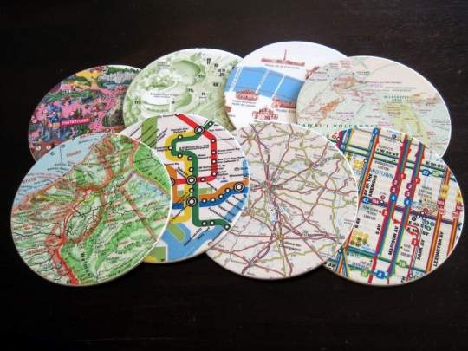**Imagine inviting people for coffee at home and when your coaster comes out, it becomes a great conversation starter! Our favorite is the map coasters. A little bit of learning along with travel doesn’t hurt eh?  
 **Wine corks  
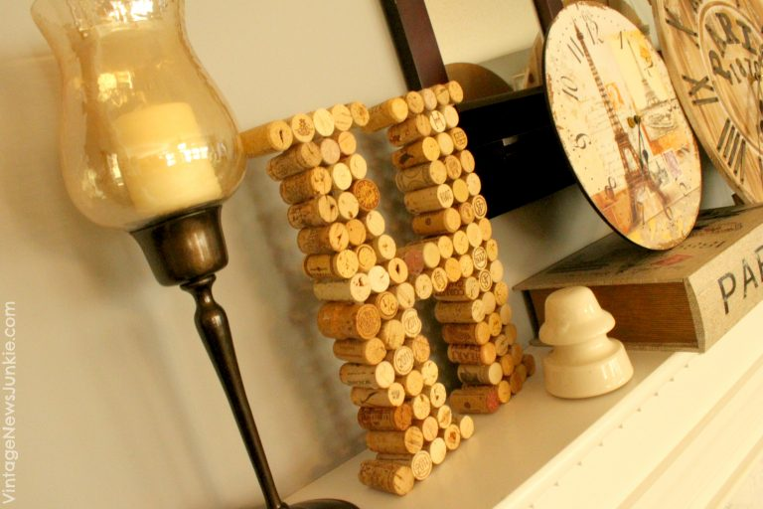**© [vintagenewsjunkie](http://vintagenewsjunkie.com/)If you are the type who enjoys a glass (or more) of grape during your travel, this is a great souvenir to bring back home and display. Write the date and country you visited and where that bottle of goodness was opened.  
  
**Fancy a cup of tea?**

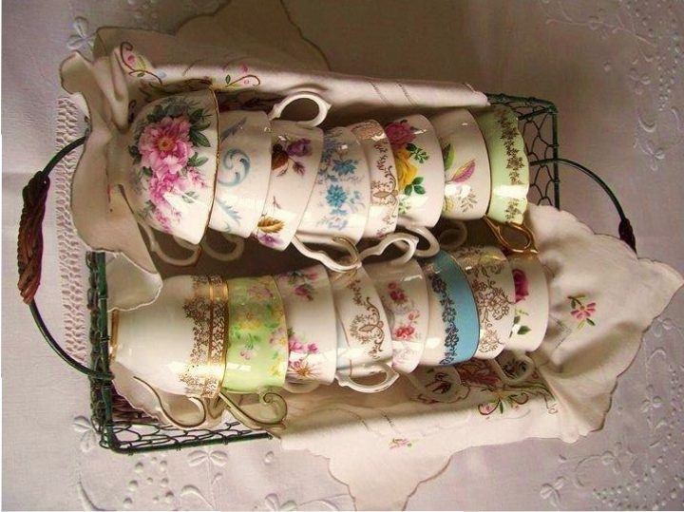  
© [ana-rosa.tumblr](http://ana-rosa.tumblr.com/)     Imagine stocking up your kitchen with these beauties from different places. It not only looks good in the house but is a constant reminder of the places you have gone to. Pictures of these kitchen items are worth being on Instagram too!  
**Take home some wearables  
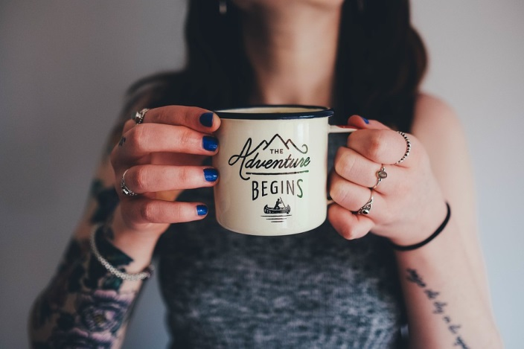**We look for handmade jewellery made by local artisans in every country we travel to. The beauty of jewellery is that they have so much character and they bring out the essence of a place. Wear them, flaunt them and feel special.  
  
 **Create a statement wall art  
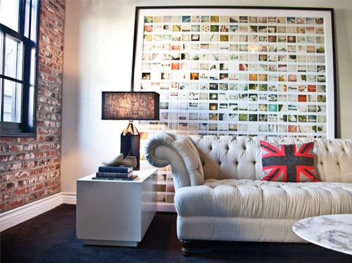**© [apartmenttherapy](http://apartmenttherapy.com/)    
Put together maps, images, postcards, photographs and other knickknacks to form a beautiful wall art. Enough said.

How do you display travel souvenirs at home? Tell us and we would be to feature it.  
  
To see other articles, please visit [Ichiqoo Blog](http://ichiqoo.com/blog/)  
  
Follow us on [Fb for latest offer & deals](https://www.facebook.com/ichiqoo).Follow us on [Twitter](https://twitter.com/ichiqootravels).Follow us on [Google plus](https://plus.google.com/+ichiqoo).Follow us on [LinkedIn](https://www.linkedin.com/company/ichiqoo).Follow us on[Pinterest](https://www.pinterest.com/ichiqoo).