Bandung, Desember 27th 2014

Dear,

Human Resource Manager

Of

PT. Chevron Indo Asia

Dear Mr/Mrs

I’m Nikita Kian Shanti, Female 22 years old. I got my bachelor degree from Padjadjaran University Faculty of Social and Politic Science majoring for Social Welfare (GPA 3.41). I would like to express my interest in the HR Generalist position at PT. Chevron Indo Asia.

My consentration is Human Resource, Social Marketing and Social Enterprise and Corporate Social Responsibility (CSR). I’m a responsible, diligent, communicative, willing to learn and willing to teamwork. I hope my abilities will be an asset your company and giving contribution for your company.

Herewith I enclose my curriculum vitae, which will give details of my qualification. I appreciate your consideration and look forward to hearing from you. Thank you for taking the time to consider this application and I look forward to hearing from you in the near future.

Respectfully yours,

Nikita Kian Shanti

**CURRICULUM VITAE**

**NIKITA KIAN SHANTI**

**Mobile: 082126947400**

**Email: kiannikita@yahoo.com**

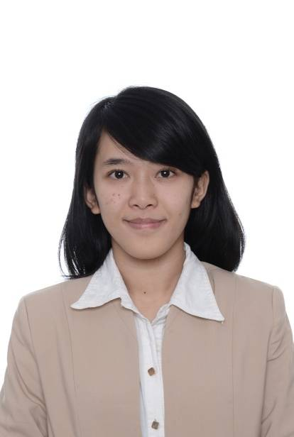

**Personal Information**

Name : Nikita Kian Shanti

Citizen : Indonesia

Place & Date of Birth : Bandung, June 15th, 1992

Age : 22 years

Gender : Female

Religion : Moslem

Address : Jl. Cikajang 11 No. 25 RT

04 RW 21. Antapani

Bandung

Faculty : Faculty of Political and Social Sciences

Major : Social Welfare

GPA : 3,41 (4scale)

**Educational Background**

2010 - 2014 : Social Welfare, Padjadjaran University Bandung.

2007 - 2010 : SMAN 14 Bandung

2004 - 2007 : SMPN 7 Bandung

1998 - 2004 : SD Salman Al-Farisi Bandung

**Informal Education**

2009–2010 : LBPP LIA (English Course) Bandung

**Organizational**

2009-2010 : Member of Cinematography 14 Senior High School

2010-2011 : Member of UNPAD Choir

2010-2013 : Member of Himpunan Mahasiswa Ilmu Kesejahteraan Sosial FISIP UNPAD

**Seminar and Training**

| **EVENT** | **INSTITUTION** | **LOCATION** | **POSITION** | **YEAR** |
| --- | --- | --- | --- | --- |
| Seminar Nasional Profesi Pekerjaan Sosial “Social Entrepreneur for a Better Life” | Social Welfare, FISIP UNPAD | Bandung | Public Relation | 2014 |
| Case Management | Yayasan Pelayanan Anak dan Keluarga | Jatinangor | As Participants | 2014 |
| Social Work for Nation, “Merespon Isu-isu Sosial Nasional dalam RangkaMenggagas Pendidikan Profesi Pekerjaan Sosial di Indonesia”  Seminar Nasional Profesi Pekerjaan Sosial “Social Protection for Difable” | Social Welfare, FISIP UNPAD  Social Welfare, FISIP UNPAD | Bandung  Bandung | As Participants  As Participants | 2012  2011 |
| Seminar Nasional Profesi Pekerjaan Sosial with Save the Children | Social Welfare, FISIP UNPAD | Bandung | As Participants | 2010 |

**Project**

|  |  |  |
| --- | --- | --- |
| **TITLE** | **PERIOD** | **POSITION** |
| Community Development in Desa Hegarmanah as Community Worker | August 2012 – December 2012 | Team Leader |
| Community Development activities in Desa Cisurupan Kecamatan Cisurupan Kota Garut | Januari 2013- Februari 2013 | As Participant |

**Skills**

1. **Software 2. Language**

* Microsoft Word - Indonesia (native)
* Microsoft Excel - English (basic)
* Microsoft Power Point

**Special Abilities**

* Human Resource
* Corporate Social Responsibility (CSR)
* Social Marketing

**Personality**

* Responsible - Willing to Learn
* Diligent - Willing to Teamwork
* Communicative