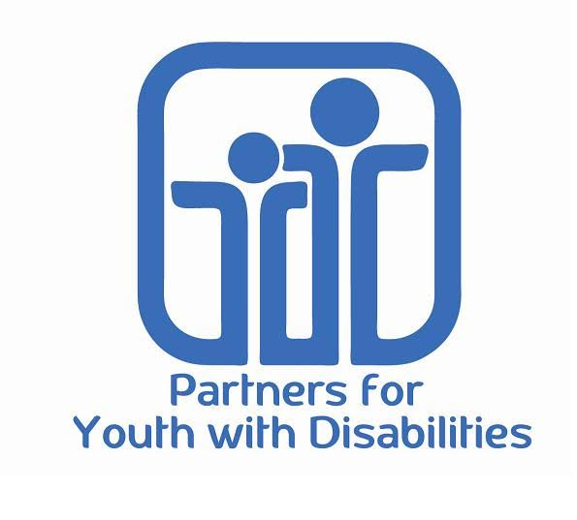**FOR IMMEDIATE RELEASE**

**Partners for Youth with Disabilities**

**95 Berkeley St., Ste. 109  
Boston, MA 02116**

**Contact:**

**Nicole Malo,**

**Development Manager**

**617-556-4075 x17**

**nmalo@pyd.org**

**Partners for Youth with Disabilities Receives a $12,500 Award from Rite Aid Foundation’s KidCents Program as Part of the “Big Hearts Give” Challenge**

*A check presentation ceremony will be held on Friday, February 19th, 2016*

BOSTON, Mass—Feb. 16, 2016—Partners for Youth with Disabilities(PYD), a leader in empowering youth with disabilities to reach their full potential for personal development, announced that it has been awarded a $12,500 grant from the Rite Aid Foundation’s KidCents program. Rite Aid will hold an award ceremony at a local Rite Aid Pharmacy in Boston.

To celebrate the one-year anniversary of KidCents, Rite Aid Foundation launched the “Big Hearts Give” Challenge to award participating charities with $5,000 to $20,000 in awards depending on the number of designations received. This incentive program ran from October 1st, 2015 through January 31st, 2016. In all, The Rite Aid Foundation’s KidCents program will donate a total of $1,597,500 to 182 KidCents charities.

Partners for Youth with Disabilities was excited to participate in the challenge and successfully reached 83 designations within several weeks from PYD supporters and Rite Aid customers to win a $12,500 award from Rite Aid Foundation. The award funds will support important PYD programs that motivate youth to reach their personal, educational, and career goals, and guide organizations in becoming more inclusive.

Nicole Malo, PYD’s Development Manager mentioned “it was phenomenal to see almost 100 people sign up. We were originally shooting for the $10,000 level award, but thanks to our supporters’ time and effort, we surpassed that goal to get to the next level. It’s a true testament to what we can do when we come together. We’re fortunate to be part of this caring community.”

Partners for Youth with Disabilities would like to invite you to the check presentation ceremony at a local Rite Aid store as part of Rite Aid’s nationwide celebration for this challenge during February and March.

* **11:00 a.m., Friday,** **February 19th, 2016**
* **Rite Aid Pharmacy located at 100 Cambridge Street in Boston (near Government Center)**

During the event, Rite Aid associates and store leadership will honor PYD with the award and thank them personally for their partnership. PYD staff members, leadership, participants and volunteers will be present to thank the Rite Aid Foundation for their generous support.

**About PYD**

Through Founder and Executive Director Regina Snowden’s vision, Partners for Youth with Disabilities has been helping young people with disabilities reach their personal, educational, and career goals through unique mentoring, creative arts, life skills development, and career-readiness programs for the past thirty years. PYD also has provided inclusion training and technical assistance to more than 100 organizations across the country to help them become more inclusive towards people living with disabilities.

**About KidCents**

The KidCents program, developed by the Rite Aid Foundation, provides Rite Aid customers an opportunity to give kids in need a chance for better lives and brighter futures. Through KidCents, members of Rite Aid's **wellness+ with Plenti** program can round up their in-store or online purchases to the nearest dollar and designate their change to one of more than 360 kid-focused nonprofit organizations that partner with KidCents.

######