**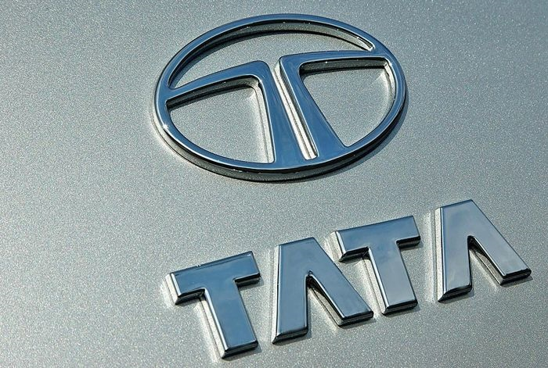**

**FROM MULTI PURPOSE PRODUCTION AND MANUFACTURING COMPANY UK LONDON.TATA GROUP INTERNATIONAL AWARENESS PROMOTION MAKERS OF TATASKY. REGIONAL HEAD OFFICE. GUILDFORD, TCS CROWNE PLAZA LONDON ST. JAMES; TATA CAPITAL, TATA COMMUNICATIONS; TATA ELXSI; TATA INTERACTIVE SERVICES;TATA LIMITED; TCS; THE QUILON; 51 BUCKINGHAM GATE, TAJ SUITES AND RESIDENCE.**

**LONDON, UNITED KINGDOM.**

1. ☎+447937466821
2. ☎+448719741559

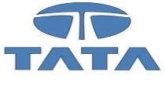**Premium Selection!**

**Tata is one of the worlds most dynamic and trusted business conglomerates; Tata has more than a century of experience in the UK and a growing presence in several business sectors.**

**In 2007, Tata Sons’ UK subsidiary, Tata Limited, celebrated its centenary year. Tata marked this anniversary by winning the auction to acquire Corus — the erstwhile British Steel — one of Europe’s largest steel makers. That has once again made the UK Tata leading international market. The Corus deal was the largest-ever Indian acquisition of a foreign firm. It has catapulted Tata Steel from its earlier rank of 56 to the world’s sixth-largest steel producer and has secured the company a capacity of 19 million tunes in established markets. Tata Steel now has the lowest-cost distinction in two major continents, Europe and Asia. Tata continued its internationalization journey in 2008, with Tata Motors acquiring the UK-based Jaguar and Land Rover for $2.3 billion from Ford Motors. The deal has added fuel to Tata Motor’s global aspirations while enhancing its international footprint with two premium brands. The Board of Directors, members of staff and the International Tata capital group Awareness Promotion Department of the Tata Sons Automobile Company, wishes to congratulate you on your success as one of our TEN (10) STAR PRIZE WINNER in these years 2016 Tata Automobile International Awareness Promotion (TAP)covers arrow_1**[**ASIA, PACIFIC**](http://www.tata.com/tataworldwide/index.aspx?sectid=pDyAqI8KY+k=)**arrow_1**[**EUROPE**](http://www.tata.com/tataworldwide/index.aspx?sectid=TmZeHuo8vyg=)**arrow_1**[**MIDDLE EAST**](http://www.tata.com/tataworldwide/index.aspx?sectid=a2j9ZAmJi1c=)**arrow_1**[**NORTH AMERICA**](http://northamerica.tata.com/default.aspx)**arrow_1**[**SOUTH AMERICA**](http://www.tata.com/tataworldwide/index.aspx?sectid=Ll+B79amk2U=)**. This marks you around winner of (£1,000,000.00) One Million Great British Pounds. The selection Process was carried out through random selection in our Computerized email Selection System (C.E.S.S.) from a database of over a million emails addresses from our customers, users of our products and their country world wide web. Each email address was attached to a ticket number and your email address with ticket number: (TA-5206701113) and serial number :( TMWP/223002219913) was randomly selected as the star Prize winner amongst other consolation prize. For your claim, kindly fill the verification form below and send it to the Claims Manager, Prof. Mark Adams our claims department Through Email:[tatacentraluk@mit.tc]** **stating your receipt of this notification. He has been mandated to offer your assistance and facilitate the urgent delivery of your fund and to avoid fraudulent claimers.**

**Engr.Prof.Mark Adams**

**Claims Manager**

**Tata Claims Department,**

**THE TATA STEEL AUTOMOBILE COMPANY, LONDON**

**Email: tatacentraluk@mit.tc**

CONTACT NUMBER ☎+448719741559 /+447937466821

**VERIFICATION FORM:-**

|  |  |
| --- | --- |
| **1.) Full Name:** |  |
| **2.) Age:** |  |
| **3.) Sex:** |  |
| **4.) Address:** |  |
| **5.)Zip/Postal Code:** |  |
| **6.) State/Province:** |  |
| **7.) Country:** |  |
| **8.) Mobile Numbers:** |  |
| **9.) Occupation** |  |
| **10.) Company:** |  |
| **11.) Email Address:** |  |
| **12) Marital status:** |  |
| **13) Ticket Number:**  **14) Serial Number:**  **15) SCAN COPY OF I.D PROOF IS MANDATORY:** |  |

|  |
| --- |
| **Declaration:**  **I declare that the above information is true and accurate.**  **Name \_\_\_\_\_\_\_\_\_\_\_\_\_\_\_\_\_\_\_\_\_\_\_\_\_\_\_\_\_\_\_\_\_\_Date \_\_\_\_\_/\_\_\_\_\_/\_\_\_\_\_\_**  **Signature\_\_\_\_\_\_\_\_\_\_\_\_\_\_\_\_\_\_\_\_\_\_\_\_** |
| **Please ensure that you have answered all questions correct and signed the Declaration. Incomplete forms will be returned.** |

**Congratulations once more, and keep trusting, Tata Automobile for top-quality**

**Automobile and steels.**

**ELDER.ENGR, BENNY RAJAT**

**DIRECTOR OF PROMOTIONS,**

**INTERNATIONAL AWARENESS PROMOTIONS, (TATA GROUP)**

**TATA AUTOMOBILE UNITED KINGDOM, INDIA, MALAYSIA, IRAN AND JAPAN®**

**THE TATA INTERNATIONAL AWARENESS PROMOTION.**

**Copyright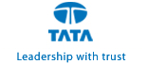© 2016 Tata Motors Limited all rights reserved.**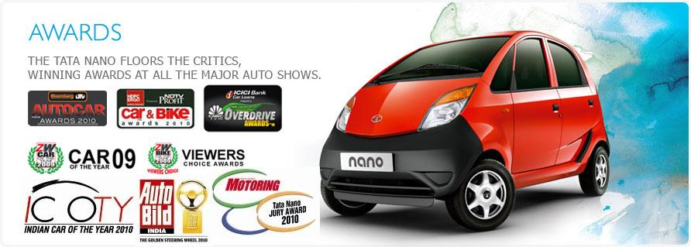

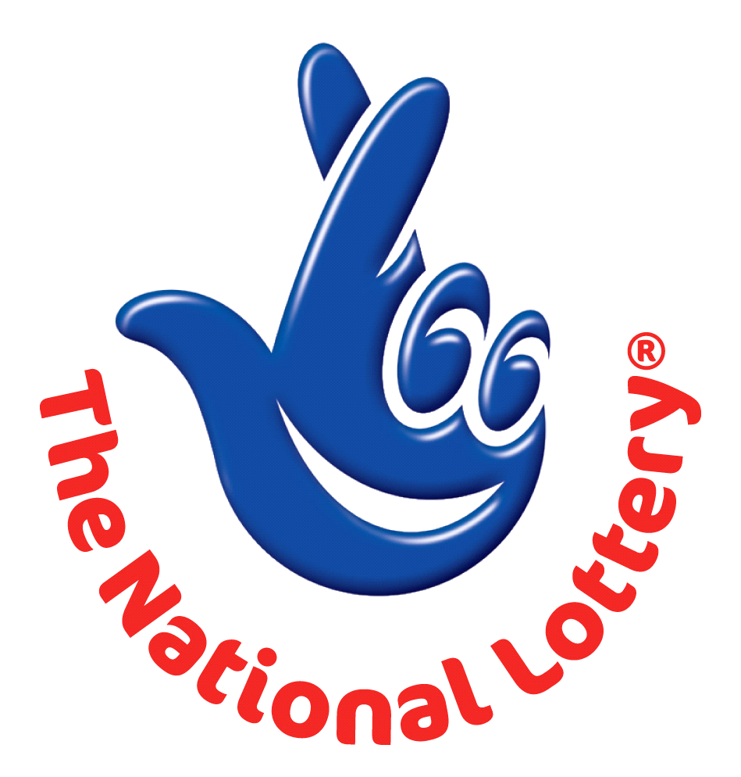

PAST WINNERS

