General Motors Fleet and Commercial

Remarketing

GENERAL MOTORS CORPORATION

2015 CALENDAR YEAR

DAILY RENTAL ACQUISITION PROGRAM TURN-IN STANDARDS AND PROCEDURES

**Design, Build, and Sell the World’s Best Vehicles!**

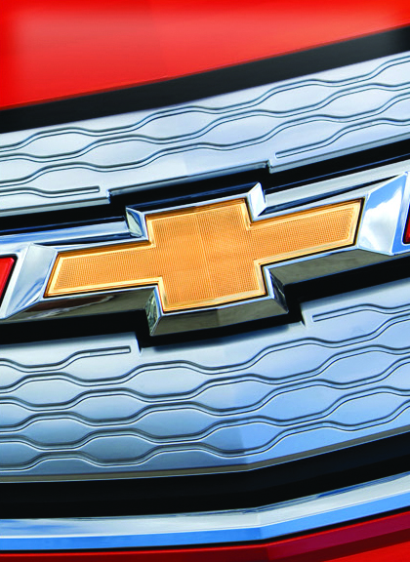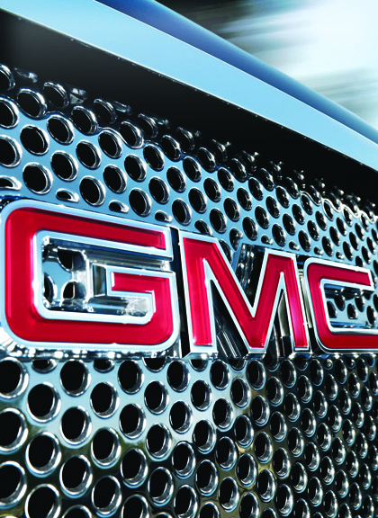

Table of Contents

**REMARKETING CONTACT INFORMATION**…………………………..…………………………………………………………………..3

**SECTION 1 – GENERAL CONDITION STANDARDS**4

* Vehicle Return Requirements4
* Title, Registration, Tax and VIN Plate6
* Vehicle Damage and Disclosure Requirements8
* Damage Allowance, Existing Damage and Previous Repairs10

**SECTION 2 – NORMAL WEAR AND TEAR AND CHARGEABLE DAMAGE**12

1. Glossary of Terms12
2. Sheet Metal and Paint13
3. Convertible Tops17
4. Front and Rear Bumpers18
5. Tires21
6. Wheels22
7. Interior Soft Trim and Carpets25
8. Vehicle Glass26

**SECTION 3 – ORIGINAL AND AFTERMARKET EQUIPMENT AND ACCESSORIES** 28

**SECTION 4 – MISSING EQUIPMENT PROGRAM (MET)**29

**SECTION 5 – VEHICLE INTEGRITY**30

**SECTION 6 – LITIGATION LIABILITY**32

**SECTION 7 – GENERAL TURN-IN PROCEDURES**33

1. Forecast33
2. Delivery34
3. Inspection at Turn-in35
4. Vehicle Reports and Reviews36
5. Acceptance / Stop Depreciation37
6. Rejects38
7. Miscellaneous39

**EXHIBIT A – VEHICLE CATEGORIES / PRIOR REPAIR LIMITS** 41

**EXHIBIT B – APPROVED TURN-BACK LOCATIONS**42

**EXHIBIT C – MET TABLE**48

**General Motors Corporation**

**Fleet and Commercial Operations**

**Remarketing Contact Information**

|  |  |  |  |
| --- | --- | --- | --- |
| **Contact** | **Office Number** | **Cell Number** | **e-Mail Address** |
| John A. Pruse  Manager, GM Remarketing | 313 665-1438 | 313 378-5335 | john.pruse@gm.com |
| Sandy Grinsell,  Remarketing Account Mgr.,  All Rental Accounts | 313 667-6437 | 313-348-1973 | sandy.grinsell@gm.com |
| Thomas Martin  Remarketing Account Mgr.,  Online Sales, Remarketing System Tables and Rental Return Guidelines | 313 667-6434 | 313 378-1230 | thomas.martin@gm.com |
| Audre’ Walls  Remarketing Account Mgr.,  Turn-back Locations & Inspections | 313 667-6444 | 313 378-4366 | audre.walls@gm.com |

**SECTION 1 - GENERAL CONDITION STANDARDS**

1. **Vehicle Return Requirements**
   1. Vehicles must be maintained as described in the Vehicle Owner’s Manual. **All body and mechanical repairs must utilize original equipment General Motors parts.** Failure to comply may result in permanent rejection of the vehicle.
      1. The repair/replacement of an engine or transmission that is due to non-compliance of vehicle maintenance will render the vehicle “Permanently Ineligible”.
   2. Each vehicle shall be in sound mechanical and electrical operating condition. All lights and lamps must be operational. Any visible warning lights, i.e., check engine, change oil, SIR, TPS, etc., on the instrument panel must be corrected prior to turn-in or the vehicle will be “Currently Ineligible”.
   3. A vehicle must comply with all aspects of the applicable program parameters or it is not eligible for return.
   4. Vehicle(s) must be returned washed and vacuumed. General Motors’ expectation of a vehicle’s condition, when returned by the rental company, is that it will be in the same condition as it is when provided to a rental customer.
      1. A dirty interior MET charge of $35 will be assessed when the interior of the vehicle is littered with trash. Excessive or offensive trash in the vehicle, such as cups, bottles, newspapers, food, bags, roadmaps, etc., that would hinder interior inspection would generate the dirty interior MET charge.
      2. Vehicles with an exterior that is too dirty to inspect will be gate released to the rental account for washing. When the vehicle is returned and inspected, a $75 re-inspection fee will be charged unless special arrangements have been made.
   5. Vehicles must have a minimum of ¼ tank of fuel with the exception of Hawaii vehicles, which cannot exceed ¼ tank of fuel. Vehicles with less than ¼ tank of fuel but more than 1/8 will be assessed a MET charge of $15. Vehicles below 1/8 tank of fuel will be deemed “Currently Ineligible” and released to the rental account for low fuel. When the vehicle is returned, a $75 re-inspection fee will be charged.
   6. Emissions labels must be in place and legible on all vehicles returned to General Motors. Vehicles without an emission label are considered “Currently Ineligible” and will be gate released to the rental account. A $75 re-inspection fee will be charged when the vehicle is corrected and returned.
   7. Vehicles must have two (2) sets of keys, programmed keyless remotes, owner manuals, floor mats, and all other remotes and headphones, included as original equipment.
   8. Vehicles must display actual mileage. General Motors approved procedures must be followed when repairing or replacing instrument clusters/odometers. Consult a General Motors dealer for proper replacement.
   9. All warranty and campaign claims should be completed prior to returning the vehicle to General Motors. Failure to complete warranty and/or campaign claims may render the vehicle “Currently Ineligible”. Parts availability concerns for warranty and campaign repairs will be addressed on a case by case basis.A $75 re-inspection fee will be charged when the vehicle is returned. Repair of existing body damage is not required for vehicles released for warranty, mechanical or campaign repairs.
   10. Any vehicle equipped with supplemental inflatable restraints (S.I.R.) including driver, passenger or side airbags that have been deployed, missing or otherwise disconnected, must be replaced with an approved OEM replacement and must meet General Motors standards prior to turn-in.
2. **Title, Registration, Tax, and VIN Plate**
   1. A vehicle submitted with a Certificate of Origin (C.O.V.) or a branded title is not eligible for return.
   2. All vehicles must have a valid and current registration, at the time of acceptance. State and local taxes must be paid prior to turn-back. The Daily Rental Company must comply with state regulations pertaining to proof of payment for state and local taxes.
   3. Titles for all turn-in vehicles must be received by a General Motors approved Title Center within three (3) business days of vehicle turn-in. The vehicle turn-in date is considered the first day. Currently, the only General Motors approved title center is the SGS Title Center.

SGS Title Center

9805-L Northcross Center Court

Huntersville, NC 28078

Phone: 704 997-1082

FAX: 704 997-1090

* 1. All title shipments to the title center must contain a packing list and include the following information:

Company Name and Address

Contact Name and Phone Number

E-mail Address and Fax Number

Full VIN for each title in the package

When sending more than ten titles, e-mail an Excel spreadsheet listing the VIN number of each title enclosed to: [Christina.Campbell@SGS.com](mailto:Christina.Campbell@SGS.com). From that list, the title center will “pre-receive” the titles electronically, verify the titles upon actual receipt, provide documented confirmation, and advise of any discrepancies.

* 1. The Daily Rental Company must remove each vehicle at an auction or turn-in site, if the title for such vehicle is not received within 30 days of the turn-in date. The vehicle will be “Currently Ineligible” and will be assessed a re-inspection fee, if it is returned.
  2. The plate containing the Vehicle Identification Number (VIN):
     1. Must be completely readable and properly attached to the dash panel. Any obstruction causing a portion of the plate to be covered is not acceptable.
     2. Cannot be damaged in any manner and must be flush and secure with rivets intact.
     3. Must meet these criteria otherwise the vehicle will be “Permanently Ineligible” and returned to the rental account.

1. **Vehicle Damage and Disclosure Requirements**
   1. The General Motors Disclosure Policy mandates that all prior damage and repairs are electronically disclosed prior to turn back, excluding warranty repairs performed by the Daily Rental Company or a General Motors dealer.
      1. Completion of the electronic disclosure requires a User ID and password to access the Remarketing Inventory Management System (RIMS). Contact the Remarketing Account Manager assigned to your account shown on page three. The User ID, password, web address and instructions will be sent via e-mail within 24 hours of request.
      2. The electronic disclosure box must be checked (Yes or No) confirming or denying previous damage. Failure to disclose previous damage at turn-in will be grounds for rejecting the vehicle.
      3. Collision damage must be disclosed and supported by repair orders. Repair orders must accurately reflect all work performed and include all associated repair costs. The inspection provider, on General Motors behalf, will request a repair order when:
         1. Previous repaired damage noted during the inspection does not agree with the disclosure
         2. The dollar amount disclosed appears too high or low based on the visual inspection. There is no arbitrary rule or guideline, such as any damage over $XXX amount or damage to X number of body panels, used as a basis for requesting a repair order.
         3. The disclosed damage areas and the disclosed repair amount appear significantly out of line.
         4. Upon request, repair orders must be received by the inspection provider within two business days of the request to maintain the original turn-in date. Repair orders that are not received by the inspection provider within seven business days will cause the vehicle to be “Currently Ineligible” and gate released from the yard until the repair order is available. A $75 re-inspection fee will be charged, if the vehicle is returned and the repair order provided.
2. **Damage Allowance, Existing Damage and Previous Repairs**
   1. General Motors will absorb the cost of repairs on vehicles returned with $450 or less existing damage.
      1. General Motors will charge the Daily Rental Company for current damage in excess of the $450 damage allowance plus a service fee.
      2. Missing equipment will not be included as part of the chargeable damage allowance, but will be charged per the Missing Equipment Program (refer to Section 4 for MET).
      3. The service fee will be applied as follows:

|  |  |
| --- | --- |
| **Amount in Excess of $450** | **Service Fee** |
| $0 to $99.99 | Equal to amount over $450 |
| $100 to $1,099.99 | $100 |
| $1,100 to $1,549.99 | $200 |

* 1. Vehicles with existing damage exceeding $2,000 are “Currently Ineligible” for return.
  2. Prior repairs cannot exceed $2,500 for Category 1 vehicles, $3,000 for Category 2 vehicles, $3,500 for Category 3 vehicles, and $4,500 for Category 4 vehicles. These amounts exclude costs related to vehicle glass, tires, wheels, wheel covers, SIR system components, “Loss of Use”, **sales tax** and towing charges. Vehicles exceeding these maximums are not eligible for turn-in. See Exhibit A – Vehicle Categories/Prior Repair Limits.
  3. Vehicles with “Poor Prior Repairs” of $700 or less will be accepted. The estimated poor prior repair cost will be charged to the Daily Rental Company under the MET program. Vehicles with poor prior repairs exceeding $700 will be considered “Currently Ineligible” and released to the Daily Rental Company.
  4. Vehicles identified as “Currently Ineligible” due to mechanical, warranty/campaign, unacceptable glass, or un-matched tires, etc., will be gate released for repairs to these conditions only, and can be returned for acceptance consideration.
  5. When returned, if the vehicle has had partial repairs on any chargeable damage identified when it was originally inspected, including poor prior repairs, the entire vehicle must be repaired to no more than $100 in chargeable damage. A $75 re-inspection fee will apply.

**SECTION 2 - NORMAL WEAR AND TEAR AND CHARGEABLE DAMAGE**

Listed below is the nomenclature commonly used to describe types of damage on inspection reports.

1. **Glossary of Terms “General Description”**
2. Abrasion – A lightly scratched or worn area of the finish either paint, clear coat, or chrome that does not penetrate to the base material of the part or panel.
3. Chip – Confined area where paint has been removed from the surface usually not larger than 1/4 inch for purposes of these return guidelines.
4. Dent – a depression of any size in the panel material whether metal, composite, or other, with or without paint damage.
5. Ding – A small dent, an inch or less in diameter, with or without paint damage.
6. Gouge – An area where the damage has penetrated the finish and removed a portion of the base material of the part or panel.
7. Scratch – A cut in the surface of any material that may or may not penetrate the finish.
8. Scuff – A worn or rough spot that is deep enough to disturb the base material of the part or panel but does not remove any base material.
9. **Sheet Metal and Paint**

The following are acceptable return conditions and applicable charges.

1. Maximum of two dents per panel that are individually no larger than one inch in diameter, does not break the paint, and qualifies for Paintless Dent Removal (PDR) are non-chargeable.
2. Scratches in the clear coat that do not penetrate the color coat and do not catch a finger nail are non-chargeable.
3. Chips to door, hood or deck lid edges that do not reach flat panel surfaces are non-chargeable.
4. An appearance fee and PDR may be used on the same panel.
5. One dent that qualifies for PDR that contains one chip inside the dent would be charged $50 for the PDR and a $20 appearance fee for the chip, totaling $70. The chip must be no larger than one-quarter(1/4) inch in diameterand cannot exhibit any spider cracks around the chip.
6. Chipped and scratched panels:
   * 1. All panels except hoods:
        1. One to three chips individually no larger than one-quarter (1/4) inch in diameter are non-chargeable.
        2. Four to six chips per panel will be charged a $20 appearance fee.
        3. Over six chips per panel will require a minimum of a panel refinish.
     2. Hood panels:
        1. The chart below shows acceptable return conditions and applicable charges for hood damage. Scratches that individually do not exceed ¼ inch in length may be used in any combination with chips but not to exceed the quantities shown in the chart.

|  |  |  |
| --- | --- | --- |
| **HOOD – LEADING EDGE, FIRST 5”** | **HOOD – ALL BUT LEADING EDGE** | **CHARGES** |
| Maximum of 6 chips / scratches | Maximum of 3 chips / scratches | Non-chargeable |
| Maximum of 10 chips / scratches | Maximum of 6 chips / scratches | $40 Appearance fee |
| Greater than 10 chips / scratches | Greater than 6 chips / scratches | Hood panel refinish |

* 1. Vehicles with damage confined to either the upper or lower half of a panel may qualify for a partial panel repair.
     1. A partial panel repair can only be considered when there is a clean break between the upper and lower portion of the panel.
     2. A clean break is defined as a body side molding, cladding, etc., that runs from one end of the panel to the other with no gaps at either end.
     3. Body lines are not a clean break and partial panel repair does not apply.
  2. The floor of a pick-up truck box is considered one panel. Two dents in the truck box no larger than one inch that do not break the paint are non-chargeable. One dent to the wheelhouse no larger than one inch that does not break the paint is non-chargeable. PDR cannot be used on the floor or wheelhouse of a pick-up truck.
  3. Paintless Dent Repair - General Motors’ inspection providers will utilize the Dent Wizard Paintless Dent Removal Guide to determine panel accessibility by vehicle. Below are PDR conditions, limitations, and applicable charges:
     1. Conditions
        1. Rounded dents up to four inches in diameter
        2. Minor creases, shallow palm prints and protrusions are allowed
        3. Dents across body feature lines are allowed
        4. PDR may be used to repair existing qualifying damage to a previously repaired panel that meets GM and industry repair standards
     2. Limitations
        1. No PDR on poor previous repairs.
        2. No PDR utilizing hole drilling.
        3. No PDR where the paint is broken unless chip/PDR applies.
        4. No PDR to sharp creases or creases over six inches.
     3. Applicable Charges
        1. Up to seven dings per panel will be charged $50 per panel.
        2. Eight to 12 dings per panel will be charged $75 per panel.
        3. Thirteen to 15 dings per panel will be charged $100 per panel.
        4. One single dent up to six inches in diameter or one large shallow dent up to 18 inches in the hood, roof or deck lid will be charged $100.

**Hail Damage Guideline**

**Acceptable Units:**

1. Vehicles with less than $2,000 in repaired or unrepaired hail damage *.
2. Hail damage must be repaired using PDR as defined by the Dent Wizard PDR Guide.

**Ineligible Vehicles:**

1. Vehicles with over $2,000 in repaired or unrepaired hail damage
2. Vehicles showing evidence of Paintless Dent Repair that used hole-drilling techniques

* Vehicles with repaired or unrepaired hail damage of less than $2,000 must provide a repair order or estimate detailing the damage and repair cost. The only approved PDR providers for these repair orders / estimates are either Dent Wizard or Dent Demon. If Dent Wizard or Dent Demon are not available contact your General Motors Remarketing Representative for approval of the selected PDR provider.

1. **Convertible Tops**

The following are acceptable return conditions with regard to convertible tops:

* 1. Stains that can be removed by normal reconditioning
  2. Abrasions that are not visually offensive
  3. Top structure must be operational and not damaged

1. **Front and Rear Bumpers**
   1. Bumpers will be inspected from a standing position. The chart below shows acceptable return conditions and applicable charges for painted and textured bumpers. Scratches that individually do not exceed ¼ inch in length may be used in any combination with chips but not to exceed the quantities shown in the chart.

|  |  |
| --- | --- |
| **FRONT OR REAR BUMPER FASCIA** | **CHARGES** |
| Maximum of two dents, no larger than one inch that do not break the paint | Non-chargeable |
| Maximum of two scratches per bumper no longer than 2” and no wider than ¼” or one scratch no longer than 4” and no wider than ¼” | Non-chargeable |
| Minor indentations in the rear bumper cover directly below the trunk opening, with minimal paint damage | Non-chargeable |
| **BUMPER COVERS WITH NO OTHER DAMAGE** | |
| Maximum of 6 chips / scratches | Non-chargeable |
| 7 – 15 chips / scratches | $20 Appearance fee |
| Greater than 15 chips / scratches | Minimum partial bumper repair |

* + 1. Partial bumper repairs to painted or textured surfaces are charged based upon the following criteria:
    2. A partial bumper repair can be performed on a rolling third or 33% of the bumper. The damage can be anywhere on the bumper as long as it is confined to an area equal to a continuous third of the bumper’s length.
    3. Partial bumper repairs cannot be used for vehicles utilizing paints commonly referred to as pearl or tri-color due to color matching concerns.
    4. The $20 appearance fee may be used on bumpers in conjunction with a partial bumper repair if the damage is located on different areas of the bumper. For example, when there is damage to the center of the bumper and a minor chip on the left end of the bumper, the partial bumper repair charge and appearance fee would apply eliminating the need for a full refinish.
    5. A cracked or punctured bumper fascia will be charged a minimum partial bumper repair fee of $125 for painted bumpers and $175 for textured bumpers using the criteria below:
       1. Crack must be less than four inches in total. Puncture must not exceed the diameter of a U.S. quarter.
       2. A maximum of two dents, individually not exceeding two inches in diameter and confined to 1/3 of the bumper area.
    6. Bumpers that are both painted and textured or two toned will be treated as separate bumpers and charged for each panel using the guidelines above.
  1. Mis-aligned front and/or rear bumper fascia from low impact collision is acceptable for $50 per bumper re-attachment fee. This charge covers the cost of re-attaching fasteners, aligning the bumper, and applies when no other damage is present. This charge cannot be used for poor previous bumper repair.
  2. Damage on the underside of the bumper observed during the undercarriage inspection, other than breakage, will not be chargeable. Cracked or broken bumpers, regardless of location will remain a chargeable repair or replacement.
  3. License plate screw holes in the front bumper cover used to attach the license plate to the bumper, without the proper bracket, will be charged a minimum $125 partial bumper repair.
  4. Metal Bumpers - Painted or Chrome:
     1. A maximum of two scratches or chips per bumper that are no longer than two inches and no wider than ¼ inch or one scratch no longer than four inches and no wider than ¼ inch that penetrates the color coat but would not require filler, are acceptable at no charge.
     2. A maximum of two dents that are individually no larger than one inch in diameter and do not damage the paint or chrome will be charged $100.
     3. Damage exceeding the above criteria or bumpers with chrome plating missing will result in a bumper replacement charge.

1. **Tires**

The following are acceptable conditions regarding all tires including full size spare tires which must meet the same inspection criteria as a road tire:

* 1. All tires must have 4/32 inch or better original tread across all primary tread grooves without any exposed belts. All tires must match by size, brand, tire line and load and speed rating.
  2. Only GM approved replacement tires are acceptable. GM Approved 2015 Replacement Tire Table is sent as a separate document. If the replacement tire cannot be located, a replacement from an approved manufacturer may be used, however, all tires must match by size, brand, tire line and load and speed rating.
  3. Tires with mushroom-type plugs, installed from the inside out, in the tread only, are acceptable. All other plugs and/or patches are unacceptable.
  4. The space saver spare tire used on most General Motors’ vehicles does not utilize the same criteria as the road tires. The space saver spare must be in the vehicle, inflated, and undamaged. The minimum 4/32 inch tread depth requirement does not apply.
  5. General Motors reserves the right to charge the Daily Rental Company via the MET Tire Program for an unacceptable repaired tire, with no right to review. Any flat, un-matched or incorrect tires will not be considered for the MET Tire Program.

1. **Wheels**

The following are acceptable conditions for aluminum/alloy wheels, stamped and steel wheels with appropriate charges:

* 1. Non-chargeable conditions
     1. The face of the wheel may have light scratches or scuffs to the surface not penetrating through to the base material.
     2. Light scratches or scuffs within one inch of the outside edge of the wheel are acceptable provided they do not, in total, exceed one-third of the circumference of the wheel and can be removed with light sanding.
  2. Chargeable conditions
     1. Scratches, scuffs or gouges that remove material or distort the surface of the wheel may be repaired for $100.
  3. Wheel Replacement
     1. Damage to the base material that exceeds conditions identified above and are not repairable will be charged for a replacement using the Mitchell Manual.
     2. Bent, cracked, or dented wheels are not repairable and must be charged for a replacement.
  4. **Chrome Clad Wheels**
     1. **A flat rate MET charge of $75 per wheel for chrome clad wheels that exhibit damage in excess of the non-chargeable conditions defined in the guidelines, where the damage is up to 50% on the wheel surface/ outer rim.**

**If the existing damage area is greater than 50% of the wheel surface /outer rim, the wheel replacement cost will be charged. This includes bent, cracked or dented wheels, deemed non-repairable as is the current guideline.**

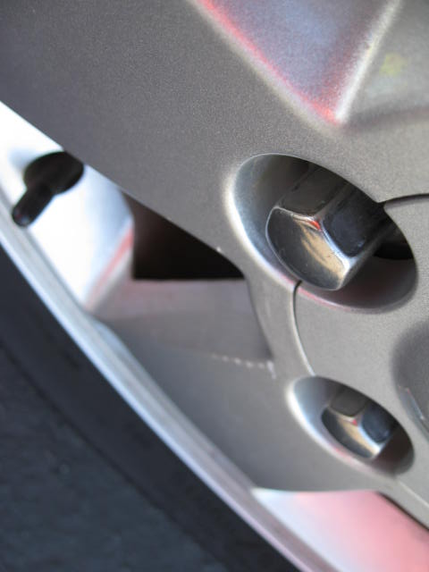

Minor scuffing non-chargeable

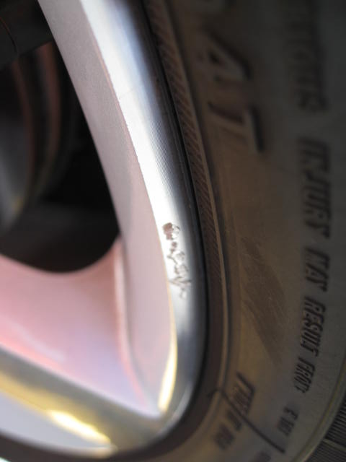

Non-chargeable wheel damage is defined as light scratches or scuffing that does not go through the paint or clear coat to the base material and may be removed with light sanding. This minor damage may cover up to 1/3 of the wheels circumference.

A $100 wheel repair will be charged for similar damage as shown in the two photos below. This form of damage is commonly referred to as “curb rash”. This amount will be charged against the $450 deductible.

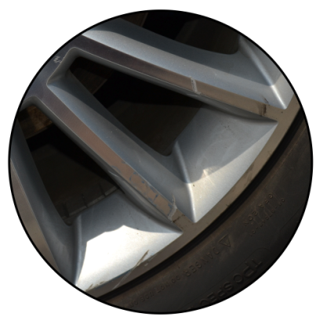 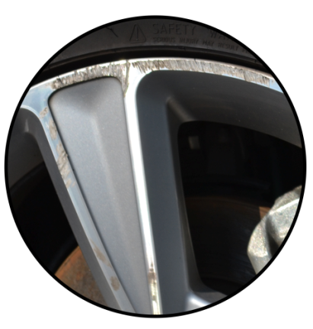

Missing material similar to or greater than this photo will require a wheel replacement charge priced from the current Mitchell Manual.

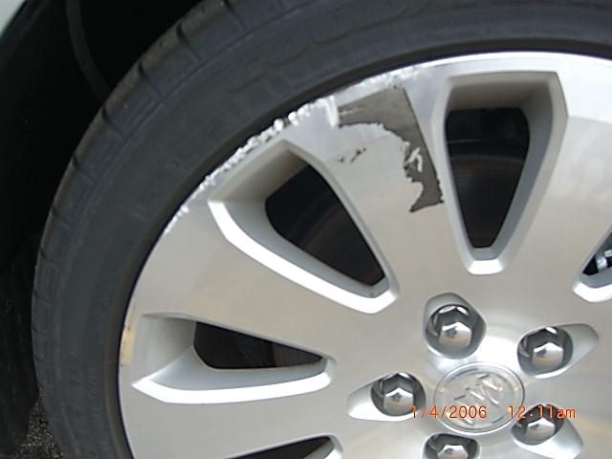 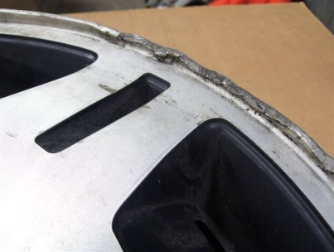

Bent, cracked or dented wheels are not repairable and must be charged for a replacement from the current Mitchell Manual.

**Alloy Wheel Repair Specialists (AWRS) is the only current General Motors approved wheel repair service. They can be contacted at 800-518-3040.**

1. **Interior Soft Trim and Carpets**
   1. All stains which can be removed by normal reconditioning are non-chargeable.
   2. Maximum of one burn that is less than ¼ inch in diameter and does not penetrate the backing material is non-chargeable.
   3. Interior Soft Trim:
      1. Leather or vinyl - tears or cuts less than two inches $100; two to four inches $125.
      2. Plain cloth, no pattern – tears or cuts less than two inches $70; two to four inches $90.
      3. The above repairs cannot be utilized if the damage crosses a seam in the material.
      4. Damage exceeding the above criteria will require a trim part replacement.
   4. Carpets:
      1. Carpet stains that require bleaching and dying will be charged $65 per section, i.e., right front, left front, etc.
      2. Carpet tear or puncture less than ¾ inch in diameter $50.
      3. Carpet tear or puncture ¾ inch to two inches in diameter $125.
      4. Damage exceeding the above criteria will require carpet replacement.
      5. Carpet retainers and sill plates must be in place. Minor surface scuffs and scratches are acceptable.
2. **Vehicle Glass**
   1. Side, Rear, and Stationary Glass
      1. Minor pinpoint chips or vertical scratches in the side door glass is acceptable and will be noted as non-chargeable.
      2. Minor pinpoint chips to any stationary or rear glass is acceptable and will be noted as non-chargeable.
      3. Any damage in excess of the above will render the vehicle “Currently Ineligible” and the vehicle will be gate-released to the rental account for correction.
      4. Side, rear, or stationery glass is not eligible for replacement under the MET Program.
   2. Windshields
      1. Pinpoint chips are non-chargeable providing the glass is not sandblasted. Sandblasted glass is defined as a series of pinpoint chips in a concentrated area.
      2. Four chips, without legs, from 1/8 inch to 3/16 inch are non-chargeable providing no more than two chips reside in the driver’s side wiper area.
      3. Chips without legs 1/8 inch or less located within one inch inbound from the frit band (windshield outer perimeter darkened area) are non-chargeable.
      4. General Motors will not accept glass that has been repaired. Only OEM glass is acceptable (See table below for GM Windshield Glass Manufacturers).
      5. Damaged windshields may be replaced under the MET program.

**GM WINDSHIELD GLASS MANUFACTURERS**

|  |  |  |  |  |  |
| --- | --- | --- | --- | --- | --- |
| **Manufacturers** | **Brand** | **Brand** | **Brand** | **Brand** | **Brand** |
| AGC | AP Tech | AP Technoglass | Asahi of America | Asahi | AP |
| Carlex |  |  |  |  |  |
| Pilkington | LOF | United LN |  |  |  |
| PPG | PGW |  |  |  |  |
| Guardian |  |  |  |  |  |
| Fuyao |  |  |  |  |  |
| Vitro | Crinamex | Autotemplex | Vitroflex |  |  |
| Saint Gobian Sekurit | Sekurit |  |  |  |  |

**SECTION 3 - ORIGINAL EQUIPMENT, AFTERMARKET EQUIPMENT AND ACCESSORIES**

1. All original equipment and accessories noted on the factory invoice must be on the vehicle. All missing parts (such as body side moldings, wheel covers, trunk mat, spare tire, rear van seats, jack and wheel wrench) are to be replaced prior to return with original GM equipment. All OEM options and accessories must be installed on the vehicle prior to being placed in daily rental service.
2. Any after-market parts or accessories such as navigational systems, pick-up truck bed liners, running boards, etc., installed by the rental account or their agent must have GM Remarketing approval prior to installation. Drilling, electrical modifications, etc., without prior approval will render the vehicle “Permanently Ineligible”. Pick-up truck bed liners, running boards, etc., must be left on the vehicle at turn back.

**SECTION 4 - MISSING EQUIPMENT PROGRAM (MET)**

1. The Missing Equipment Program (MET) is designed to expedite turn-in by allowing the Daily Rental Company to pay for select missing parts or accessories as determined by GM Remarketing (refer to Exhibit C), as opposed to replacing the parts or accessories. Missing MET items will be deducted from the repurchase payment to the Daily Rental Company. Missing MET items will not be included as part of the $450 chargeable damage allowance (Refer to General Condition Standards – Section 4).
2. A MET charge will be assessed for vehicles turned in with one or more missing floor mats, on vehicles so equipped. The Rental Account will be charged for a front or rear set of floor mats if one is missing. Floor mats are required per the Minimum Equipment Requirements.
3. Keyless remotes, key fobs, and combo keys must be operational. A $30 re-programming fee will be charged for key fobs that do not operate the vehicle. The re-programming fee is included in the MET charge for missing key fobs and combo keys.

**SECTION 5 - VEHICLE INTEGRITY**

1. Damage which compromises the integrity of the vehicle, repaired or not, will be grounds for permanently rejecting the vehicle. Any undercarriage damage resulting from improper tie-down of the vehicle will result in permanent rejection. Minor damage that has not been repaired (i.e., small dents, scrapes, or scratches) which does not compromise the structural integrity of the vehicle is acceptable on the following components:
   * 1. Floor Panel and Trunk Floor
     2. Mid-rail Assembly – no bulging or deformity of side rails; enlarged (not torn) stamped holes and surface scratches less than 12 inches are acceptable
     3. Outer Rocker Panels and Pinch Welds
     4. Frame Rails and Rail Extensions
     5. Sub-Frame Assemblies (Engine Cradles
     6. Torque Box Cover – non-collision related
2. Total time for frame set-up and measure of 2.0 hours or less and 1.5 hours or less for any cosmetic repair is acceptable on the following components, provided there is no structural damage and the repairs meet GM standards:
   * 1. Frame rail and rail extensions
     2. Apron and upper reinforcements
     3. Cowl panel
     4. Hinge and Windshield “A” pillar
     5. Center “B” pillar
3. Pulling or sectioning frame rails, door frames, and pillars are not acceptable. Repairs that utilize body filler or Bondo will, in most cases, cause the vehicle to be permanently rejected.
4. Repaired damage or replacement of the following components is acceptable:
   * 1. Radiator core support
     2. Frame rail extensions
     3. Engine sub-frame (replacements only)
     4. Outer rocker panel
     5. Rear body panel
     6. Quarter panel (proper sectioning is acceptable)
     7. Roof (repair only, no repair to roof rails)
5. Vehicles with misaligned doors are considered “Currently Ineligible” due to the difficulty in determining the cause of the misalignment.

**SECTION 6 - LITIGATION LIABILITY**

1. At General Motors’ discretion, the Daily Rental Company may be named in any litigation brought against General Motors as a result of the rental company’s failure to disclose damages or use of non-GM OEM parts. If a Daily Rental Company attempts to return vehicles with non-disclosed damage or purposely conceals prior repairs, it will result in loss of turn-back privileges.

**SECTION 7 - GENERAL TURN-IN PROCEDURES**

1. **Forecast**
   * 1. Daily Rental Company must notify GM in writing at least 30 days prior to vehicle turn-in, of the turn-in location and the return volumes.
     2. Daily Rental Company must provide the turn-in location with a two week forecast of daily return volumes every week.
     3. GM on occasion may limit daily return volumes based upon yard capacities.
     4. Forecast should be sent via e-mail to the respective General Motors account representative. Contact information including E-mail addresses can be found on page three. Failure to provide forecast, may result in delayed acceptance of vehicles.
2. **Delivery**
   1. Vehicles returned for repurchase shall be delivered to a General Motors approved turn-in location and parked in the designated return area at no expense to General Motors. A list of GM approved locations is attached and is subject to change at General Motors’ discretion (Exhibit B). Normal operating hours for delivery is 8 am to 5 pm, Monday through Friday. The Daily Rental Company should allow sufficient time to prepare the vehicle for turn-in including:
      1. Inspect and prep vehicle according to GM Return Guidelines, i.e., clean, vacuum, repair or replace items, as needed
      2. Miscellaneous M.E.T. items should be visible on the front seat
      3. Mark vehicle as a rental repurchase unit
      4. Provide electronic damage/repair disclosure
      5. Submit a clear title to an approved Title Center (prior to returning vehicle recommended)
      6. Transport vehicle to nearest GM approved turn-back location
      7. Upon arrival at turn-back location, obtain directions to the inspection area
      8. Park vehicle and leave unlocked
3. **Inspection at Turn-In**
   1. Vehicles will be inspected by an authorized representative of GM, using an electronic Condition Report. The initial vehicle inspection will be provided to the Daily Rental Company at General Motor’s expense.
   2. The Daily Rental Company will be charged $75 for each inspection or verification required after the initial inspection. The $75 re-inspection fee will be charged when a vehicle has been previously inspected and removed by the Daily Rental Company prior to acceptance, or when the Daily Rental Company replaces MET items.
   3. Hawaii vehicles will be charged $115 for each inspection required after the initial inspection.
4. **Vehicle Reports and Reviews**
   1. Vehicle Condition Reports, Missing Title Reports, Met/non-Met Reports, and Gate-Release reports are available daily through the General Motors Vehicle Inspection Website (VIW). Rental Accounts can access this data using an assigned I.D. and password that can be obtained by contacting the GM Rental Support Representative.
   2. Rental Accounts are provided a Met/Non-Met report by the inspection provider detailing vehicles that have been inspected and are available for review. The report is printed twice daily, mid-day and closing. The report printed at the end of the day will contain information on only those vehicles completed after the mid-day report was printed.
   3. Vehicle worksheets are printed and available to the rental accounts throughout the day.
   4. Reviews are conducted throughout the day. Reviews must be completed prior to 3:00 pm the day following printing of the worksheet. If the review is not completed prior to 3:00 pm, the vehicle will be processed as shown on the original inspection.
   5. Vehicles with current damage under $450 and MET charges under $100 will be processed as written, with no right to review. Programming of key fobs is not included in the $100 total and is not a reviewable MET charge.
5. **Acceptance / Stop Depreciation**
   * 1. Depreciation stops and the vehicle will be accepted once it has passed inspection, a lien-free title has been provided, and all program requirements have been satisfied.
     2. A copy of the condition report or an electronic file will serve as the acceptance receipt for the Daily Rental Company. The date used to stop depreciation will be identified on the acceptance line of the condition report or the electronic file.
6. **Rejects**
   * 1. Rejected or ineligible vehicles must be removed from return locations within three business days of notification. Failure to remove these vehicles may delay the processing of any additional returns until the rejects have been resolved.
     2. Vehicles that are classified as permanent rejects by the inspection provider will be assessed a $75 service charge. General Motors Remarketing will provide a quarterly invoice which will include the VIN, turn back location, and turn-in date. Payment is expected within 14 days.
     3. It is General Motors’ practice to ship vehicles once they pass the inspection process, with or without acceptance. On rare occasions, the title arrives late and the vehicle exceeds the maximum allowable in-service time. When this occurs, these vehicles will be rejected and all charges incurred by the auction, including shipping cost, will be charged to the Daily Rental Account and must be paid prior to release of the vehicle.
     4. If disqualifying damage is noted after vehicle acceptance, General Motors will invoice the Daily Rental Company for the vehicle purchase price, an administrative fee of $250, plus any additional costs incurred following vehicle acceptance (i.e., freight, cleanup, repairs), by a debit to current funds, or if no funds are available, a check forwarded to:

General Motors Corporation

Fleet and Commercial Operations – Remarketing

Renaissance Center

Tower 100, 19th Floor

MC 482-A19-B36

Detroit, MI 48265-1000

* + 1. Vehicles removed from the program are the responsibility of the Daily Rental Company. The Daily Rental Company must arrange vehicle pick-up at the location designated by General Motors.

1. **Miscellaneous** 
   * 1. Rental Account request for return of vehicle:
     2. Prior to acceptance
        1. Vehicle will be temporarily rejected by General Motors and the vehicle will be returned to the rental account. If the vehicle is returned at a later date, a $75 re-inspection fee will be charged.
     3. After acceptance
        1. Payment can be stopped – The vehicle will be released to the rental account from its current location. A $250 administrative fee will be charged to the rental account in addition to **any** expenses incurred by GM including inspection cost, shipping, marshaling yard fee, and auction expenses.
        2. Payment cannot be stopped or funds have already been disbursed – The vehicle will not be returned to the rental account.
   1. Mechanical and body shop labor rates used to calculate chargeable damage are shown below and are subject to change:
      1. $40.00 Paint and Metal Repair
      2. $40.00 Part Replacement or Mechanical
   2. Auction and Marshaling Yard Property
      1. Any abuse of personnel or property at a GM approved return facility by a Daily Rental Company representative will result in the immediate expulsion of said person from the property.
   3. Holidays and Closures
      1. All General Motors approved turn-in locations will be closed on the following dates:
         1. **January 1**
         2. **May 25**
         3. **July 3**
         4. **September 7**
         5. **November 26**
         6. **November 27**
         7. **December 24 – January 1, 2016**
      2. **The last day for rental returns is December 21, 2015. Vehicle reviews must be completed by December 23, 2015.**
      3. General Motors reserves the right to amend this list of dates at its discretion.

GENERAL MOTORS

EXHIBIT A

VEHICLE CATEGORIES / PRIOR REPAIR LIMITS

|  |  |  |  |
| --- | --- | --- | --- |
| **CATEGORY #1** | **CATEGORY #2** | **CATEGORY #3** | **CATEGORY #4** |
| **$2,500** | **$3,000** | **$3,500** | **$4,500** |
|  |  |  |  |
| **CHEVROLET** | **CHEVROLET** | **CHEVROLET** | **CHEVROLET** |
| Cruze | Equinox | Impala | Corvette |
| **Sonic** | Malibu | Camaro | Suburban |
| **Spark** | Captiva | Express | Tahoe |
|  |  | Colorado |  |
|  | **GMC** | Silverado |  |
|  | Terrain | Traverse |  |
|  |  |  |  |
|  | **BUICK** | **BUICK** | **CADILLAC** |
|  | **Encore** | LaCrosse | **(All Models)** |
|  | **Verano** | Regal |  |
|  |  | Enclave | **GMC** |
|  |  |  | Yukon / XL |
|  |  |  |  |
|  |  | **GMC** |  |
|  |  | Savana |  |
|  |  | Canyon |  |
|  |  | Sierra |  |
|  |  | Acadia |  |
|  |  |  |  |
|  |  |  |  |
|  |  |  |  |
|  |  |  |  |

**GENERAL MOTORS**

EXHIBIT B

**APPROVED TURN-BACK LOCATIONS**

**ALABAMA**

ADESA Birmingham AA

804 Sollie Dr., Moody, AL 35004-0817 (205) 640-7761

**ARIZONA**

ADESA Phoenix AA

6740 W. GERMANN, CHANDLER, AZ 85226 (520) 796-1428

**CALIFORNIA**

Richmond Distribution Center

980 Hensley Rd. Richmond, CA 94804 **(510) 232-9883**

San Bernardino Distribution Center

**1500 W. Rialto Ave, San Bernardino, CA 92410**

**(909) 889-7616**

**COLORADO**

Union Pacific Railroad

**9900 Brighton Rd. North**, Henderson, CO 80640 (303) 286-0345

**CONNECTICUT**

Southern AA

164 South Main St., East Windsor, CT 06088-0388 (860) 292-7550

**FLORIDA**

Orlando Distribution Center

1600 Pine Avenue, Orlando, FL 32824 (407) 438-5505

Palm Center Distribution Center

15400 Corporate Road **South**, Jupiter, FL 33478 (561) 799-7177

**GEORGIA**

ADESA Atlanta AA

5055 Oakley Industrial Blvd., Fairburn, GA 30265 (770) 357-2133

**GENERAL MOTORS**

**APPROVED TURN-BACK LOCATIONS – CONT’D.**

**HAWAII**

Honolulu Distribution Center

Pier 51 B Sand Island Road, Honolulu, HI 96819 (808) 848-8146

Maui Distribution Center

Pier 1 - 105 Ala Luna Street, Kahului, HI 96732 (808) 848-8146

**IDAHO**

Brasher’s Idaho AA

7355 Eisenman Rd., Boise, ID 83716 (208) 395-3111

**ILLINOIS**

**Manheim Arena AA**

**550 South Bolingbrook Dr., Bolingbrook, IL 60440** (**630) 679-2111**

ABC St. Louis AA

721 South 45th Street, Centreville, IL 62207 (636) 332-1227 X227

**INDIANA**

ADESA Indianapolis AA

2950 East Main Street, Indianapolis, IN 46168 (317) 838-5777

**LOUISIANA**

ADESA Shreveport AA

7666 Highway 80 W., Shreveport, LA 71109, (318) 938-7903 x425

**IAA Baton Rouge AA**

**15315 Highway 190, Covington, LA 70754 (985) 867-3699**

**MARYLAND**

Baltimore/Jessup

8459 Dorsey Run Road, Jessup, MD 20794 (301) 604-7316

**MASSACHUSETTS**

ADESA Boston AA/Framingham

63 Western Avenue, Framingham, MA 01701 (508) 620-2959

**GENERAL MOTORS**

**APPROVED TURN-BACK LOCATIONS - CONT’D.**

**MICHIGAN**

Manheim Detroit AA,

600 Will Carleton Road, Carleton,MI 48117 (313) 333-3989

**MINNESOTA**

ADESA Minneapolis AA

17600 Territorial Road, Maple Grove, MN 55369 (763) 420-2143

**MISSOURI**

ADESA Kansas City

1551 ADESA Drive, Belton, MO 64081 (816) 318-9912

**FOR ST. LOUIS PLEASE SEE ILLINOIS**

**NEBRASKA**

**Manheim Omaha Marshalling Yard**

**9201 S, 144th St., Omaha, NE 68138 (402) 490-1679**

**NEVADA**

Brasher’s Reno AA

6000 Echo Ave., Reno, NV 89506 (775) 828-3427

Union Pacific Railroad

4740 East Tropical Parkway, Las Vegas, NV 89115 (702) 632-2863

**NEW JERSEY**

Port Newark Distribution Center

Lot B Craneway Street, Port Newark, NJ 07114 (973) 274-1737

**NEW MEXICO**

BNSF Railway

102 Woodward, Suite B, Albuquerque, NM 87102 (505) 247-2087

**NEW YORK**

State Line AA

830 Talmadge Hill Road, Waverly, NY 14892 (607) 565-3533

**GENERAL MOTORS**

**APPROVED TURN-BACK LOCATIONS - CONT’D.**

**NORTH CAROLINA**

Greensboro AA, Inc.,

3802 West Wendover Avenue, Greensboro, NC 27407 (336) 856-2440

**NORTH DAKOTA**

ADESA Fargo

1650 East Main Ave., West Fargo, ND 58078 (701) 282-8203 x139

**OHIO**

Columbus Fair AA

2170 New World Dr., Columbus, OH 43207 (614) 497-1710

**OKLAHOMA**

Dealers AA of Oklahoma City

2900 West Reno Ave., Oklahoma City, OK 37107 (405) 290-7192

**OREGON**

Union Pacific Railroad

9003 North Columbia, Portland, OR 97203-1045 (503) 283-1465

**PENNSYLVANIA**

Pittsburgh Independent AA

378 Hunker Waltz Mill Road, New Stanton, PA 15672 (724) 910-1842

**MANHEIM PENNSYLVANIA**

**1190 Lancaster Road, Manheim, PA, 17545 (810) 252-2247)**

**SOUTH CAROLINA**

Charleston AA

651 Precast Lane, Moncks, SC 29641 (843) 761-0541 X139

**TENNESSEE**

ADESA Memphis AA

5400 **Getwell Rd. at Holmes Rd**., Memphis, TN **38118** (901) 365-8978

**GENERAL MOTORS**

**APPROVED TURN-BACK LOCATIONS - CONT’D.**

ADESA Nashville AA

631 Burnett Road, Nashville, TN 37138 (615) 240-3023

**TEXAS**

ADESA San Antonio AA

200 S. Callaghan Road, San Antonio, TX 78227 **(210) 434-4999**

ADESA Houston

4526 North Sam Houston Parkway, West, Houston, TX 77086 **(281) 885-5243**

ADESA Dallas AA

3501 Lancaster-Hutchins Rd., Hutchins, TX 75141 (972) 284-4778

**UTAH**

Brasher’s Salt Lake AA

780 South 5600 West, Salt Lake City, UT 84104-5300 (801) 366-3836

**WASHINGTON**

Tacoma Distribution Center

2810 Marshall Ave. Suite “B”, Tacoma, WA 98421 (253) 719-1761

**WISCONSIN**

Greater Milwaukee AA

**8801 W. Brown Deer Road**, Milwaukee, WI 53224  **(414) 355-5515**

EXHIBIT C

| **MET DESCRIPTION** | **MET PRICE** | **COMMENTS** |
| --- | --- | --- |
|  |  |  |
| ANTENNA MAST | 8 | **ROOF OR FENDER** |
| CARGO NET - TRUNK | 17 |  |
| CARGO SHADE | 108 |  |
| CHARGING CABLE - VOLT | 420 |  |
| COMBINATION KEY / FOB | 73 |  |
| CONVERTIBLE BOOT - CAMARO | 413 |  |
| CONVERTIBLE BOOT BAG | 55 |  |
| CUP HOLDER | 15 |  |
| CUP HOLDER-MULTIPLE | 30 |  |
| DIRTY INTERIOR | 35 |  |
| DOME LAMP COVERS-MULTIPLE | 10 |  |
| DOME LIGHT COVER | 5 |  |
| DVD REMOTE CONTROL | 48 |  |
| DVD WIRELESS HEADPHONE 1 SET | 125 |  |
| DVD WIRELESS HEADPHONE 2 SETS | 250 |  |
| ELECTRONIC ENGINE KEY | 35 |  |
| EMERGENCY HIGHWAY PKG | 144 |  |
| FLOOR MAT - CARGO - SUV - VAN | 50 |  |
| FLOOR MAT - FRONT - VAN | 22 |  |
| FLOOR MATS - FRONT - CAR | 34 |  |
| FLOOR MATS - FRONT - SUV | 40 |  |
| FLOOR MATS - REAR - CAR | 24 |  |
| FLOOR MATS - REAR - SUV | 45 |  |
| FLOOR MATS - REAR - VAN | 30 |  |
| FOOT PEDAL PAD | 5 |  |
| FOOT PEDAL PAD-MULTIPLE | 10 |  |
| GM LOGO SMALL ALL | 8 |  |
| HANGER HOOK | 5 |  |
| HAWAII - SHIP BACK SURCHARGE | 450 |  |
| HAWAII OUTER ISLAND SHIPPING | 75 |  |
| KEYLESS REMOTE (1) INCLUDES PR | 97 |  |
| KEYLESS REMOTE (2) INCLUDES PR | 187 |  |
| KEYLESS REMOTE PROGRAM 1 OR 2 | 30 | **INCLUDES COMBO KEY** |
| MET VERIFICATION #1 | 75 |  |
| MET VERIFICATION #2 | 75 |  |
| MISC. MET #4 | 40 |  |
| MISC. MET #5 | 50 |  |
| MISCELLANEOUS M.E.T. # 1 | 10 |  |
| MISCELLANEOUS M.E.T. # 2 | 20 |  |
| MISCELLANEOUS M.E.T. # 3 | 30 |  |
| MLDG DR RVL 1 CAR | 60 |  |
| MLDG DR RVL 2 CAR | 60 |  |
| MLDG ROCKER 1 CAR | 120 |  |
| MLDG ROCKER 1 TRK | 131 |  |
| MLDG ROCKER 2 CAR | 120 |  |
| MLDG ROCKER 2 TRK | 131 |  |
| MLDG ROOF SEAM L CAR | 31 |  |
| MLDG ROOF SEAM R CAR | 31 |  |
| MLDG SIDE F DR CAR | 78 |  |
| MLDG SIDE F DR TRK | 59 |  |
| MLDG SIDE FDR TRK | 23 |  |
| MLDG SIDE RR DR CAR | 67 |  |
| MLDG SIDE RR DR TRK | 54 |  |
| NAME PLATE RR TRK | 29 |  |
| NAVIGATION CD/DVD | 260 |  |
| NAVIGATION COMPACT FLASH CARD | 199 |  |
| ON SITE REPAIR (05/15/00) | 75 |  |
| ORGANIZER PACKAGE - CARGO | 120 |  |
| OWNER'S MANUAL ALL | 25 | **FOR ALL MANUALS** |
| PLASTIC LUG NUT COVER | 13 |  |
| REPAIR VERIFICATION #1 | 75 |  |
| REPAIR VERIFICATION #2 | 75 |  |
| RF ALLOY WHEEL APPEARANCE FEE | 50 |  |
| RR ALLOY WHEEL APPEARANCE FEE | 50 |  |
| SPARE TIRE COVER - CAR - TRUNK | 45 |  |
| TIRE 14" ALL - #1 | 120 |  |
| TIRE 14" ALL - #2 | 120 |  |
| TIRE 14" ALL - #3 | 120 |  |
| TIRE 14" ALL - #4 | 120 |  |
| TIRE 15" ALL - #1 | 130 |  |
| TIRE 15" ALL - #2 | 130 |  |
| TIRE 15" ALL - #3 | 130 |  |
| TIRE 15" ALL - #4 | 130 |  |
| TIRE 16" ALL EXCEPT CAR - #1 | 210 |  |
| TIRE 16" ALL EXCEPT CAR - #2 | 210 |  |
| TIRE 16" ALL EXCEPT CAR - #3 | 210 |  |
| TIRE 16" ALL EXCEPT CAR - #4 | 210 |  |
| TIRE 16" CAR - #1 | 160 |  |
| TIRE 16" CAR.- #2 | 160 |  |
| TIRE 16" CAR.- #3 | 160 |  |
| TIRE 16" CAR.- #4 | 160 |  |
| TIRE 16" LEFT INSIDE DUAL - TRK | 210 |  |
| TIRE 16" RIGHT INSIDE DUAL - TRK | 210 |  |
| TIRE 17" ALL #1 | 240 |  |
| TIRE 17" ALL #2 | 240 |  |
| TIRE 17" ALL #3 | 240 |  |
| TIRE 17" ALL #4 | 240 |  |
| TIRE 17" LEFT INSIDE DUAL - TRK | 240 |  |
| TIRE 17" RIGHT INSIDE DUAL - TRK | 240 |  |
| TIRE 18" ALL #1 | 250 |  |
| TIRE 18" ALL #2 | 250 |  |
| TIRE 18" ALL #3 | 250 |  |
| TIRE 18" ALL #4 | 250 |  |
| TIRE 19" ALL NON-PERFORMANCE #1 | 159 |  |
| TIRE 19" ALL NON-PERFORMANCE #2 | 159 |  |
| TIRE 19" ALL NON-PERFORMANCE #3 | 159 |  |
| TIRE 19" ALL NON-PERFORMANCE #4 | 159 |  |
| TIRE 19" PERFORMANCE #1 | 516 |  |
| TIRE 19" PERFORMANCE #2 | 516 |  |
| TIRE 19" PERFORMANCE #3 | 516 |  |
| TIRE 19" PERFORMANCE #4 | 516 |  |
| TIRE 20" ALL NON-PERFORMANCE #1 | 310 |  |
| TIRE 20" ALL NON-PERFORMANCE #2 | 310 |  |
| TIRE 20" ALL NON-PERFORMANCE #3 | 310 |  |
| TIRE 20" ALL NON-PERFORMANCE #4 | 310 |  |
| TIRE 20" PERFORMANCE #1 | 473 |  |
| TIRE 20" PERFORMANCE #2 | 473 |  |
| TIRE 20" PERFORMANCE #3 | 473 |  |
| TIRE 20" PERFORMANCE #4 | 473 |  |
| TIRE 21" PERFORMANCE #1 | 545 |  |
| TIRE 21" PERFORMANCE #2 | 545 |  |
| TIRE 21" PERFORMANCE #3 | 545 |  |
| TIRE 21" PERFORMANCE #4 | 545 |  |
| TIRE 22" #1 | 268 |  |
| TIRE 22" #2 | 268 |  |
| TIRE 22" #3 | 268 |  |
| TIRE 22" #4 | 268 |  |
| TIRE INFLATION COMPRESSOR | 119 |  |
| TIRE SEALANT CANISTER | 31 |  |
| **WHEEL, CHROME CLAD DAMAGE** | **75** | **NEW** |
| WHEEL COVER 1 CAR | 55 |  |
| WHEEL COVER 1 TRUCK | 39 |  |
| WHEEL COVER 2 CAR | 55 |  |
| WHEEL COVER 2 TRUCK | 39 |  |
| WHEEL COVER 3 CAR | 55 |  |
| WHEEL COVER 3 TRUCK | 39 |  |
| WHEEL COVER 4 CAR | 55 |  |
| WHEEL COVER 4 TRUCK | 39 |  |
| WHEEL CTR CAP 1 CAR | 26 |  |
| WHEEL CTR CAP 1 TRK | 21 |  |
| WHEEL CTR CAP 2 CAR | 26 |  |
| WHEEL CTR CAP 2 TRK | 21 |  |
| WHEEL CTR CAP 3 CAR | 26 |  |
| WHEEL CTR CAP 3 TRK | 21 |  |
| WHEEL CTR CAP 4 CAR | 26 |  |
| WHEEL CTR CAP 4 TRK | 21 |  |
| **WINDSHIELD GLASS** | **240** | **REVISED** |