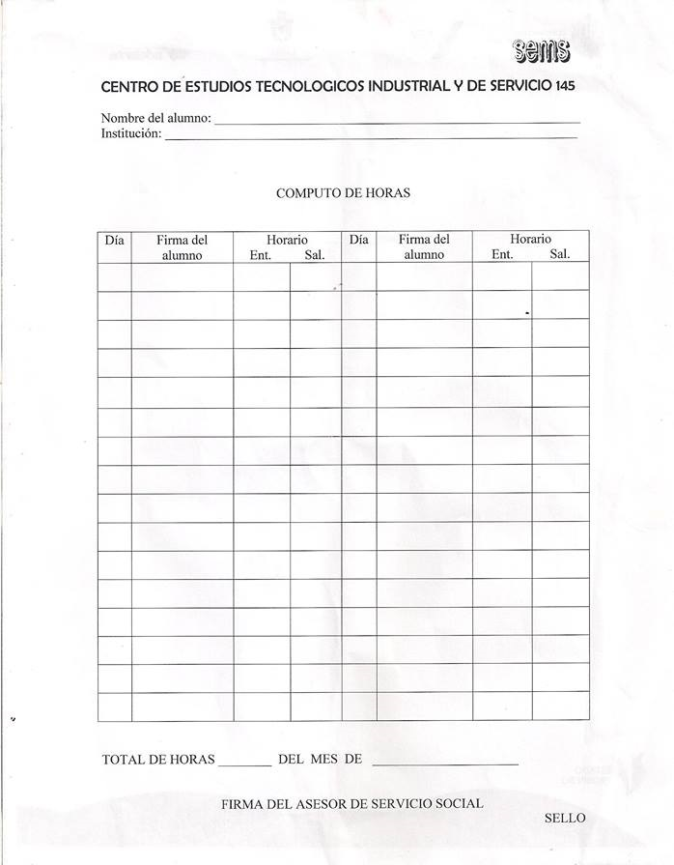

Lizbeth Botello Angeles

IMSS

1 2:00pm 7:00pm 23 2:00pm 7:00pm

2 2:00pm 7:00pm 24 2:00pm 7:00pm

3 2:00pm 7:00pm 25 3:00pm 7:00pm

4 3:00pm 7:00pm 28 3:00pm 7:00pm

7 3:00pm 7:00pm 29 2:00pm 7:00pm

8 2:00pm 7:00pm 30 2:00pm 7:00pm

9 2:00pm 7:00pm 31 2:00pm 7:00pm

10 2:00pm 7:00pm 1 3:00pm 7:00pm

11 3:00pm 7:00pm 4 3:00pm 7:00pm

14 3:00pm 7:00pm 5 2:00pm 7:00pm

15 2:00pm 7:00pm 6 2:00pm 7:00pm

16 2:00pm 7:00pm 7 2:00pm 7:00pm

17 2:00pm 7:00pm 8 3:00pm 7:00pm

18 3:00pm 7:00pm 11 3:00pm 7:00pm

21 3:00pm 7:00pm 12 2:00pm 7:00pm

22 2:00pm 7:00pm 13 2:00pm 7:00pm

148 Marzo - Abril

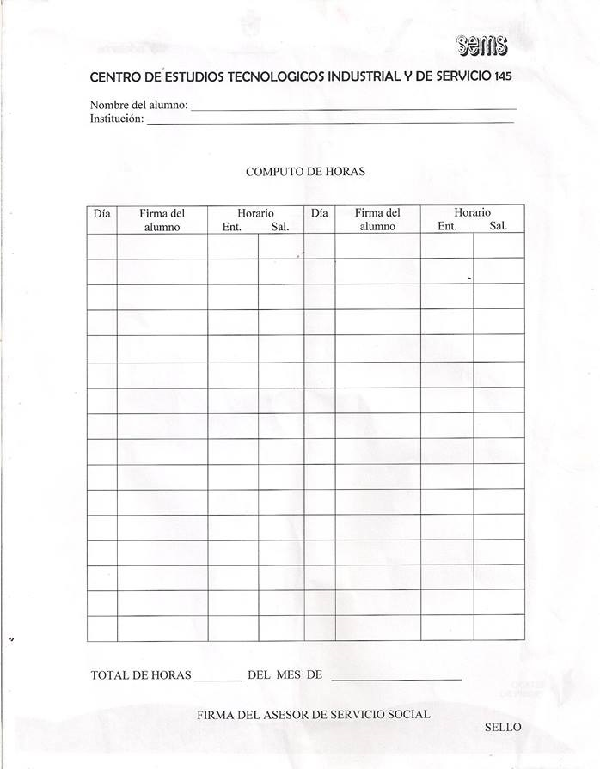

Lizbeth Botello Angeles

IMSS

14 2:00pm 7:00pm 6 3:00pm 7:00pm

15 3:00pm 7:00pm 9 3:00pm 7:00pm

18 3:00pm 7:00pm 10 2:00pm 7:00pm

19 2:00pm 7:00pm 11 2:00pm 7:00pm

20 2:00pm 7:00pm 12 2:00pm 7:00pm

21 2:00pm 7:00pm 13 3:00pm 7:00pm

22 3:00pm 7:00pm 16 3:00pm 7:00pm

25 3:00pm 7:00pm 17 2:00pm 7:00pm

26 2:00pm 7:00pm 18 2:00pm 7:00pm

27 2:00pm 7:00pm 19 2:00pm 7:00pm

28 2:00pm 7:00pm 20 3:00pm 7:00pm

29 3:00pm 7:00pm 23 3:00pm 7:00pm

2 3:00pm 7:00pm 24 2:00pm 7:00pm

3 2:00pm 7:00pm 25 2:00pm 7:00pm

4 2:00pm 7:00pm 26 2:00pm 7:00pm

5 2:00pm 7:00pm 27 3:00pm 7:00pm

147 Abril - Mayo



Lizbeth Botello Angeles

IMSS

30 3:00pm 7:00pm 21 7:00am 3:00pm

31 2:00pm 7:00pm 22 7:00am 3:00pm

1 2:00pm 7:00pm 23 7:00am 3:00pm

2 2:00pm 7:00pm 24 7:00am 3:00pm

3 3:00pm 7:00pm 27 7:00am 3:00pm

6 7:00am 3:00pm 28 7:00am 3:00pm

7 7:00am 3:00pm 29 7:00am 3:00pm

8 7:00am 3:00pm 30 7:00am 3:00pm

9 7:00am 3:00pm 1 7:00am 3:00pm

10 7:00am 3:00pm 4 7:00am 3:00pm

13 7:00am 3:00pm 5 7:00am 3:00pm

14 7:00am 3:00pm

15 7:00am 3:00pm

16 7:00am 3:00pm

17 7:00am 3:00pm

20 7:00am 3:00pm

188 Junio - Julio