|  |  |  |  |
| --- | --- | --- | --- |
| **Date** | **Modules/Target** | **Comments** | **Students Reaction** |
|  |  |  |  |
|  |  |  |  |
|  |  |  |  |
|  |  |  |  |
|  |  |  |  |
|  |  |  |  |
|  |  |  |  |
|  |  |  |  |





Load data

Input command

Save data

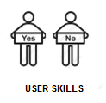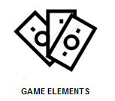

Load game elements

Load game resources

Improved users skills