****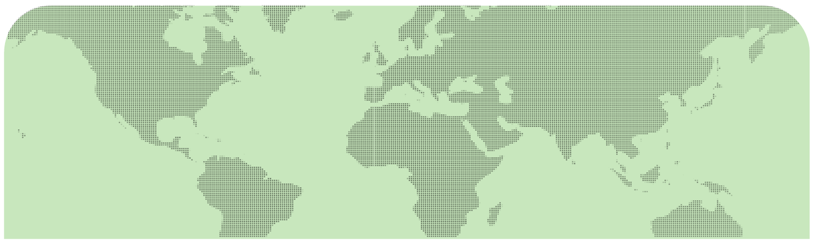

**From strategy to action: what new air emissions policies mean for the oil and gas industry**

Paris / COP21

EU Industrial Emissions Directive and the US Refinery Sector Rule

**93rd PERF Meeting**

**Hosted by Chevron**

**28 Portland Place, London, W1B 1LY**

**May 4th & 5th, 2016**

There is no charge to attend the 93rd PERF Meeting but you must register to participate. All participants are encouraged to register by April 8th. Please return this registration form via email to [PERFLondon@chevron.com](mailto:PERFLondon@chevron.com). When we receive your completed registration form, we will confirm you your participation. However, registrations will also be accepted on-site.

For any questions regarding registration and logistics, please contact [PERFLondon@chevron.com](mailto:PERFLondon@chevron.com).

**Registration Information**

|  |  |  |
| --- | --- | --- |
| First Name: | | Last Name: |
| Job Title: | | |
| Company/Organization: | | |
| Address: | | |
| City: | State: | |
| Zip Code: | Country: | |
| Phone: | | |
| Email: | | |

**Select Attendance Days**

Note that we encourage you to participate both days.

|  |
| --- |
| PERF Board of Director Activities – Tuesday, May 3rd (Invitation only)  RMDG Meeting  Lunch  Dinner  Day 1 – Wednesday, May 4th  Lunch  Reception |
| Day 2 - Thursday, May 5th |
| Lunch |

Please indicate any special considerations (dietary, accessibility, etc.):

**Venue and Recommended Hotels**

The main meeting on 4-5th May will take place at **28 Portland Place**, 1st floor Heggie and Harben rooms.

<http://www.itavenues.co.uk/venues/28-portland-place/>

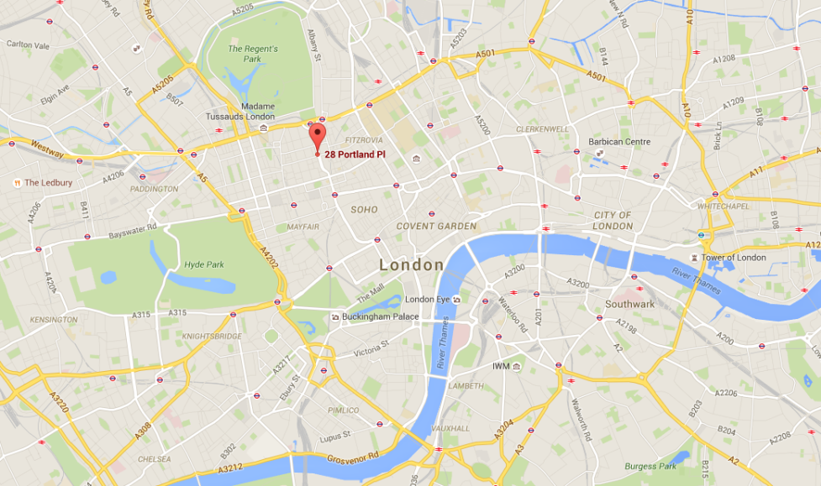

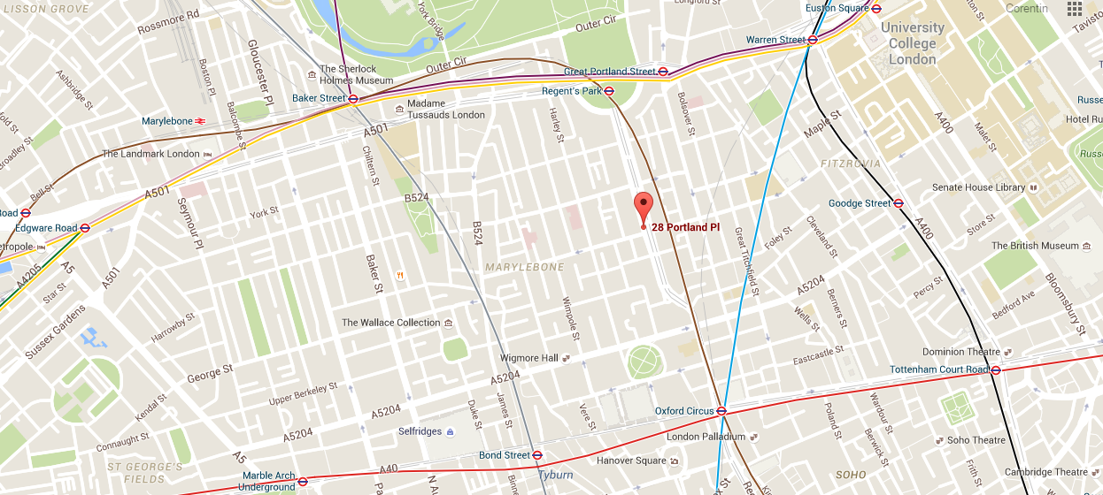

This will also be the location for the evening reception on May 4th.

There are many hotels available in the vicinity of Portland Place. There will not be a block of rooms reserved for the meeting, so please take care of your own accommodations.

Recommended hotels (although there are many other options nearby):

* [The Langham](http://www.langhamhotels.com/en/the-langham/london/?dispy=tllon-ta-hotelwebsite-201512)  which is 2 minutes from Portland Place
* [Marriott Marble Arch](http://www.marriott.com/hotels/travel/lonma-london-marriott-hotel-marble-arch/)