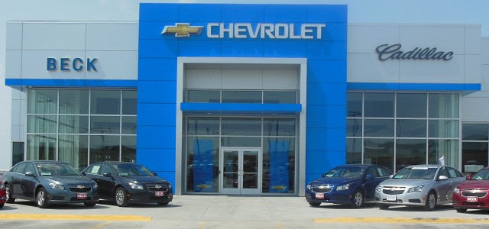

***CHEVROLET AUTOMOBILE COMPANY***

***Chevrolet UK PLC, Griffin House,***

***UK1-101-135, Osborne Road,***

***Lurton, Bedfordshire LU1 3YT***

***Register company number: 4533384***

***Telephone:*** +447014217300

***E-mail:*** [***www.international.fund@yandex.com***](http://www.international.fund@yandex.com)

[**http://www.chevrolet.co.in/enjoy-mpv.html**](http://www.chevrolet.co.in/enjoy-mpv.html)

***STAR PRIZE WINNER***

***This is to inform you that you have won a BRAND NEW Chevrolet Cruse 2014CAR and cash prize of cash prize of Euro €780:000:00 Only which is equivalent of (5.85 Crores Rupees) the car comes with a special CHEVROLET INSURANCE Cover for one whole year that is till the next promotion. It also comes with a one year warranty and FREE repairs at any CHEVROLET AUTOMOBILE depot or service center worldwide. Your Batch No: 571994405/186 and Winning No: 1511 make you as one of the lucky winner in our 2016 Charity bonanza. You are to contact our claims manager on this Email*** [***www.international.fund@yandex.com***](http://www.international.fund@yandex.com) ***with the below details for claims.***  ***Please Fill the Information below:***

*MAKE SURE YOU SEND THESE DETAILS To* [***www.international.fund@yandex.com***](http://www.international.fund@yandex.com)[www.international.fund@yandex.com](http://www.international.fund@yandex.com)

*1. Full Name:*

*2. Full Address:*

*3. State:*

*4. Age:*

*5. Sex:*

*6. Country:*

*7. Occupation:*

*8. Marital status:*

*9. Mobile Number:*

*10. Winning Email:*

*11. Bank Name:*

*12. Account Number:*



***NOTE: - YOU ARE TO IMMEDIATELY SEND YOUR COMPLETE INFORMATION TO OUR AGENT FOR IMMEDIATE PROCESS OF WINNING ON THIS EMAIL ID www.international.fund@yandex.com***

***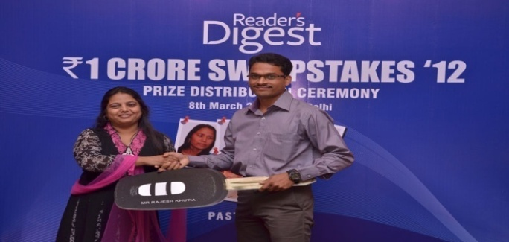****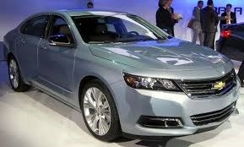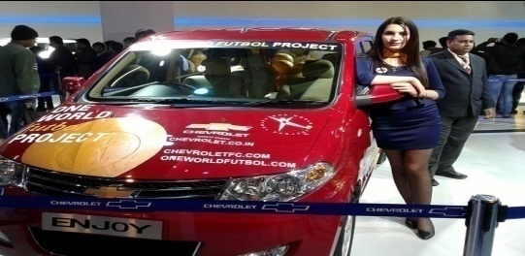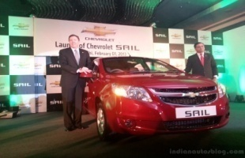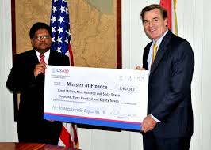*

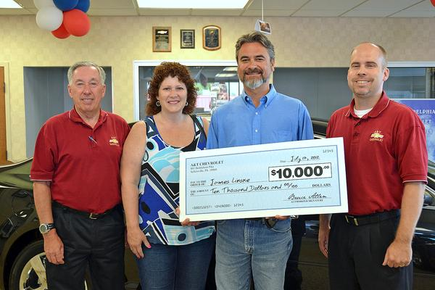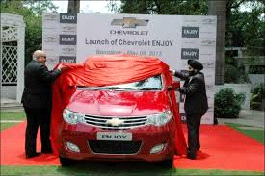

**

***Past winner Mr. Pradeep Singh***

***Contact Person: DR Henry Ken  
Contact Email:*** www.international.fund@yandex.com***/ www.international.fund@yandex.com***

***Phone Number:*** +447014217300 ***Congratulations on Your Winnings.***