The Oxford Centre for Spiritual Growth

presents

**‘The Art and Spirituality of**

**Sieger Kӧder’**



**A reflective study day**

led by

**Magdalen Lawler SND**

& **Tom McGuinness SJ**

**Saturday 19th October 2013**

**10.30 am - 4.00 pm**

**The Friends’ Meeting House**

**St Giles, Oxford**

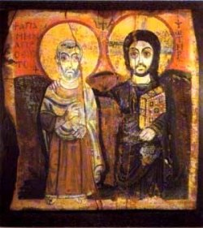

*For further details contact*

*The Oxford Centre for Spiritual Growth*

*Email:* [*info@ocsg.uk.net*](mailto:info@ocsg.uk.net)

*07803 031 977*

[*http://www.ocsg.uk.net*](http://www.ocsg.uk.net)