capture-20131208-115213.jpg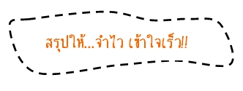

**Adverb of frequency**

**คำวิเศษณ์แสดงความถี่**

**ตัวอย่าง**

Often , rarely , hardly , scarcely , sometimes , never, everyday , always , usually , regularly

**Adverb of time**

**คำวิเศษณ์แสดงเวลา**

**ตัวอย่าง**

Today , yesterday , tomorrow , finally , still , before , now , soon , already , next year ,

in the morning , late ,

this evening



**Adverb of place**

**คำวิเศษณ์แสดงสถานที่**



**Adverb of manner**

**คำวิเศษณ์แสดงอาการ**

**ตัวอย่าง**

successfully ,

slowly , fast ,

beautifully

**Adverb คำวิเศษณ์**

**ตัวอย่าง**

around , there , here ,

up , down , inside , outside , near , everywhere

**Adverb of degree**

**คำวิเศษณ์แสดงระดับ**

**ตัวอย่าง**

very ,

So ,

almost