**University of Palestine**



**College of Applied Engineering & Urban Planning**

**Experiment 7**

**The Capacitor**

|  |  |
| --- | --- |
| **Instructor's Name** |  |
| **Student's Name** |  |
| **Date** |  |
| **Section** |  |
| **Grade** |  |
| **Notes** |  |

**Experiment 7**

**The Capacitor**

Objectives:

Familiarization with charging and discharging processes and time constant concept.

Theory:

The capacitor is a component employed extensively in electrical and electronic circuits. Capacitors are designated by the letter C. the unit of capacitance is farad F. The farad is too large unit, and it is therefore customary to use sub-unit: the microfarad (µF), nanofarad (nF) and the picofarad (pF). Quantitatively:

1 µF= 10-6 F 1nF= 10-9 F 1 pF= 10-12 F

The capacitor consists of two parallel plates, separated by an insulating material layer. The insulator may be air or any other insulating material with suitable characteristics. The capacitance of a capacitor is determined by **three factors**:

1. The overlapping area (A) of the two plates.
2. The distance (d) between the plates.
3. The dielectric constant (K) which is characteristic of the type of insulation between the plates.

The mathematical expression for the capacitance as a function of the three previous factors is given by:

C = K ε0 (A / d) (6-1)

Where ε0 is the permittivity of free space =8.85 *10-12 c2/N.m.

The charge which accumulates in the capacitor causes a potential difference between the plates to appear. The mutual relationship between the charge and voltage in a capacitor of given capacitance is given by:

V= Q/C (6-2)

Where:

V: voltage across the capacitor in volt.

Q: charge in coulombs.

C: capacitance in farad.

**Behavior of the capacitor in DC circuits**

1. **charging process:**

Figure (6-1) shows an electric circuit comprising a resistor, capacitor, and voltage source. After the switch is closed, the charging process begins and the voltage across the capacitor rises gradually until it reaches its maximum values as shown in figure (6-2). The instantaneous voltage across the capacitor is expressed mathematically by:

V= E (1- e-t/RC) (6-3)

Where:

V= instantaneous voltage across the capacitor.

E=voltage of the charging source in volts.

t=time in seconds.

e= base of the natural logarithms (e=2.718).

R=resistance in ohms.

C=capacitance in farads.

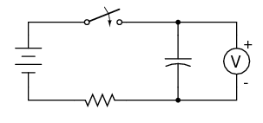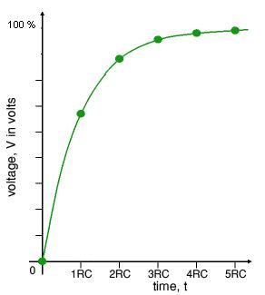

Figure (6-1) Figure (6-2)

The product of the resistance in the circuit and the capacitance is defined as the time constant (τ) of the circuit

τ= RC (6-4)

Let us consider the current in the circuit. Current will flow in the circuit as long as the capacitor is not completely charged. This current will be maximum at the instant the switch is closed, and decrease exponentially as the charging continues. The variation of current in an RC circuit as a function of time is shown in figure (6-3) and given mathematically by:

i=Imax e-t/RC (6-5)

Imax =E/R

where:

i: instantaneous current in amperes.

Imax= maximum current in amperes

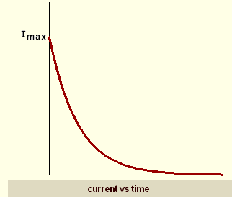

Figure (6-3)

Apparatus:

DC voltage source, multi meter, stopwatch and two capacitors.

Setup and Procedure:

1. Connect the circuit as shown in figure (6-1) with E=25 v and R= .
2. Close the switch and measure the capacitor voltage each 10 seconds.
3. Using equations (6-3) and (6-5), calculate the capacitor voltage and current for the given periods of time.
4. Plot the capacitor charging curve (voltage and current)

Using measured voltage and calculated current for plotting.

|  |  |  |  |
| --- | --- | --- | --- |
| Charging time (s) | Measured voltage (v) | Calculated voltage (v) | Calculated current |
| 10 |  |  |  |
| 20 |  |  |  |
| 30 |  |  |  |
| 40 |  |  |  |
| 50 |  |  |  |
| 60 |  |  |  |
| 70 |  |  |  |
| 80 |  |  |  |
| 90 |  |  |  |
| 100 |  |  |  |

1. **Discharging process:**

If we disconnect the voltage source after the end of the charging process figure (6-4), the capacitor causes current to flow through the load R. The flow of current causes the discharge of the charge accumulated in the capacitor. The behavior of the voltage across the capacitor and the discharging current is given mathematically by equations (6-6) and (6-7) respectively and graphically by figure (6-5).

V= E e-t/RC (6-6)

i=Imax e-t/RC (6-7)

VC

R

E C

t

Figure (6-4) Figure (6-5).

Apparatus:

DC voltage source, multi meter, stopwatch and two capacitors.

Setup and Procedure:

1. Connect the circuit as shown in the figure (6-4) with R= .
2. Open switch S2 and close switch S1 for two minutes.
3. Open switch S1 and close switch S2. Measure capacitor voltage each 10 seconds.
4. Using equations (6-1) and (6-2), calculate the capacitor voltage and current for the given periods of time.
5. Plot the capacitor charging curve (voltage and current)

Using measured voltage and calculated current for plotting.

|  |  |  |  |
| --- | --- | --- | --- |
| Discharging time (s) | Measured voltage (v) | Calculated voltage (v) | Calculated current |
| 10 |  |  |  |
| 20 |  |  |  |
| 30 |  |  |  |
| 40 |  |  |  |
| 50 |  |  |  |
| 60 |  |  |  |
| 70 |  |  |  |
| 80 |  |  |  |
| 90 |  |  |  |
| 100 |  |  |  |