

SEKOLAH MENENGAH KEBANGSAAN BATU 8, JALAN PUCHONG

47100 PUCHONG, SELANGOR DARUL EHSAN

|  |
| --- |
| **CAPACITOR IN PARELLEL AND SERIES** |
| **PHYSICS 960/4** |

**Prepared for**

**En. Lee Peng Kong**

**Prepared by**

**LEE SENG KIT (971105-14-6287)**

**SOO RONG LIANG (970108-10-5267)**

**PUAH PIDIAEN (970724-05-5267)**

**2015/2016**

SEKOLAH MENENGAH KEBANGSAAN BATU 8, JALAN PUCHONG

47100 PUCHONG, SELANGOR DARUL EHSAN

**PERAKUAN CALON**

Saya akui kertas projek ini adalah hasil kerja saya sendiri

kecuali nukilan dan ringkasan yang setiap satunya

telah saya jelaskan sumbernya.

Tandatangan : __________________________________________________

Nama Calon : __________________________________________________

Tandatangan : __________________________________________________

Nama Calon : __________________________________________________

Tandatangan : __________________________________________________

Nama Calon : __________________________________________________

Tandatangan : __________________________________________________

Nama Calon : __________________________________________________

Tarikh : __________________________________________________

**ABSTRACT**

*Type the abstract of the project here. Italic, all in one paragraph, no indent. The abstract is typically a short summary of the project based on the following five questions: 1. What is the aim of your project / 2. Why do you carry out this project / 3. How do you carry it out / 4. What do you get from your results / 5. What impact do you get from the project? An example is shown below.*

**1.0 INTRODUCTION**

**1.1 PROBLEM STATEMENT**

1. How to determine the time constant, τ of discharging circuit for a capacitor connected in parallel and series circuit?
2. Is capacitors connected in series or capacitors connected in parallel have a higher time constant?

**1.2 HYPOTHESIS**

1. Time constant, τ = CR of discharge circuit for a capacitor connected in parallel and series circuit is the time taken for the charge ( or potential difference, or current ) in the capacitor to decrease to $\frac{1}{e}$ of the initial charge. The unit for time constant is second (s).

The time constant, τ of discharging circuit for a capacitor connected in parallel and series circuit can be determined by the formulae

1. Capacitors connected in parallel has a higher time constant than Capacitor connected in series.

**2.0 LITERATURE REVIEW**

A capacitor consists of two [conductors](https://en.wikipedia.org/wiki/Electrical_conductor) separated by a non-conductive region.[[13]](https://en.wikipedia.org/wiki/Capacitor#cite_note-Ulaby_p168-13) The non-conductive region is called the [dielectric](https://en.wikipedia.org/wiki/Dielectric). In simpler terms, the dielectric is just an [electrical insulator](https://en.wikipedia.org/wiki/Insulator_(electrical)). Examples of dielectric media are glass, air, paper, [vacuum](https://en.wikipedia.org/wiki/Vacuum), and even a [semiconductor](https://en.wikipedia.org/wiki/Semiconductor)[depletion region](https://en.wikipedia.org/wiki/Depletion_region) chemically identical to the conductors. A capacitor is assumed to be self-contained and isolated, with no net [electric charge](https://en.wikipedia.org/wiki/Electric_charge) and no influence from any external electric field. The conductors thus hold equal and opposite charges on their facing surfaces,[[14]](https://en.wikipedia.org/wiki/Capacitor#cite_note-Ulaby_p157-14) and the dielectric develops an electric field. In [SI](https://en.wikipedia.org/wiki/SI) units, a capacitance of one [farad](https://en.wikipedia.org/wiki/Farad) means that one[coulomb](https://en.wikipedia.org/wiki/Coulomb) of charge on each conductor causes a voltage of one [volt](https://en.wikipedia.org/wiki/Volt) across the device.

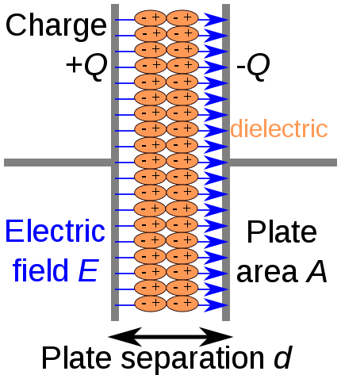

An ideal capacitor is wholly characterized by a constant [capacitance](https://en.wikipedia.org/wiki/Capacitance) *C*, defined as the ratio of charge ±*Q* on each conductor to the voltage *V* between them

$$C=\frac{Q}{V}$$

Because the conductors (or plates) are close together, the opposite charges on the conductors attract one another due to their electric fields, allowing the capacitor to store more charge for a given voltage than if the conductors were separated, giving the capacitor a large capacitance.

Sometimes charge build-up affects the capacitor mechanically, causing its capacitance to vary. In this case, capacitance is defined in terms of incremental changes :

$$C=\frac{dQ}{dV}$$

The **RC time constant**, also called tau, the [time constant](https://en.wikipedia.org/wiki/Time_constant) (in [seconds](https://en.wikipedia.org/wiki/Second)) of an [RC circuit](https://en.wikipedia.org/wiki/RC_circuit), is equal to the product of the circuit resistance (in [ohms](https://en.wikipedia.org/wiki/Ohm_(unit))) and the circuit [capacitance](https://en.wikipedia.org/wiki/Capacitance) (in[farads](https://en.wikipedia.org/wiki/Farad)), i.e.

{\displaystyle \tau =RC}

It is the time required to charge the [capacitor](https://en.wikipedia.org/wiki/Capacitor), through the [resistor](https://en.wikipedia.org/wiki/Resistor), by ≈ 63.2 percent of the difference between the initial value and final value or discharge the capacitor to ≈36.8 percent. This value is derived from the mathematical constant [*e*](https://en.wikipedia.org/wiki/E_(mathematical_constant)), specifically {\displaystyle 1-e^{-1}}, more specifically as voltage to charge the capacitor versus time

Charging :

{\displaystyle V(t)=V_{0}(1-e^{-t/\tau })}

Discharging :

{\displaystyle V(t)=V_{0}(e^{-t/\tau })}

**3.0 METHODOLOGY**

**3.1 MATERIALS AND APPARATUS**

1. A 1.5V Battery
2. Two 5.0V, 0.33F Capacitors
3. A 200 Ω resistor
4. Connecting wires with crocodile clips

**3.2 PROCEDURE**

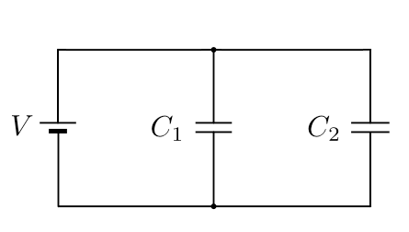

1. The apparatus were set as shown as Figure.
2. 2 capacitors were charged to 1.5V.

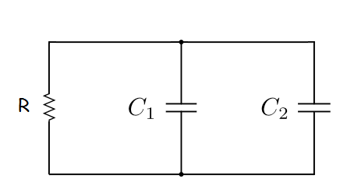

1. R was set to 1k Ω. The capacitors in parallel circuit were discharged to the resistor.
2. The current and potential difference of resistor were recorded.
3. The apparatus were set as shown as Figure.

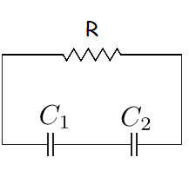

1. R was set to 1k Ω. The capacitors in series circuit were discharged to the resistor.
2. The current and potential difference of resistor were recorded.
3. The graph of charge and potential difference of resistor were plotted.
4. Time constant was determined from the graph.

**4.0 OBSERVATION AND RESULTS**

**4.1 OBSERVATION**

(a) Capacitor in Parallel Circuit

|  |  |
| --- | --- |
| Time (s) | Potential Difference (V) |
| 0 | 1.483 |
| 5 | 0.800 |
| 10 | 0.730 |
| 15 | 0.687 |
| 20 | 0.652 |
| 25 | 0.625 |
| 30 | 0.596 |
| 35 | 0.570 |
| 40 | 0.546 |
| 45 | 0.522 |
| 50 | 0.500 |
| 55 | 0.475 |
| 60 | 0.459 |
| 65 | 0.440 |
| 70 | 0.422 |
| 75 | 0.400 |

Table 1 : Potential difference of resistor with time for capacitor in Parallel Circuit

(b) Capacitor in Series Circuit

|  |  |
| --- | --- |
| Time (s) | Potential Difference (V) |
| 0 | 2.890 |
| 5 | 1.095 |
| 10 | 0.843 |
| 15 | 0.792 |
| 20 | 0.741 |
| 25 | 0.692 |
| 30 | 0.653 |
| 35 | 0.609 |
| 40 | 0.574 |
| 45 | 0.541 |
| 50 | 0.507 |
| 55 | 0.476 |
| 60 | 0.446 |
| 65 | 0.521 |
| 70 | 0.395 |
| 75 | 0.370 |

Table 2 : Potential difference of resistor with time for capacitor in Series Circuit

**4.2 ANALYSIS DATA**

When capacitors connected in parallel circuit and discharged to a resistor,

$$V=V_{0}(e^{-\frac{t}{RC}})$$

When $t=RC$, $V=V_{0}\left(e^{-\frac{RC}{RC}}\right)$

$V=\frac{V_{0}}{e}$

$V_{0}=3.0V$, V=1.104V

From the graph, t =40.125s

When capacitors connected in series circuit and discharged to a resistor,

$$V=V_{0}(e^{-\frac{t}{RC}})$$

When $t=RC$, $V=V_{0}\left(e^{-\frac{RC}{RC}}\right)$

$V=\frac{V_{0}}{e}$

$V_{0}=1.5V$, V=0.552V

From the graph, t =4.125s

**4.3 DISCUSSION**

Based on the experiment, we plotted a graph of potential difference of resistor, V against time, s. We can determined the time constant .

$$V=V_{0}(e^{-\frac{t}{RC}})$$

**4.4 PRECAUTIONS**

1. The battery and capacitors are assumed to be brand new and recently produced as to neglect any external leakage prior to usage.
2. All connection were cleaned using sand paper and all connections were made sure to be tight and clean.

**4.5 ASSUMPTION**

1. Current dissipated as heat and effect of heating of wire in the circuit is ignored.
2. Voltage drop after continuous use of battery is neglected and the battery and and capacitors were assumed to have a constant steady discharge throughtout the experiment.

**4.6 METHOD TO IMPROVE ACCURACY**

1. A digital multimeter was used to ensure greater sensitivity and higher accuracy of results.