|  |  |  |
| --- | --- | --- |
| Contact: Liz McNeill  Phone: (405) 521-6102  www.labor.ok.gov | 3117 N Stiles, Suite 100  Oklahoma City, OK 73105 | Oklahoma Department of lABOR |

# **media ADVISORY**

COMMISSIONER COSTELLO AWARDS LONG WAVE INC. THE

ENTREPRENEURIAL EXCELLENCE AWARD

Oklahoma City, September 10, 2013 - Commissioner Mark Costello presented Long Wave Inc. the Entrepreneurial Excellence in Oklahoma Award. The award was presented to CEO/founder Phil Miller at their facility in Bricktown on September 5.

Long Wave Inc. provides a variety of clients and military divisions with tower and antennae installation, software and communication engineering as well as offers program management, maintenance, and IT services.

They have been the recipients nine times of the Inc 500/5000 Fastest Growing Private Companies and have been awarded the 2013 Inner City 100 Hall of Fame.

Commissioner Costello stated, “In my travels throughout the state, I have enjoyed visiting with some amazing business owners and listening to their unique stories about why they started their company and how it has evolved over the years. I want to honor these entrepreneurs for their commitment to Oklahoma and for their success in creating opportunities for other Oklahomans.”

“Long Wave Inc. is one such example; they provide services throughout Oklahoma as well as abroad. Congratulations to Long Wave Inc. for winning the Entrepreneurial Excellence in Oklahoma Award.”

Commissioner Costello and the Oklahoma Labor Department will continue to recognize entrepreneurs through the Entrepreneurial Excellence in Oklahoma Award.

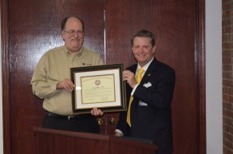 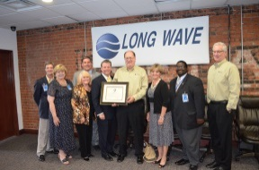

Pictured: CEO Phil Miller with Commissioner Mark Costello

Picture (2) Phil Miller and Commissioner Costello and community guests

-30-