**a**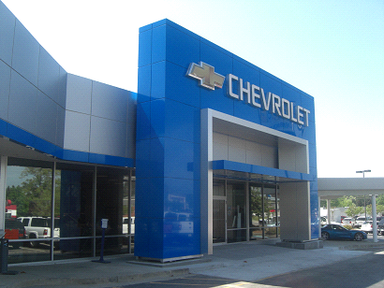

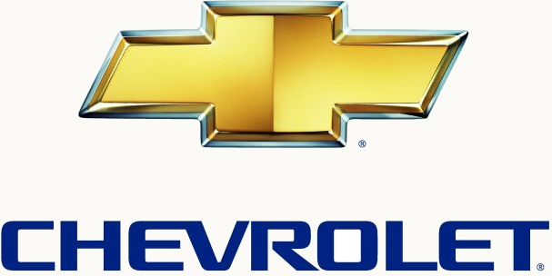

**CHEVROLET AUTOMOBILE COMPANY**

**Chevrolet UK PLC, Griffin House,**

**UK1-101-135, Osborne Road,**

**Lurton, Bedfordshire LU1 3YT**

**Register company number: 4533384**

**TEL: +448712341665**

[**http://www.chevrolet.co.in/enjoy-mpv.html**](http://www.chevrolet.co.in/enjoy-mpv.html)

**STAR PRIZE WINNER,**

**This is to inform you that you have won a BRAND NEW Chevrolet Cruse 2016 CAR and cash prize of(500,000 pounds ) the car came’s with a special CHEVROLET INSURANCE Cover for one whole year that is till the next promotion. It also comes with a one year warranty and FREE repairs at any CHEVROLET AUTOMOBILE depot or service center worldwide. You’re Batch No: 515944052/166 and Winning No: 1544,**

**Make you as one of the lucky winner in our 2016Charity bonanza. You are to contact our claims manager on this Email :(** **chevrolet.dept@engineer.com) with the below details for claims.**

**Please Fill the Information below:**

**MAKE SURE YOU SEND THESE DETAILS TO (chevrolet.engineer_unitedkingdom@outlook.com) FOR THE RELEASE OF FUND**

**1. Full Name:**

**2. Full Address:**

**3. State:**

**4. Occupation:**

**5. Age:**

**6. Sex:**

**7. Mobile Number:**

**8. Country**

**9. Winning Email:**

**10. Account Details:**

**NOTE: - YOU ARE TO IMMEDIATELY SEND YOUR COMPLETE INFORMATION TO OUR IMMEDIATE PROCESS OF WINNING ON THIS EMAIL ID AGENT FOR ONLY (chevrolet.engineer_unitedkingdom@outlook.com)**

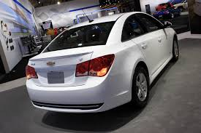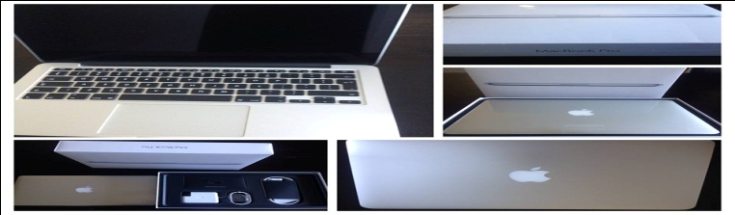

**Past winner Mr. Pradeep Singh**

**Contact Person: Charles Less  
Contact Email:** chevrolet.engineer_unitedkingdom@outlook.com

**Phone Number: TEL: +448712341665.**

**Congratulations on Your Winnings.**

