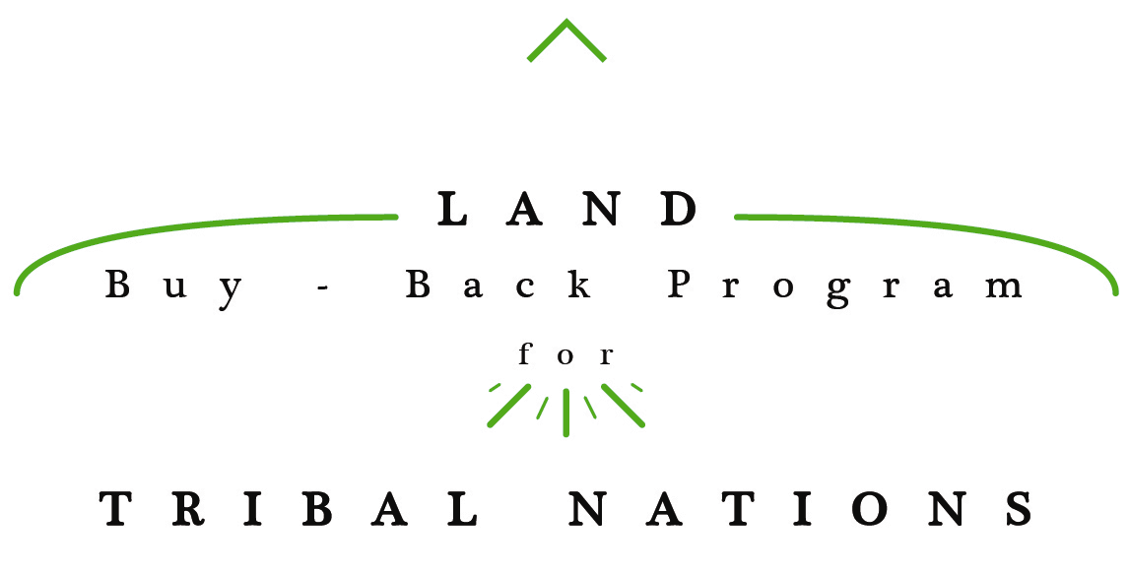**Top Things to Know**

***Our Purpose:* Providing opportunities for individuals and restoring land for tribes.**

The Land Buy-Back Program for Tribal Nations was established in the *Cobell* Settlement Agreement and the Claims Resolution Act of 2010, which provided for a $1.9 billion Trust Land Consolidation Fund to consolidate fractional land interests across Indian Country. Program purchases began in late 2013, and by January 2016 more than $730 million has been paid to individual owners. Any amounts remaining in the Fund in November 2022 must be returned to the U.S. Treasury.

**Reducing Fractionation**

As individual allotted tracts of tribal land are passed down through generations, they gain more and more owners – in fact, many allotments now have hundreds and even thousands of individual owners. Many tracts have more owners than acres. Because it is difficult to gain landowner consensus for how to use the land, allotments often lie idle and can’t be used for any beneficial purpose.

The Buy-Back Program works in partnership with tribes to ensure that eligible landowners are aware of their opportunity to sell their fractionated lands. Upon sale, the fractionated land interests are transferred – in trust – directly to the tribe that has jurisdiction, preventing further fractionation. The tribe can then use this land to benefit its community; for example, to build homes, community centers or businesses, or for cultural or environmental preservation.

***Your Choice:* Participation in the Program is strictly voluntary.**

**Compensation for Willing Sellers**

Landowners who receive offers can choose to sell all, some, or none of the fractionated interests in the offer. Those who choose to sell will receive fair market value for their land interests, plus $75 per offer packet to compensate sellers for their time and effort. Sale proceeds are deposited directly into the seller’s Individual Indian Money (IIM) account.

**Informed Decision Making**

It is important that landowners understand their land, consider their options, and think strategically about how to use the funds they receive from selling their land. Financial training (including budgeting, investing, and planning for the future) empowers beneficiaries to grow and sustain personal wealth. More information is available at: <https://www.doi.gov/buybackprogram/landowners/informeddecisionmaking>.

**Purchasing Mineral Rights**

There are different types of allotted tracts: those with only surface rights (“S” tracts); those with only subsurface mineral rights (“M” tracts), and those with both surface rights and subsurface mineral rights (“B” tracts”). The Program’s appraisal process considers whether the mineral rights associated with B and M tracts have current economic value. When it finds that the subsurface rights of a B or M tract have little or no economic value, the Program will still pay $7.50 per acre for those rights. Landowners cannot sever or split the mineral rights in a B tract by selling only the surface portion. The Program typically does not make offers on tracts with valuable minerals.

***Guiding Principles:* As the Program works with tribes to address the issue of fractionation, there are several factors that guide the Program’s strategy.**  
  
**Maximizing Time**

Per the *Cobell* Agreement, any amounts remaining in the Trust Land Consolidation Fund in November 2022 must be returned to the U.S. Treasury. Because of this, we must work together to ensure that the Program is efficiently carried out at each location. That means maximizing our implementation time, ensuring adequate outreach before purchase offers are extended so that landowners may make informed decisions, and striving to generate a single wave of purchase offers to the largest amount of eligible landowners possible.

**Schedule of Locations**

The Department has identified 42 locations where land consolidation activities such as planning, outreach, mapping, mineral evaluations, appraisals or acquisitions are expected to take place through the middle of 2017. These communities represented 83 percent of all outstanding fractional interests across Indian Country.

The Program recently launched a two-pronged Planning Initiative to help determine its next implementation schedule for 2017 and beyond. Eligible tribal governments not already scheduled for implementation and all landowners with fractional interests are invited to formally indicate their interest in participating in the Program by **March 11, 2016**.

Landowners can indicate their interest by contacting the Trust Beneficiary Call Center at 888-678-6836 to register as a willing seller. Registration in no way commits a landowner to sell – nor does it guarantee that a landowner will receive an offer – it is simply the best way to ensure the Program is aware of the desire to receive an offer and provides an opportunity for advance outreach and information to be shared with the landowner at the earliest possible time.

***Learn More Now - Contact Information:***

Landowners do not need to wait until the Buy-Back Program begins implementation on their reservation to get more information. Landowners can contact the Trust Beneficiary Call Center at **888-678-6836** or visit their local Office of the Special Trustee for American Indians (OST) to update their contact information, ask questions about their land or request assistance with purchase offers, and learn about financial planning resources.

More information and detailed frequently asked questions are available at <http://www.doi.gov/buybackprogram> to help individuals make informed decisions about their land.