JUNE 2016 ACT II PLAYBILL

**Bridge Luncheon, Tuesday June 21st, 11:00 am**

**McCormick & Schmick’s Seafood & Steaks Restaurant**

600 Ashwood Pkwy, Atlanta, GA 30338

**Menu**: **Salmon Rigatoni Asparagus**/ artichokes/ mushroom/ pesto cream sauce **OR**

**Parmesan Crusted** **Chicken**/ lemon caper sauce/ mashed potatoes/ green beans & carrots. Dessert: Ice cream with berries. Coffee, tea, or soft drinks. $20.00/ person inclusive (tax & gratuity).

Reservations must be made by Thursday, June 16th. Contact Carol Kelleher at

770-396-3321 or [KelleherF@bellsouth.net](mailto:KelleherF@bellsouth.net)

=====================================================================

**Calendar of Upcoming Events for June and July 2016**

* Wednesday, June 1 - Dues are due NOW !*** (see below)
* Thursday, June 16 - Board Meeting 10 am, Nancy Buterbaugh
* Thursday, June 16 - Atlanta Botanical Garden, *Chihuly* & dinner
* Friday, June 17- Yak & Yarn 10am, Peggy Thomas
* Tuesday June 21 - Bridge Luncheon/ McCormick’s 11am
* Sunday June 26 - Gwinnet Braves game, 2 :05pm
* Monday, June 27 - Lake Lanier Boat Trip, 10am - 2pm

===================================================

* Tuesday, July 12 - Book Club 10am, The Perfume Collector, Marjorie Parker
* Sunday, July 17 - Social, Stage Door Players *Kiss Me Kate* & Carbonara Trattoria
* Sunday, July 31 - Summer Pool Party, 5pm - 8pm (details coming)

\*\*\***Dues are due!** $30.00 Membership Fee. Please make check payable to **ACT II** and send to Norene Garrett, 4306 N. Shallowford Rd, Apt 1405, Atlanta, GA 30341. Be sure to get your payments in before the June 30th grace period ends.

The directory committee is already compiling an up-to-date list of all active members. If you have any changes to your address, phone, etc., please send them to Karen Phillips or Susan Cicero ASAP.

**\* Playbill:** Please submit items (preferably in writing) for the Playbill by the **25th**. Playbill will be sent out on or before the **1st** of each month. If you do not receive newsletter, or have any problem with it, let me know. [joanne.leisen@verizon.net](mailto:joanne.leisen@verizon.net) or 571-330-4703.

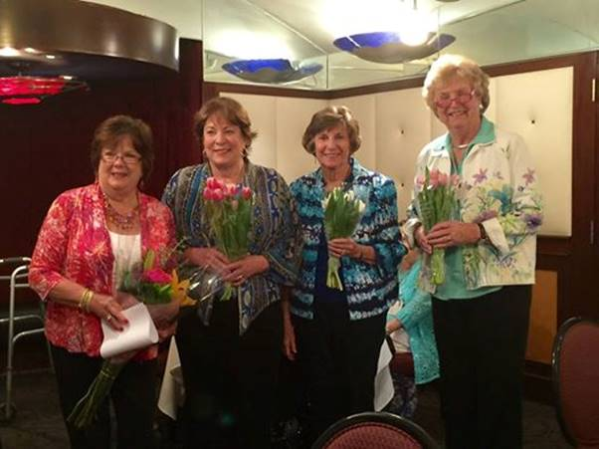=====================================================================

**Officers for the ACT II year of 2016-2017**

|  |
| --- |
| President Judy Florence  Vice President JoAnne Leisen  Secretary Ann Starling  Treasurer Noreen Garrett |

**Committees and Chairwomen for this year are as follows**:

|  |  |
| --- | --- |
| BRIDGE LUNCHEON: | RECIPE LUNCHEON: Nancy Buterbaugh, |
| Reservations: Carol Kelleher | Karen Phillips, Judy Stevens |
| Restaurant Coordinators: Chickie Ching |  |
| Jo Strott, Susan Teel | PUBLICITY: Judy Florence, JoAnne Leisen |
| Bridge: Kay Schehlein |  |
|  | SOCIALS: Mona Webster, Joan Rush, and |
| MARATHON: Jo Strott, Ellen Donalson | Jean Meyers |
|  |  |
| BOOK CLUB: Sally Birsinger, Shirley Espy | SUNSHINE/ TELEPHONE: Susan Cicero |
|  |  |
| DIRECTORY: Karen Phillips, Susan Cicero | YAK & YARN: Peggy Thomas |
|  |  |
| PLAYBILL: JoAnne Leisen | PROGRESSIVE DINNER: combine with Social??? |
|  |  |
| POTPOURI/LUNCH BUNCH: Marjorie | CHRISTMAS LUNCHEON: Karen Phillips, Dec 8 |
| Parker, Jo Strott |  |
|  | CHRISTMAS DINNER: Judy Florence, Dec. 15 |

**=====================================================================================**

**BOARD MEETING**: Thursday, June 16, 10:00 am, home of Nancy Buterbaugh, 4826 Coach Lane, 770-393-9947. Call Nancy if you plan to attend. Everyone is invited to sit in on these meetings. All committee chairmen are urged to attend.

**POTPOURI:** Thursday, June 16, Atlanta Botanical Garden, *Chihuly Nights*, and Dinner at **Linton’s**. Tickets $22.00/ person. Carpool, 5pm at Georgetown. Call Marjorie Parker, 770-393-8552.

**YAK AND YARN:** Friday, June 17, home of Peggy Thomas. Call Peggy 770-393-1860.

**GWINNET BRAVES GAME:** Sunday, June 26. Game starts at 2:05pm. Seats in shade. Tickets are purchased! $15.00 per ticket payable to Judy Florence ASAP. Call Judy or Mona for tickets or info.

**LAKE LANIER BOAT TRIP:** Monday, June 27, 10:00am – 2:00pm. Pack your lunch and enjoy a plush ride on a pontoon boat cruising the lake. Call Mona Webster for details.

**MARATHON BRIDGE: WINNERS May 23, Congratulations!** #1 Kay Schehlein - 5,000

#2 Elizabeth Crawford #3 Karen Phillips #4 JoAnne Leisen #5 Ellen Donelson

**BOOK CLUB:** Tuesday, July 12 at 10am, home of Marjorie Parker 770-393-8552. *The Perfume Collector* by Kathleen Tessaro. *Note: “Find book choices by June 15.” If you have questions, call Sally Bersinger.

=====================================================================================

**ACT II SOCIAL:** SUNDAY, July 17, 2016 2 OO PM

**STAGE DOOR PLAYERS**

Play: ***“Kiss Me Kate”*** *(Cole Porter’s greatest score)*

Cost: $24.00 per Person

Make your check payable to Mary Jo Stewart

Your check is your confirmed reservation

Payment is due at the June 21st Act II luncheon

Please specify if you plan to join the group for dinner (*Dutch treat*) after the play at Carbonara Trattoria.

============================================================================

**SUMMER POOL PARTY:** Sunday, July 31, 5-8pm at Brooke Farm is planned in lieu of Progressive Dinner.

Details to follow.

**JUNE BIRTHDAYS -** 1 Judy Gilmore 9 Carol Kelleher 13 Ann Starling 14 Sally Byers

24 Jody Piratzky 29 Marg Chapin Have a wonderful Birthday and a great year too!