1. **What is the Chevron Invoice and Payment Status (CIPS) system?**

The Chevron Invoice and Payment Status (CIPS) system is a self service, web based tool, available 24x7, which allows Users to search for specific invoices and payments. Detailed information displayed includes invoice and payment numbers, dates, amounts, currencies, etc. for all transaction activity within the last 365 calendar days. Questions can be submitted by you and will be responded to by Chevron Supplier Relations Teams on-line using the CIPS ‘Inquiry’ feature. CIPS also offers an option allowing Suppliers to receive Payment Remittance Advices via Email and/or SMS text.

1. **How Do Users Access CIPS?**

CIPS is available through the internet at <https://cips.chevron.com>. Access controls are now in place so you’ll need to approve the access requests of all of your employees before they’ll be able to use the tool.

1. **How Do I Approve a Request for a UserID?**

As soon as one of your employees has submitted a CIPS Access Request, you’ll receive a system generated Email requesting your review and approval.

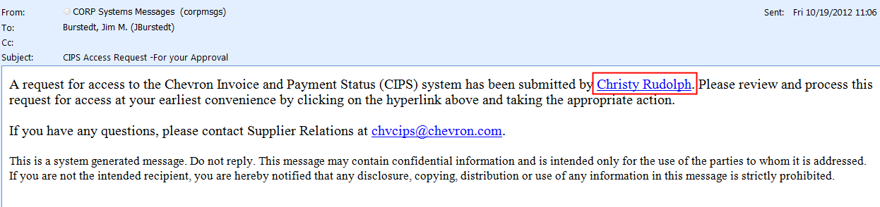

Click the ***Name*** link in the Email to be directed to the CIPS Website. You will be presented with the *CIPS User Access Approval* screen which displays all of your employees who are requesting access.

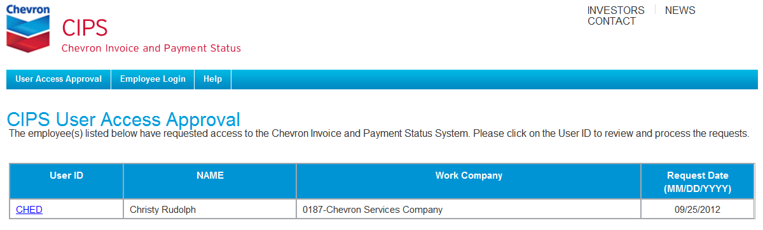

Click the ***UserID*** of the User Access Request you wish to review;

A Request Details window will appear. Review the information that’s been provided by the Requestor, add your own comments, and click ***Approve*** if you want access granted or ***Reject*** if you don’t.

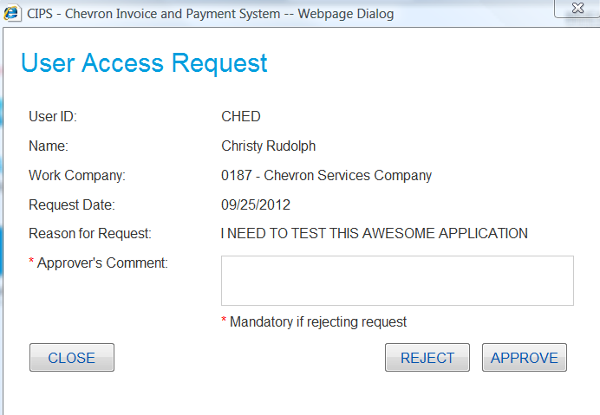

**Note:** You will receive an immediate success message. Emails from the system advising the status of the Access Request will be sent to the employee.

**IMPORTANT!** For Information Protection Compliance purposes, it’s the “PMP Supervisor” who is ultimately responsible for ensuring that system access of their employees is appropriate. If you have been asked to approve access for an employee for whom you are not the PMP Supervisor, you will need to contact the Requestor and that Supervisor to confirm that access is appropriate. In all cases, the PMP Supervisors will be responsible for completing the semiannual SOX User Access Compliance Reviews.

**Other Resources Available**

For more details on the full functionality of the CIPS tool and related processes, a complete How-To Guide, as well as a Frequently Asked Questions document, are available on the Help tab. In addition, more information is available by contacting Supplier Relations;

|  |  |  |  |
| --- | --- | --- | --- |
| **CIPS Contact** | **Email Address** | **Telephone** | **Hours of Operation** |
| Manila | [chvcips@chevron.com](mailto:chvcips@chevron.com) | 1-925-827-7741 | 7a–4p Pacific |
| Buenos Aires | [cips.bassc@chevron.com](mailto:cips.bassc@chevron.com) | 54-11-338-1895 | 9a-6p BsAs |