Removing the Apostrophe from the iPhone name to improve Bluetooth operation on devices running iOS 7.0 and higher.

This can be quickly done directly from the iPhone itself following these steps.

1. Touch “Settings” icon on iPhone home screen

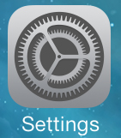

1. Touch “General”



1. Touch “About”



1. Touch “Name”



1. Select the Apostrophe ( ‘ ) and remove it



1. Touch “About” when done



1. Phone name without ( ‘ ) should work properly, after establishing a new Bluetooth connection.

