**Synthesis Lab Equipment**

*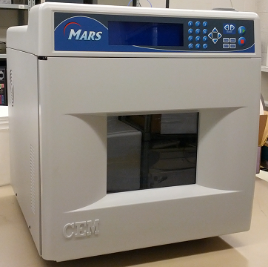***CEM Matthews Laboratory Oven/Microwave**

*Mars 230/60, Model 907501*

*Quantity in Lab: 1*

* Inside Width: 12 in
* Inside Depth: 12.5 in
* Inside Height: 11.5 in
* Voltage Rating: 110 V
* Frequency Rating: 60 Hz
* Power Rating: 600 W
* Heat Source: Integral
* Variable Power Output: 1- 100% in 1% increments

**Bruker FT-IR**

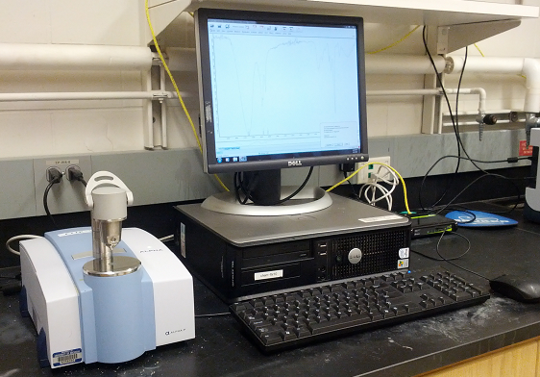*Model Alpha-P*

The single reflection diamond ATR module is designed to ease analysis, while the ergonomic one-finger clamp mechanism simplifies sample positioning. The versatility allows for a variety of sampling options for liquid flow through analysis and temperature controlled measurements.

*Quantity in Lab: 1*

* Software wizard guides user through FT-IR use
* Quick and easy to use
* Often used for quality assurance
* Flexible sampling

**Shimadzu Gas Chromatograph with Auto Injector and Auto Sampler**

*GC-2010, AOC-20i, AOC-20s*

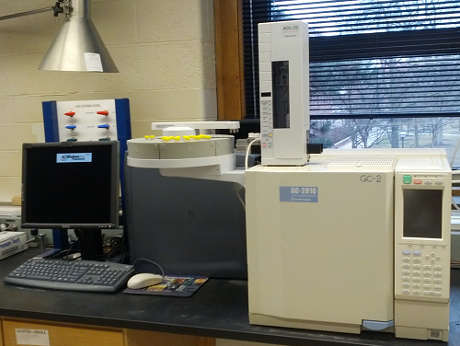Capillary gas chromatographs are used in a variety of fields, such as pharmaceuticals and petrochemistry. The GC-2010 was designed to meet the modern demands for higher analysis speed, greater accuracy, and easier operation, all of which are factors that contribute to reduced operator load. The auto-injector produces the highest degree of reliability and is capable of injecting samples into a range of injection ports. The auto sampler adds to the efficiency of the chromatograph, handling up to 150 vials using a carousel and robotic arm.

*Quantity in Lab: 2*

* Vial Size: 1.5 mL and 4.0 mL
* Maximum Number of 1.5 mL Samples: 150
* Maximum Number of 4.0 mL Samples: 96
* Samples Injection Method: Liquid Injection via Microsyringe
* Number of Samples Injections: 1~99 Injections per Sample
* Syringe Speed: Fast and Slow
* Plunger Speed: Fast, Medium, and Slow
* Wait Time: 0~99.9 s following sample aspiration
* 3 Modes of Samples Injection: Traditional, Solvent Flush, and Solvent Flush with Second Solvent
* Sample Cooling/Heating: 0-60°C

*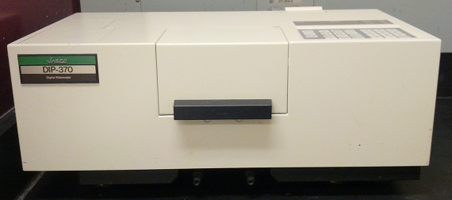***JASCO Digital Polarimeter**

*Model DIP-370*

*Quantity in Lab: 1*

* Angular range: +90o
* Measurement accuracy: +0.002% (up to +1o) +0.2% (+1o or more)
* Response speed: 4o/sec
* Light source: Na lamp (589 nm) as standard
* Measurement system: Faraday symmetric angular oscillation by the optical null method
* Sample chamber: light path length 100 mm max
* Data output: thermal paper printout & analog output

**Shimadzu UV-Visible Spectrophotometer**

*Model PharmaSpec UV-1700*

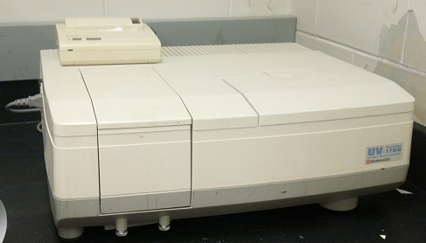All samples, whether transparent or containing a suspension, can be measured and quantitated with the UV-1700. Enzyme reactions can be measured in up to 16 cells at once. The absorbance or transmittance for a sample can be measured for up to 8 different wavelengths. Quantitative analysis can be performed for up to 8 components mixed in a sample.

*Quantity in Lab: 1*

* Multi Wavelength Measurement
* Multi-component Analysis
* Multicell Kinetic Measurement
* Micro Volume Sample Measurement
* Spectral Bandwidth: 1 nm
* Wavelength Range: 190 to 1100 nm
* Wavelength Accuracy: ±0.3 nm
* Wavelength Repeatability: ±0.1 nm
* Wavelength Scan Rates: 6000 nm/min (slew), 3000 nm/min to 10 nm/min (scanning)
* Photometric Range: -0.5 to +3.0 Abs, 0.0 to 300% transmittance
* Recording Range: -3.99 to +3.99 Abs, -399 to +399% transmittance
* Photometric Accuracy: ±0.004 Abs (at 1.0 Abs), using NIST930D filter
* Photometric Repeatability: ±0.002 Abs (at 1.0 Abs)
* Noise Level: 0.002 Abs (P-P) 0.0002 A (RMS) (700 nm)
* Automatic Baseline Correction
* Light Source: 20 W halogen lamp, deuterium lamo
* Monochromator: aberration-corrected blazed holographic grating
* Detector: silicone photodiode
* Sample Compartment Dimensions: 110.0 W x 230.0 D x 105.0 H (mm)

**Thermolyne Furnace**

*Model 1400*

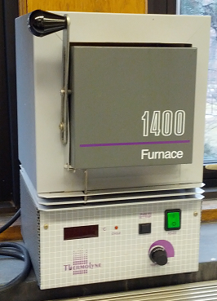This small, bench top muffle furnace is versatile, economical, and designed for ashing both inorganic and organic samples. It also it used for determining suspended and volatile solids, for gravimetric analysis, for ignition tests, and for heat treating of small pieces of steel. The temperature can accurately be controlled using the set point knob, and thermocouple break protection prevents thermocouple failure by cutting power to the heating elements. Power to the element is also removed upon opening of the door. Special atmospheres may be injected through a 0.95 cm diameter port at the chamber rear, which is also where chamber temperature can be monitored.

*Quantity in Lab: 1*

* Temperature Range: 100°C 1100°C
* Chamber Dimensions (WxHxD): 4.7 x 4.9 x 5.6 in
* Stability at 1000°C: ±0.5°C
* Uniformity at 1000°C: ±5.0°C
* Display shows actual temperature or setpoint
* Ceramic fiber insulation
* Embedded heating element on top and sides

*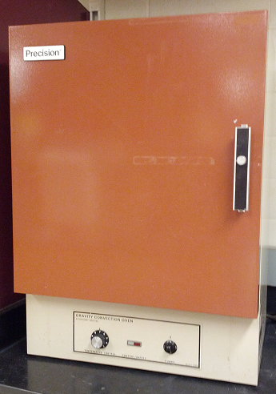***Precision Gravity Convection Oven**

*Economy Model 18EG*

*Quantity in Lab: 2*

* 110 V
* 19” x 18” x 14”
* 2 Shelves
* Max Temperature: 225°C
* Maximum Power Consumption: 1420 W