|  |
| --- |
| **ABYSSINA COMPRESSOR & MAINTENANCE SDN BHD.** (800187-W) |
| No: 109, Jalan Suria Puchong 2, Pusat Perniagaan Suria Puchong, 47110 Puchong |
| **Tel:** 03-89591998  **Fax :** 03-89592998 |
| **Email:** procurement@acmcompressor.com  **Web:** [www.acmcompressor.com](http://www.acmcompressor.com) |



**REQUEST FOR QUOTATION**

**OUR REF : ACM(PF)16-0013 - 9-5/8” x 12-1/4” ULTRA-LOW FRICTION COMPOSITE MATERIAL/TORQUE AND**

**DRAG REDUCER**

**CLOSING DATE : 10.06.2016 @ 1200HRS**

**NOTES**

1. **PLEASE CONFIRM COMPLIANCE WITH MATERIAL SPEC BELOW**
2. **PLEASE ATTACHED GA DRAWING WHERE APPLICABLE**
3. **PLEASE PROVIDE ALL CERTIFICATE WHERE APPLICABLE**

**SCOPE OF WORK**

* 1. CONTRACTOR is required to supply Centralizer 9-5/8” x 12-1/4” Ultra-Low Friction Composite Material/ Torque and Drag Reducer that meet or exceed API 10D specification.
  2. CONTRACTOR is required to supply Centralizer 9-5/8” x 12-1/4” Ultra-Low Friction Composite Material/ Torque and Drag Reducer with following specifications including centralization programs:
     1. Type:

Rigid Body, preferably comes with low friction material i.e Teflon

* + 1. Blade:

Bladed type, high total flow area

* + 1. Cementing Operation:

Able to provide casing “ stand-off” for shallow long horizontal well with an optimum centralizer placement.

* + 1. Stop Collar:

Slip on

* + 1. Compatibility:

1. 9-5/8” 47ppf – 53.5ppf casing
2. Oil base Mud
3. Water base Mud
4. Rotate while run in hole
   * 1. Performance
5. Low Co-efficient of friction material
6. Low Running Force
7. High Restoring Force
8. Drag and torque reduction while run in / rotate the casing through horizontal well

1.3 CONTRACTOR is required to provide Centralizer Placement and Torque and Drag Analysis Report for 9- 5/8” Casing to demonstrate the Scope of Work and shall meet minimum specification of the Ultra-low friction / Torque and Drag Reducer Centralizer. The Well Info provided include the following :

1. Well Schematic and casing information
2. Mud Weight
3. Vertical Section
4. Well trajectory
5. Offset Well Stick Chart

**Refer to Attachment 2 for details of specifications.**

The Centralizer Placement and Torque & Drag Analysis Report for 9-5/8” Casing shall include but is not limited to the following:

Input and assumption

Centralizer Placement Model

Stand – off Calculation and Profile

Torque simulation and graph

* Rotation while running the casing at 20 rpm and 30 rpm
  + 1. Calibration of simulation with the actual nearest well profile (if applicable)

Well Information Appendix - Well type A

1. Well Schematic and Casing information

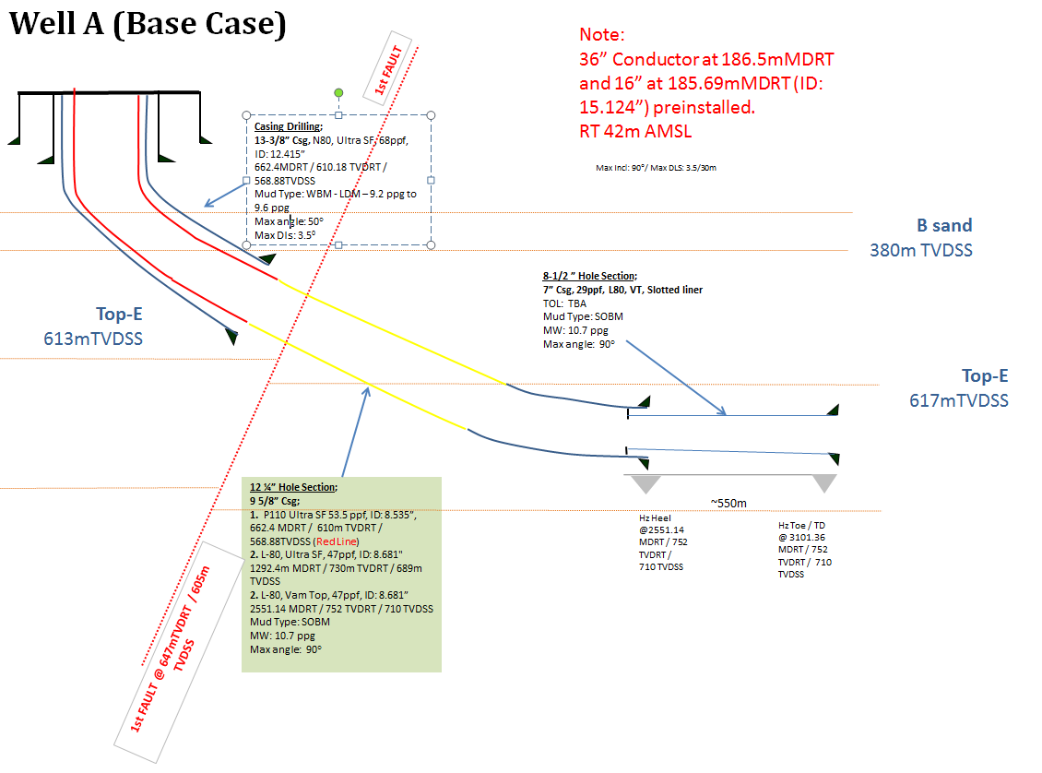

1. Mud Information



1. Vertical Section

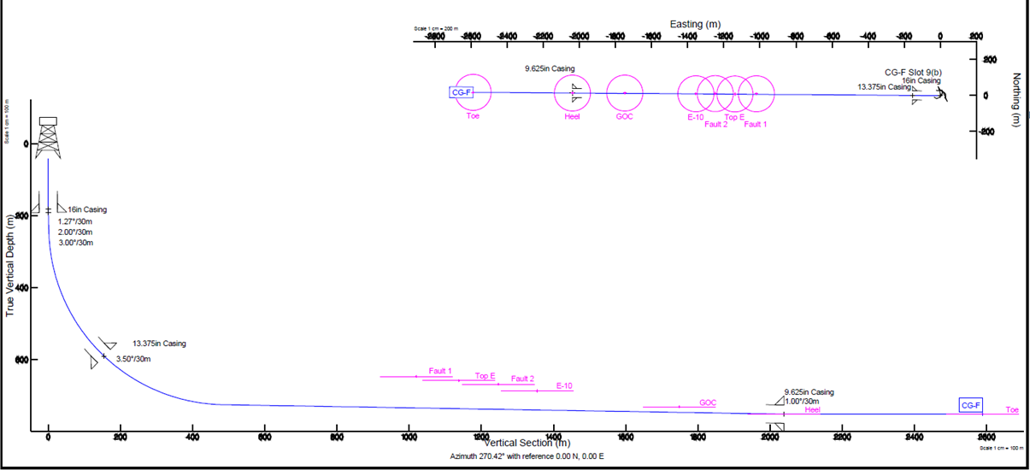

1. Well Trajectory (Attachment 2)
2. Offset Well Stick Chart (Attachment 2)



**NOTE: Your offer should be accompanied with;**

1. **Official Quotations**
2. **Warranty Period**
3. **Technical Specifications**
4. **Data Sheet & Catalog (Drawing)**
5. **Certificates belong to the offered items**
6. **Estimate Weight**
7. **FOB Port, Country of Origin**
8. **Freight Charges**
9. **Validity Offer at least : 90 Days**
10. **Delivery Point : (DAP) Kemaman Supply Base**