**TABLE OF CONTENTS**

# What is CIPS?

# How do I access CIPS as a Supplier?

# How do I access CIPS as a Chevron Employee?

# How do I approve an Access Request from a Chevron employee?

# As a Supplier, how do I login to CIPS?

# What if I have forgotten my CIPS Password?

# What if I have forgotten the answer to my Password Reset Question?

# What if I have forgotten my CIPS User ID?

# As a Chevron Employee, how do I login to CIPS?

# How do I search for an Invoice?

# How do I search for a Payment?

# How do I export the Search results to Excel?

# How do I submit a General Inquiry?

# How do I submit an Invoice Inquiry?

# How do I submit a Payment Inquiry?

# How do I monitor the status of my Inquiries?

# As a Supplier, how do I maintain the General attributes of my User profile?

# As a Chevron Employee, how do I maintain the General attributes of my User profile?

# How do I enroll for the Email or SMS Text delivery option for my remittance advices?

# How do I add additional Supplier Records?

# How do I change my password?

# As a Chevron employee, how do I request access to Chevron Pipeline activity?

# What is CIPS?

CIPS is a self-service website displaying invoice and payment details for all Supplier invoice activity conducted with Chevron’s largest Business Units worldwide. Details available in the website include invoice number, invoice date, invoice amount, discount amount, withholding tax, GST/VAT amount, purchase order or service order numbers, contract numbers, payment method, currency, etc. – basically all information you as a Supplier need to be able to track the status of your invoices and understand when payments to settle those invoices have been made or can be expected.

CIPS is available 24x7 and will;

* display and retain 12 rolling months worth of data,
* offer a self-service enrollment feature for Users, using specific invoice data to validate a User’s identity,
* offer an option to receive payment remittance advices via email or SMS text,
* provide the ability for Users to submit inquiries and monitor their status directly in the website,
* limit the visibility of payables data to just those entities and transactions to which a User should have access,
* utilize a standard, enterprise-wide presentation format for invoices and payments, and
* provide ten language options for User customization

In most, if not all cases, it’s expected that the use of CIPS will eliminate the need and expense currently incurred by Users to track the status of their invoices and payment via telephone calls or Emails.

Only Users with a valid business need should request access to CIPS, and by proceeding with a CIPS enrollment request, each User will be implicitly agreeing to Chevron’s Terms of Use, details of which are located as a link at the top of the Enrollment page.

[Back to Top]

# How do I Access CIPS AS A SUPPLIER?

CIPS is available through the internet at <https://cips.chevron.com>. User Access controls are in place so you’ll be prompted to create a valid User ID during your first visit to the website. If you do not have reliable internet access but would still like to utilize CIPS’ Payment Remittance Advice feature, contact one of Chevron’s Supplier Relations Teams;

|  |  |  |  |
| --- | --- | --- | --- |
| **CIPS Contact** | **Email Address** | **Telephone** | **Hours of Operation** |
| Manila | [chvcips@chevron.com](mailto:chvcips@chevron.com) | 1-925-827-7741 | 7a-4p Pacific |
| Buenos Aires | [cips.bassc@chevron.com](mailto:cips.bassc@chevron.com) | 54-11-338-1895 | 9a-6p BsAs |

Open the CIPS website and on the **Supplier Login** screen, click ***Enroll***.

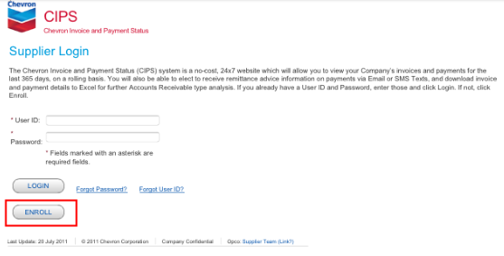

A **Supplier Enrollment** screen will appear listing the data required to create your User ID. The Supplier Name, Invoice Date and Invoice Number from an invoice submitted to Chevron within the last 60 calendar days will be required to authenticate the information you provide.

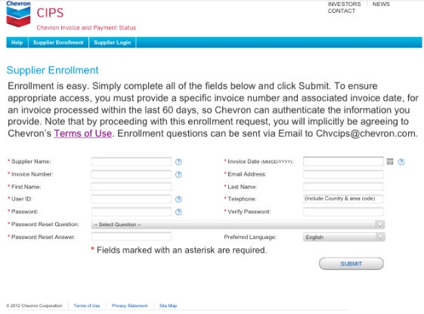

Provide the requested information and click ***Submit***. (All information available in CIPS is sensitive in nature and must be protected against improper disclosure. Only Users with a valid business need should request access.)

If mandatory data is missing or if we were unable to validate your identity (CIPS requires a partial string of the Supplier name, and the exact Invoice Number and Invoice Date of an invoice Chevron has processed for you in the last 60 days), then you’ll receive an error message.

Provide the missing or incorrect data and click ***Submit***.

If all the required data is provided and CIPS is able to authenticate your identity, you’ll receive a success message.



**Note:** By proceeding with your enrollment request, you will be implicitly agreeing to Chevron’s Terms of Use, located as a link at the top of the Enrollment page.

Click ***Login*** to proceed.

[Back to Top]

# How do I Access CIPS AS A CHEVRON EMPLOYEE?

CIPS is available through the internet at <https://cips.chevron.com>. You’ll need to create a valid User ID (which will default to your Chevron Network ID) and receive Supervisor approval before being able to use the tool.

Open the CIPS website and an **Employee Enrollment** screen will appear.

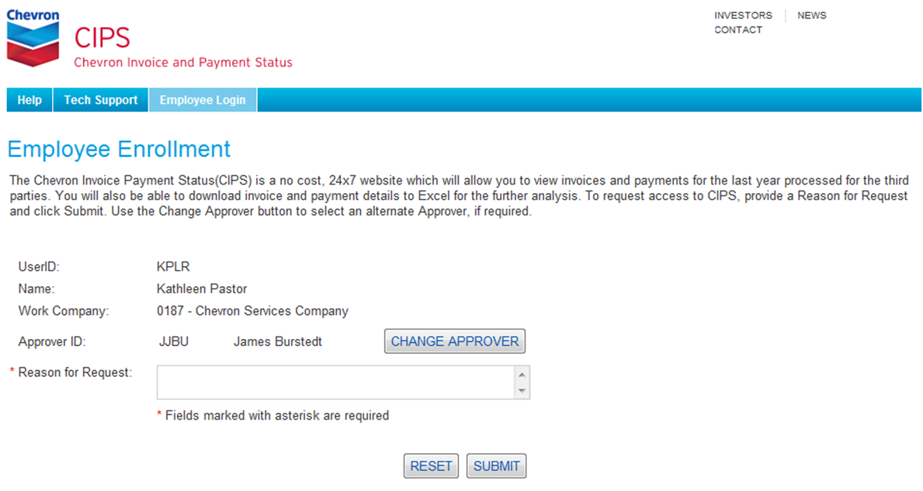

All information available in CIPS is sensitive in nature and must be protected against improper disclosure. Only Employees with a valid business need should request access.

Note: For Information Protection compliance purposes, all Access requests need to be approved by your Supervisor.

If your Supervisor is not available, an alternate Approver can be selected. (Your actual Supervisor will be notified of your choice of an alternate, and will still be responsible for the periodic SOX reviews of CIPS system access.) Click ***Change Approver.***

A Search by Contact pop-up window will appear.

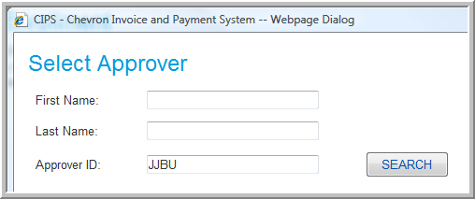

Enter a First Name and Last Name, or the Approver ID, of your alternate Approver (all three fields support partial string searches) and click ***Search.***

All Approver ID information meeting the search criteria will be presented in the *Search Result* section.

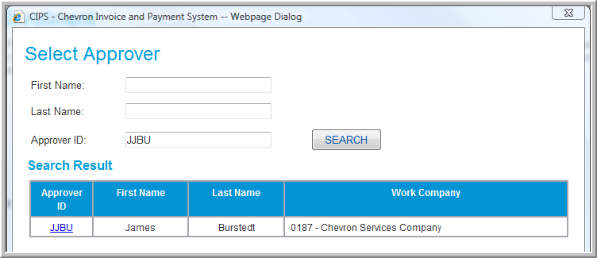

Identify the desired Alternate Approver and click their ***Approver ID***.

You’ll be returned to the **Employee Enrollment** screen. (Note that the Approver ID is now that of the alternate Approver.)



Provide a reason for your access request and click ***Submit***. If the Reason for Request is missing then you’ll receive an error message.

When all the required data is provided you’ll receive a success message and your request will be forwarded to your Approver.

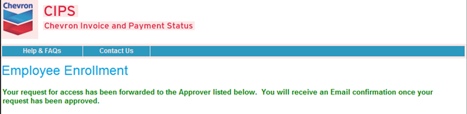

You’ll be notified via Email as soon as your Access Request has been processed.

[Back to Top]

# how do I approve an Access request from A CHEVRON EMPLOYEE?

As soon as a Chevron employee has submitted a CIPS Access Request identifying you as the Access Approver, you’ll receive a system generated Email requesting your review and approval. The requestor’s name in the Email will be a hyperlink.

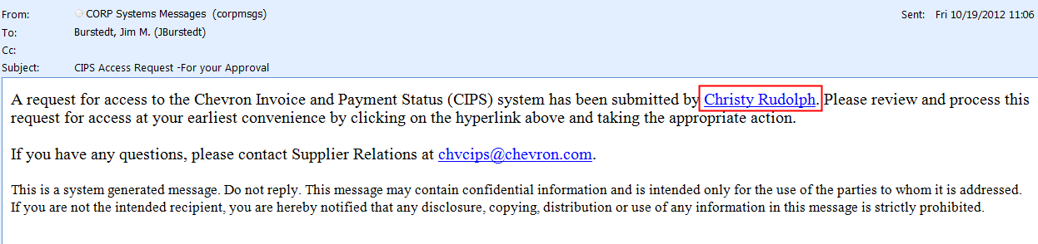

Click the ***Requestor’s Name*** link in the Email to be directed to the CIPS Website.

You will be presented with the **CIPS User Access Approval** screen which displays all of the Chevron employees who are requesting your review of their Access Requests.

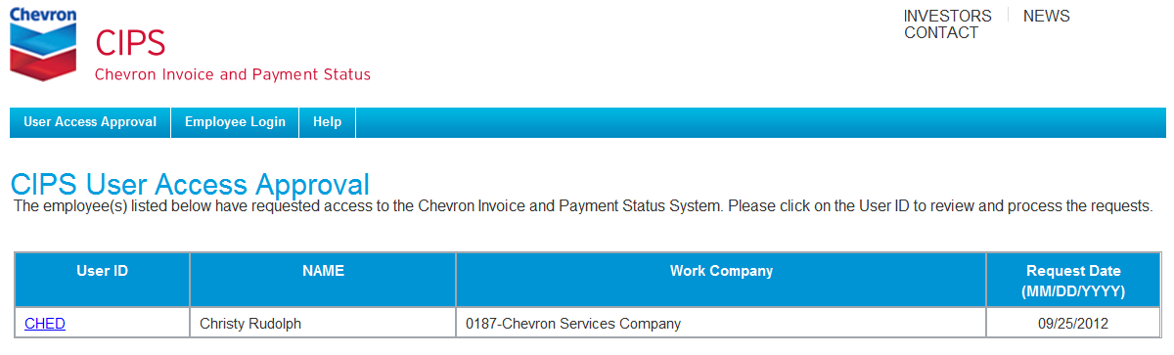

Click the ***User ID*** of the User Access Request you wish to review.

A Request Details window will appear.

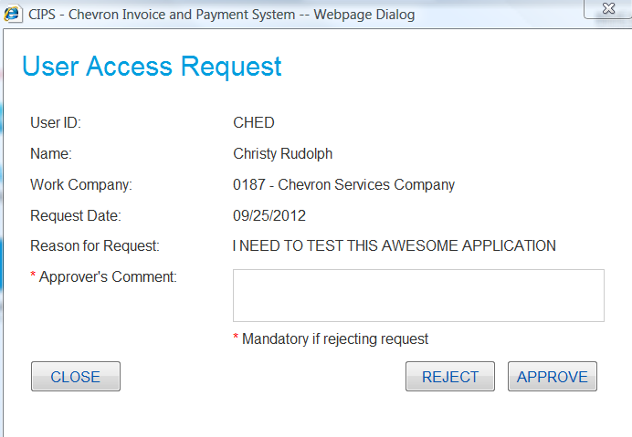

Review the information that’s been provided by the Requestor. If access for this User is appropriate, add your own comments, and click ***Approve.*** If access for this User is not appropriate, add a comment describing your reason for rejecting the request, and click ***Reject***. (Click ***Close*** if you want to take no action at this time.)

Failure to provide an Approver’s Comment will generate an error message.

Provide an Approver’s Comment, and again click either ***Approve*** or ***Reject***.

You will receive one of two immediate success messages.



Emails from the system advising the status of the Access Request will be sent to the employee.

IMPORTANT! For Information Protection Compliance purposes, it’s the “PMP Supervisor” who is ultimately responsible for ensuring that system access of their employees is appropriate. If you have been asked to approve access for an employee for whom you are not the PMP Supervisor, you will need to contact the Requestor and that Supervisor to confirm that access is appropriate. In all cases, the PMP Supervisors will be responsible for completing the semiannual SOX User Access Compliance Reviews.

[Back to Top]

# AS A SUPPLIER, how do I LOGIN TO cips?

Once you’ve been successfully enrolled, go to the CIPS Website where you’ll be presented with the **Supplier Login** screen.

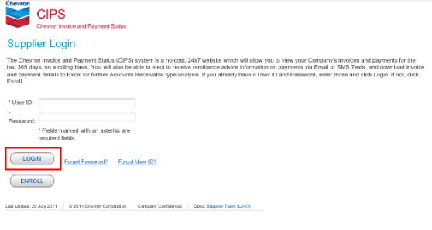

Enter your User ID and Password and click ***Login***.

If your User ID and/or Password cannot be validated, then you’ll receive an error message. Click ***Back to Login*** and try again.

When your User ID and Password have been validated, you’ll be presented with the **Search for Invoices and Payment** screen.

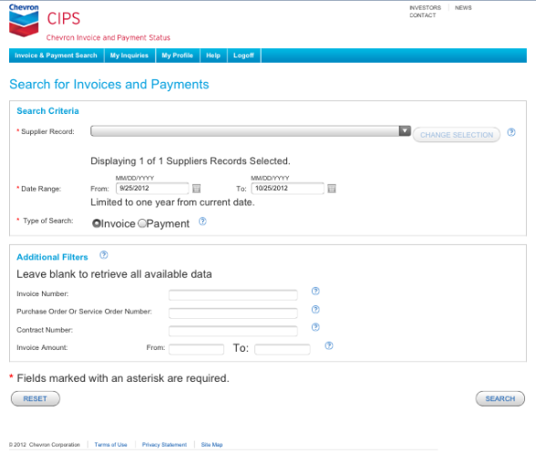

[Back to Top]

# WHAT IF I HAVE FORGOTTEN MY CIPS PASSWORD?

If you have forgotten your Password, CIPS provides a reminder process.

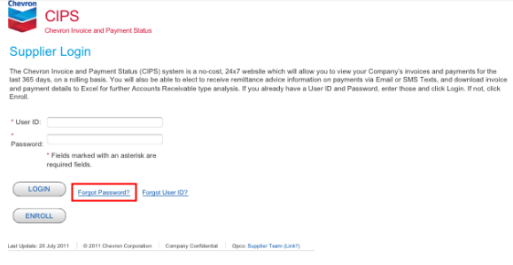

Click ***Forgot Password***.

A Supplier Password Reset window will appear.

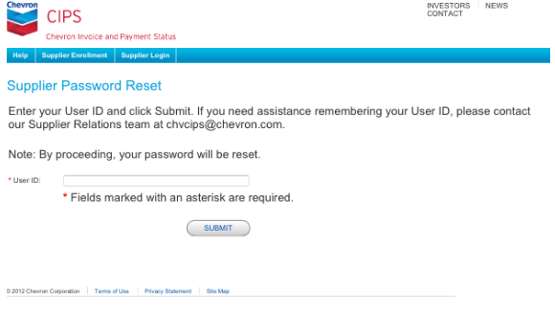

Enter your User ID and click ***Submit***.

An error message will appear if the entered User ID cannot be verified by CIPS. You will have three chances to provide the correct User ID. After the third unsuccessful attempt, your User ID will be locked and you’ll need to contact Supplier Relations via Email ([chvcips@chevron.com](mailto:chvcips@chevron.com)) for assistance.

When your User ID has been verified, the **Supplier Password Reset** screen will be redisplayed with your Password Reset Question.

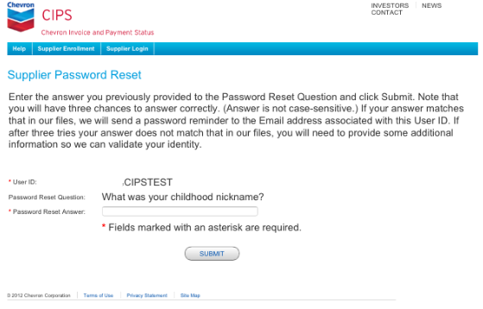

Enter your answer to the Password Reset Question and click ***Submit***.

An error message will appear if the Answer you entered does not match that in the CIPS user database. A correct answer will generate a Password Reminder Email sent to the Email address associated with your User ID.

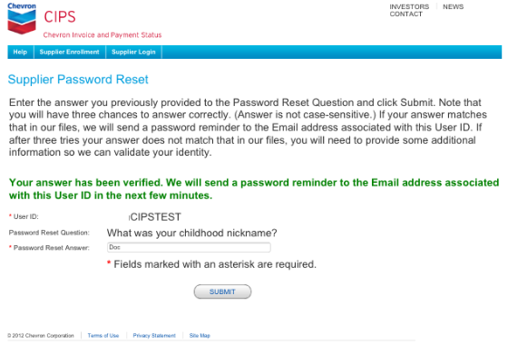

[Back to Top]

# WHAT IF I HAVE FORGOTTEN THE ANSWER TO MY PASSWORD RESET QUESTION?

You will have three chances to provide the correct Answer to your Password Reset Question. After the third unsuccessful attempt, the **Supplier Password Reset** screen will be refreshed and you’ll need to re-validate your User ID by providing the Supplier Name, Invoice Number and Invoice Date of an invoice processed by Chevron in the last 60 days.

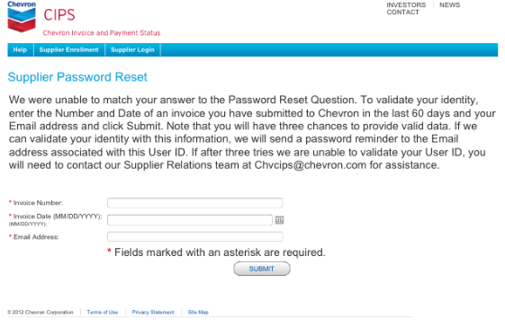

Enter the Supplier Name, Invoice Date and Invoice Number from an invoice submitted to Chevron within the last 60 calendar days and click ***Submit***.

If the invoice information you provide cannot be validated, an error message will appear. When the invoice information has been validated, a success message will be displayed, and a Password Reminder Email will be sent to the Email address associated with your User ID.

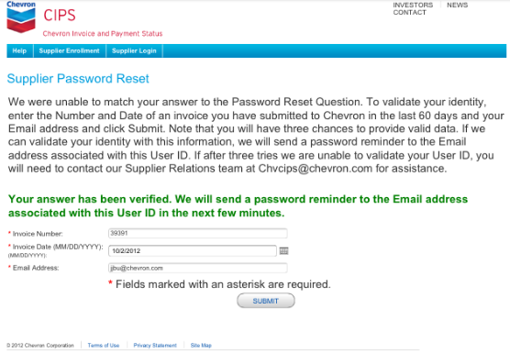

[Back to Top]

# WHAT IF I HAVE FORGOTTEN MY CIPS User ID?

If you have forgotten your User ID, CIPS provides a reminder process.

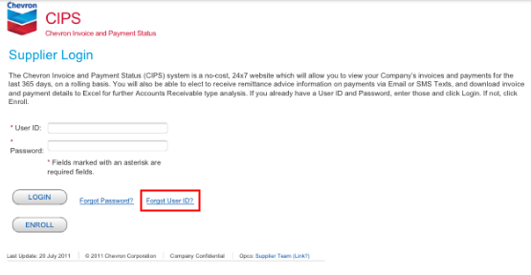

Click ***Forgot User ID***.

A Forgot User ID window will appear.

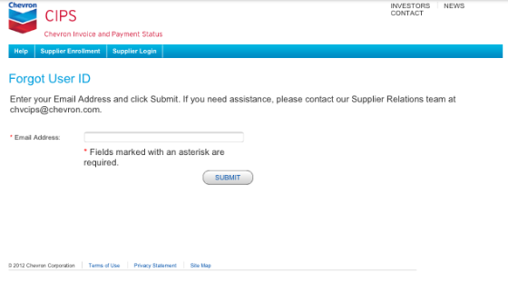

Enter your Email Address and click ***Submit.***

If the Email Address you provide cannot be validated, an error message will appear. A valid Email Address will generate a success message and a User ID reminder Email will be sent to the Email address associated with your User ID.

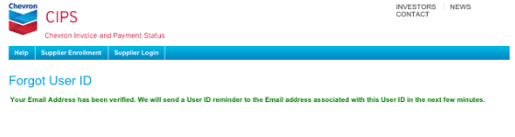

[Back to Top]

# AS A CHEVRON EMPLOYEE, how do I LOGIN TO cips?

Once you’ve been successfully enrolled, go to the CIPS Website where access will be controlled by Single-Sign-On using your Smart Badge. (There are no separate Login IDs or Passwords required.) You will be presented with the **Search** screen where you will need to search for the Supplier records in which you are interested.

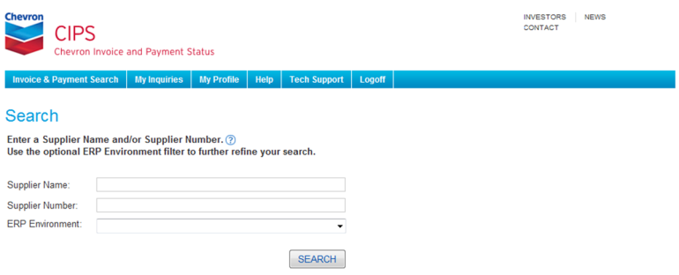

Note: Vendor activity with certain Chevron Business Units (i.e., Pipeline, Downstream & Oronite) is sensitive and therefore its visibility will be restricted. If you are a Downstream employee, you will be unable to see vendor activity with Oronite, and vice versa. Visibility to Pipeline activity can be provided by special approval from Pipeline. Submit a Pipeline Access Request from the My Profile tab.

[Back to Top]

# HOW DO I SEARCH FOR AN INVOICE?

Available Search Criteria and Additional Filters will be displayed on the **Search for Invoices and Payments** screen. (Suppliers will have visibility only to those Supplier Records for which they’ve explicitly requested access, either during the initial Enrollment or by adding them via the Additional Supplier Records process found on the My Profile tab. Employees will have visibility, subject to the Business Unit restrictions for Pipeline, Downstream & Oronite activity, to all Supplier Records selected during the Search process at Login.) The Date Range defaults to a 30 day period but 365 days of history is available. Two Search Types are available – ‘Invoice’ and ‘Payment’ – with ‘Invoice’ as the default.



To modify or restrict the Supplier Records used for your searches, click ***Change Selection***.

Suppliers will be presented with a list of their available Supplier Records. Select/deselect the desired Supplier Records and click ***Save***.

Employees will be presented with the **Search** screen. Modify the Supplier Search criteria and click ***Search***.

After modifying the Supplier Record lists, Users will be returned to the **Search for Invoices and Payments** screen.

Modify the Search Criteria if needed, add any desired optional Additional Filters, and click ***Search***.

Note: If the Additional Filters are left blank, all data meeting the Search Criteria will be presented.

Note: You’ll be able to navigate to other CIPS options simply by clicking on the desired tabs in the Menu Bar.

All transactions meeting the Search Criteria and Additional Filters will be presented on the **Invoice Summary Results** screen in an intuitive, easy to understand format, with data sortable by clicking on the column label, additional information available via hyperlink functionality and with results exportable to Excel.

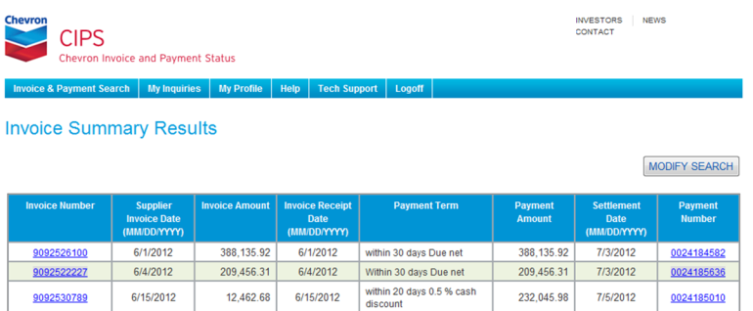

Note: Invoices processed but not yet paid will be identified with a ‘Pending’ tag in the Payment Number column.

Click the ***Invoice Number*** to see additional details for each invoice.

The Invoice Detail Results pop-up will appear.

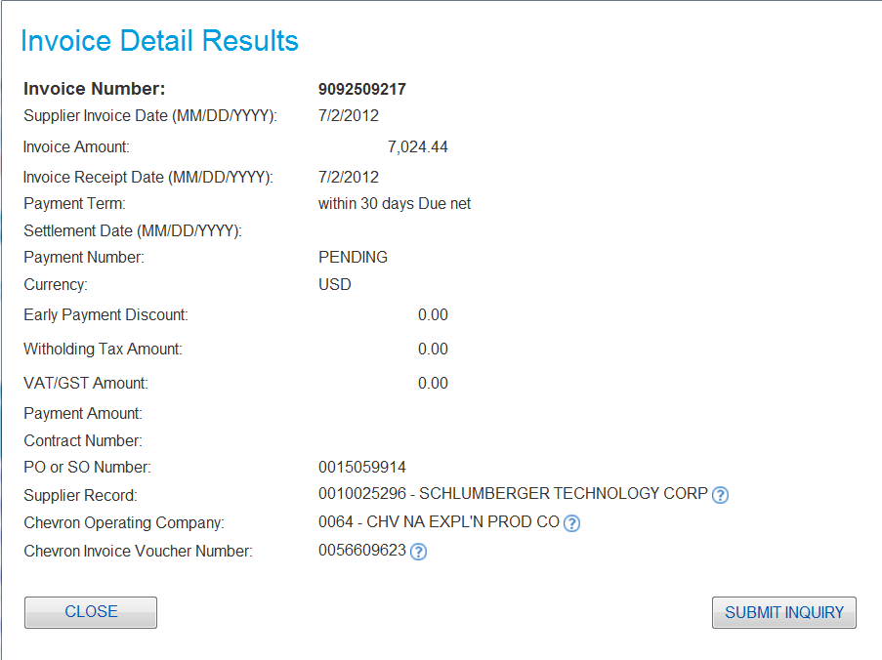

Click ***Close*** to return to the **Invoice Summary Results** screen.

[Back to Top]

# HOW DO I SEARCH FOR A PAYMENT?

Available Search Criteria and Additional Filters will be displayed on the **Search for Invoices and Payments** screen. (Suppliers will have visibility only to those Supplier Records for which they’ve explicitly requested access, either during the initial Enrollment or by adding them via the Additional Supplier Records process found on the My Profile tab. Employees will have visibility, subject to the Business Unit restrictions for Pipeline, Downstream & Oronite activity, to all Supplier Records selected during the Search process at Login.) The Date Range defaults to a 30 day period but 365 days of history is available. Two Search Types are available – ‘Invoice’ and ‘Payment’ – with ‘Invoice’ as the default. Change the Type of Search to ‘Payment’.

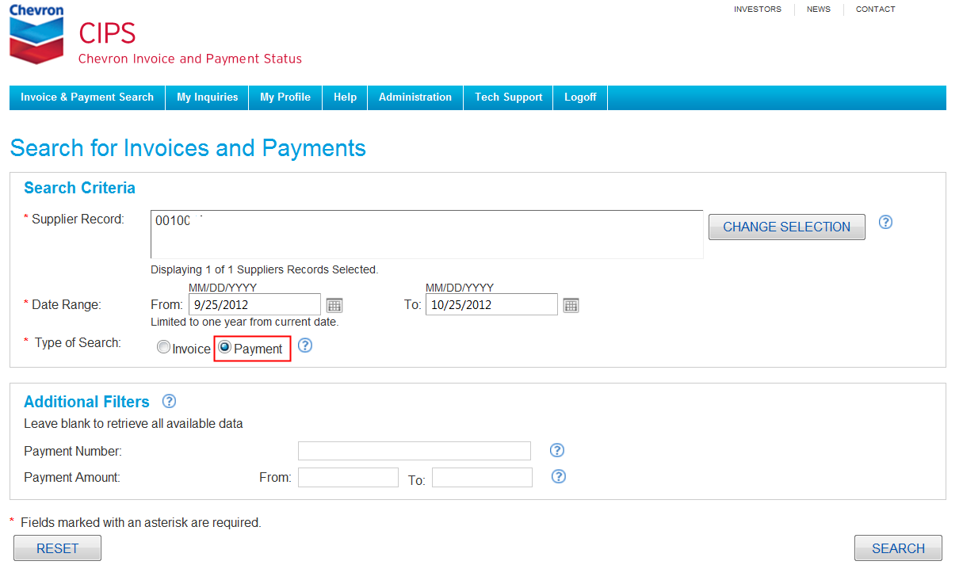

To modify or restrict the Supplier Records used for your searches, click ***Change Selection***. Suppliers will be presented with a list of their available Supplier Records. Select/deselect the desired Supplier Records and click ***Save***.

Employees will be presented with the **Search** screen. Modify the Supplier Search criteria and click ***Search***.

After modifying the Supplier Record lists, Users will be returned to the **Search for Invoices and Payments** screen.

Modify the Search Criteria if needed, add any desired optional Additional Filters, and click ***Search***.

Note: If the Additional Filters are left blank, all data meeting the Search Criteria will be presented.

Note: You’ll be able to navigate to other CIPS options simply by clicking on the desired tabs in the Menu Bar.

All transactions meeting the Search Criteria and Additional Filters will be presented on the **Payment Summary Results** screen in an intuitive, easy to understand format, with data sortable by clicking on the column label, additional information available via hyperlink functionality and with results exportable to Excel.

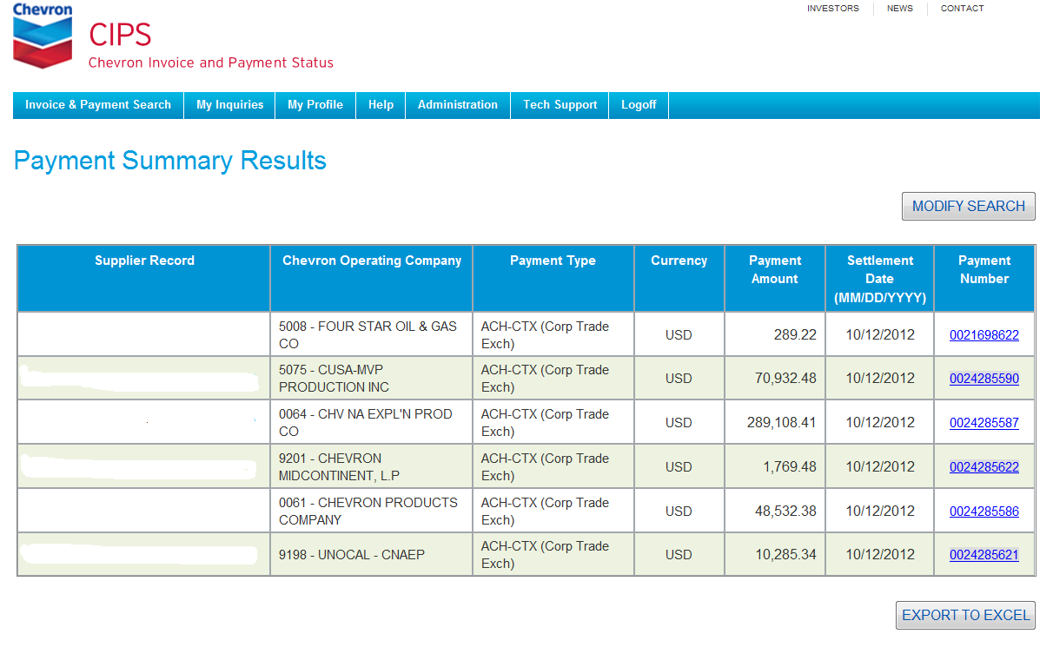

Click the ***Payment Number*** to see all the invoices settled by that payment.

The **Payment Detail Results** screen will appear.

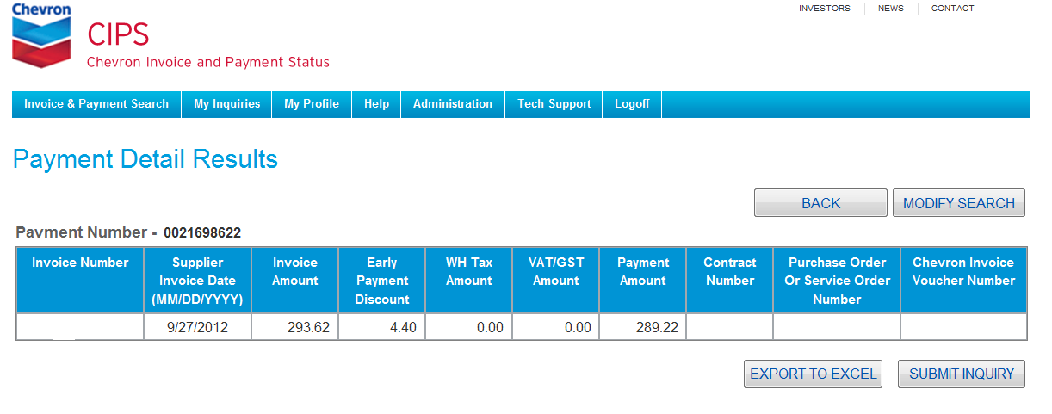

[Back to Top]

# HOW DO I EXPORT THE SEARCH RESULTS TO EXCEL?

All the Search Results screens include the option to download the details to Excel to handle searches returning more rows of transactional data than can be easily displayed on the screen. In addition to the data columns displayed on the Search Results screens, the export feature will also capture all other data columns associated with the transactions.

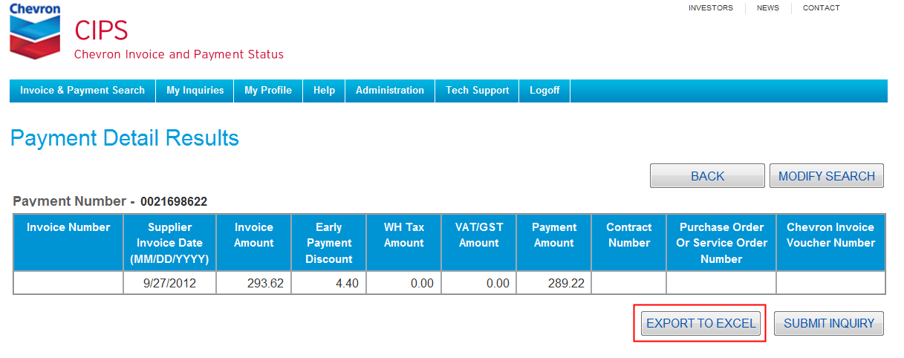

Click ***Export to Excel***.

Excel opens with a File Download prompt window.



Click the desired Excel action.

[Back to Top]

# HOW DO I SUBMIT A GENERAL INQUIRY?

General Inquires are created from the Inquiry Status window of the My Inquires tab and are intended for questions regarding your Profile, User access, system navigation, etc.

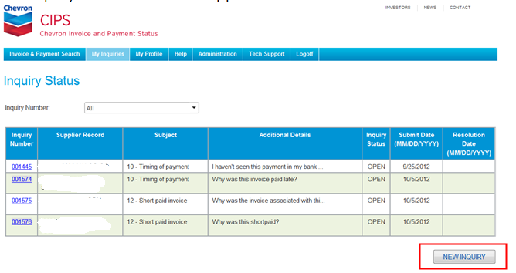

Click ***New Inquiry***.

The General Inquiry window will appear.

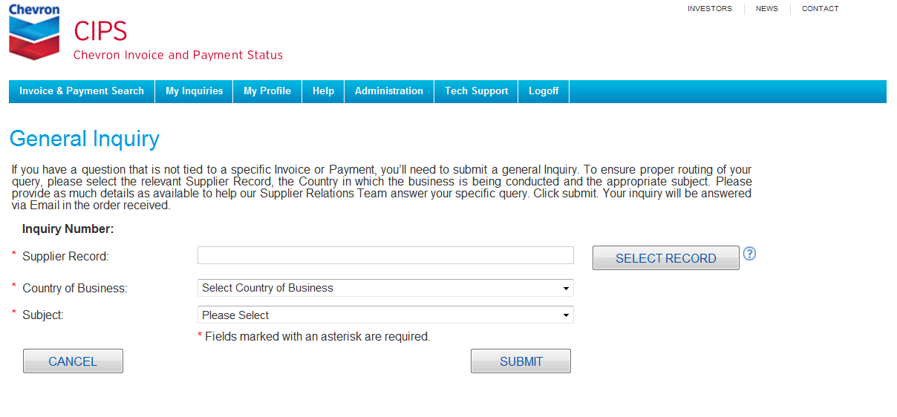

To ensure proper routing of your inquiry, the relevant Supplier Record, the Country in which the business is being conducted and the appropriate Subject are required fields.

If more than one Supplier Record is available and you want to change it, click ***Select Supplier***. (This change will be relevant for this General Inquiry only.) Suppliers will be presented with a list of their available Supplier Records.

Select/deselect the desired Supplier Records and click ***Save***.

Employees will be presented with the **Search** screen. Modify the Supplier Search criteria and click ***Search***.

After modifying the Supplier Record lists, Users will be returned to the **General Inquiry** screen.

Note: The Data Entry fields are conditional on the Subject chosen.

To ensure a timely and complete response, please provide as much detail as possible in the Additional Details field and click ***Submit.***

You’ll receive an on-screen confirmation if all the required information has been provided.

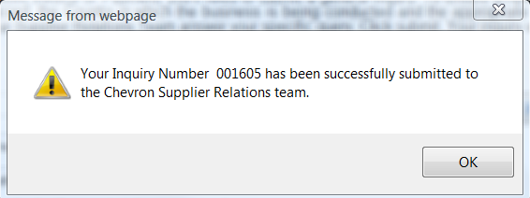

Click ***OK***. When your Inquiry has been answered, you’ll be notified by Email with instructions on how to find the response.

[Back to Top]

# HOW DO I SUBMIT AN INVOICE INQUIRY?

Invoice Inquiries are created from the **Invoice Detail Results** screen and are intended for questions regarding that particular invoice.

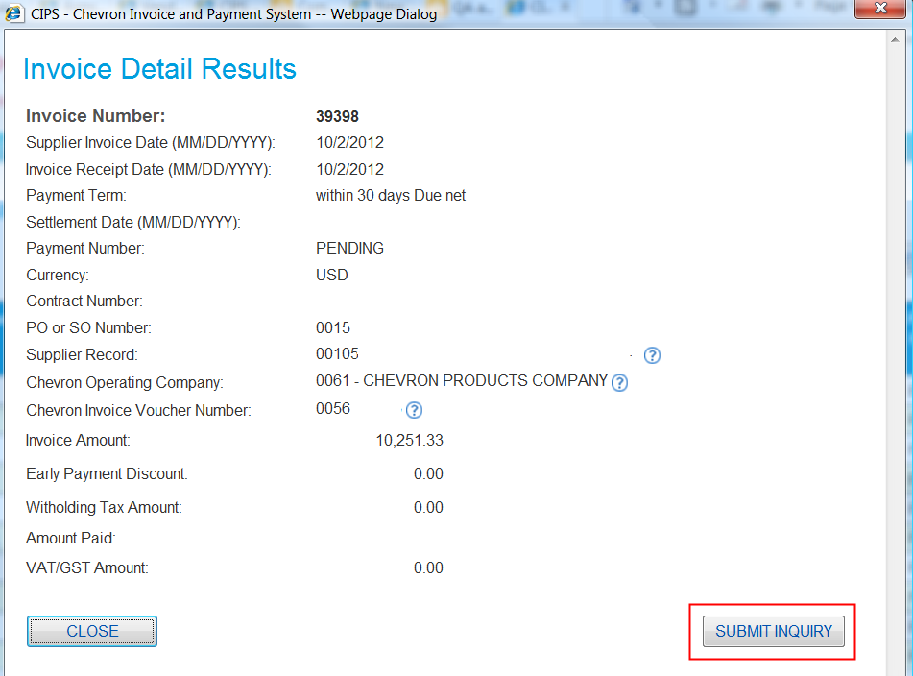

Click ***Submit Inquiry***.

The **Invoice Inquiry** screen will appear.

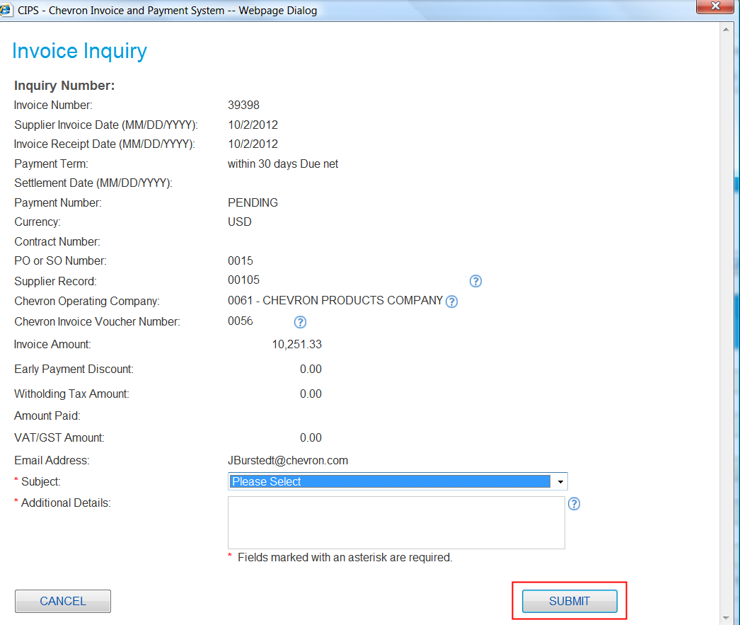

Choose the appropriate Subject and, to ensure a timely and complete response, please provide as much detail as possible in the Additional Details field and click ***Submit.*** (Click ***Cancel*** to return to the **Invoice Detail Results** screen.)

You’ll receive an on-screen confirmation if all the required information has been provided.



Click ***OK***. When your Inquiry has been answered, you’ll be notified by Email with instructions on how to find the response.

[Back to Top]

# HOW DO I SUBMIT A PAYMENT INQUIRY?

Payment Inquiries are created from the **Payment Detail Results** screen and are intended for questions regarding that payment.

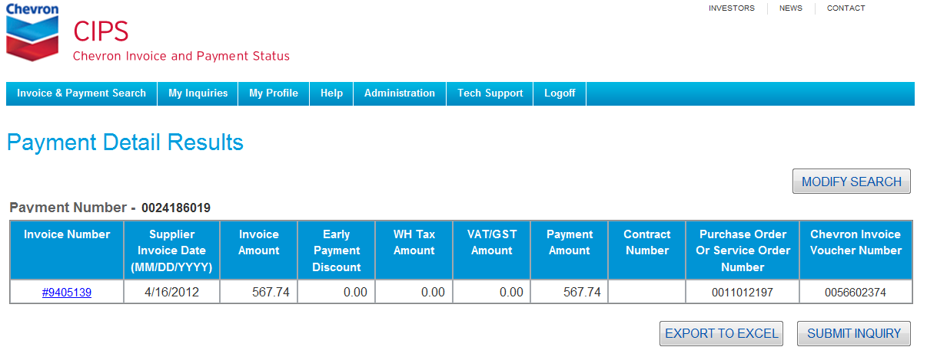

Click ***Submit Inquiry***.

The **Payment Inquiry** screen will appear.

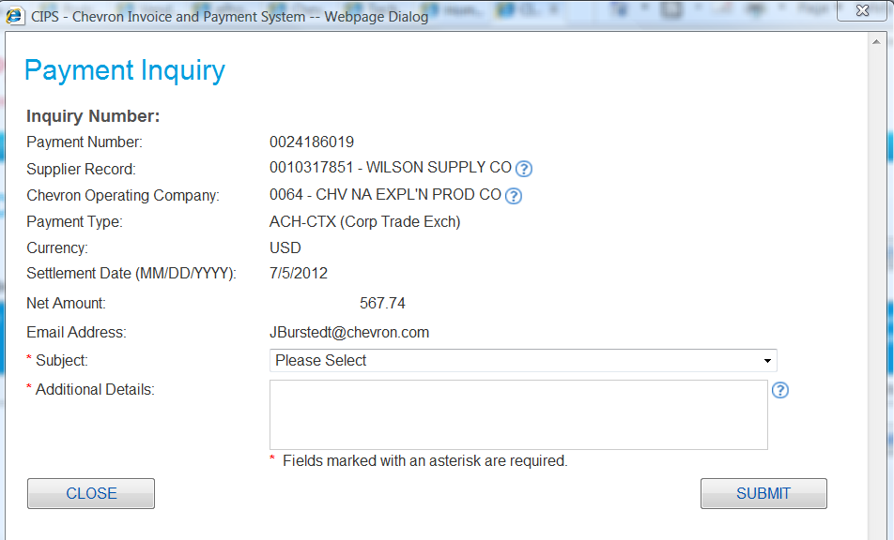

Choose the appropriate Subject and, to ensure a timely and complete response, please provide as much detail as possible in the Additional Details field and click ***Submit.*** (Click ***Cancel*** to return to the **Invoice Detail Results** screen.)

You’ll receive an on-screen confirmation if all the required information has been provided.

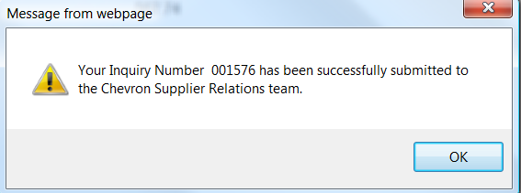

Click ***OK***. When your Inquiry has been answered, you’ll be notified by Email with instructions on how to find the response.

[Back to Top]

# HOW DO I MONITOR THE STATUS OF MY INQUIRIES?

All of your inquiries will be displayed in an **Inquiry Status** screen on your My Inquiries tab, with the Open inquiries listed first. Use the optional Inquiry Number drop down field to find a specific inquiry. The display can be sorted by clicking on the column headers. An ‘Open’ inquiry is one which has been submitted and routed to Supplier Relations for resolution, while a ‘Closed’ inquiry is one where an answer has been provided. Inquires will be answered in the order received. Because Chevron operates worldwide in multiple time zones, responses typically will be provided within 3 business days.

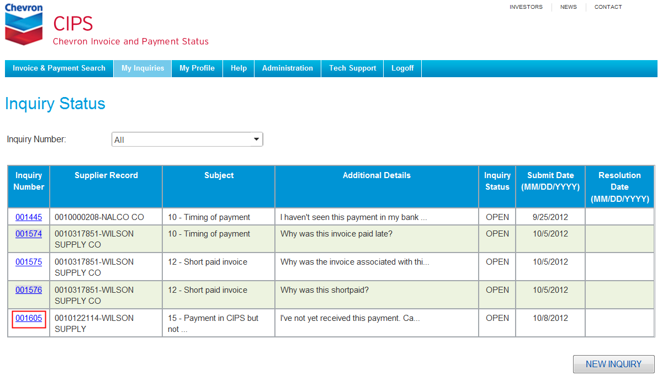

To view a response for an Inquiry which has been Resolved, click the ***Inquiry Number.***

The Inquiry pop-up window will appear.

Review the response to your Inquiry. When finished, click ***Close***.

[Back to Top]

# As a supplier, hOW DO I MAINTAIN THE GENERAL ATTRIBUTES OF MY USER PROFILE?

General User Profile attributes for Suppliers are defined to include First Name, Last Name, Email Address, Telephone Number and Preferred Language, and are found on the **My Profile** screen of the My Profile tab.

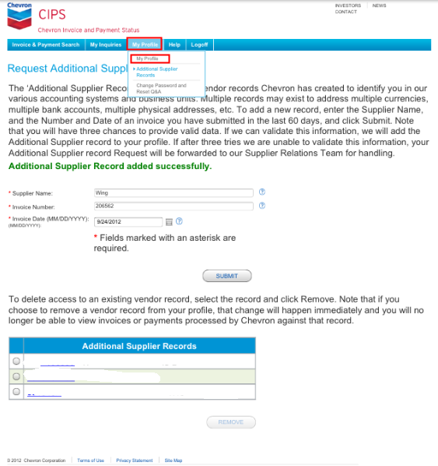

The *Language Preference* section allows you to change the language in which the CIPS screens will appear. Use the dropdown list to view and select the supported languages.

Make all desired changes and click ***Save***.

The **My Profile** screen will refresh with a success message.

[Back to Top]

# As a CHEVRON EMPLOYEE, hOW DO I MAINTAIN THE GENERAL ATTRIBUTES OF MY USER PROFILE?

User Profile attributes for employees are defined to include Search Defaults, Pipeline Access and Preferred Language. (Since CIPS access is controlled by Single-Sign-On and your Smart Badge, there is no password and your personal attributes cannot be changed.) User Profile attributes are found on the **My Profile Update** screen of the My Profile tab.

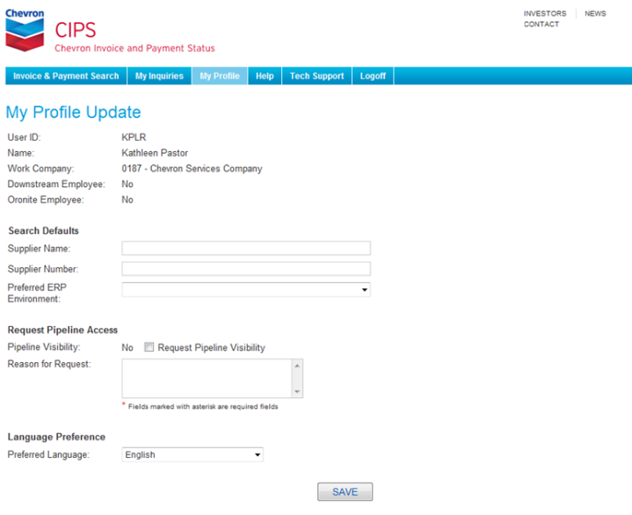

The *Search Defaults* section allows you to customize the Supplier Records that will automatically appear in the *Supplier Record* section of the **Search for Invoice and Payments** screen. Leave this section blank unless you want to limit your initial searches to only a few Suppliers.

The *Request Pipeline Access* section indicates if you have visibility to Supplier invoice activity with the Pipeline Company Codes. If not, and you need such visibility, click the Request Pipeline Visibility box and complete the Reason for Request field.

The *Language Preference* section allows you to change the language in which the CIPS screens will appear. Use the dropdown list to view and select the supported languages.

Make all desired changes and click ***Save***.

The **My Profile Update** screen will refresh with a success message.

With the exception of the request for visibility to Pipeline activity, all changes will be reflected immediately. Pipeline access requests will be separately routed for review and approval. You will be notified by Email when that review has been completed.

[Back to Top]

# How do I enroll for the Email or SMS Text delivery option for my remittance advices?

As a Supplier, you can receive remittance advices from CIPS via either Email and/or SMS text for each payment you receive from Chevron. (This delivery option will apply to each Supplier Record tied to your User ID.) Select the My Profile option on the My Profile tab to provide the required information. Select the Email Remittance and/or the SMS Tex Remittance options. 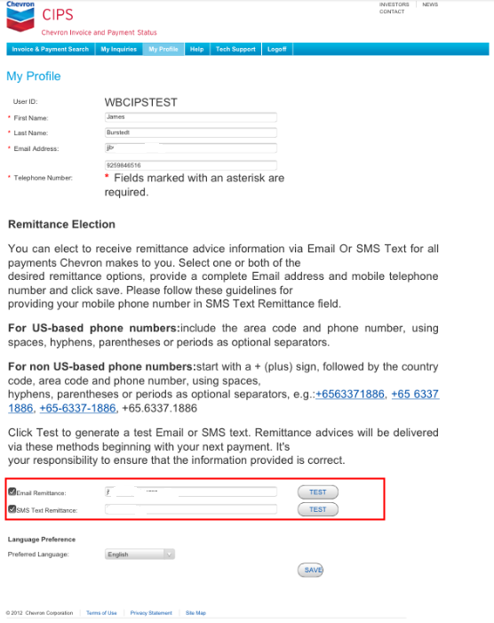

Provide the Email address and/or the telephone number to which you want the remittance advices sent (note the format requirements for the telephone numbers) and click ***Test***.

Note: The Email address and/or the telephone number used for delivery of the remittance advices can be different from those listed in the *General Profile* section.

You’ll receive an on-screen confirmation if all the required information has been provided.

Click ***OK*** to close the confirmation messages.

As soon as you’ve received the test messages, click ***Save***.

The *My Profile* screen will refresh with a success message.

The Emails will contain remittance information in three formats – HTML, CSV and ASCII. The HTML and CSV formats will include columns for Supplier Record, Chevron Operating Company, Settlement Date, Payment Document Number, Payment Method, Currency and Payment Amount in the header section. The detail section will include columns for Invoice Number, Supplier Invoice Date, Invoice Amount, Invoice Receipt Date, Payment Term, Early Payment Discount, Withholding Tax Amount, VAT/GST Amount, Payment Amount, Contract Number, Purchase Order or Service Order Number and Chevron Invoice Voucher Number.

The Texts will contain a CIPS Payment Notification label and fields for Settlement Date, Chevron Operating Company, Payment Document Number and Net Amount Paid (including currency), with each invoice separately listed by invoice number and net amount paid.

For additional information regarding the remittance advices, Users will be expected to log onto the CIPS website or contact their local Chevron Finance representative.

[Back to Top]

# How do I ADD ADDITIoNAL SUPPLIER RECORDS?

Chevron creates Supplier Records in our various accounting systems to uniquely identify Suppliers, using a combination of a randomly assigned number, your legal business name, and in the cases of Chevron’s non-U.S., upstream locations, a ‘country’ code. While the vast majority of Chevron’s Suppliers will only have a single Supplier Record, if you do business with Chevron in more than one country, with more than one Chevron legal entity or in more than one currency, then you will have been assigned multiple Supplier Records. To have visibility in CIPS to the activity in these additional Supplier Records, you’ll need to make individual requests to have them added to your User ID.

Select the Request Supplier Records option on the My Profile tab to provide the required information.

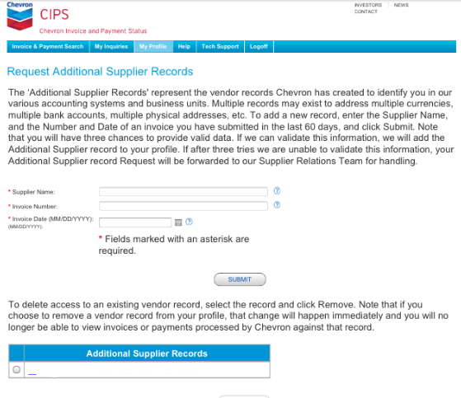

Enter at least a 2 character partial string in the Supplier Name field, and the exact Invoice Date and Invoice Number from an invoice submitted to Chevron within the last 60 calendar days, and click ***Submit***.

If the Supplier Name, Invoice Date and Invoice Number do not match an invoice in the CIPS database, an error message will be displayed.

If all the required data is provided and CIPS is able to authenticate your new invoice information, you’ll receive a success message and the new Supplier Record will be added to your list of available records.

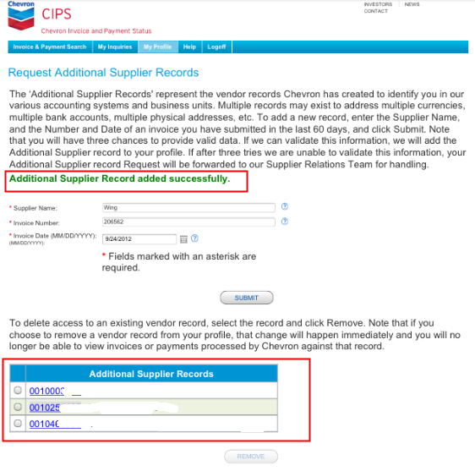

You also have the ability to delete Supplier Records that may no longer be needed. In this case, select the obsolete records in the *Additional Supplier Records* section and click ***Remove***.

[Back to Top]

# How do I CHANGE MY PASSWORD?

Select the Change Password option on the My Profile tab. The **Password Change** screen will appear.

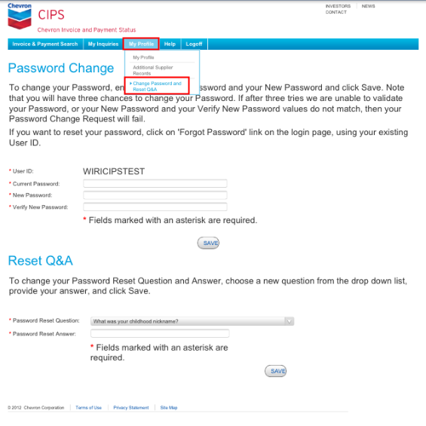

The Password Reset Question and Answer are required fields but do not have to be changed to change your password. Passwords must be between 8 and 20 characters and contain at least one Special Character, at least one numeric character, and at least one upper case alpha. Enter your Password information and click ***Save***.

If any required fields are missing, or if the Current Password, New Password or Confirm New Password field cannot be verified or don’t match, then an error message will be displayed.

Update your information and click ***Save***. The **Password Change** screen will refresh with a success message.

[Back to Top]

# As a Chevron employee, how do I request access to Chevron Pipeline activity?

Click the My Profile tab to view your **My Profile Update** screen.

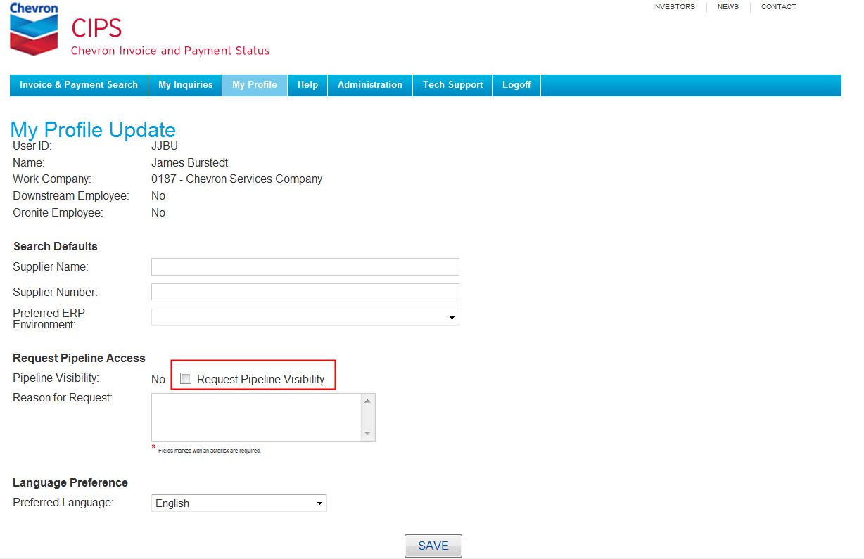

In the *Request Pipeline Access* section, check the Request Pipeline Visibility option, provide a Reason for Request and click ***Save***.

If the Reason for Request is missing then you’ll receive an error message.

When all the required data has been provided, you’ll receive a success message and your request will be forwarded to the Pipeline Approver. You will be notified by Email when their review has been completed.

[Back to Top]