**Morphine..**

**Research For : PhytoChemistery Department**

* **Presented By :**

1. **Aya Tareq Mohammed .**
2. **Aya Zoghly Elsayed .**
3. **Bassant Samy Ahmed .**
4. **Esraa Mohsen Mahmoud .**
5. **Eslam Mohammed Hany .**
6. **Kariem Mohammed Hemdan .**
7. **Salma Khaled Abd-Elfattah .**
8. **Sandy Essam Youssef .**
9. **Marwa Rashad Ibraheim .**

**10-Mai Omaya Khalil .**

**11- Youssra Alaa Ibraheim .**

* **Presented To :-**

**Dr.Amany Kamal Ibraheim.**

**Dr .Dina Mohammed .**

**General Information :**

**Morphine is a** [**pain medication**](https://en.wikipedia.org/wiki/Analgesic) **of the** [**opiate**](https://en.wikipedia.org/wiki/Opiate) **type which is found naturally in a number of plants and animals. It acts directly on the** [**central nervous system**](https://en.wikipedia.org/wiki/Central_nervous_system) **(CNS) to decrease the feeling of pain. It can be taken for both** [**acute pain**](https://en.wikipedia.org/wiki/Acute_pain) **and** [**chronic pain**](https://en.wikipedia.org/wiki/Chronic_pain)**. Morphine is frequently used for pain from** [**myocardial infarction**](https://en.wikipedia.org/wiki/Myocardial_infarction) **and during** [**labour**](https://en.wikipedia.org/wiki/Childbirth)**. It can be given by mouth, by** [**injection into a muscle**](https://en.wikipedia.org/wiki/Intramuscular)**, by** [**injecting under the skin**](https://en.wikipedia.org/wiki/Subcutaneous_injection)**,** [**intravenously**](https://en.wikipedia.org/wiki/Intravenously)**, into the space around the** [**spinal cord**](https://en.wikipedia.org/wiki/Spinal_cord)**, or** [**rectally**](https://en.wikipedia.org/wiki/Rectal_administration)**. Maximum effect is around 20 min when given intravenously and 60 min when given by mouth while duration of effect is between three and seven hours.**

**Formulation :**

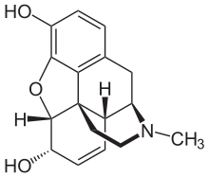 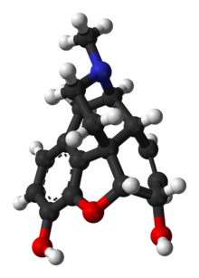

**C17H19NO3**

**Natural occurrence**

[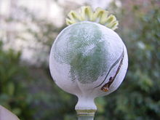](https://en.wikipedia.org/wiki/File:Slaapbol_R0017600.JPG)

**A freshly-scored opium poppy seedpod bleeding latex.**

**Morphine is the most abundant opiate found in** [**opium**](https://en.wikipedia.org/wiki/Opium)**, the dried** [**latex**](https://en.wikipedia.org/wiki/Latex) **extracted by shallowly scoring the unripe seedpods of the** [***Papaver somniferum***](https://en.wikipedia.org/wiki/Papaver_somniferum) **poppy. Morphine is generally 8–14% of the dry weight of opium, although specially bred** [**cultivars**](https://en.wikipedia.org/wiki/Cultivar) **reach 26% or produce little morphine at all (under 1%, perhaps down to 0.04%). The latter varieties, including the 'Przemko' and 'Norman' cultivars of the opium poppy, are used to produce two other alkaloids,** [**thebaine**](https://en.wikipedia.org/wiki/Thebaine) **and** [**oripavine**](https://en.wikipedia.org/wiki/Oripavine)**, which are used in the manufacture of semi-synthetic and synthetic opioids like** [**oxycodone**](https://en.wikipedia.org/wiki/Oxycodone) **and** [**etorphine**](https://en.wikipedia.org/wiki/Etorphine) **and some other types of drugs.** [***P. bracteatum***](https://en.wikipedia.org/wiki/Papaver_bracteatum) **does not contain morphine or** [**codeine**](https://en.wikipedia.org/wiki/Codeine)**, or other narcotic** [**phenanthrene**](https://en.wikipedia.org/wiki/Phenanthrene)**-type, alkaloids. This species is rather a source of** [**thebaine**](https://en.wikipedia.org/wiki/Thebaine)**. Occurrence of morphine in other** [**Papaverales**](https://en.wikipedia.org/wiki/Papaverales) **and** [**Papaveraceae**](https://en.wikipedia.org/wiki/Papaveraceae)**, as well as in some species of** [**hops**](https://en.wikipedia.org/wiki/Hops) **and** [**mulberry**](https://en.wikipedia.org/wiki/Mulberry) **trees has not been confirmed. Morphine is produced most predominantly early in the life cycle of the plant. Past the optimum point for extraction, various processes in the plant produce codeine,** [**thebaine**](https://en.wikipedia.org/wiki/Thebaine)**, and in some cases negligible amounts of** [**hydromorphone**](https://en.wikipedia.org/wiki/Hydromorphone)**,** [**dihydromorphine**](https://en.wikipedia.org/wiki/Dihydromorphine)**,** [**dihydrocodeine**](https://en.wikipedia.org/wiki/Dihydrocodeine)**, tetrahydro-thebaine, and** [**hydrocodone**](https://en.wikipedia.org/wiki/Hydrocodone) **(these compounds are rather synthesized from thebaine and oripavine).**

**Before using morphine :**

You should not take this medicine if you have ever had an allergic reaction to morphine or other narcotic medicines, or if you have:

* severe asthma or breathing problems;
* a blockage in your stomach or intestines; or
* a bowel obstruction called paralytic ileus.

Do not use morphine if you have used a MAO inhibitor in the past 14 days. A dangerous drug interaction could occur. MAO inhibitors include isocarboxazid, linezolid, methylene blue injection, phenelzine, rasagiline, selegiline, tranylcypromine, and others.

Some medicines can interact with morphine and cause a serious condition called [serotonin syndrome](https://www.drugs.com/mcd/serotonin-syndrome). Be sure your doctor knows if you also take medicine for depression, mental illness, Parkinson's disease, migraine headaches, serious infections, or prevention of nausea and vomiting. Ask your doctor before making any changes in how or when you take your medications.

To make sure morphine is safe for you, tell your doctor if you have:

* any type of breathing problem or lung disease;
* a history of head injury, brain tumor, or seizures;
* a history of drug abuse, alcohol addiction, or mental illness;
* urination problems;
* liver or kidney disease;
* problems with your gallbladder, pancreas, or thyroid; or
* if you use a sedative like Valium (diazepam, alprazolam, lorazepam, Ativan, Klonopin, Restoril, Tranxene, Versed, Xanax, and others).
* It is not known whether this medicine will harm an unborn baby. If you use morphine while you are pregnant, your baby could become dependent on the drug. This can cause life-threatening withdrawal symptoms in the baby after it is born. Babies born dependent on habit-forming medicine may need medical treatment for several weeks. Tell your doctor if you are pregnant or plan to become pregnant.

## Medical uses

### Pain: Morphine is used primarily to treat both acute and chronic severe [pain](https://en.wikipedia.org/wiki/Pain). It is also used for pain due to [myocardial infarction](https://en.wikipedia.org/wiki/Myocardial_infarction) and for labor pains. Its duration of analgesia is about three to seven hours.

**However, concerns exist that morphine may increase mortality in the setting of** [**non ST elevation myocardial infarction**](https://en.wikipedia.org/wiki/Non_ST_elevation_myocardial_infarction)**. Morphine has also traditionally been used in the treatment of** [**acute pulmonary edema**](https://en.wikipedia.org/wiki/Acute_pulmonary_edema)**. A 2006 review, though, found little evidence to support this practice. A 2016 Cochrane review concluded that morphine is effective in relieving cancer pain. Side-effects of nausea and constipation are rarely severe enough to warrant stopping treatment.**

### Shortness of breath: Immediate-release morphine is beneficial in reducing the symptom of [shortness of breath](https://en.wikipedia.org/wiki/Shortness_of_breath) due to both [cancer](https://en.wikipedia.org/wiki/Cancer) and noncancer causes. In the setting of breathlessness at rest or on minimal exertion from conditions such as advanced cancer or end-stage cardiorespiratory diseases, regular, low-dose sustained-release morphine significantly reduces breathlessness safely, with its benefits maintained over time.

### Opioid use disorder: Morphine is also available as a slow-release formulation for [opiate substitution therapy](https://en.wikipedia.org/wiki/Opiate_substitution_therapy) (OST) in Austria, Bulgaria, and Slovenia, for addicts who cannot tolerate either methadone or [buprenorphine](https://en.wikipedia.org/wiki/Buprenorphine).

## How should I use morphine?

Take morphine exactly as prescribed by your doctor. Follow all directions on your prescription label. Morphine can slow or stop your breathing, especially when you start using this medicine or whenever you dose is changed. Never take morphine in larger amounts, or for longer than prescribed. Tell your doctor if the medicine seems to stop working as well in relieving your pain.

Morphine may be habit-forming, even at regular doses. Never share this medicine with another person, especially someone with a history of drug abuse or addiction. **MISUSE OF NARCOTIC MEDICINE CAN CAUSE ADDICTION, OVERDOSE, OR DEATH, especially in a child or other person using the medicine without a prescription. Selling or giving away morphine to any other person is against the law.**

Always check your bottle to make sure you have received the correct pills (same brand and type) of medicine prescribed by your doctor. Ask the pharmacist if you have any questions about the medicine you receive at the pharmacy.

Stop taking all other around-the-clock narcotic pain medications when you start taking morphine.

Do not crush, chew, or break an **extended-release tablet**. Swallow it whole to avoid exposure to a potentially fatal dose.

To make swallowing easier, you may open the Avinza capsule and sprinkle the medicine into a spoonful of applesauce. Swallow right away without chewing. Do not save the mixture for later use.

Measure liquid medicine with a special dose-measuring spoon or medicine cup, not with a regular table spoon. If you do not have a dose-measuring device, ask your pharmacist for one.

Take the medicine at the same time each day.

**Do not stop using morphine suddenly, or you could have unpleasant withdrawal symptoms. Ask your doctor how to safely stop using this medicine.**

**Never crush or break a morphine pill to inhale the powder or mix it into a liquid to inject the drug into your vein. This practice has resulted in death with the misuse of morphine and similar prescription drugs.**

**Store at room temperature, away from heat, moisture, and light.**

**Keep track of the amount of medicine used from each new bottle. Morphine is a drug of abuse and you should be aware if anyone is using your medicine improperly or without a prescription.**

**Do not keep leftover morphine pills or liquid. Ask your pharmacist where to locate a drug take-back disposal program. If there is no take-back program, flush any unused pills or liquid down the toilet. Disposal of medicines by flushing is recommended to reduce the danger of accidental overdose causing death. This advice applies to a very small number of medicines only. The FDA, working with the manufacturer, has determined this method to be the most appropriate route of disposal and presents the least risk to human safety.**

## What happens if I miss a dose?

**Morphine is sometimes taken only once per day, and sometimes 2 or 3 times per day. Since morphine is used for pain, you are not likely to miss a dose. If you do miss a dose, take the medicine as soon as you remember. Then take your next dose as follows:**

* **If you take morphine 3 times per day: Take your next dose 8 hours after taking the missed dose.**
* **If you take morphine 2 times per day: Take your next dose 12 hours after taking the missed dose.**
* **If you take morphine 1 time per day: Take your next dose 24 hours after taking the missed dose.**

**Do not take extra medicine to make up a missed dose. Do not take more than your prescribed dose in a 24-hour period.**

## What happens if I overdose?

Seek emergency medical attention or call the Poison Help line at 1-800-222-1222. **A morphine overdose can be fatal, especially in a child or other person using the medicine without a prescription.** Overdose symptoms may include slow breathing and heart rate, severe drowsiness, muscle weakness, cold and clammy skin, pinpoint pupils, and fainting.

## What should I avoid?

**Do not drink alcohol. Dangerous side effects or death can occur when alcohol is combined with morphine.**

**This medication may impair your thinking or reactions. Avoid driving or operating machinery until you know how morphine will affect you. Dizziness or severe drowsiness can cause falls or other accidents.**

## Morphine side effects

**Get emergency medical help if you have signs of an allergic reaction to morphine: hives; difficult breathing; swelling of your face, lips, tongue, or throat.**

**Like other narcotic medicines, morphine can slow your breathing. Death may occur if breathing becomes too weak.**

**Call your doctor at once if you have:**

* **slow heart rate, sighing, weak or shallow breathing;**
* **chest pain, fast or pounding heartbeats;**
* **extreme drowsiness, feeling like you might pass out;**
* **infertility, missed menstrual periods;**
* **impotence, sexual problems, loss of interest in sex; or**
* **low cortisol levels - nausea, vomiting, loss of appetite, dizziness, worsening tiredness or weakness.**

**Seek medical attention right away if you have symptoms of serotonin syndrome, such as: agitation, hallucinations, fever, sweating, shivering, fast heart rate, muscle stiffness, twitching, loss of coordination, nausea, vomiting, or diarrhea.**

**Morphine is more likely to cause breathing problems in older adults and people who are severely ill, malnourished, or otherwise debilitated.**

**Common morphine side effects may include:**

* **drowsiness, dizziness;**
* **constipation, stomach pain, nausea, vomiting;**
* **headache, tired feeling;**
* **anxiety; or**
* **mild itching.**

**Test of Morphine Alkaloid :-**



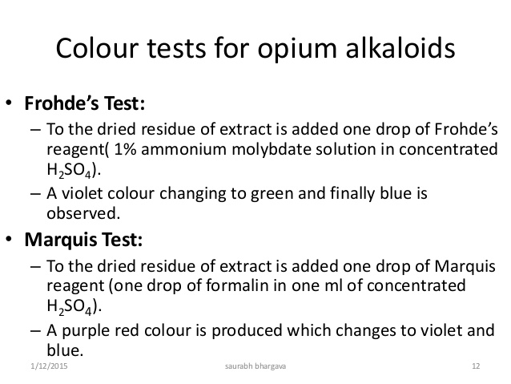

**Morphine Drugs Examples :-**

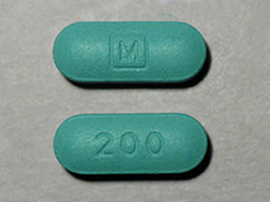

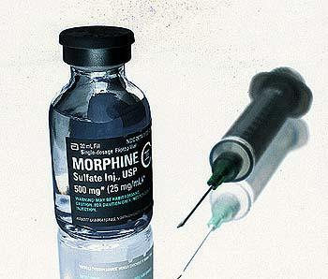

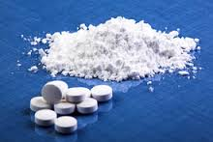

**Reference :-**

**1 logo.png**



