组装主体六个角件  
http://www.hkepc.com/forum/images/default/attachimg.gif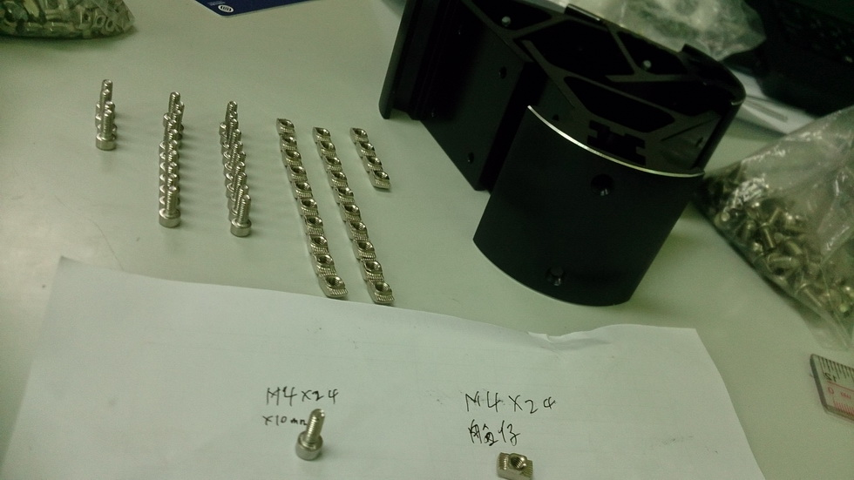

[**下載**](http://www.hkepc.com/forum/attachment.php?aid=MTc1ODgwOHxlMDEzYTRkYXwxNDI2ODA3MzE5fGI0ZWU0UGVPZkZuN2NPa240aHN6RlZISmpHTEsyblF5Q3Vudk9XT29LY3UrME5B&nothumb=yes) (134.3 KB)

2015-1-30 12:16

1) 所需零件如图  
http://www.hkepc.com/forum/images/default/attachimg.gif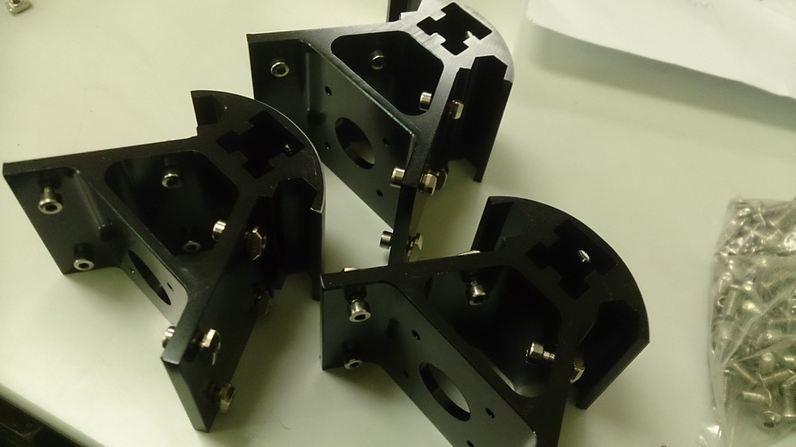[**下載**](http://www.hkepc.com/forum/attachment.php?aid=MTc1ODgwOXw0NmRlZjYxNnwxNDI2ODA3MzE5fGI0ZWU0UGVPZkZuN2NPa240aHN6RlZISmpHTEsyblF5Q3Vudk9XT29LY3UrME5B&nothumb=yes) (123.08 K2015-1-30 12:16

2) 将螺丝装上，船底向外  
http://www.hkepc.com/forum/images/default/attachimg.gif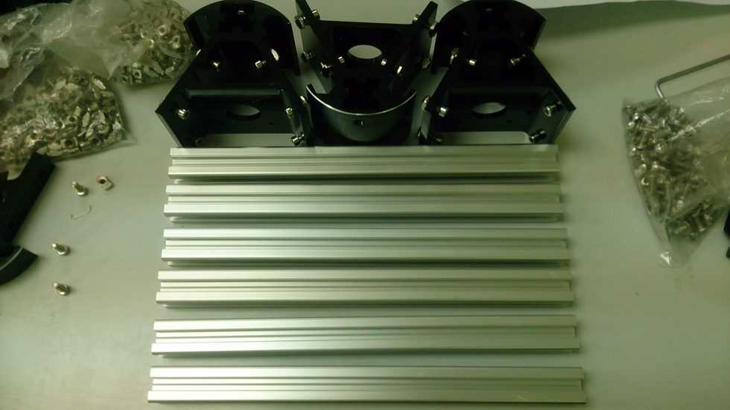

[**下載**](http://www.hkepc.com/forum/attachment.php?aid=MTc1ODgxMHxiM2IxMjBhYnwxNDI2ODA3MzE5fGI0ZWU0UGVPZkZuN2NPa240aHN6RlZISmpHTEsyblF5Q3Vudk9XT29LY3UrME5B&nothumb=yes) (145.02 KB)

2015-1-30 12:16

3) 准备6支短的铝型材  
http://www.hkepc.com/forum/images/default/attachimg.gif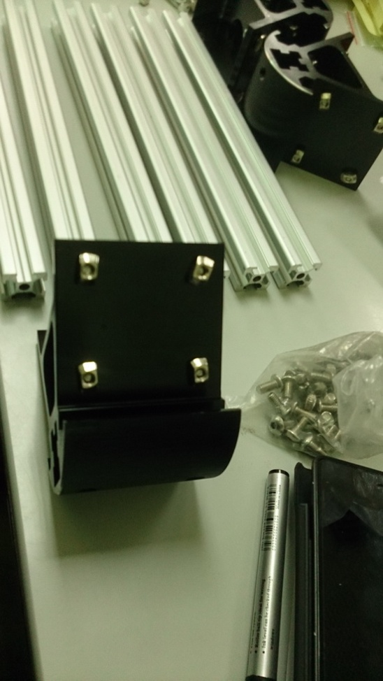

[**下載**](http://www.hkepc.com/forum/attachment.php?aid=MTc1ODgxMXwxOGRmYjU3MnwxNDI2ODA3MzE5fGI0ZWU0UGVPZkZuN2NPa240aHN6RlZISmpHTEsyblF5Q3Vudk9XT29LY3UrME5B&nothumb=yes) (144.08 KB)

2015-1-30 12:16

4) 放平那些船形螺母，方便卡上铝型材  
http://www.hkepc.com/forum/images/default/attachimg.gif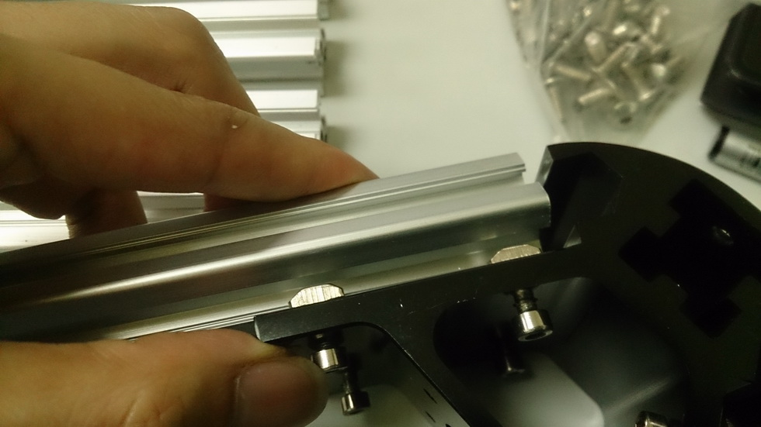

[**下載**](http://www.hkepc.com/forum/attachment.php?aid=MTc1ODgxMnwxY2NkZjQ3MXwxNDI2ODA3MzE5fGI0ZWU0UGVPZkZuN2NPa240aHN6RlZISmpHTEsyblF5Q3Vudk9XT29LY3UrME5B&nothumb=yes) (124.1 KB)

2015-1-30 12:16

5) 这样会容易卡一点http://www.hkepc.com/forum/images/default/attachimg.gif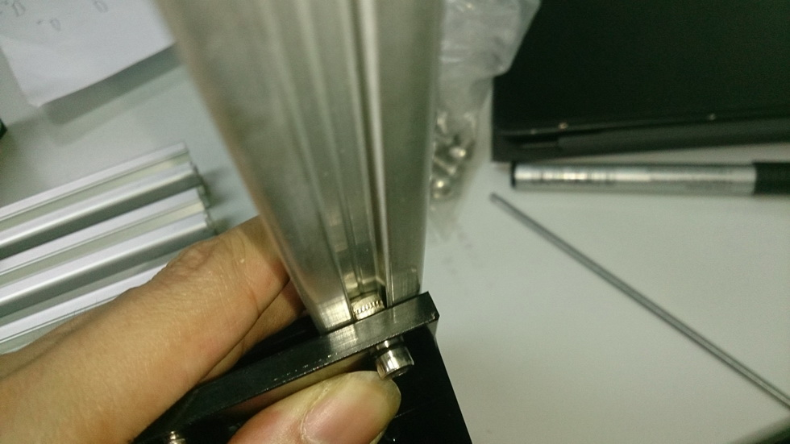

[**下載**](http://www.hkepc.com/forum/attachment.php?aid=MTc1ODgxM3xhYjc1MjcwZnwxNDI2ODA3MzE5fGI0ZWU0UGVPZkZuN2NPa240aHN6RlZISmpHTEsyblF5Q3Vudk9XT29LY3UrME5B&nothumb=yes) (130.56 KB)

2015-1-30 12:16

6) 装完上去，未上紧的时候会是直的  
http://www.hkepc.com/forum/images/default/attachimg.gif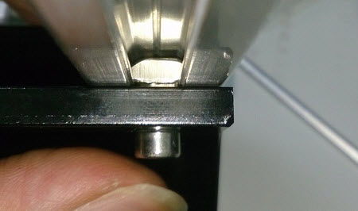

[**下載**](http://www.hkepc.com/forum/attachment.php?aid=MTc1ODgxN3xlNWM3ZmYyMXwxNDI2ODA3MzE5fGI0ZWU0UGVPZkZuN2NPa240aHN6RlZISmpHTEsyblF5Q3Vudk9XT29LY3UrME5B&nothumb=yes) (17.85 KB)

2015-1-30 12:16

7) 上紧时转的力会自动将船形螺母打横，注意如果船仔螺母上得太贴就不会转动  
http://www.hkepc.com/forum/images/default/attachimg.gif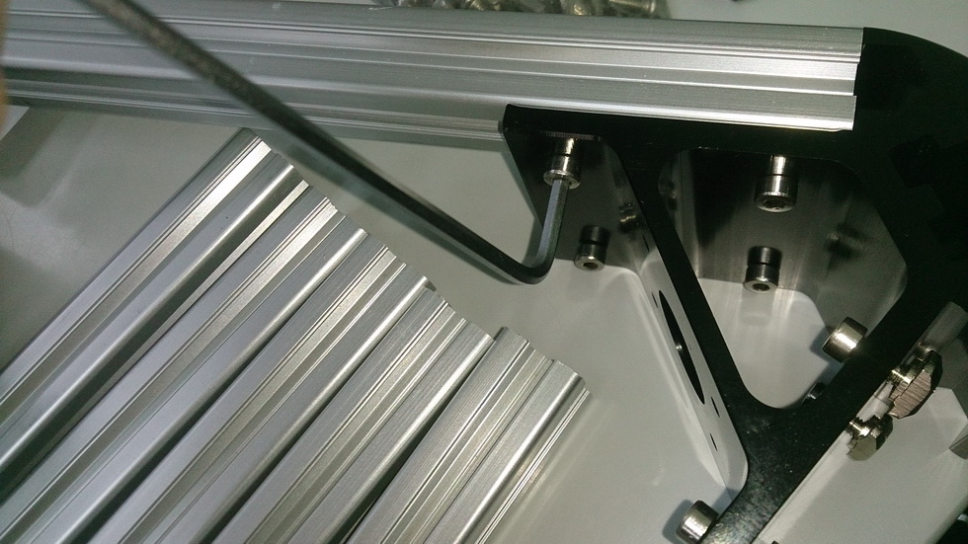

[**下載**](http://www.hkepc.com/forum/attachment.php?aid=MTc1ODgxNHxlMmE5ZTRmZnwxNDI2ODA3MzE5fGI0ZWU0UGVPZkZuN2NPa240aHN6RlZISmpHTEsyblF5Q3Vudk9XT29LY3UrME5B&nothumb=yes) (198.61 KB)

2015-1-30 12:16

8)上紧时建议先上里面那个个，因为这样可以拉一拉铝型材看看是否上紧，来确认船仔螺母是否打横了  
http://www.hkepc.com/forum/images/default/attachimg.gif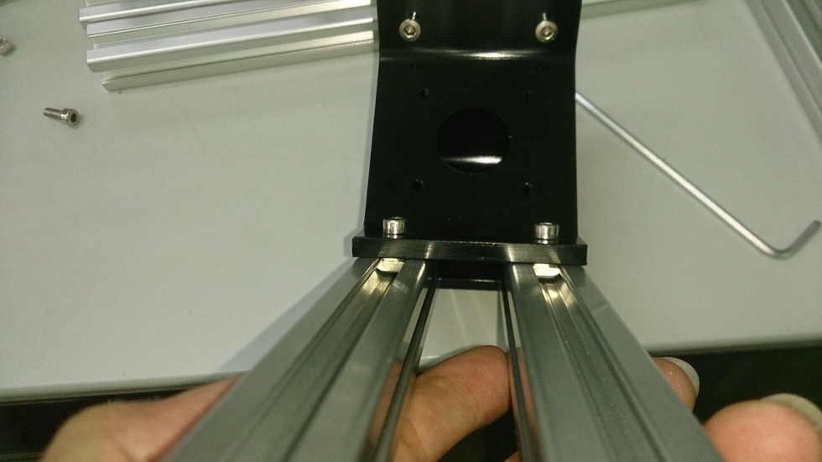

[**下載**](http://www.hkepc.com/forum/attachment.php?aid=MTc1ODgxNXwwODY3MGRhNnwxNDI2ODA3MzE5fGI0ZWU0UGVPZkZuN2NPa240aHN6RlZISmpHTEsyblF5Q3Vudk9XT29LY3UrME5B&nothumb=yes) (126.88 KB)

2015-1-30 12:16

9) 检查有没有上好  
http://www.hkepc.com/forum/images/default/attachimg.gif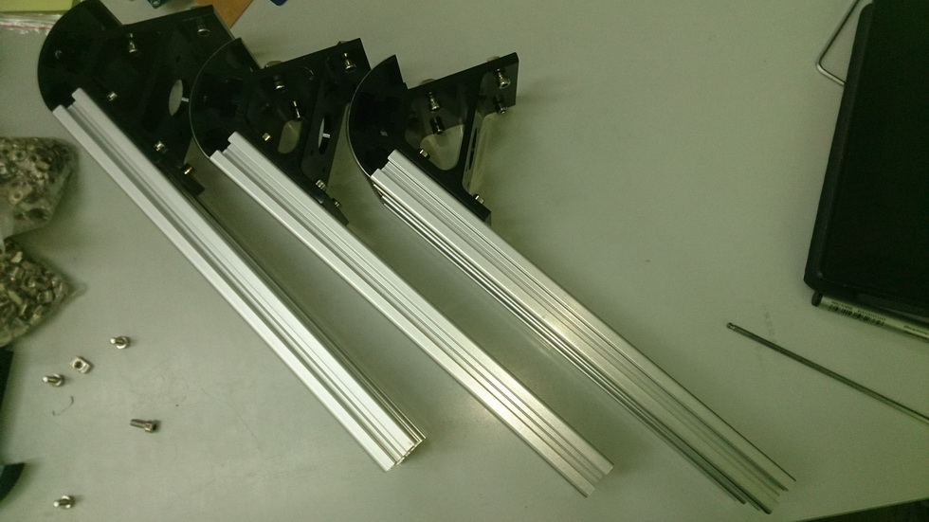

[**下載**](http://www.hkepc.com/forum/attachment.php?aid=MTc1ODgxNnxlZTVlYzNlNnwxNDI2ODA3MzE5fGI0ZWU0UGVPZkZuN2NPa240aHN6RlZISmpHTEsyblF5Q3Vudk9XT29LY3UrME5B&nothumb=yes) (149.94 KB)

2015-1-30 12:16

10)底层半组完成  
http://www.hkepc.com/forum/images/default/attachimg.gif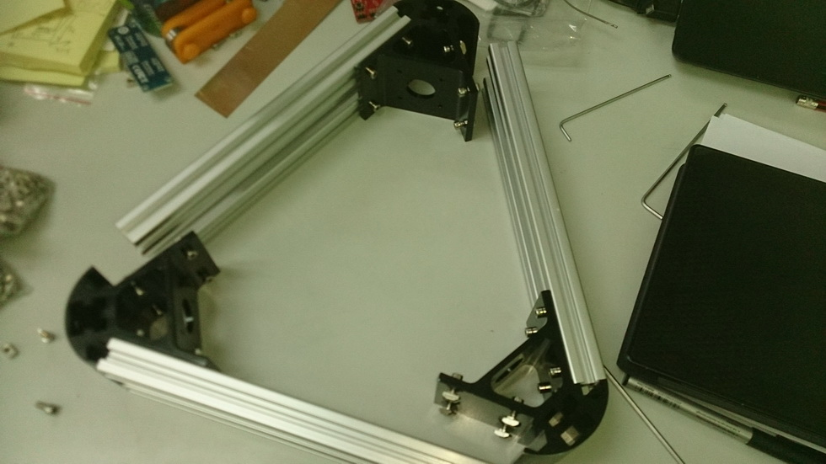

[**下載**](http://www.hkepc.com/forum/attachment.php?aid=MTc1ODgyOXw0MDgzNTJiNHwxNDI2ODA3MzE5fGI0ZWU0UGVPZkZuN2NPa240aHN6RlZISmpHTEsyblF5Q3Vudk9XT29LY3UrME5B&nothumb=yes) (141.54 KB)

2015-1-30 13:03

11)放好位置，全部卡好  
http://www.hkepc.com/forum/images/default/attachimg.gif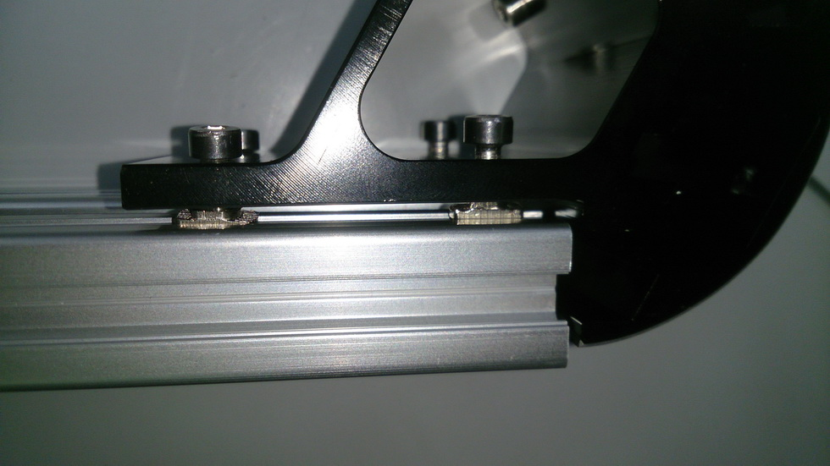

[**下載**](http://www.hkepc.com/forum/attachment.php?aid=MTc1ODgzMHxiZjc5MTEzNXwxNDI2ODA3MzE5fGI0ZWU0UGVPZkZuN2NPa240aHN6RlZISmpHTEsyblF5Q3Vudk9XT29LY3UrME5B&nothumb=yes) (140.03 KB)

2015-1-30 13:03

12)卡进去时要注意船形螺丝螺母不可以太实  
http://www.hkepc.com/forum/images/default/attachimg.gif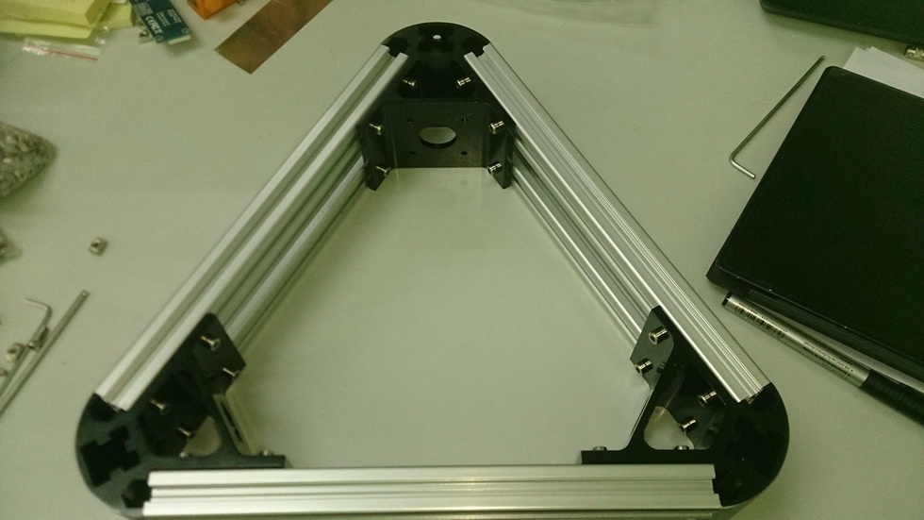

[**下載**](http://www.hkepc.com/forum/attachment.php?aid=MTc1ODgzMXwzNTU4MmZkZXwxNDI2ODA3MzE5fGI0ZWU0UGVPZkZuN2NPa240aHN6RlZISmpHTEsyblF5Q3Vudk9XT29LY3UrME5B&nothumb=yes) (146 KB)

2015-1-30 13:03

13) 底层完成  
  
http://www.hkepc.com/forum/images/default/attachimg.gif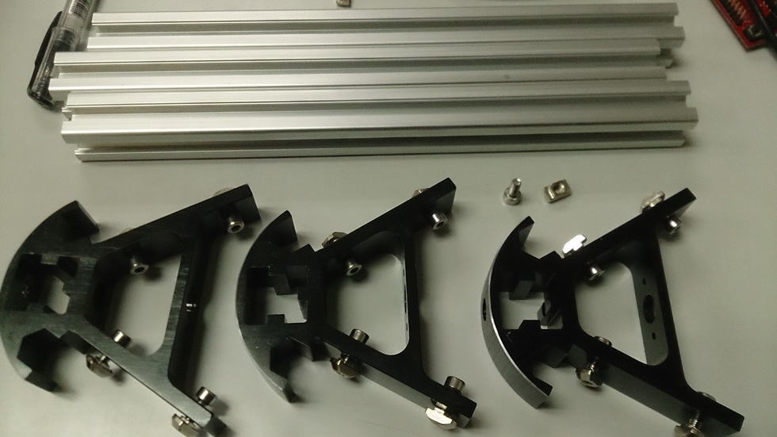

[**下載**](http://www.hkepc.com/forum/attachment.php?aid=MTc1ODgzMnxjOTJjNzhmM3wxNDI2ODA3MzE5fGI0ZWU0UGVPZkZuN2NPa240aHN6RlZISmpHTEsyblF5Q3Vudk9XT29LY3UrME5B&nothumb=yes) (140.29 KB)

2015-1-30 13:03

14)上层同样这样做。  
http://www.hkepc.com/forum/images/default/attachimg.gif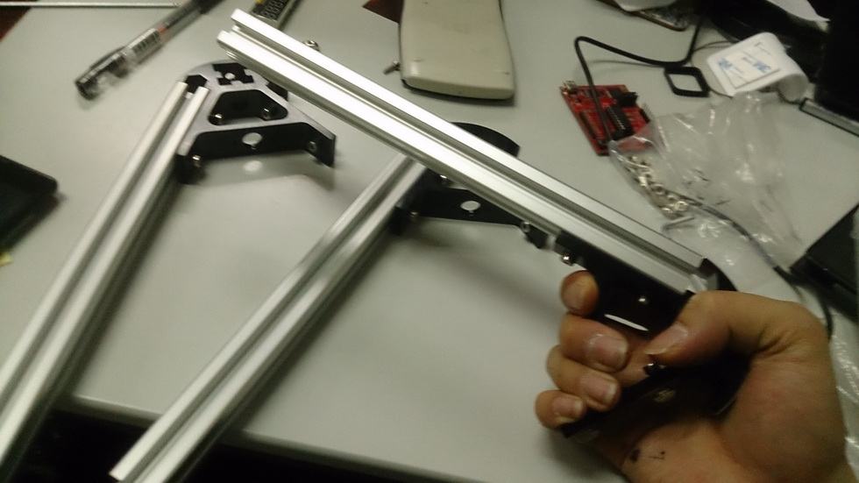

[**下載**](http://www.hkepc.com/forum/attachment.php?aid=MTc1ODgzM3w1ZWZhOTgxMXwxNDI2ODA3MzE5fGI0ZWU0UGVPZkZuN2NPa240aHN6RlZISmpHTEsyblF5Q3Vudk9XT29LY3UrME5B&nothumb=yes) (141.78 KB)

2015-1-30 13:03

15)半组完成  
http://www.hkepc.com/forum/images/default/attachimg.gif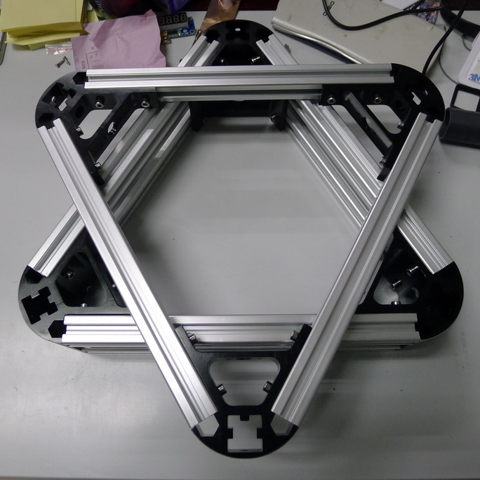

[**下載**](http://www.hkepc.com/forum/attachment.php?aid=MTc1ODgzNHxhNzkxYTliOHwxNDI2ODA3MzE5fGI0ZWU0UGVPZkZuN2NPa240aHN6RlZISmpHTEsyblF5Q3Vudk9XT29LY3UrME5B&nothumb=yes) (148.29 KB)

2015-1-30 13:03

16)主体六芒星完成  
  
安装顶层皮带轮  
http://www.hkepc.com/forum/images/default/attachimg.gif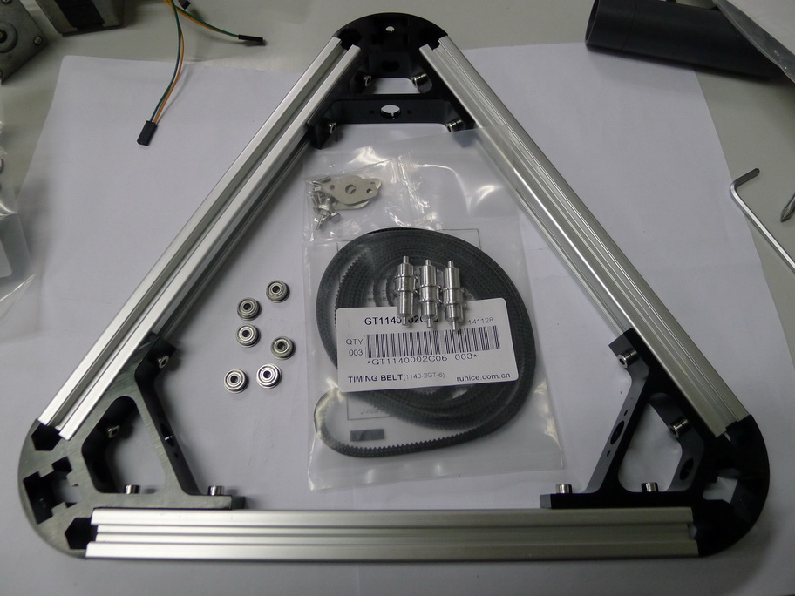

[**下載**](http://www.hkepc.com/forum/attachment.php?aid=MTc1ODgzNXw4YWRiMzkyY3wxNDI2ODA3MzE5fGI0ZWU0UGVPZkZuN2NPa240aHN6RlZISmpHTEsyblF5Q3Vudk9XT29LY3UrME5B&nothumb=yes) (178.77 KB)

2015-1-30 13:08

1)材料如图，如果你同我一样用闭圈的皮带，需注意这儿是要先装上。  
http://www.hkepc.com/forum/images/default/attachimg.gif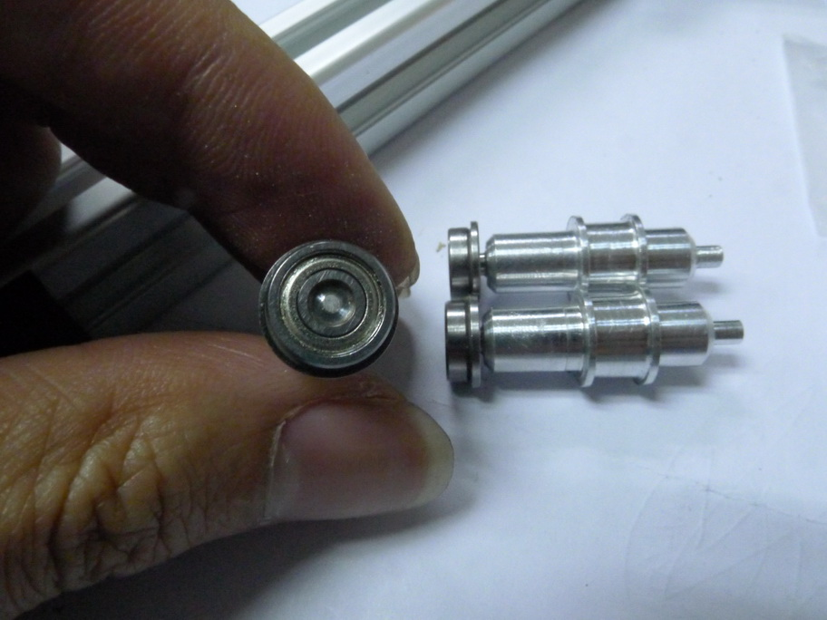

[**下載**](http://www.hkepc.com/forum/attachment.php?aid=MTc1ODgzN3wwNThlZmI3MnwxNDI2ODA3MzE5fGI0ZWU0UGVPZkZuN2NPa240aHN6RlZISmpHTEsyblF5Q3Vudk9XT29LY3UrME5B&nothumb=yes) (158.02 KB)

2015-1-30 13:08

http://www.hkepc.com/forum/images/default/attachimg.gif[**下載**](http://www.hkepc.com/forum/attachment.php?aid=MTc1ODgzNnwyZWE5NzkyZnwxNDI2ODA3MzE5fGI0ZWU0UGVPZkZuN2NPa240aHN6RlZISmpHTEsyblF5Q3Vudk9XT29LY3UrME5B&nothumb=yes) (154.41 KB)

2015-1-30 13:08

2)轴承是用有法兰那种。   
3)先装长那边，轴承边靠近皮带轮  
3.5)如果用闭合式皮带，这里就要先穿上  
http://www.hkepc.com/forum/images/default/attachimg.gif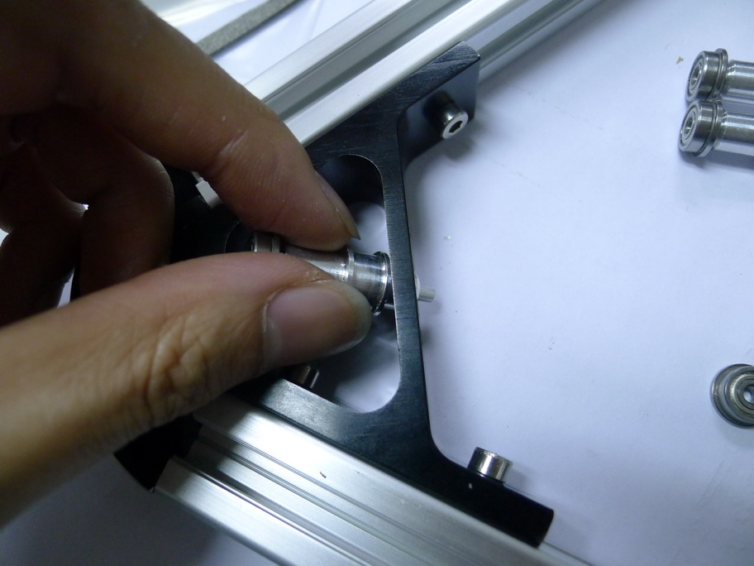

[**下載**](http://www.hkepc.com/forum/attachment.php?aid=MTc1ODgzOHw4NTNiYjExNnwxNDI2ODA3MzE5fGI0ZWU0UGVPZkZuN2NPa240aHN6RlZISmpHTEsyblF5Q3Vudk9XT29LY3UrME5B&nothumb=yes) (153.83 KB)

2015-1-30 13:08

4)先将短头那边穿过  
http://www.hkepc.com/forum/images/default/attachimg.gif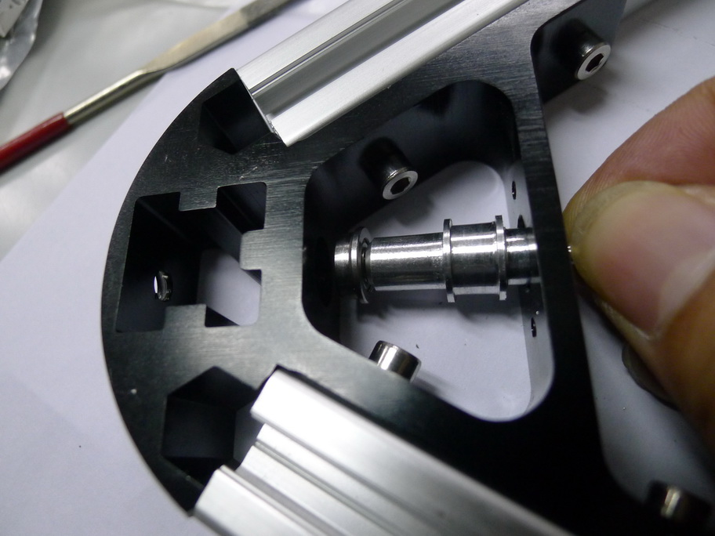

[**下載**](http://www.hkepc.com/forum/attachment.php?aid=MTc1ODgzOXxmN2IxMjBhZnwxNDI2ODA3MzE5fGI0ZWU0UGVPZkZuN2NPa240aHN6RlZISmpHTEsyblF5Q3Vudk9XT29LY3UrME5B&nothumb=yes) (160.86 KB)

2015-1-30 13:08

5)再将长过边推入架上边个槽  
http://www.hkepc.com/forum/images/default/attachimg.gif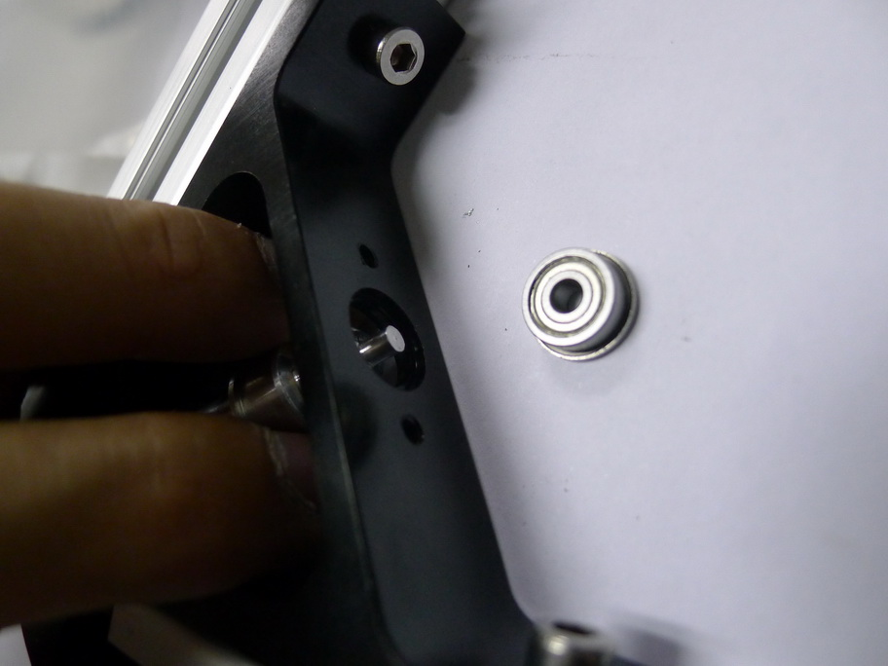

[**下載**](http://www.hkepc.com/forum/attachment.php?aid=MTc1ODg0MHw0OTkxMzA5MnwxNDI2ODA3MzE5fGI0ZWU0UGVPZkZuN2NPa240aHN6RlZISmpHTEsyblF5Q3Vudk9XT29LY3UrME5B&nothumb=yes) (121.51 KB)

2015-1-30 13:08

http://www.hkepc.com/forum/images/default/attachimg.gif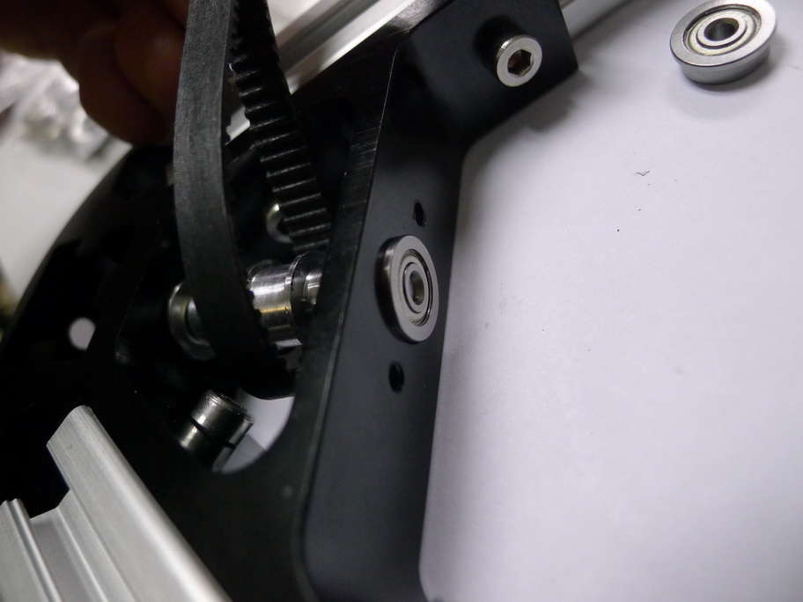

[**下載**](http://www.hkepc.com/forum/attachment.php?aid=MTc1ODg0MXxhZjYzZTMxZHwxNDI2ODA3MzE5fGI0ZWU0UGVPZkZuN2NPa240aHN6RlZISmpHTEsyblF5Q3Vudk9XT29LY3UrME5B&nothumb=yes) (134.35 KB)

2015-1-30 13:08

6)套上另一边的轴承  
http://www.hkepc.com/forum/images/default/attachimg.gif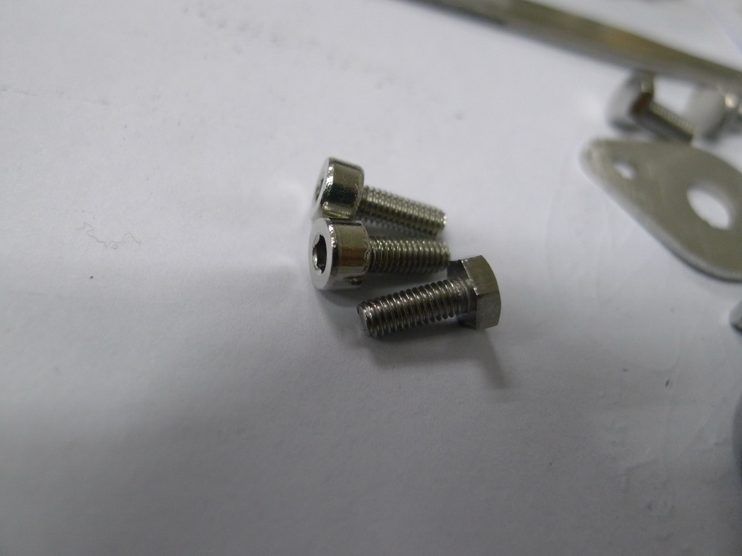

[**下載**](http://www.hkepc.com/forum/attachment.php?aid=MTc1ODg0MnwxNDNkNzI5Y3wxNDI2ODA3MzE5fGI0ZWU0UGVPZkZuN2NPa240aHN6RlZISmpHTEsyblF5Q3Vudk9XT29LY3UrME5B&nothumb=yes) (114.96 KB)

2015-1-30 13:08

7)用附送的螺丝或M3螺丝装上顶盖，上到底即可  
http://www.hkepc.com/forum/images/default/attachimg.gif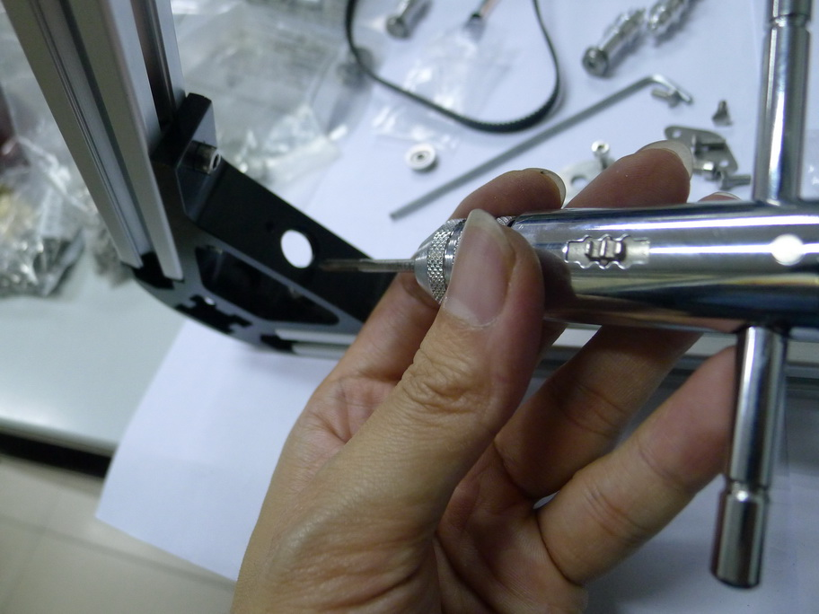

[**下載**](http://www.hkepc.com/forum/attachment.php?aid=MTc1ODg0M3w3NDY1YzI4NXwxNDI2ODA3MzE5fGI0ZWU0UGVPZkZuN2NPa240aHN6RlZISmpHTEsyblF5Q3Vudk9XT29LY3UrME5B&nothumb=yes) (166.1 KB)

2015-1-30 13:08

ps:如果M3牙太实，可能自己再攻多次牙  
http://www.hkepc.com/forum/images/default/attachimg.gif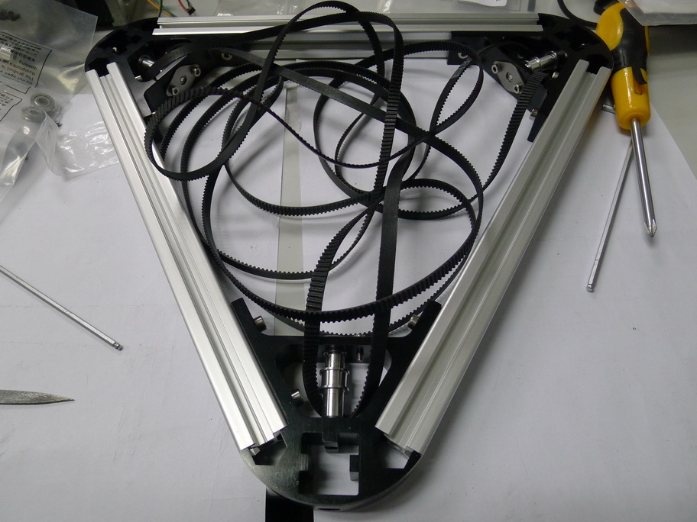

[**下載**](http://www.hkepc.com/forum/attachment.php?aid=MTc1ODg0NHxiODMyZWNlY3wxNDI2ODA3MzE5fGI0ZWU0UGVPZkZuN2NPa240aHN6RlZISmpHTEsyblF5Q3Vudk9XT29LY3UrME5B&nothumb=yes) (200.92 KB)

2015-1-30 13:08

8)完成安装顶层皮带轮