  
  
  
  
  
  
  
  
  
  
Throughout the year, students have been provided with opportunities to take part in enrichment and charitable activities that support their learning, develop their skills and benefit the school community. As we enter the final term of the academic year, we would like to share with you news of the students’ successes and achievements. We are proud of each member of the All Hallows family and hope that you enjoy learning more about school life.

**Summer Newsletter**

**All Hallows RC High School**  
Specialising in Business, Enterprise & Sports

**Caritas Ambassadors: Dementia Friends**

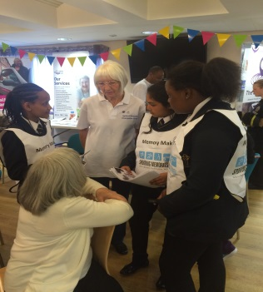Our Caritas Ambassadors became ‘Dementia Friends’ as the group took part in a training session delivered by Naomi Lewis from Salford Community Leisure.  Since the session, the Caritas Ambassadors have enjoyed regular visits to The Humphrey Booth Centre in Swinton enhancing the inter-generational Dementia Friends links.

The students particularly enjoyed taking part in the singing session led by ‘The Charleston Charlies’ and they received many positive comments from the elderly visitors about their fantastic attitudes and wonderful company.

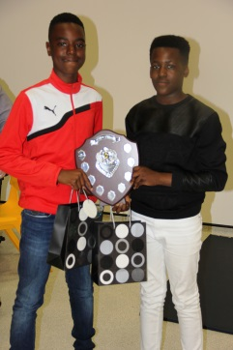**All Hallows’ Got Talent**

A group of year 7 girls raised £62 for Macmillan by organising and hosting a talent show for year 7 students on 27th May.  The All Hallows’ Got Talent judges were thoroughly impressed by the variety of talent on show which included dancers, gymnasts, musical performers, singers and a speed painter.

A wonderful morning of entertainment was enjoyed by everyone involved and special congratulations go to our winners; Nathan Ungudi and Gumcy Mata, AKA ‘Gloskiz’, with their amazing drumming performance.

**Sporting Memories Inter-generational Project**

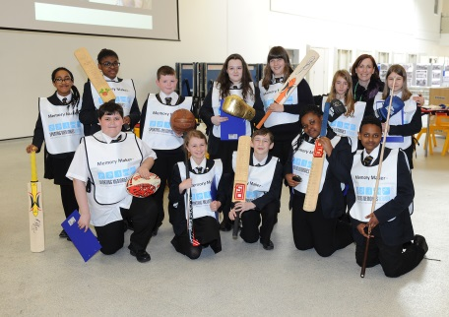All Hallows hosted a community event in April together with the Sporting Memories Network inviting members of the local community into school to chat to students about their memories of sport in Salford.  Salford Museum kindly provided photos and memorabilia for display and students enjoyed chatting to local residents and recording their memories of iconic Salford sporting venues such as Manchester Racecourse at Castle Irwell and Salford Lads Club.

**Well done to Mrs Grannell!**

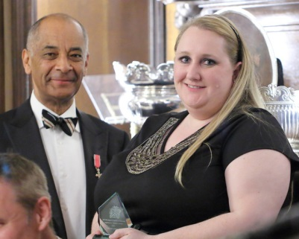Our very own Mrs Grannell has had her hard work and enthusiasm for her subject recognised by the Worshipful Company of Educators as she was presented with an Inspirational Educator Award at a ceremony in London in April.  Mrs Grannell was nominated as a result of the new initiatives in ICT and Computer Science which she has implemented in school including empowering the students through ICT leading to the development of the All Hallows Digital Leaders Programme.

**5 Star Futures Class of 2016**

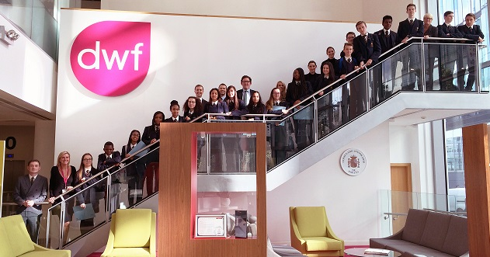For the last five years, All Hallows has had the privilege of inviting volunteers and mentors from DWF law firm into school to work with a group of year 10 students. The 5 Star Futures Programme develops employability and work place engagement with students through a series of focused and dedicated workshops. The Class of 2016 joined graduates from previous years in what is now recognised nationally as a programme of excellent practice. We look forward to working with the Class of 2017!

**Student Council and Construction Class Project**

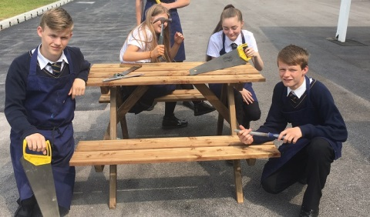

Members of the Student Council wanted to take an active part in improving school facilities. Not happy just to look for an off the shelf product, the students who are also members of the School Council, took matters into their own hands and produced a number of picnic benches for use by students across outside areas. We hope you agree that they have done a fine job.

**The Manchester University Gateway Programme**

Over the last year, 60 more able pupils (MAP) from each year group have attended the Gateway Programme. The aim of the programme is to raise awareness of the benefits of university and to develop pupils’ aspirations. The pupils focus on different themes and take part in various workshops, which build on their skills as well as developing new ones. By the end of the five year programme, students have acquired numerous skills including; leadership, networking, problem solving and debating to name just a few. The feedback from students has been fantastic, 92% are more likely to consider attending university, 93% know the benefits of university and 96% enjoyed the visit.

**Sporting Successes**

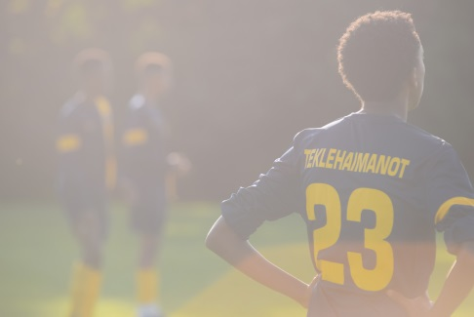All Hallows’ sports teams have achieved a number of notable successes this academic year. The year 7 / year 8 girls football team made it to the last 16 teams out of 600 in the English Schools Football Competition. Building on this impressive achievement, they went on to secure glory at the Salford Futsal (5 a side) Tournament, claiming the top spot to be crowned Salford Champions – very well done girls! The year 7 boys football team reached the final of the Salford Schools Competition, narrowly missing out to Moorside High in a thrilling match that ended 4 - 3. The year 7 boys rugby team have been crowned Salford Champions and will now represent Salford at the AJ Bell Stadium on 5th July 2016, we wish the team the very best of luck. Finally, year 11 pupil Nichita Matei entered the English Schools Football Photo Competition and won first prize with a stunning photograph of his teammates. Nichita’s prize was a PS4 for himself and £1,000 for the school which has enabled the PE department to order new kit and training equipment for the sports teams.

**Year 11 National Citizen Service Programme**

National Citizen Service (NCS) offers 16 and 17 year olds in Salford and Trafford an opportunity to participate in a personal development programme. The participants engage in a pre-programme 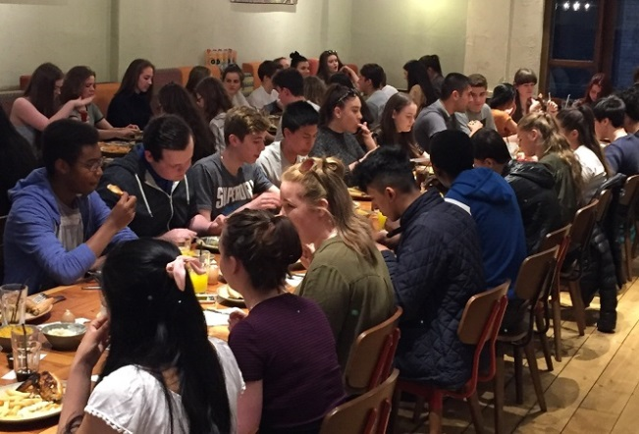 of team building activities, followed by residential experiences that will provide the skills and knowledge necessary for their task of creating and delivering a social action project that will benefit the community. All Hallows students have taken part in the programme for a number of years and will be heavily involved again this summer. We are heartened to learn that as students leave us from Year 11 their personal commitment to improving their communities and the volunteer ethos developed and encouraged in school, continues.

**PiXL Edge**

All Year 7 pupils are enrolled on an enrichment programme called PiXL Edge.  The aim is develop attributes within young people to give them the greatest chance of achievement.  We focus on Leadership, Organisation, Resilience, Initiative and Communication.  Every Year 7 pupil has completed a resilience event; they all completed the Sports Relief Mile on 18th March 2016 They raised nearly £1000 as a year group, a remarkable achievement!  Year 7 pupils are now working on other areas of the PiXL Edge qualification.  The next event to take place is the organisation of a Summer Fair which will take place before the end of this term.  We are really proud of the effort and commitment that has been demonstrated by our year 7 pupils.

**Story Writing Success**

Earlier in the year, the English department encouraged year 9 pupils to enter a nationwide competition for story writing called Spinechillers. Students had to write a complete scary story in exactly 100 words and the department had a great response to the challenge. A number of our students were given the opportunity to have their work published and I can now confirm that six of the students entered are now published writers. Very well done to Tom Taylor, Kanyin Talabi, Demi-Leigh Higham, Kyle Eric Holme, Abbie McCarty and Deiko Iverieli.

And finally we would like to wish all our year 11 leavers the very best of luck in their examinations. They have worked incredibly hard, including attending revision camps during school holidays and weekends and taking part in live Twitter revision sessions. Follow us @allhallowsrc. We are incredibly proud of their efforts and we are sure you are too. They deserve to do well.

**Advance Notice**

* The annual theme park experience trip will take place on Monday 4th July with invited pupils from years 7 – 10.
* The school sports day will take place on Wednesday 13th July (weather permitting).
* School will close at 1.45 pm on Wednesday 20th July 2016 and reopens on Monday 5th September at 8.30am.

**ALL HALLOWS RC HIGH SCHOOL HOLIDAY PATTERN 2016 - 2017**

|  |  |  |  |  |  |  |  |  |
| --- | --- | --- | --- | --- | --- | --- | --- | --- |
|  | **PUPIL DAYS** | | |  | |  | | **SCHOOL DAYS PER HALF TERM** |
|  | **BANK HOLIDAY** | | |  | |  | |
|  | **SCHOOL CLOSURE** | | |  | |  | |
|  | **Mon** | **Tues** | **Wed** | | **Thurs** | | **Fri** |  |
| **Sept 2016** |  |  |  | | 1 | | 2 | **AUTUMN OPEN** |
|  | 5 | 6 | 7 | | 8 | | 9 | **35**  **Please note the 1st and 2nd September are staff training days – school is closed to pupils on these dates.** |
|  | 12 | 13 | 14 | | 15 | | 16 |
|  | 19 | 20 | 21 | | 22 | | 23 |
|  | 26 | 27 | 28 | | 29 | | 30 |
| **Oct** | 3 | 4 | 5 | | 6 | | 7 |
|  | 10 | 11 | 12 | | 13 | | 14 |
|  | 17 | 18 | 19 | | 20 | | 21 |
|  | 24 | 25 | 26 | | 27 | | 28 | **AUTUMN HALF TERM** |
| **Nov** | 31 | 1 | 2 | | 3 | | 4 | **38**  **2nd December – staff training day – school is closed to pupils on this date.** |
|  | 7 | 8 | 9 | | 10 | | 11 |
|  | 14 | 15 | 16 | | 17 | | 18 |
|  | 21 | 22 | 23 | | 24 | | 25 |
| **Dec** | 28 | 29 | 30 | | 1 | | 2 |
|  | 5 | 6 | 7 | | 8 | | 9 |
|  | 12 | 13 | 14 | | 15 | | 16 |
|  | 19 | 20 | 21 | | 22 | | 23 |
|  | 26 | 27 | 28 | | 29 | | 30 | **AUTUMN CLOSE** |
| **Jan 2017** | 2 | 3 | 4 | | 5 | | 6 |
|  | 9 | 10 | 11 | | 12 | | 13 | **30** |
|  | 16 | 17 | 18 | | 19 | | 20 |
|  | 23 | 24 | 25 | | 26 | | 27 |
| **Feb** | 30 | 31 | 1 | | 2 | | 3 |
|  | 6 | 7 | 8 | | 9 | | 10 |
|  | 13 | 14 | 15 | | 16 | | 17 |
|  | 20 | 21 | 22 | | 23 | | 24 | **SPRING HALF TERM** |
| **March** | 27 | 28 | 1 | | 2 | | 3 | **25** |
|  | 6 | 7 | 8 | | 9 | | 10 |
|  | 13 | 14 | 15 | | 16 | | 17 |
|  | 20 | 21 | 22 | | 23 | | 24 |
|  | 27 | 28 | 29 | | 30 | | 31 |
| **April** | 3 | 4 | 5 | | 6 | | 7 | **SPRING CLOSE** |
|  | 10 | 11 | 12 | | 13 | | 14 |
|  | 17 | 18 | 19 | | 20 | | 21 | **28** |
|  | 24 | 25 | 26 | | 27 | | 28 |
| **May** | 1 | 2 | 3 | | 4 | | 5 |
|  | 8 | 9 | 10 | | 11 | | 12 |
|  | 15 | 16 | 17 | | 18 | | 19 |
|  | 22 | 23 | 24 | | 25 | | 26 |
| **June** | 29 | 30 | 31 | | 1 | | 2 | **SUMMER HALF TERM** |
|  | 5 | 6 | 7 | | 8 | | 9 | **34** |
|  | 12 | 13 | 14 | | 15 | | 16 |
|  | 19 | 20 | 21 | | 22 | | 23 |
|  | 26 | 27 | 28 | | 29 | | 30 |
| **July** | 3 | 4 | 5 | | 6 | | 7 |
|  | 10 | 11 | 12 | | 13 | | 14 |
|  | 17 | 18 | 19 | | 20 | | 21 |
|  | 24 | 25 | 26 | | 27 | | 28 |
|  | 31 |  |  | |  | |  |
| **Total Pupil Days** | | | | | | | | **190 days** |