**EMMC IMEI writer tool guide**

**Please note that computer must install phone driver, then below operations will have effect.**

1. **Double click “QualcommTool.exe”**

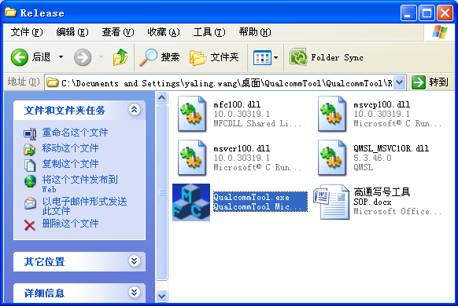

**2. Normal tool image.**

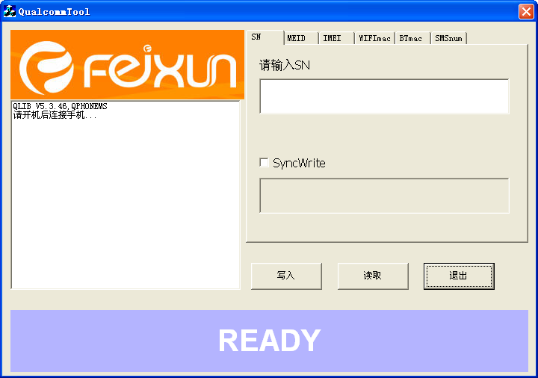

**3.Choose “IMEI” option and check “IMEI2”, Input right IMEI number(15 units) in both IMEI.**

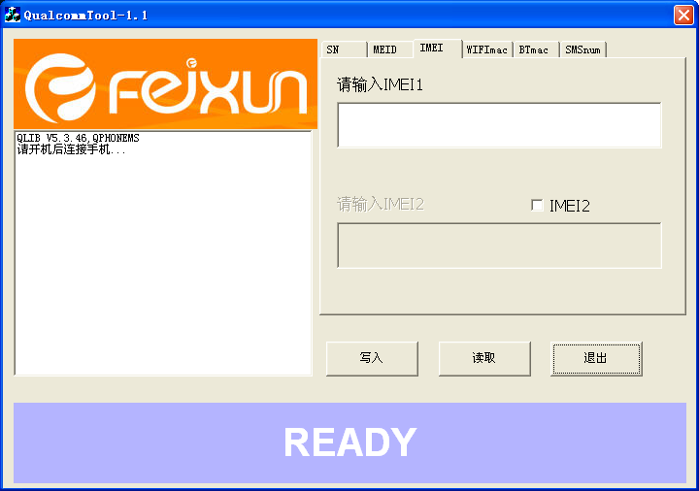

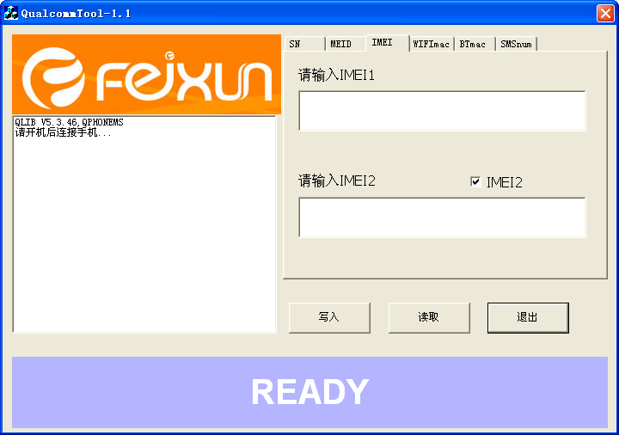

**4.Choose “写入”(First button), after appearing pass, then IMEIs have been written into phone.**

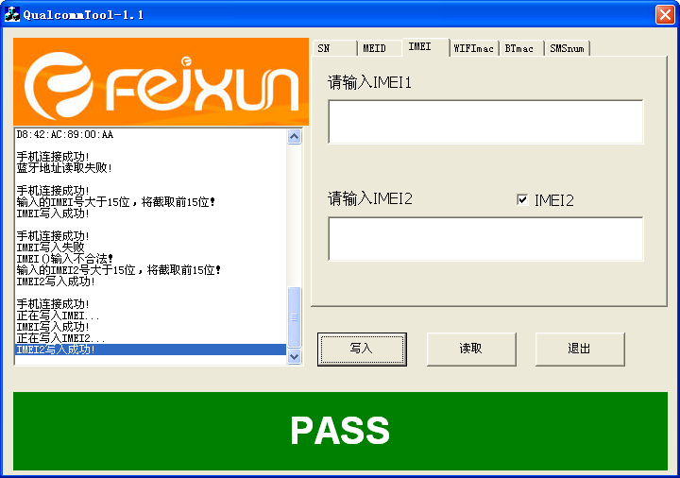

**5. Please restart the phone after all operations have been finished. Then new IMEI will be enabled.**