# **Evaluation of Assessment Diaries and GradeMark at the University of Glamorgan**

## 

## **JISC Assessment and Feedback Programme Strand B**

|  |  |  |  |
| --- | --- | --- | --- |
| **Project Information** | | | |
| **Project Title (and acronym)** | **The evaluation of Assessment Diaries and GradeMark at the University of Glamorgan** | | |
| **Start Date** | 1 September 2011 | **End Date** | 30 August 2012 |
| **Lead Institution** | University of Glamorgan | | |
| **Partner Institutions** | N/A | | |
| **Project Director** | Haydn Blackey | | |
| **Project Manager & contact details** | Dr. Karen Fitzgibbon  [kfitzgib@glam.ac.uk](mailto:kfitzgib@glam.ac.uk) | | |
| **Project website** | <http://celt.glam.ac.uk/node/153> | | |
| **Project blog/Twitter ID** | <http://assessdiariesgrademark.wordpress.com/> | | |
| **Design Studio home page** | <http://jiscdesignstudio.pbworks.com/w/page/50671157/Glamorgan%20Assessment%20Diaries%20Project> | | |
| **Programme Name** | Assessment and Feedback Programme – Strand B | | |
| **Programme Manager** | Lisa Gray | | |

Acknowledgements

The project team wish to acknowledge the contributions of students and staff at the University of Glamorgan. Grateful thanks are also given to the JISC programme team for their guidance and support during the project lifecycle.

Table of Contents

1. Executive summary 4

1.1 Brief description of project 4

1.2 Evaluation questions and purpose of evaluation 4

1.3 Brief summary of evaluation methodology 4

1.4 Summary of main findings, and implications of these 4

1.5 Summary of recommendations (Recommendations) 5

2. Background and context 7

2.1 Purpose of the evaluation and core evaluation questions 7

2.2 Description of the project and its context 7

2.3 Target population and relevant stakeholders involved in the project 9

2.4 Related work/studies 9

3. Evaluation approach 11

3.1 Evaluation framework or overview 11

3.2 Data collection and analysis 11

3.3 Evaluation limitations 12

4 Evaluation findings 13

4.1 Student and Staff Expectations of Assessment Diaries 13

4.2 Student and Staff Experiences of Assessment Diaries 14

4.3 Student and Staff Expectations of GradeMark 19

4.4 Student and Staff Experiences of GradeMark 19

4.5 Staff expectations and experiences of the tools in relation to workload 23

4.6 Benefits for students with specific learning requirements 26

4.7 Project Dissemination 26

5 Good Practice 28

5.1 Good Practice in Assessment Diaries 28

5.2 Good Practice in GradeMark 28

6 Conclusions 29

7 Recommendations 31

7.1 Assessment Diaries 31

7.2 GradeMark 32

8 References 33

9 Appendices 33

Appendix 9.1 Workflow diagram for administrative staff Assessment Diaries experience 34

Appendix 9.2 Workflow diagram for GradeMark (BEFORE introduction of GradeMark) 36

Appendix 9.3 Workflow diagram for GradeMark (AFTER introduction of GradeMark) 37

Appendix 9.4 Screen shot of Assessment Diaries 38

Appendix 9.5 Screen shot of GradeMark 39

# **Executive summary**

## Brief description of project

This project evaluated two assessment and feedback related innovations currently being used at the University of Glamorgan in two faculties (Advanced Technology and Business & Society), aimed at addressing the issue of assessment bunching and the issue of poor feedback to students. The two innovations are 1) Assessment Diaries and 2) GradeMark.

## Evaluation questions and purpose of evaluation

Assessment and feedback practice in Higher Education in the UK has long been the major source of student dissatisfaction (National Student Surveys). While technologies are increasingly being used as tools to improve the assessment experience for students and staff, the use of technologies in improving the assessment experience is still patchy

Evaluation questions:

* How the tools impact on the student experience from a student perspective
* How the tools impact on the academic staff experience, including pedagogy and workload

## Brief summary of evaluation methodology

The evaluation approach was informed by an action research methodology using a ‘look, think, act cycle’ (Stringer, 2007). The look stage of the project is equivalent to the baseline activity associated with identifying current practice. The think stage of the project is related to the data gathering, interviewing and analysis. The act stage of the cycle is related to the recommendations emerging from the earlier part of the action research cycle. In a true action research approach, the current project will continue to inform further ‘look, think, act’ cycles. This means that the recommendations being put into practice as a result of the current project will lead to further action research enquiry.

Two online questionnaires, focus groups and interviews were used to explore student and staff perspectives and experience of using the two tools.

## Summary of main findings, and implications of these

The key findings from the project are that both staff and students agreed that the tools when used consistently can improve the assessment and feedback experience.

The Assessment Diaries were found to have met their aims of reducing bunching for both staff and students and providing feedback deadlines in the majority of cases. For the diaries to continue to meet their purpose, they need to contain accurate information, and be used consistently for all assessment deadlines. In particular, the Assessment Diaries enabled improved access to assessment deadlines and dates for students. Students participating in the project reported that this helped with their time and task management. Similarly, the Assessment Diaries also facilitated academic staff in managing the workload associated with setting assessments and coordinating marking deadlines. Administrative staff commented on how the Assessment Diaries streamlined the entire assessment and feedback handling process.

The use of GradeMark is seen by most students and staff as a useful and stable vehicle through which to provide learner feedback. Students clearly see the benefits online feedback could provide, in particular, the easy access to feedback. However, this change in accessibility does not instantly change the established poor practice and attitudes some students experience in engaging with feedback for their own learning. It should also be acknowledged that staff wished to explore a range of online feedback tools of which Grademark is only one option. Students described the benefits as easy access and securely stored assessment and feedback comments that are readily available for them to use for their next assignments. Perhaps the most important aspect of the data from the survey was the realisation that students were fairly open in their expectations of online feedback in comparison with other forms of feedback – it was their actual experience of online feedback which led to their preference about how they would like to receive feedback in the future. It was interesting to see that the improvements students suggested were more from a pedagogical perspective in terms of the quality of feedback and their engagement with that feedback.

## Summary of recommendations (Recommendations)

Recommendations for further development of Assessment Diaries

* Improve flexibility of the current system to enable multiple assessment deadlines for different tutorial groups and single assessments comprising incremental tasks.
* Provide staff with the opportunity to amend existing assessment information
* Establish links between Assessment Diaries, Turnitin and Blackboard to facilitate single entry of information
* Ensure the assessment deadlines are created through collaborative dialogue and not individually determined, to maintain programme overview.
* Develop an overview of all assessment deadlines for HoLTs, Head of Divisions/Departments and administrative staff
* Raise awareness of the need for complete and accurate assessment information for all assessment information i.e. date of submission, title of assessment, type of assessment
* Raise student awareness of the purpose of Assessment Diaries
* Enhance the automated reminders for students to include: Module code, module title, assessment title, frequency of reminders, personalisation of reminders to stop system from sending reminders to students who have submitted and develop automated alerts to inform students when feedback is made available
* Establish a grace period of one month from the release of Assessment Diary for the course to enable staff to input assessment and feedback deadlines. After one month, activate the staff email reminders where assessment and feedback deadlines are missing

Recommendations for further development in the application of GradeMark

* Establish links through BlackBoard between GradeMark and student record system (Quercus Plus) to avoid duplication of mark entry
* Raise awareness of the student view of marked work so that students understand the functionality associated with GradeMark
* If tutors are unable to give feedback on the date specified, inform students about delays
* Raise staff awareness of: the time saved across the entire feedback process i.e. not having to physically collect and hand back work; and the use of FireFox as the primary browser to maximise system speed

# **Background and context**

### Purpose of the evaluation and core evaluation questions

Assessment and feedback practice in Higher Education in the UK has long been the major source of student dissatisfaction (National Student Surveys). While technologies are increasingly being used as a tool to improve the assessment experience for students and staff, the use of technologies in improving the assessment experience is still patchy. In response to student satisfaction survey and findings from a [Change Academy project](http://celt.glam.ac.uk/sites/default/files/CHANGE%20ACADEMY%20Case%20Study%201st%20March%20_2_.pdf), the University designed and developed an Assessment Diary to capture submission and feedback dates. Further, the University encouraged the use of online marking through GradeMark. (Details of these technologies are explained further in section 2.2)

The purpose of the JISC assessment and feedback project was to identify the extent to which the tools had an impact on the assessment and feedback experience for students and staff with a focus on two faculties within the University.

The core evaluation questions were as follows:

* Staff experience and perception of the use of Assessment Diaries and GradeMark
* Student experience and perception of the use of Assessment Diaries and GradeMark

Having established the core evaluation questions, the project team determined the following topics to be explored further:

* whether Assessment Diaries and GradeMark open up a dialogical space for staff and students (Wegerif, 2007)
* whether the tools meet student and staff expectations in relation to pedagogy and workload
* whether the tools address the issues highlighted in the baseline data, including bunching and poor feedback

### Description of the project and its context

The University of Glamorgan has long identified as part of its strategic vision the key role assessment has as the crucial element to improving the student learning experience. Technology has played a significant part in developing and implementing a revised approach to curriculum design at the University by placing assessment at the heart of learning. Two major assessment and feedback innovations, Assessment Diaries and GradeMark, were introduced as part of the institution-wide Change Academy Project - “Putting assessment at the heart of learning” supported by the Higher Education Academy and the Leadership Foundation in 2009-2010. The tools (Assessment Diaries and GradeMark) have since been slowly introduced and implemented across the institution. As is the case with many innovations in Technology Enhanced Learning (TEL), these tools were interpreted and adopted at different levels across the University.

The tools were aimed at addressing the issue of assessment bunching, communication of assessment and feedback dates and the timeliness and quality of feedback to students. Assessment bunching is a term used to describe what happens when several assessment deadlines fall on the same date.  For example, a student studying six modules with varying assessment tasks finds that four of the modules have submission deadlines on the same date.  The issues associated with assessment bunching are commonly identified as less time being spent on each of the assessments, thus impacting on the quality of the submissions, and lower attendance in lectures and seminars whilst students are concentrating on the multiple assessments to be submitted. These issues have been frequently highlighted in the literature as major challenges towards improving student and staff assessment and learning experiences. For example, the NUS (National Union of Students), Bloxham and Boyd (2007) and the REAP (Re-engineering Assessment Practices) project have also stressed the need for time on task and speedy and detailed feedback. In addition, assessment bunching was also identified as a key issue within the University from the Change Academy project. The University of Glamorgan project team believes that the technology makes a significant contribution to enabling and enhancing dialogue in and between students and staff.

**The Assessment Diary**

The Assessment Diary is essentially a simple list of module codes and titles, dates for assessment submission and return of feedback. This information is posted on the institution’s VLE, Blackboard. The diary uses an in house web-based front end which is provided within Blackboard and is personalised giving students and tutors clear, easily accessible information about when assignments are to be submitted and returned. A series of automated reminders to students are generated two weeks before submission, one week before and on the day of the submission deadline. Automated reminders are also sent to staff.

**GradeMark**

GradeMark is an online marking tool that is part of the Turnitin plagiarism software. The project team view GradeMark as more than a tool to improve the quality of feedback as when used effectively it is seen as a tool that can significantly improve student and staff assessment experiences. This can be achieved by better managing the feedback process and offering students and staff a tool through which to discuss assessment and feedback.

For details of how the assessment diaries and GradeMark led to examples of good practice in technology-enhanced assessment, see Section 5.

### Target population and relevant stakeholders involved in the project

The table below illustrates the involvement that key stakeholder groups have had in the project.

Table : Stakeholder involvement in the project

|  |  |
| --- | --- |
| **Stakeholder** | **Involvement** |
| Students | Active participants sharing their expectations and experiences of the tools in relation to assessment and feedback. |
| Academic staff | Active participants sharing their expectations and experiences of the tools in relation to workload and pedagogy |
| Technical staff and staff developer | Active participants sharing their expectations and experiences of the tools. |
| Administrative staff | Active participants sharing their expectations and experiences of the tools in relation to workload. |
| Project team and Steering group | Planning, organising, analysing, evaluating and disseminating the project. |

### Related work/studies

The project team identified several related projects which have helped inform the background and rationale for this project.

* Gwella Programme - [Enhancing Learning and Teaching through Technology in Wales](http://www.heacademy.ac.uk/resources/detail/flexible-learning/enhancement-programmes-wales)

The Gwella Programme report provides background information about technology enhanced learning in Wales and the role Glamorgan played in the project.

* Change Academy Project supported by the Higher Education Academy and the Leadership Foundation - [Putting assessment at the heart of learning](http://www.jisc.ac.uk/media/documents/programmes/elearning/digiassess_puttingassess.pdf). – University of Glamorgan

The Change Academy project aimed to encourage academic staff to pilot innovative assessment in line with assessment for learning principles. The use of technology was not a predetermined outcome for the Change Academy project, but the project found that a number of technologies have played a key role in the drive towards greater innovation, effectiveness and efficiency in assessment practice. In particular, the assessment diary was first piloted in one department as part of the Change Academy project and due to its success, it was rolled out across the University.

The evaluation of assessment diaries in the JISC Assessment and Feedback Project provided us with much insight into the benefit assessment diaries have on staff and students’ assessment experiences. It enabled the University to improve the current assessment diaries with specific developments identified by staff and students.

* [Turnitin or Turnitoff Project](http://turnitin.wetpaint.com/page/Turn+it+in+or+Turn+it+off+Project) – University of Glamorgan

The Turnitin or Turnitoff Project was a small scale project that looked at students and staff experiences of Turnitin and GradeMark. The overall finding was that students and staff are generally positive about the use of Turnitin and GradeMark. The project also identified some technical and pedagogical difficulties, such as the initial learning curve experienced by staff, the poor stability of the platform, and confusion with terminology.

The evaluation of GradeMark in the JISC Assessment and Feedback Project enabled us to investigate further whether some of the issues identified in the Turnitin or Turnitoff project. It is clear from the JISC Assessment and Feedback Project findings that the platform has developed much since the Turnitin or Turnitoff project and staff have become more familiar with the tool. The evaluation of GradeMark identified new issues which are detailed in section 4. However, it is heartening to find that staff and students remain positive overall about the use of GradeMark. In addition, the evaluation of GradeMark also looks at the experiences of non-users. This is also detailed in section 4.

* [Ebeam Project](http://www.jisc.ac.uk/whatwedo/programmes/elearning/assessmentandfeedback/ebeam.aspx) - University of Huddersfield

The Ebeam project is also funded under JISC assessment and feedback programme. The project also looks at the use of GradeMark and there are similarities in findings that the two projects look forward to discussing further in a collaborative exploration of assessment and feedback technologies.

The following projects helped to inform the project methodologies and evaluation approach:

* JISC [Learner experiences of e-learning](https://wiki.brookes.ac.uk/display/JISCle2/About)

The programme with its focus on learner voice informed our methodologies and evaluation approach in particular with our students interviews and focus groups. For example, the [elicitation techniques](https://wiki.brookes.ac.uk/display/JISCle2m/Elicitation) specifically for talking to learners in [interview](https://wiki.brookes.ac.uk/display/JISCle2m/Interviewing)s.

* Oxford University [Cascade project](http://jiscdesignstudio.pbworks.com/w/page/24181944/Cascade%20Project)

The Cascade project provided us with background idea into the way workload issues can be looked at and presented in the project. It was useful to see how the Cascade project break down different process and estimated time for each process in their online assessment handling system.

# **Evaluation approach**

The evaluation approach was informed by an action research methodology using a ‘look, think, act cycle’ (Stringer, 2007). The look stage of the project is equivalent to the baseline activity associated with identifying current practice. The think stage of the project is related to the data gathering, interviewing and analysis. The act stage of the cycle is related to the recommendations emerging from the earlier part of the action research cycle. In a true action research approach, the current project will continue to inform further ‘look, think, act’ cycles. This means that the recommendations being put into practice as a result of the current project will lead to further action research enquiry.

### Evaluation framework or overview

The dialogic theory by Wegerif (2007) is particularly useful for the project as he proposes that technology should be seen as a tool that opens up the dialogical space that is essential for people to think and learn. The project team sought to explore whether the tools enabled such dialogue in and between student and staff.

### Data collection and analysis

* + 1. Methods used and why they were chosen

The project team designed two online questionnaires (available on the [JISC Design Studio)](http://jiscdesignstudio.pbworks.com/w/page/49920023/Assessment%20and%20Feedback%20Programme) using GoogleDocs in order to gather the views, expectations and experiences of students’ use of Assessment Diaries and GradeMark. The Assessment Diaries questionnaire explored experiences surrounding submission and feedback dates in an attempt to understand the wider context within which the Assessment Diaries were operating. The GradeMark questionnaire explored experiences around feedback processes and the use of online marking.

Focus groups were held with students from different faculties, courses and levels of study to capture a wide range of viewpoints and experiences of the tools. (Focus groups notes are available on the JISC Design Studio)

Staff interviews were held with academic, technical and staff development colleagues to ascertain their experiences of the tool and the impact on the usage of workload. (Interview questions are available on the JISC Design Studio)

* + 1. Approaches to analysis

The project team used a thematic analysis approach (Braun & Clarke, 2006) to the data captured from the questionnaire, focus groups and interviews. This led to the creation of common themes extracted from the data which facilitated a comparative analysis of expectations and experiences from the viewpoints of students and staff.

### Evaluation limitations

The project team included Heads of Learning and Teaching (HoLTs) from the participating faculties. However, while the number of participants from both faculties were representative and there were equal opportunities for participation, there was an imbalance between students and staff able to participate. However, the findings showed that the experience from students and staff were almost identical leading the project team to conclude that the imbalance in faculty participation had not had any negative impact on the findings.

# **Evaluation findings**

The response rates to the Assessment Diaries and GradeMark questionnaire were 80 and 156 students respectively with a further 36 students participating in five focus groups. These students are from the Faculty of Business and Society and the Faculty of Advanced Technology. Within the two faculties, there were 19 academic staff interviewees, 4 administrative staff interviewees and 3 technical/staff developers. The following sections outline the key findings.

### Student and Staff Expectations of Assessment Diaries

The majority of student questionnaire responses showed that they expected to be given their assessment deadlines through a variety of communication channels i.e. through module handbooks, via email or from the module tutor.

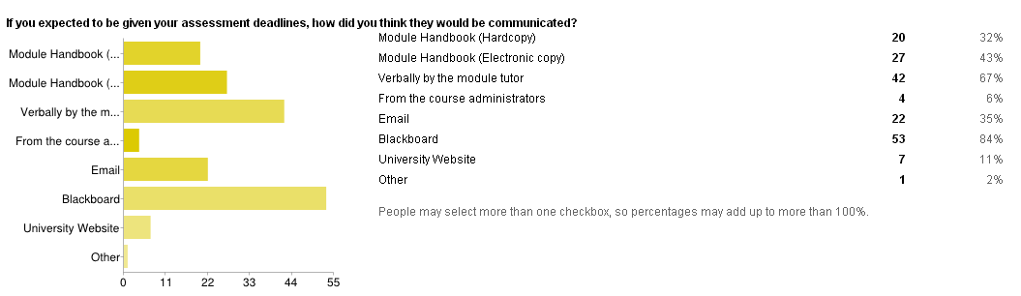

Figure 1: Student expectations of the way assessment deadlines would be communicated

Of these, the majority had this expectation met in that they received their assessment deadlines from a variety of sources. One unexpected outcome is that 35% of respondents from the questionnaire said that they expected the dates to be given via email – something that would have been unusual before the Assessment Diaries were created.

When asked whether they expected to receive feedback dates, the responses to the questionnaires fell into two main groups. One group (48% of respondents) expected to be given assessment deadlines and feedback dates. Of these 80% had their expectations met. The second group (15%), expected to be given only the assessment deadline dates, but NOT their feedback dates. In comparing expectations with experiences, even though these students did not expect to receive feedback dates, 50% of them did.

In the focus groups, students’ views tended to reinforce the questionnaire results with most students saying they expected to be given feedback dates. An interesting point that arose in the focus groups was the extent to which students understood their role in assessment in terms of taking responsibility for managing their deadlines and responding to feedback.   
  
Staff expectations concerning the Assessment Diaries tended to focus on the need to manage student assessment deadlines as well as their own marking deadlines. It was also apparent that a small number of staff felt the Assessment Diary would enable students to better plan and execute their assessments.

### Student and Staff Experiences of Assessment Diaries

Student and staff experiences of using the assessment diaries can be summarised under the following themes:

* + 1. Student awareness of Assessment Diaries

When asked to indicate their actual experience of the provision of assessment deadlines, a small number of questionnaire respondents (13%) were aware of the Assessment Diary (the question allowed students to choose more than one option). At first sight this level of awareness appears to be very low. However, in the student focus groups it became apparent that students are receiving their deadlines via BlackBoard. This indicates that the students are receiving their assessment deadlines, but do not recognise these dates as coming from the Assessment Diary tool. The next question on the questionnaire reinforces this finding as there are 94 instances (from a multiple answer question) of students indicating some experience of using the Assessment Diary tool. Of those instances, by far the most common comment was that students found the diary enabled them to plan their time better.

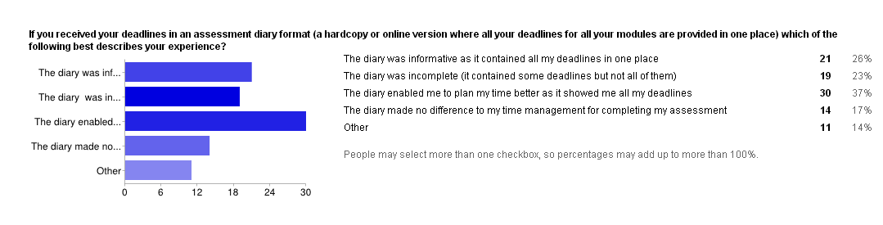

Figure 2: Student experience on using Assessment Diaries

However this wasn’t always the consensus view expressed in the student focus groups where some students used the diaries for the dates and information, but did not mention using it to plan their time more effectively. This is interesting when compared with the staff expectation that students would use the diary to improve their time and task management of assessment.

* + 1. Information Accuracy

It is concerning to note that students stated that the Assessment Diaries are often incomplete. This was expressed in multiple ways and included: inaccurate assessment information, missing deadlines and/or feedback dates. This quote from the student focus groups expresses the point well:

*Whether students use the diaries depends on the module that we are doing, if we are confident in the lecturers and we have been discussing when the assessment is (sic) due, rather than just checking on the diaries. Depends on the modules.*

From the interviews with staff it became apparent that the incomplete data in the Assessment Diaries was more complex than might appear at first sight. For example, a number of staff commented that the Assessment Diaries do not provide sufficient flexibility for setting multiple assessment deadlines for different tutorial groups. A further indicator of complexity concerns assessments which comprise a number of small incremental tasks. The Assessment Diaries allow for one date per assessment type and therefore the students would see ‘lab report’ due on a certain date, but may be unaware that this assessment actually comprises three different reports of lab work. One member of staff interviewed said ‘you almost have to fool the technology.’ This is also reflected in our interview with technical support staff identifying that the lack of flexibility in setting up different dates is a recurring issue.

* + 1. Feedback Dates

In relation to the student experience of whether feedback dates given in the Assessment Diaries were met, of the students who received feedback dates in the Assessment Diaries, the majority (66%) received their feedback on the date specified or earlier, with the remainder (34%) receiving their feedback later than the date specified.

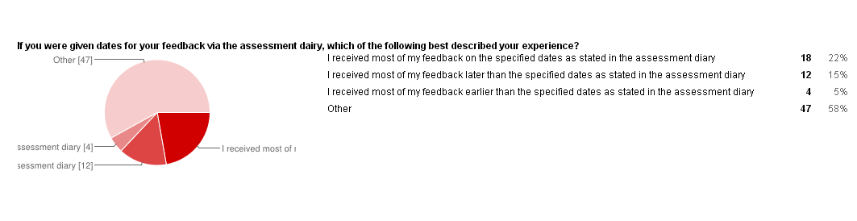

Figure 3: Students experience with assessment diaries regarding feedback dates

The student focus groups reinforced the importance of knowing when they would receive feedback. One group mentioned having an online ‘feedback party’ where they all shared messages on Facebook whilst they were waiting for the 11:59 feedback release time. The focus group participants also confirmed that if tutors are unable to give feedback on the date specified, the tutor normally informs the students and tells them when they will receive their feedback.

* + 1. Students reflections

The final question on the questionnaire asked students to suggest improvements about the way in which assessment and feedback dates are communicated. This was an open ended question which did not provide any answer prompts. Amongst the 31 open comments received the majority of comments did not suggest specific improvements, but were reflections from their experience with the tools. The following themes emerged:

Consistency

Bunching

Quality of feedback

From the questionnaire, 55% of responses concerned the **consistency** of the diaries. These comments related to two specific areas (1) the accuracy of information included in the diaries, (2) the consistency with which academic staff choose to use the diaries or not. One student comment relating to the latter said:

*Although I am happy with the way assessments are being handled in the vast majority of times, I do feel that if the tutors would make use of the Blackboard Assessment Diary fully then it would make things a lot simpler for us to keep an eye on the deadlines.*

Very few questionnaire responses mentioned assessment **bunching** in relation to the improvement of the Assessment Diaries. It could be interpreted that this is because students see the diary as a tool to help them manage their own deadlines i.e. one dimensional, rather than a tool which facilitates tutors in the careful management of deadline setting and the avoidance of bunching i.e. two dimensional, in enhancing the student experience. This would indicate that academic staff have not necessarily explained the full rationale behind the Assessment Diaries, and simply introduced them to students as a tool for them to manage their own deadlines.

The interviews with staff demonstrated how carefully the course teams approach the setting of assessment deadlines. All those interviewed mentioned the need for the course team to meet and agree both assessment deadlines and dates for feedback as illustrated in the following excerpts:

*It’s meaningless if you don't have the meeting first, "rubbish in then rubbish out". If everyone puts individual dates in, without the overview, I [Course Leader] can't check if there is bunching - it's also too late by then. It's much better to be pro-active.*

*Before the use of diaries there was no dialogue between colleagues, the introduction of the diaries reinforced/highlighted the bunching issue*

The frequency with which academic staff mentioned the importance of the overview meetings is further reinforced by the number of staff reflecting on the importance of sharing information about assessment deadlines. The diaries serve their purpose but academic staff stressed the importance of the need for willingness to negotiate deadlines within teaching teams.

It was interesting to note that students often related questions about feedback dates to the quality of the feedback they received. For the purposes of this report however, **quality of feedback** will be explored later when discussing online feedback in relation to the use of GradeMark.

From the student focus groups, the main improvement suggested concerned the automated reminders for assessment deadlines. In all focus groups this was a consistent concern and a number of students said that the problems with the current timing and wording of reminders were causing them concern as shown below:

*Would be better if the reminder included the details of the module title rather than just the code. The reminder should acknowledge that you have actually submitted.*

*Sometimes the diaries send you reminders that you have an assignment due within a month, but I don't really want to know yet, I still have other things to do, so it doesn't really help me prioritise.*

*Would prefer reminders a week before, then five days and three days before. Send alerts when new assessments are added or a current assessment is updated or changed i.e. any amendments should be notified.*

*Would be good to have an automated message when feedback is released*

* + 1. Unexpected outcomes

One unexpected outcome from interviewing academic staff was the concern about the pedagogical value of using reminders for students studying at all levels. It was felt that this may lead to under-development of independent or autonomous learning skills. To balance this argument, some academic staff felt that the diaries are assisting students in upskilling their time and task management abilities by providing a framework within which to approach the management of their assessment task.

It was interesting that staff also suggested improvements around automated messages, but in this case the messages concern the automated reminders to staff about populating the Assessment Diaries.

*I am not sure if the alerts for staff are important as we are normally really aware of these dates. I don't get particularly annoyed but some people do. I am not suggesting that they don't have alerts but maybe think of the frequency of the alerts.*

It was also the case that some staff mentioned in their interview that the reminders were sometimes for modules they no longer teach on.

The students see the positive contribution that the diaries make to managing their assessments but the incompleteness of the information sometimes prevents them from using it, whereas for the staff it works but it currently fails to capture the complexities of assessment. The students want to use the diaries and the staff can see the benefits of them using the diaries, but the inconsistent application and lack of information accuracy noted in the student focus groups, means the students are sometimes reluctant to engage with them.

### Student and Staff Expectations of GradeMark

No matter what the student expectation of the mode of feedback, 75% of respondents found the overall experience of accessing and using online feedback was positive, indicating that the interface and online environment is stable and fit for purpose. Further analysis of the student experience suggests that students understand the purpose of feedback in terms of shaping future learning, as the majority of them say they use the feedback to inform their next piece of work, or to have discussions with their peers or tutor. This was true of all groups, no matter what their stated preference for the vehicle of receiving feedback. Of the 156 responses to the student questionnaire concerning online feedback, only 15% expected their feedback to be provided electronically online. Although there were a large proportion of respondents expecting a combination of online and written feedback (35%) the number expecting only handwritten comments was 25%.

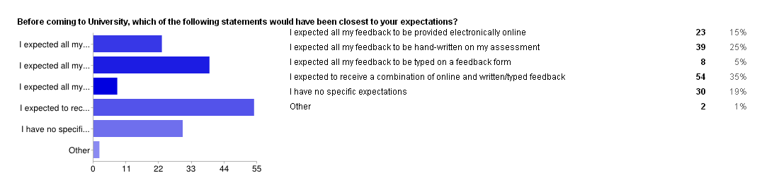

Figure 4: Student expectations concerning the provision of feedback approaches BEFORE coming to University

### Student and Staff Experiences of GradeMark

Of the 156 students who responded to the questionnaire, 29% found online feedback saved them time, although conversely 28% found it more difficult to use online feedback (students could choose more than one answer option). Perhaps the most important aspect of the data from the survey was the realisation that students were fairly open in their expectations of online feedback in comparison with other forms of feedback – it was their actual experience of online feedback which led to their preference about how they would like to receive feedback in the future. Perhaps this suggests that there is a role for further staff and student dialogue about the tools that are available and how best these can enhance student learning. An example of why the dialogue is needed is that students commented that they were unaware of some of the functions within GradeMark, such as needing to actually hover over the comment bubbles in order to see the feedback, and the use of the rubrics where students could see a breakdown of their grades.

Overall, from the student experiences of using GradeMark the picture remains somewhat unclear with almost the same numbers of students saying they are more engaged with their feedback online as those who find it more difficult to engage with feedback provided online as illustrated from the discussion in one focus group:

*Student A: I am more likely to look at it over and over again if it's hardcopy*

*Student B: I think it's just what we’re used to, we don't like changes or to go through the hassle of switching on the laptop.*

*Student C: it's also easier to reference to it when you are writing a new piece, you just flick through and go oh there it is and write.*

* + 1. Student and Staff perspectives of the advantages and disadvantages of online marking

The main benefits students saw with using online feedback were that it was easily stored and re-accessed (64%) and that they were able to avoid illegible handwriting by tutors (60%). It was noted that 52% stated the main advantage was easy access which somewhat counterbalances the 38% who saw online access as the main disadvantage.

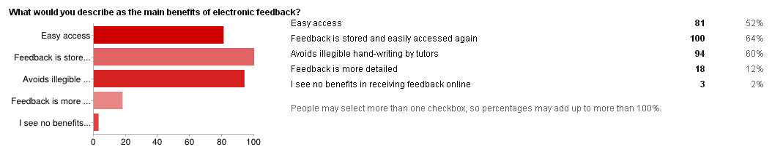

Figure 5: Advantages of GradeMark from student perspectives

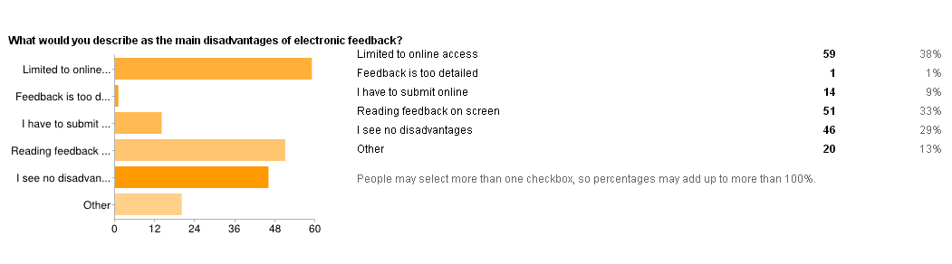

Figure 6: Disadvantages of GradeMark from student perspectives

The students identified the key advantages as being the technical/online/system/process aspects of GradeMark. When asked what they saw as the main disadvantage of online feedback, 38% of students said that they were limited to online access, 33% reported reading feedback on screen as the main disadvantage, with a proportion of the sample (29%) saying they saw no disadvantages in using online feedback.

It was interesting to see that the improvements students suggested were more from a pedagogical perspective in terms of the quality of feedback and their engagement with that feedback. In relation to the themes identified (shown in bold below) some student and staff comments were as follows:

Table : Student and staff suggested improvements by theme

|  |  |  |
| --- | --- | --- |
| **Theme** | **Student views** | **Staff views** |
| **Clear assessment criteria** | *‘a better understanding of how essays are marked, so you know what more needs to be done to get a higher grade. It would be preferable to see what specifics can be improved upon, over just general guidelines.’* | *We used to use a rubric across the department to highlight areas such as writing styles, research, content, presentation etc. And a summary on what is good and what needs to be improved. And we hope that we can transfer that online on GradeMark and so students can see very clearly an overview of what they are doing well and what they need to improve across the different modules. If we are doing (providing feedback) in the same way, it will provide more useful feedback for students. The concern is for students to take away feedback that is useful.* |
| **Quality of feedback** | *‘make it more detailed, I feel like they do not take the time to explain and point out what needs to be modified.’* | *The benefit from a student perspective is that when you use these tools properly it gives them clearer idea on what the problem is and what the solution is. Like when the wrong use of words, like there and their, on paper you just circle it, so students might not understand what the problem is. Whereas on GradeMark the tools provide the explanations too, it is build in.* |
| **Consistency of feedback** | *‘I do feel that it is simply down to the person giving the feedback as I experienced very little from some tutors and the feedback didn't have much impact and lacked tips for the next assignment. On the other hand other tutors were extremely helpful and not only provided feedback but feed forward which I found incredibly useful as I’ve already used it to improve on my next assignments.’* | *It was easy to see the grades and how the feedback matched with the grade. I think the comment bank may build up over time for things like referencing and directing students to further sources of support. When students queried grade, I was able to go back and look at all my comments and see how the grade had been achieved.* |
| **Dialogue** | *‘I want lecturers to still give written feedback as it feels much more personal and not like you are another statistic on a screen.’* | *‘We meet with first year students as part of our retention and progression. We will say what sort of feedback have you been getting overall. They usually say they don't know, but what we can do now is to look at their Turnitin feedback together and identify whether they are getting common feedback from different tutors and how they can work on that. Before Turnitin we will have to rely on students having all the coursework together with them. But now, the feedback and discussions do not have to tie in to a specific module/assignment and we can have a much more intelligent conversation with our students.’* |
| **Benefits** | *‘Everything is good. I access this type of feedback very easily. Mostly I recommend electronic feedback.....’* | *‘I like that I know whether students have read the feedback. I like the reduction of paper, consistency and flexibility, it is quite intuitive. I have got a question bank, so its quicker. I’m able to give more feedback because its targeted at the right point and gives better feedback. I’m also able to direct students to additional resources. It‘s a win-win situation, quicker and better feedback.’* |

From an academic staff perspective of those who used GradeMark, the disadvantages were more concerned with the limitations of GradeMark, i.e. the limitation to only able to mark text based assessments and workload issues and these are presented below. It has become apparent that some staff are willing to forgive the limitations of the technology – particularly with regard to GradeMark freezing when used through Internet Explorer. This forgiveness stems from the fact that they like the underpinning pedagogy and processes involved in online marking. For academic staff who are yet to engage with online marking, the reasons given relate to the discipline within which they are based, their personal preference for a marking environment that does not restrict them to using a computer and the success of their current feedback practices. This was neatly summarised by a students in one of the focus groups:

*I have one lecturer who didn't use it but he gave us face to face individual feedback which was really nice. But then again, I have another lecturer who uses it really well, she provides general comments and also specific points for each individual, and she also did a summary for the class about common issues. That was really nice.*

As part of the student focus groups, students offered their opinions concerning possible incentives that could be used to encourage staff who currently do not use online marking. These are summarised as follows:

* *Emphasise that this is what students want*
* *Single log in, single point of mark entry so they are not duplicating effort*
* *Know that it is giving students a better learning experience*
* *Should be a choice - shouldn't be mandatory. Tell them it gives students the best opportunity to get the best out of their marking*
* *Pay tutors to mark online - there has to be some sort of incentive otherwise the quality of the feedback might be affected*
* *The work is safer, they don't have to carry stuff around*
* *provide support and training, make them feel at ease. This might encourage them to have a go*

### Staff expectations and experiences of the tools in relation to workload

* + 1. Workload impact of Assessment Diaries

Initially staff thought that where large groups were involved, it was going to be difficult meeting the feedback dates.  However, staff experience showed that ‘as long as you communicate to students and explain why it might be a bit late, students are fine.’ Students commented that they just need to know when the feedback is due and at the same time, staff felt that ‘the diary opens a line of communication.’ Some staff felt that publishing the feedback dates was a good way to ‘stop emails from students 3 days after the submission deadline asking for feedback.’  However, an unexpected outcome was the number of staff who referred to the Assessment Diaries as a mechanism to manage their own marking deadlines to ‘avoid personal bunching’ and manage their marking loads.  One interviewee mentioned that as staff know when they plan to set assessment deadlines, the Assessment Diaries present no extra work.  However, as the co-ordinator she felt that the ‘workload comes from chasing staff to give me the dates.’

One of the major concerns regarding workload is the current setting of Assessment Diaries which requires staff to input assessment information twice - before entering assessment deadline information into Blackboard, staff must first input the same information into the Assessment Diaries page. As one member of staff commented:

*In terms of integration with Blackboard, there needs to be a more transparent process, as current workload is so high, anything to help our situation and students are good.*

*I feel that I am just entering the same information in more places. I have done all that on Turnitin and on the Blackboard site anyway. It does take time, I could spend that time doing other things.*

There is also concern about the degree of flexibility once the deadline has been entered into the diary. Currently, once the assessment deadline has been set in the Assessment Diaries folder, staff cannot amend the dates without significant knock-on effects to their workload, which would include repeating the process from the beginning. This in turn has impacted on staff willingness to set assessment deadlines in the diaries, resulting in the inconsistency that students reflected on.

For the diaries to work effectively, a number of staff have commented on the importance of having team meetings to agree submission dates across different modules within a course. For some, these meetings are existing practice. For others, these meetings would represent additional activities.

For the administrative staff, the introduction of Assessment Diaries linking to Blackboard and the student record system has reduced a significant amount of administrative work emailing and chasing academic staff for their assessment deadlines and feedback dates. In addition, administrative staff also used to have to manually email students individually who had not submitted their assessments to remind them of the support available (shown in a workflow diagram in Appendix 1, section 9.1). Administrative staff commented that they used to be able to highlight quickly if any particular students had missed more than one assignment and provide proactive student support as they maintained their own schedule of assessment deadline dates. However, their feedback as part of this project was that while the linkage of Blackboard and the student record system with Assessment Diaries reduced administrative work they felt that they have lost the personal touch and relationship engendered through their role in supporting students as they do not currently have access to an overview of the assessment deadlines for each course.

* + 1. Workload impact of GradeMark

Interview respondents were divided on whether GradeMark reduced or increased marking time.  Several mentioned the elimination of paper handling as a positive aspect of online marking and that the process was quite intuitive and offered them flexibility in terms of location for marking i.e. home or work.  Interestingly one interviewee felt that marking on GradeMark took longer, but it was more beneficial as:

*it was easier than marking on paper and there were no worries about losing scripts - no trudging around with piles of scripts.*

However, there were conflicting views from some respondents who found it much more difficult to mark on screen than on paper.   Of those that found it easier, the use of the comment bank was often mentioned as a benefit in terms of marking speed.  One respondent no longer asks students to submit a hard copy of their essays alongside their electronic submission (previous convention) on any module he teaches:

*Better for them and better for me. I get a clear record of who has submitted when, and what feedback I have given to which students. So it is clear for the external examiners as well. Also, my line manager can see when I gave feedback. My prime mission is to find something that will save me time.*

Reflecting on the comments made in the interviews, academic staff seem to make a direct comparison between the time taken to mark a physical script and to mark online and the speed of the system. They were less aware of the saving of time on the entire feedback process, which involved tracking student submissions, or using lecture time to hand back assessments or having multiple interruptions from students collecting marked work at different times. Only a minority of interviewees reflected on the entire feedback process in relation to identifying workload associated with online and offline marking as suggested below:

*I think the whole process is quicker. We used to rely on the faculty administrators to collect the work and then we have to collect them a few days later and ask the student to come and collect their work. With Turnitin the whole process is a lot quicker. Students do not lose their work. Whether the "marking" is faster I think depends on each individual and it will be different. But the whole process is definitely quicker.*

Similarly, administrators commented that their workload is reduced due to the automated submission for most assessments. However, administrators commented that they are currently still duplicating the workload of lecturers when it comes to mark entry. Once lecturers have entered marks into GradeMark, they are also required to provide those marks to the administrators to be entered into the student record system. This duplication of effort indicates the need to view assessment and feedback as a complex process in order to really reduce workload for everyone involved. (Please see Appendix 9.2 and 9.3 for changes in workflow before and after introduction of GradeMark)

### Benefits for students with specific learning requirements

The Assessment Diaries provide students with specific learning requirements with a personalised assessment tool that increases their ability to manage the time and tasks associated with the completion of assessments. This is of particular benefit for dyslexic students as they can use the diaries with their study support tutor or with staff from the education drop-in centres.

The benefits associated with the use of GradeMark to provide feedback are particularly valuable for students with specific learning requirements as it facilitates the revisiting of assessment feedback in a central repository that students can call upon in an accessible way. In addition, students can email their feedback to their study support tutor for advice and guidance. This also facilitates the monitoring of student achievement by study support tutors who can access an overview of students’ completed assessments and feedback.

### Project Dissemination

The following table shows a number of events the project team attended to share the progress and outcomes of the project:

Table : Project dissemination

|  |  |  |
| --- | --- | --- |
| **Date** | **Event** | **Dissemination activity** |
| 24 April 2012 | JISC Learning and Teaching Experts Meeting | Poster presentation. Available from the [Design Studio](http://jiscdesignstudio.pbworks.com/w/browse/#view=ViewFolder&param=Glamorgan%20Assessment%20Diaries) |
| 25 June 2012 | Visit from Roger Pearson (Oxford University) | Discussions of Assessment Diaries approach and technical support |
| 16 July 2012 | Turnitin UK Advisory Meeting | Discussions on the embedding of GradeMark for all online assessment |
| 19 July 2012 | Ariadne e-journal | Request from editor to produce paper outlining the project. Paper available from <http://www.ariadne.ac.uk/issue69/fitzgibbon-lau> |
| 24-25 July 2012 | PASS event Bradford University | Invited to participate in discussion and share project outcomes |
| 9 November 2012 | JISC Show and Tell Webinar | A link to the webinar recording can be found [here](http://bit.ly/jiscelopenwebinars) |
| 16 November 2012 | JISC Online Conference Activity Week | A link to the webinar recording can be found [here](http://www.jisc.ac.uk/whatwedo/programmes/elearningpedagogy/elpconference12/activityweek.aspx) |

# **Good Practice**

During the process of this project, the tools were found to have encouraged innovative uses which led to good practice outside of the main purpose of the tools some of which are shown below:

### Good Practice in Assessment Diaries

* Assessment Diaries used as part of developmental conversations between personal tutors and students where tutors can have a better understanding of the student’s progress with assessment.
* The use of Assessment Diaries to look at the overall assessment diet within a programme or course
* The innovative approach taken to determining the feedback time frame e.g. agreeing to return some work within 10 working days and requiring other work to be returned in 25 working days. This gives students a very specific point at which feedback will be received and provides tutors with the flexibility to produce effective feedback that takes account of complexities in the assessment design as well as large class numbers.

### Good Practice in GradeMark

* Facilitating personal tutor/student conversations by accessing work marked online to engage students in active learning through the use of multiple feedback sources across all modules on a stage of study.
* Staff developing marking rubrics for each level of classification which ensure that when students compare their marked work the comments are directly related to the level of academic performance.

# **Conclusions**

From our research, it is clear that the use of Assessment Diaries can have a positive impact on both students and staff assessment and feedback experiences. The Assessment Diaries were found to have met their aims of reducing bunching and providing feedback deadlines in the majority of cases. For the diaries to continue to meet their purposes, they need to contain accurate information, and be used consistently for all assessment deadlines. This project identified that these are the key elements to student confidence in the diaries. To achieve this, a significant part of the process must be a collective dialogue amongst programme teams to identify reasonable deadlines and feedback dates. From a learning and teaching perspective, the concern about the diary process is whether the current mechanisation of the date and the rigidity of the system drive academic staff to set assessments using traditional formats such as single summative essays or reports that fit the current system settings, rather than being creative with assessment practice. This perception that the system could drive practice negatively was also apparent from the GradeMark interviews:

*If it makes you stop doing something that works really well, technology gets in the way, just for the sake of saying we have online feedback. I fear that driving staff down this road would make them revert to forms of assessment that are easy to submit and mark online rather than being innovative with assessment practices.*

This concern is also shared by support staff:

*Does the technology support the change in assessment or does it restrict it? We need to be careful that we don't push a tool for the sake of pushing the tool. Push assessments that are clear and transparent. We must maintain a choice of approaches and tools.*

Reassuringly, the evidence to date from our training staff is that academic staff who are already experimenting with innovative assessment are not going to change their assessment methods to fit the diaries:

*I am not seeing a pattern where people are choosing traditional methods of assessment. They want to stick with creative and innovative methods, but the Assessment Diaries must fit those needs. They would prefer not to use Assessment Diaries rather than change their assessments to 'boring' methods.*

The use of GradeMark is seen by most students and staff as a useful and stable vehicle through which to provide learner feedback. Students clearly see the benefits online feedback could provide, in particular, the easy access to feedback. However, this change in accessibility does not instantly change the established poor practice and attitudes some students have in engaging with feedback for their own learning.

*Depends on the grade and also if the next assessment says go back to the previous feedback. If I'm happy with the mark, I don't go back.*

GradeMark offers a tool to those who are already engaged in good feedback practice - those who provide robust feedback using other methods will also provide robust feedback online.

*Assessment Diaries never changed my practice in providing feedback. I try to mark as quickly as I can, as I think that is a prime objective of a lecturer's job - to mark and feedback assignments. If I finish marking earlier then good, if I can’t' finish them, I email the students.*

*I don't see particularly how it reduced our workload, or changed anything specifically. I have always set my assignments at different times to manage my own marking. And you will still have to read it, give feedback, so you still have to do all the intellectual work.*

The project revealed that where feedback practice could be enhanced, the use of online feedback alone is not the panacea for poor feedback practice.

# **Recommendations**

### Assessment Diaries

|  |  |  |  |
| --- | --- | --- | --- |
|  | Recommendations | Cross reference to report section | Responsibility for actions |
| 1. | Flexibility of the system to facilitate creative assessments  Improve flexibility of current system to enable multiple assessment deadlines for different tutorial groups and single assessments comprising incremental tasks.  Create ability to provide staff with one further opportunity to amend existing assessment information  Established links between Assessment Diaries, Turnitin and Blackboard to facilitate single entry of information | 4.2.2  4.5.1  4.5.1 | LCSS and Head of TEL  LCSS  LCSS and Head of TEL |
| 2. | Ensure the assessment deadlines are created through collaborative dialogue and not individually determined to maintain programme overview. | 4.2.4 | HoLTs |
| 3. | Develop an overview of all assessment deadlines for HoLTs, Head of Divisions/Departments and administrative staff | 4.2.4 and 4.5.1 | LCSS and Head of TEL |
| 4. | Information Accuracy:  Raising awareness of the need for complete and accurate information for all assessments. | 4.2.2 and 4.2.4 | Heads of Learning and Teaching (HoLTs) and CELT |
| 5. | Awareness of the Assessment Diaries  Raise student awareness of the purpose of Assessment Diaries | 4.2.4 | Head of TEL and Project team |
| 6.  6.1  6.2  6.3  6.4 | Automated Reminders  Automated reminders for students should include:  Module code, module title, assessment title.  Frequency of reminders  Reminders to be sent to students 1 week, 5 days and 3 days before the assessment deadlines  Personalisation of reminders  Stop system from sending reminders to students who have submitted  Develop automated alerts to inform students when feedback is made available | 4.2.4  4.2.3  4.2.4  4.2.4, 4.5.1 | LCSS  LCSS  LCSS  LCSS |
| 7. | Automated reminders for staff  Established a grace period of one month from the release of assessment for the course to enable staff to input assessment and feedback deadlines. After one month, activate the staff email reminders where assessment and feedback deadlines are missing | 4.2.4 | HoLTs and LCSS |

### GradeMark

|  |  |  |  |
| --- | --- | --- | --- |
|  | Recommendations | Cross reference to report section | Responsibility for actions |
| 1. | Established links between GradeMark and student record system (Quercus Plus) to avoid duplication of effort | 4.5.2 | LCSS and Head of TEL |
| 2. | Raise awareness of the student view of marked work so that students understand the functionality associated with GradeMark | 4.4 | Head of TEL and Project team |
| 3. | If tutors were unable to give feedback on the date specified, informed students about delays and when they will receive the feedback as part of the marking process | 4.5.1 | LCSS and Head of TEL |
| 4. | Raise staff awareness of: the time saved across the entire feedback process i.e. not having to physically collect and hand back work etc; the use of FireFox as the primary browser to maximise system speed. | 4.5.2 | Heads of Learning and Teaching (HoLTs) and Project team |

It can be seen from the recommendations above, that Assessment Diaries will be enhanced by the developments proposed as a result of this project. As GradeMark is a commercial product that is developed externally, the recommendations are less to do with the enhancement of the system and more concerned with the development of effective feedback practice.

Assessment and feedback is a hugely complex process and the use of any single technology should not be seen as the answer to the long standing debates about the continuing need for ongoing enhancement of assessment and feedback practices in higher education. This project has however demonstrated that technologies developed by institutions and those available commercially can make a significant contribution to enhancement if careful consideration is given to the pedagogical application of the tools.

# **References**

Braun, V., & Clarke, V. (2006). Using thematic analysis in psychology. *Qualitative Research in Psychology, 3*, 77-101.

The REAP project [www.reap.ac.uk](http://www.reap.ac.uk)

Stringer, E. (2007). *Action Research* (3rd ed.). Thousand Oaks, CA: Sage.

Wegerif, RB (2007) [Dialogic or Dialectic?  The significance of ontological assumptions in research on Educational Dialogue](http://scholar.google.com/scholar?q=%22Dialogic%20or%20Dialectic?%20%C2%A0The%20significance%20of%20ontological%20assumptions%20in%20research%20on%20Educational%20Dialogue%22+Wegerif). *British Educational Research Journal* (3), 347-361.

# **Appendices**

### Workflow diagram for administrative staff Assessment Diaries experience

### Workflow diagram for GradeMark (BEFORE introduction of GradeMark)

### Workflow diagram for GradeMark (AFTER introduction of GradeMark)

### Screen shot of Assessment Diaries

### Screen shot of GradeMark

### Appendix 9.1 Workflow diagram for administrative staff Assessment Diaries experience

### Appendix 9.2 Workflow diagram for GradeMark (BEFORE introduction of GradeMark)

### Appendix 9.3 Workflow diagram for GradeMark (AFTER introduction of GradeMark)

### Appendix 9.4 Screen shot of Assessment Diaries

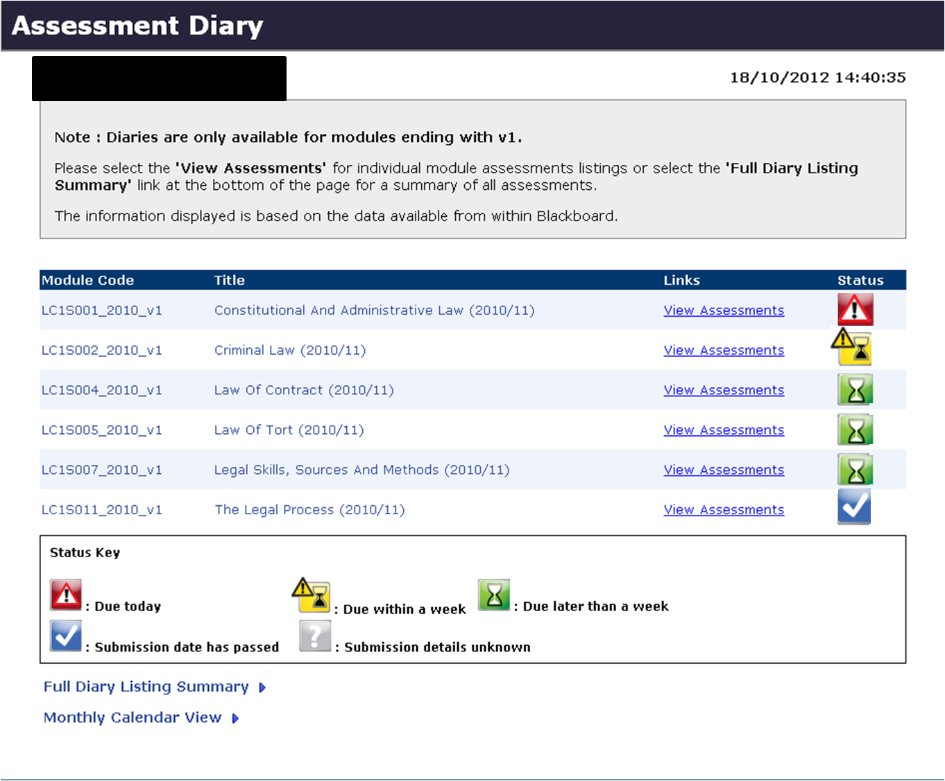

### Appendix 9.5 Screen shot of GradeMark

