*To have your password reset, please contact the GSA OCFO Service Desk. They will reset your password, and you will receive two separate emails. One will be your VCSS user ID and the other will be your temporary password.*

Go to the **VCSS Website** 🡪[**https://vcss.ocfo.gsa.gov/Default.aspx**](https://vcss.ocfo.gsa.gov/Default.aspx)

Click on “**Support Request**” button.

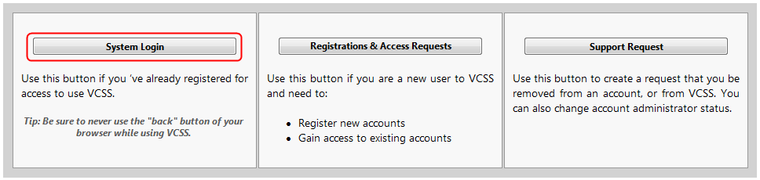

​

Click on the “**Statements**” tab, and choose the “**View and Print Statements**” sub-menu item.

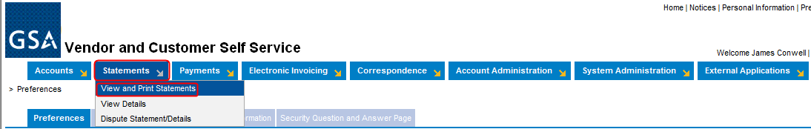

You can use any of the “**Search Criteria**” fields to perform the search. The most commonly used is “**Account Code**” (**BOAC**) or “**Agency Location Code**” (**ALC**), for which you want to view the statements/bills by.

*Note: As you begin to search, the system will provide the list of accounts with that set of characters.

Click “**Search**.”

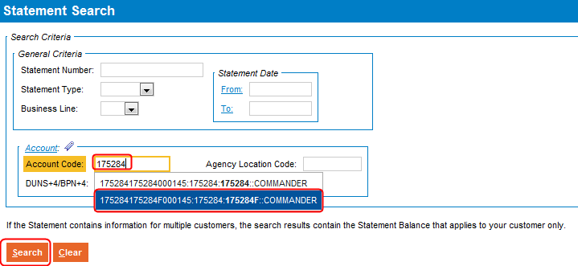

You will be presented with a list of all bills/statements for that Account Code or ALC. You may also have multiple pages of bills/statements; you can sort these in ascending or descending order by clicking on any of the column headings.

*Note: You can only view one bill/statement at a time. To download multiple statements, please repeat the following steps for each bill/statement you need to save/print.

To view the details for all statement dates in an Excel spreadsheet, place a check in the box to the left of “**Statement Number**.”

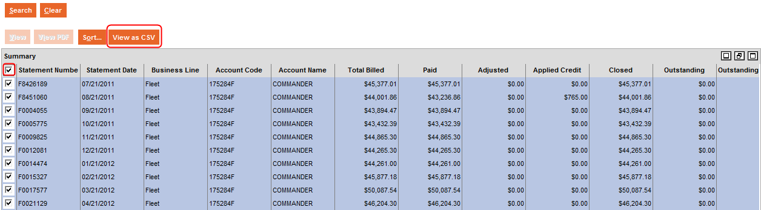

Your browser will refresh and, depending on your browser security settings, will indicate how to download the CSV file.

The most common steps will be for Internet Explorer to have a yellow pop-down window, stating that it is blocking the file from downloading to protect your security. Right-click on this message bar, and choose “**Download File …**”

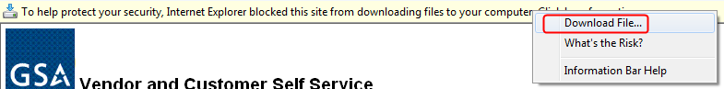

You will get an error message; click “**Retry**.” This may take a few minutes, depending on the size of the file being downloaded.

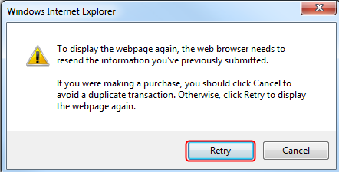

You will either get an option to “**Open**” or “**Save**" at this point.

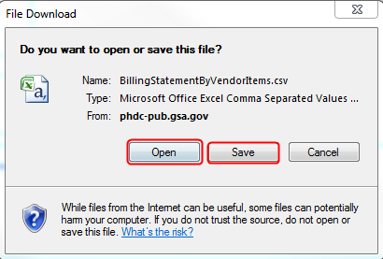

**Or** you will need to click on the “**View as CSV**” button again to view in Excel.

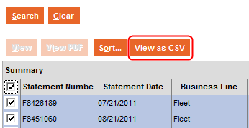

Once opened in Adobe, you can view, print and save the file.