Are You Planning To Work From Home?

The greatest developments in new house building aren't such things as marble surfaces and glass sinks. New behemoths that were ostentatious any longer observed in the community that just developed. New homebuilders hear purchasing developments, viewing their cents and producing smart, eco-friendly options in supplies. Usefulness may be the key phrase in your home building business.

Possibly, the largest change in house building may be the dimension of the house itself. Based on [**New Homes California**](http://www.calpaydayloans.com) Builders' National Association, people homes' typical dimension fallen between 2007. The entire aspect of the new house reduced from 10% to 15%, which provides along the buying price of the home. Customers have the money to take care of the lavish lifestyle anymore or no further observe the requirement.

Energy-efficiency may be the next greatest pattern in new house building that will be unsurprising. Contractors are employing better ways of building, selecting to invest profit places that'll not just create the house green but will even attract the budget of the customer. Choosing windows that are greater that help preserves higher R-value in your New Homes California is one method to improve energy performance.

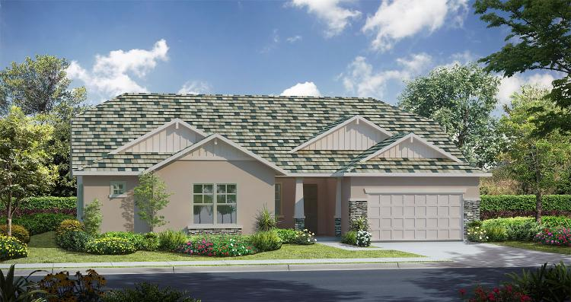Effectively, therefore, the homeowner gets a possible advantage of ventilation securing duct-work, has become a regular section of house building. Utilizing closed-cell spray foam insulation in attics and surfaces, in the place of red batted efficiency, escalates the R-value of the house significantly. Possibly, contractors opting for to create energy-efficient homes for the environment's great. Or maybe, it's an effort to remain aggressive in a market where foreclosure property is abundant and inexpensive. In either case, the customer advantages.

Those who have experienced the actual property marketplace for some decades understands that the worthiness of one's house to improve is upgrading / or and your kitchen. In case your purpose would be to reduce building expenses the change can also be correct. Fresh New Homes California builders have started to scale how big kitchens back. Bathrooms are currently dropping square footage aswell. However, they will also be decreasing in figures. Houses, formerly having 2 or 3 bathrooms, may have a couple of on quantity of rooms.

The children' unique toilet or perhaps a downstairs' powder room isn't any longer the pattern. Usually, there's the first bathroom for an half-bathroom for individuals who inhabit the master suite and visitors. Resort-style door- bathrooms that are less are now actually a scarcity in new houses.

Alternatively, there's the built-in linen cabinet. Your kitchen is smaller but with usefulness in your mind; designed during the most-used space in your home. Typically, this can be a multiple-use room, so new New Homes California builders are incorporating functions for all those uses. Possibly, you will see a receiving stop for notebooks and mobile phones. Or even the capability to sit in a breakfast club; in multiples methods, in a dining table or in a built-in desk area.