www.*pimentelrealty*.com

**PLAN DE NEGOCIOS   
RENTA DE PROPIEDADES**

**PIMENTEL REALTY  
DISTRITO NACIONAL, SANTO DOMINGO**

**ÚLTIMA EDICIÓN: 24 NOVIEMBRE 2016**

**TABLA DE CONTENIDOS**

**Introducción....................................................................................................................**

* 1. Resumen ejecutivo 4
  2. Objetivos del negocio 4
  3. Misión 4
  4. Principios rectores 5
  5. Claves para el éxito 5
  6. Descripción de la empresa 5
  7. Propiedad intelectual 5
  8. Forma legal 6
  9. Resumen de puesta en marcha 6
  10. Ubicación e instalaciones 7
  11. Productos 7
  12. Productos/Servicios descripción 7
  13. Comparación competitiva 7
  14. Sourcing de productos y servicios 8
  15. Gestión de inventario 8
  16. Almacenamiento y cumplimiento 8
  17. Productos / servicios futuros 8
  18. Análisis de mercado 8
  19. Análisis de la indústria 9
      1. Tamaño de mercado 9
      2. Participantes en la industria 10
      3. Competidores principales 10
      4. Segmentos de mercado 11
  20. Pruebas de mercado 12
  21. Estrategia de segmentación de mercado objetivo 12
      1. Necesidades del mercado 13
      2. Tendencias de mercado 13
      3. Crecimiento del mercado 13
  22. Posicionamiento 13
  23. Estrategia de Marketing e Implementación 13
  24. Análisis FODA 13
      1. Fortalezas 14
      2. Debilidades 14
      3. Oportunidades 14
      4. Amenazas 14
  25. Estrategia pirámide 14
  26. Propuesta única de venta (PUV) 15
  27. Ventaja competitiva 15
  28. Estrategia de Marketing y Posicionamiento 16
      1. Declaración de posicionamiento 16
      2. Estrategia de precios 16
      3. Estrategia de Promoción y Publicidad 16
      4. Sitio web 16
      5. Programa de marketing 16
  29. Estrategia de ventas 17
      1. Pronóstico de ventas 17
      2. Programa de ventas 17
  30. Legal 17
  31. Milestones 18
  32. Estrategia de escape 18
  33. Organización y Gestión 18
  34. Estructura organizativa 18
  35. Equipo directivo 18
  36. Equipo directivo faltante 19
  37. Plan de personal 19
  38. Junta Directiva 19
  39. Plan financiero 19
  40. Supuestos importantes 20
  41. Costos de puesta en marcha 21
  42. Fuente y uso de fondos 22
  43. Análisis de punto de equilibrio 23
  44. Proyecciones 23
      1. Ganancias y pérdidas proyectadas 23
      2. Flujo de efectivo proyectado 25
      3. Hoja de balance proyectada 26
  45. Business Ratios 27

# Resumen ejecutivo

Pimentel Realty (PR) es una nueva SRL, administrada por Manuel Pimentel con propósitos de comprar y retener propiedades que generen ingresos pasivos en base a contratos de renta.

PR llena el vacío del mercado de aparta estudios en el Distrito Nacional, Santo Domingo, al proveer propiedades de calidad, bien cuidadas a inquilinos bien calificados. Ni las propiedades ni los inquilinos se eligen de forma precipitada, sino más bien de una manera planificada con un propósito bien definido y metódicamente. El proceso de selección de propiedad es bien riguroso cumpliendo una lista de reglas y está basado en las normas de inversión a largo plazo, los inquilinos son evaluados personalmente por el dueño. Cada propiedad consta con un plan de contingencia con una estructura estratégica y operativa que ayudará a controlar una situación de emergencia y a minimizar sus consecuencias negativas.

PR confía que la clave de inversiones exitosas en bienes raíces es estar comprometido a largo plazo, tanto en el proceso de selección de la propiedad y en screening del inquilino.

PR va a comprar como primera propiedad, una casa bien cuidada que se dividira en 6 aparta estudios, cada uno con espacio para una habitación, baño y cocida: todo separado. La propiedad ya con el 50% (3 unidades) en alquiler se ocupará de pagar por el monto del préstamo mensual, dejando la renta de los otros 3 aparta estudios libre como ganancias y aportes adicionales al capital. PR tiene un contrato en la casa y el valor de venta es RD$3,500,000. La propiedad necesita subdividirse y mantenimiento cosmético, el tiempo estimado de remodelación tomará tres meses para completarse en un costo aproximado de RD$800,000 haciendo un total de RD$4,300,000.00.

Tres inquilinos, conocidos por el dueño con un excelente crédito y referencias, han sido entrevistados y están listos para rentar inmediatamente.

El dueño de PR va a tomar un préstamo del 80% del valor de la inmueble de RD$3,440,000 para comprar la propiedad de inversión, El crédito estará basado en 20 años (240 meses), pagando aproximadamente RD$43,000 pesos mensuales por 240 meses; donde se incluye el interés + capital, seguro de vida del solicitante, seguro de propiedad. La renta por unidad (6 en total) es de RD$15,000 pesos mensuales. El siguiente plan de negocios proveerá la historia de PR con sus presentes y futuros planes al igual que su habilidad para pagar esta obligación financiera.

# Objetivos del negocio

* + - Invertir en propiedades de calidad que tengan espacios para construir seis a ocho aparta estudios.
    - Localizar inquilinos bien calificados, con el deseo de alquilar a largo plazo.
    - Generar ingresos pasivos.

# Misión

El objetivo de PR es invertir en calidad – tanto en sus propiedades y en sus inquilinos. Uno de los mayores errores cometidos por los nuevos inversores de bienes raíces está en una mala selección de inmuebles. Aún peor es su proceso de selección de los inquilinos, a menudo con poco o ningún conocimiento de crédito y ni chequeos de backgrounds. En PR el dueño esta extremadamente enfocado a su negocio y su compromiso. Su compromiso con el largo plazo pueden ser vistos en su extrema dedicación tanto en sus propiedades y su proceso de selección meticuloso de la búsqueda de inquilinos a largo plazo.

# Principios rectores

PR tiene los siguientes como sus principales rectores:

# Tratar la inversión como un negocio, ante todo.

Muchos propietarios de bienes raíces fallarán en tomar en serio su inversión y mantendrán los registros de negocios descuidados o muy mínimos. Con el tiempo esta falta de disciplina puede penetrar en otros aspectos del negocio que resulta en una mala tendencia de la empresa.

# Selectivo proceso de selección de inquilinos

En lugar de aceptar la primera persona en la puerta para firmar el contrato de arrendamiento, PR se reunirá personalmente con cada solicitante para una entrevista personal. PR está buscando contratoa de arrendamiento a largo plazo con inquilinos de calidad. Se requiere que todos los solicitantes pasen el chequeo del crédito y verificación de antecedentes, así como proporcionar los depósitos aplicables. Las referencias son una necesidad y siempre serán verificadas.

# Proporcionar un servicio ejemplar a los inquilinos

El objetivo de PR es lograr niveles de ocupación a largo plazo. Si el inquilino tiene un lavamanos roto, entonces, van a arreglarlo - ese mismo día! ¡Punto! La propiedad estará limpia, bien mantenida y manejada profesionalmente.

# Claves para el éxito

PR está totalmente comprometido a hacer que su negocio de alquiler de propiedades sea un éxito a largo plazo con futuros planes de expansión. Es esta dedicación y motivación que los diferencia de sus competidores locales. Los siguientes son lo que PR entiende son sus claves para el éxito:

* + - **Administración de propiedades** - El propietario de PR gestionará personalmente la propiedad de alquiler y no dependerán de un equipo de administración de propiedades externo. De esta manera, todas las reparaciones se pueden abordar de inmediato, los alquileres se cobrarán en el momento oportuno y el libro mayor de contabilidad se mantendrá vigente y actualizado.
    - **Invertir solo en inversiones sostenibles y de gran calidad -** PR no está interesado en las propiedades para ‘flipping’. Antes de realizar cualquier compra, las propiedades serán evaluadas plenamente para determinar el flujo de efectivo positivo y su sostenibilidad a largo plazo.

# Descripción de la empresa

Pimentel Realty, ("PR"), es una SRL recién formada, creada con el objeto de crear, comprar y retener aparta estudios localizados en el Distrito Nacional, en las principales áreas de Santo Domingo para obtener ingresos pasivos por contratos de arrendamientos en los mismos. PR esta manejada por Manuel Pimentel.

# Propiedad Intelectual

Manuel Pimentel es un residente del distrito Nacional.

# Forma legal

*Pimentel Realty* es una SRL.

# Resumen de puesta en marcha

Manuel Pimentel con un determinado plan estratégico de venta de bienes raices vendió 15 propiedades como agente inmobilario, para recaudar en capital RD$4,000,000.00. Para luego conseguir propiedades en el distrito nacional subdivisibles para invertir y convertir en activos con ganancias de arredamientos. Para esto hizo un extenso estudio estratégico donde se detallan los requisitos que han de tener las propiedades prospectas para este tipo de inversión.   
  
Para considerar la completa evaluación de una propiedad, esta debe de cumplir en su totalidad un criterio clave, los requisitos son:  
  
**Valor**  
  
1. La propiedad tiene que tener el precio correcto, menor que el valor actual en el mercado, con aspiración a su incremento con el tiempo , **el valor por pies cuadrados ha de ser un 20% a un 30%, que el mercado**.  
  
**Edificación**  
1. **Ser edificables y divisibles** en al menos 5 apartaestudios.  
  
2.   
  
**Ubicación**  
1. Estar cerca de una(s) avenida(s) principal(es), con **transporte público** cerca.  
  
2. El lugar donde se encuentre la propiedad, tiene que **ser tranquilo y seguro**.  
  
3.   
  
**Cash-flow**  
1. La propiedad debe de poder pagar el capital, los intereses, seguros y demas gastos mensualmente sin problemas, con un 50% en funcionamiento. **Si la propiedad es de 6 apartaestudios, con 3 de estos rentados se ha de poder cubrir los gastos mensuales.**  
  
2. El precio pedido por alquiler, ha de ser **30% menor que la competencia**, en esa area.

**Plan de contingencia**  
1.  
  
La primera propiedad la cual reune estos requisitos, necesita subdividirse en 5 apartaestudios individuales, un mantenimiento cosmético, y adiciones desde nuevos inodoros, lavaderos, duchas, fregaderos, puertas, ventanas, instalaciones electricas, pintura.  
  
Pimentel planea en subcontratar el proyecto y tenerlo completado en 90 dias laborables y que los inquilinos ya pueden mudarse de inmediato.  
  
Aquí abajo esta un resumen detallado el presupuesto de la construcción:

|  |
| --- |
| Descripción |
| Cocinas: 5x nuevos fregaderos 2x2 en metal: RD$3,500.00 x 5 = RD$17,500.00  Costo de mano de obra: RD$500.00 x 5 = RD$3,000.00  Materiales necesarios para el trabajo:  Tubos  Cintas  Cemento |
| Habitaciones: 5x Ventanales en metal:  Costo de mano de obra:  Materiales necesarios para el trabajo: |
| Banos: 5x nuevas cabezas de ducha 5x nuevos lavamanos  5x nuevos inodoros  Costo de mano de obra:   Materiales necesarios para el trabajo: |
| Mantenimiento Cosmetico:  Materiales necesarios para el trabajo: 20 latas de pintura:   Costo de mano de obra:  Materiales necesarios para el trabajo: |
| Gastos insperados: 30% del presupuesto |
| Seguridad:  5x montajes de verjas para las ventanas: 5x puertas de hierro  Costo de mano de obra:  Materiales necesarios para el trabajo: |
| En general: |
|  |

Manuel Pimentel conoce personalmente al Ing. X, de la Constructora X.

El Ing. X aprobó el presupuesto y da seguridad que el proyecto estará terminado en el tiempo preestablecido con minimos costos extras. El ingeniero es de confiar y es bien conocido en la comunidad por su integridad, proyectos en tiempo y la calidad de sus terminaciones. El tiempo estimado para completar la renovación y rehabitalación es de 3 meses.

PR ha localizado y aprobado 5 clientes para esta propiedad también. Estos prospectos and pasado el riguroso chequeo de credito y sus referencias han sido confirmadas.

# Ubicación e instalaciones

PR investigó extensivamente el mercado local y encontró que cumplía con su criterio clave. The Red Mill Estates neighborhood has lush landscaping, larger than average lots and is primarily owner occupied. The surrounding neighborhoods are middle class suburbs with five grocery stores within a 5 mile radius, various restaurants, and shopping malls 3 miles away near the easily accessible I-65. The property is located in the Franklin City Elementary School District.

The property is clean and well maintained by the original owner. Updates to the property will primarily be cosmetic to bring the property to current market standards.

# Productos

# Productos/Servicios descripción

REV provides clean, quality homes in growing markets to well qualified tenants. The primary source of revenue is rental income. Supplemental income will include:

Forfeited Deposits Bounced Check fees (NSF) Late charges

Damage and Cleaning Charges Application fees

Pet Charges

Lease Termination charges

# Comparación competitiva

There are seven rental income properties within a 1 mile radius of the subject along with several multifamily apartment units. For comparison purposes, the multifamily units have been excluded from this comparison. Rents per square foot range from a high of $1.11 to a low of $0.83 per square foot (“PSF”). The average market rent PSF in the Franklin market is $1.01. The subject rent PSF is $0.98 and compares favorably with the market.

Following is a table outlining the local comparables:

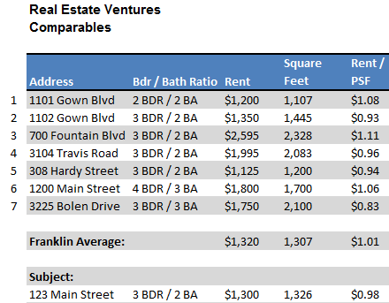

# Sourcing de productos y servicios

N/A

# Gestión de inventario

N/A

# Almacenamiento y cumplimiento

N/A

# Productos / servicios futuros

REV has near term plans to purchase additional quality income producing properties sufficient to generate, passive income streams.

# Análisis de mercado

Franklin, Tennessee, located in Williamson County, is a Principal City in the in the Nashville Metropolitan Statistical Area (“MSA”) and is ranked 31 in the United States. According to the **University Of Tennessee’s 2012 Economic Outlook**, Williamson County is one of the fastest growing counties in the state, expanding by 44.7% over the prior year.

[Health Spring,](http://en.wikipedia.org/wiki/HealthSpring) [Community Health Systems,](http://en.wikipedia.org/wiki/Community_Health_Systems) [Healthways,](http://en.wikipedia.org/wiki/Healthways) [Home Instead Senior Care,](http://en.wikipedia.org/wiki/Home_Instead_Senior_Care) MedSolutions Inc, [Magazines.com](http://en.wikipedia.org/wiki/Magazines.com), the [Provident Music Group](http://en.wikipedia.org/wiki/Provident_Music_Group), Renal Advantage Inc, [World](http://en.wikipedia.org/wiki/World_Christian_Broadcasting) [Christian Broadcasting](http://en.wikipedia.org/wiki/World_Christian_Broadcasting) and [Nissan'](http://en.wikipedia.org/wiki/Nissan_Motors)s North American headquarters are based in Franklin.

There are over 1,600 businesses in the surrounding 3 mile radius of the subject. The majority of the local businesses are in the service category and comprise 40.1% of the local employment base followed by 20.8% in the retail trade.

Franklin vacancy levels were reported to be 6% compared to the industry average of 7.9%.

# SOURCE: Trulia, Bureau of Labor Statistics

# Análisis de la indústria

The housing market recovery has remained true to the old real estate axiom of “location, location, location.” How your local market is faring today – and if it makes more sense to buy or rent, to sell now or to hold off if possible – is largely determined by unique, local factors and fundamentals. Timely and comprehensive local market information will be even more important in 2013 as buyers continue to seek bargains and sellers look to maximize returns. **Source: Zillow Research**

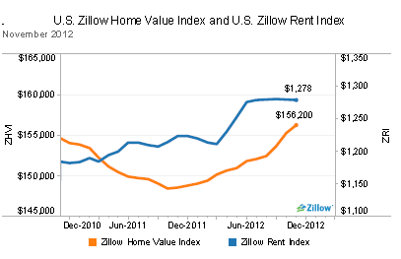

# Tamaño de mercado

A recent survey of Franklin, Tennessee revealed there are currently 67 single family residences available for rent. The average monthly rental charge ranges from

$2,202 monthly to $1,058 monthly. The middle tier monthly rent is $1,283 or

$1,031,532 annualized.

REV’s portion of the $1 million market represents 1.51% of market share.

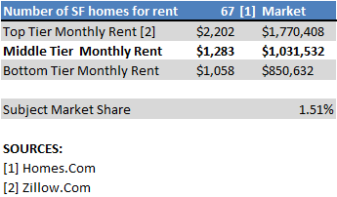

# Participantes en la industria

The primary participants in the rental real estate market are other single family residences and apartments. However, other indirect competitors include: condos, mobile homes, trailers, garage apartments and duplexes. Sellers of homes that offer rent to own options pose yet another form of competition.

# Competidores principales

Within a one mile radius of the subject are 10 apartment complexes and 7 single family residences available for rent. For comparison, this analysis will focus only on the single family residences available for rent.

*1101 Gown Blvd*

1. *BDR / 2 BA*

*$1,200 month / 1,107 SF*

This property competes closely with the subject. However, the subject is superior with its extra square footage and additional bedroom.

*1102 Gown Blvd*

1. *BDR / 2 BA*

*$1,350 month / 1,445 SF*

This property is most comparable to the subject. Comparable Number Two has 119 additional square feet are and is $0.05 lower in monthly rent.

*700 Fountain Blvd*

*3 BDR / 2 BA*

*$2,595 month / 2,328 SF*

This property has the largest square footage of the comparables and is located on acreage. It is also the demanding the highest monthly rental charge. Based on these factors Comparable Number 3 is an indirect competitor.

*3104 Travis Road*

*3 BDR / 2 BA*

*$1,995 month / 2,083 SF*

This property competes directly with the subject. With an additional 757 square feet, this property is priced $0.02 PSF below the subject and could appeal to the value renter. The downside to this property is its inferior location – which is across the street from a landfill. The property has been vacant for four months and it is rumored the owner will be dropping the asking rental price.

*308 Hardy Street*

1. *BDR / 2 BA*

*$1,125 month / 1,200 SF*

Comparable Number 5 is slightly older and smaller the subject. Built in 1980, the property is 126 feet smaller than the subject. The property is clean and well maintained and is considered a direct competitor with the subject.

*1200 Main Street*

1. *BDR / 3 BA*

*$1,800 month / 1,700 SF*

This property is larger than the subject by over 300 feet. Asking rent is higher than the subject as well and higher than the $1,100-$1,400 range REV is hoping to attract. This property has an additional bedroom. Based on these factors; Comparable Number 6 is considered an indirect competitor.

*3225 Bolen Drive*

*3 BDR / 3 BA*

*$1,750 month / 2,100 SF*

Comparable Number 7, like Comps 3 and 4 is substantially larger than the subject. The asking monthly rent of $1,750 is also above the range REV is targeting. The property has exceptional value with rents per square foot the lowest in the market at

$0.83 and will appeal to the value renter. The property is clean and well maintained. Based on its larger square footage and higher asking monthly rent, Comparable Number 7 represents an indirect competitor.

# Segmentos de mercado

The 1 mile radius surrounding the subject had a population of 7,199 at the 2010 Census and is expected to grow to 7,363 by the Year 2017. The majority of the homes are owner occupied with 1,950 housing units and a reported 793 renter occupied units from the 2010 Census. Rental units are expected to grow to 854 by the Year 2017. The median age at 2010 was 34. **Source: BUSINESSDECISION.INFO**

Residents within a 1 mile radius of the subject are comprised primarily of two market segment groups: *In Style* represents 52.7% of the market share and *Crossroads* with 35.4% of the market or 88.1% cumulative market. The *In Style* market is comprised primarily of residents that live in the suburbs but prefer the city lifestyle. These residents prefer townhomes to traditional single family homes and have a median household income of $182,665. REV is targeting the latter group, *Crossroads,* as their primary target customer. Following is a brief summary of their target occupant:

*Crossroads* neighborhoods are growing communities in small towns. Married couples with and without children and single parents are the primary household types in these areas. They have a median age of 32.2 years. This population is growing at 1.6% annually faster than the US population. The median household income is $43,799. Children are the focus of their lives. They drive domestic cars and trucks and handle the maintenance themselves.

# Source: ESRI.COM/Tapestry

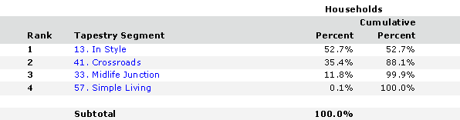

# Pruebas de mercado

Prior to selecting the rental unit, REV placed an advertisement for rent with the online classifieds at Linda’s place of employment, Franklin Elementary. The response was overwhelming! REV had 14 candidates to choose from! The majority of these applicants were fellow teachers or friends of teachers. All applicants were families, both single income and dual income. REV had to inform the turned down applicants that the property was already leased.

Based on this market ‘test’ REV decided to put the “pedal to the metal” and make an offer on the property.

# Estrategia de segmentación de mercado objetivo

REV is targeting families with children – single family households or dual income households. The target tenant is young, under the age of 35 and is likely to have some additional financial obligations, such as student loan debt and car note debt that they want to pay off prior to considering home ownership. Many of the new teachers at Linda’s

school fit the target profile and REV will continue to pursue this target group as tenants. The target rent is the $1,100-$1,400 range.

# Necesidades del mercado

Given the option of raising a family in a traditional single family home compared to an apartment complex, REV’s target tenant prefers the former. The Red Mill Estates neighborhood and surrounding neighborhoods are growing residential neighborhoods making the location ideal for REV’s tenants. With limited direct comparables, the demand for single family residences available for rental is high in this market.

# Tendencias de mercado

* + - * Homeownership make financial sense when the occupant is planning on staying 5+ years and has the cash flow cover the normal repair and maintenance costs. And as we leave the recession behind us over time tenants may vacate to pursue homeownership.
      * Renting still makes financial sense for REV’s targeted tenant who does not want the additional cost/time burden of property maintenance.

# Crecimiento del mercado

The local single family rental home market increased 1.4% over the prior year.

# Source: Zillow Rent Index

# Posicionamiento

REV will position itself as the rental property of choice when it comes to quality properties in solid neighborhoods, by actively staying current on local market conditions.

# Estrategia de Marketing e Implementación

REV will own, operate, and lease clean, well maintained single family residences to well qualified tenants. Others often miss the mark by investing in low quality properties which will not provide sufficient ROI (return on investment). Additionally other landlords often fall short in responding to tenants needs for repairs. When a tenant calls requesting repairs to say a leaky faucet, REV will have a repairman on premises that same day and more than likely one of the owners will personally make the repair. What will set REV apart from other property managers will be its unique ability to bring quality properties and tenants together. The following sections address the various tactics that will contribute to this effort.

# Análisis FODA

SWOT stands for strengths, weaknesses, opportunities and threats. A SWOT analysis is a method for strategic planning that evaluates these four elements as they relate to REV’s business objectives. The following section helps demonstrate REV’s marketing strategy:

# Fortalezas

* + - * The rental property is well located in a growing neighborhood with easy access to neighborhood schools, shopping and restaurants. Located less than 5 minutes from I-65, the commute to Nashville is less than 20 minutes.
      * REV has an approved tenant in place with a security deposit. The tenant has excellent credit and payment history. The tenant is known by REV and works as a teacher at the same school as Linda Rogers.
      * Upgrades to the property will be made by a reputable contractor with a 15 year history with the owners of REV. The owners of REV will paint the property themselves which will further reduce expenses.
      * REV will come out of pocket in excess of $67,000 toward the house purchase and capital improvements resulting a low, loan to value (LTV) ratio of 50%.
      * The owners of REV have ‘day jobs’ and thus have additional income sources and savings to draw from to support business operations.

# Debilidades

* + - * New entrants into real estate property management, REV has limited experience owning and managing investment income properties.

# Oportunidades

* + - * Franklin has low vacancy levels at 6% compared to the national average of 7.9%.
      * The property is located in a strong growing community and the fastest growing county in the state.
      * REV has an opportunity to participate in a $1 million local real estate rental market.

# Amenazas

* + - * Investment real estate is economically tied – changes in unemployment, rent spikes and changes in the economy could adversely impact demand for rental units.
      * Declination in the local neighborhood could impact attractiveness of rents
      * Cost overruns in the construction budget and failure to complete upgrades in time could impact REV’s cash flow.

# Estrategia pirámide

REV will only lease solid, clean, well maintained investment properties that generate positive cash flow.

In order to meet these objectives, REV will not make the mistakes many new landlords make and perform thorough due diligence prior to purchasing any property; All perspective properties must meet the following requirements:

* + - Property must be clean and well maintained
    - Property must be a growing community with low vacancy rates
    - Rents will be priced within market range – typically between the $1,100-$1,400 range
    - Property must generate positive passive income
    - All tenants will be required to: Pass background and credit checks; Provide verifiable references
    - Provide non-refundable application fee to cover the costs associated with these checks.
    - All tenants will be required to provide a security deposit.
    - Tenants will be required to make payments via EFT which will further ensure payments will be made as agreed and on time.

REV will strive to be a superlative landlord as well – by responding within one hour to any tenant issues regarding repairs and maintenance during normal business hours of operation. Weekend and evening calls will be answered the following business day unless it is a life threatening emergency (such as the smell of gas, water main breaks) in which case the owners will be paged immediately and an emergency response service will be sent.

On a monthly basis, REV will change and replace air filters and monitor smoke and radon detectors.

# Propuesta única de venta (PUV)

The owners of REV love what they do! And it shows in from the quality of the properties they invest in to the caliber of tenants they lease to. They thoroughly review the property and analyze the real estate market. REV will continually monitor and evaluate the local market trends. They are in this for the long term!

# Ventaja competitiva

REV utilizes a thorough due diligence process prior to purchasing and investing in any property. By doing their homework, REV can competitively price their rents – often at or below market. Thoroughly knowing their market gives REV the competitive edge over their competitors. Further, Steve’s background in painting and his extensive connections in the construction field in the local Franklin market, gives REV the competitive edge when in it comes to knowing the quality and caliber of the local contractors. Many competitors will fall short and subcontract often to the lowest bidder with unknown track records. If a major tenant repair is required, REV will be prepared and have the ability to select the best contractor at a fair price. This in turn will keep expenses down and profit margins and return on investment on target.

# Estrategia de Marketing y Posicionamiento

REV’s marketing strategy incorporates a **Focus Strategy** – that is, it targets a specific target market. REV concentrates their marketing efforts on attracting solid, credit worthy tenants that are motivated to live in growing, thriving comminutes.

# Declaración de posicionamiento

REV is a high quality real estate investment corporation. REV carefully and methodically selects its rental properties in growing neighborhoods, with low vacancy rates. The properties are clean, well maintained and provide positive cash flow. In keeping with their its high quality standards, REV’s tenants, reflect these attributes as well and have exceptional credit scores, timely rental payment history and a strong desire to live long term with their families in a solid community. REV is committed to their properties for the long term – they do not foster a “here today gone tomorrow” mentality. Above all REV’s owners love what they do and are committed to the company for the long term.

# Estrategia de precios

REV utilizes C**ompetition Based Pricing** – in which prices are based on the market. The company’s thorough due diligence process assures that they never buy the highest priced property or the lowest priced for that matter.

# Estrategia de Promoción y Publicidad

REV will primarily rely on advertising in the Franklin Elementary School Online Classified Ads and **Word of Mouth** advertising.

As properties become available, REV will post signage in front of the property. As a last resort, REV will post classified ads with the local newspaper and Craigslist.

# Sitio web

REV’s website features properties available to rent, the business phone number to contact for information regarding renting or who to contact for repairs. Additionally the website will have links to complete an online application and links to key articles for tenants such as the importance of obtaining sufficient renters insurance for example.

In the event that a property is available, the site will feature photos of the property along with detailed description of the property, amenities, details of the surrounding neighborhood and any concessions that are currently available.

# Programas de Marketing

REV is uniquely sized to both personally own and manage its investment properties. Through their extensive contacts in the Franklin area, REV hopes to rely on Word of Mouth advertising and not be forced to allocate a large portion of their budget to advertising costs. However, in the event that a property remains vacant for 30+

days, REV has a policy in place to purchase classified advertising space in both the local newspaper and on Craigslist.

# Estrategia de ventas

REV will meet with prospects right on site. The prospects will be greeted and treated with the utmost professionalism in a relaxed and respectful environment. The first meeting is an opportunity for the owners of REV to decide on leasing to the prospective tenant. If the prospect seems disagreeable, unpleasant or makes unrealistic requests, REV will not lease the property. If however the prospect is professional, and has reasonable requests, then this meeting will be considered along with the credit report and background check in making a decision to lease.

# Pronóstico de ventas

The following table represents the estimated sales from the rental unit the initial three years of operations. The analysis assumes 100% leased and no escalations in rent the initial two years.

# Table 5.6.1 Annual Sales Forecast

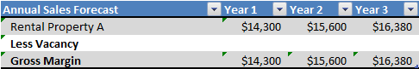

# Programa de ventas

The owners of REV personally lease their properties and do not need to pay incentives to sales agents. However, just like sales agents, the owners of REV are motivated to lease properties quickly- after all vacant properties do not generate revenue! Although the owners of REV are motivated to get tenants in quickly they will not ‘rush’ at the expense of sacrificing quality. If REV is unable to find a perspective tenant in a reasonable amount of time (approximately 30 days) then the cost of doing business are the advertising costs associated with placing classified ads with the local newspaper and Craigslist.

# Legal

Clean title and zoning, will be instrumental in purchasing investment real estate. The title search and tax record search must confirm this prior to REV purchasing any property. The title search must be free of liens.

All maintenance and repairs will be performed by bonded and licensed contractors that are in good standing with the state.

# Milestones

Following are the Milestones REV believes will allow them to meet their objectives.

# Table 5.8 Milestones

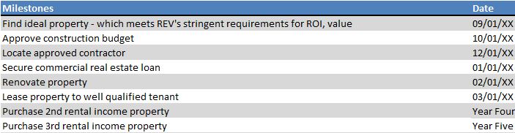

# Estrategia de escape

In the event the rental unit remains vacant for an extended period of time or in the event that extreme repairs and depletes all cash reserves, the secondary recourse will be to the owners. After the owners have depleted their personal reserves, the property will be sold. Proceeds will be used to satisfy obligations to creditors and any surplus will be returned to the owners.

# Organización y Gestión

The following section highlights ownership and future staffing expectations of REV:

# Estructura organizativa

Both Linda and Steve Rogers will own and manage the subject real estate. Steve Rogers will perform routine maintenance requirements and repairs. Linda Rogers will manage the daily bookkeeping requirements. She will submit payments to vendors such as trash service and recycling service, and forward the required information to REV’s certified public accountant for preparation of the annual income taxes.

# Equipo directivo

Steve Rogers will oversee the day to day maintenance of the rental unit. On a monthly basis he will replace air filters, inspect the grounds, and make notations of the overall physical condition of the property. The tenant will be put on notice for example if the yard needs to be mowed or weeds appear to be an issue. The tenant will have sufficient time to remedy the notice and will be fined daily until the issue has been resolved.

Steve has successfully owned and operated his painting business for 15+ years and is in the neighborhood on a daily basis. He will drive by the property frequently for visual inspections of the property. He is readily available in the event the tenant has any repair needs.

Linda Rogers will oversee the day to day bookkeeping needs for the rental property.

All tenants will be required to agree to EFT (electronic funds transfer) for monthly payments – which should minimize the need to collect rents.

# Equipo directivo faltante

REV does not have an accountant or attorney on its staff. Income tax preparation and consulting services will be provided by the owner’s long term personal public accountant. REV will rely on their title company to verify clear title.

# Plan de personal

Steve and Linda Rogers will own and operate REV but draw no salary; both owners have outside incomes and will not draw salaries from the properties.

# Table 6.4 Personnel Plan

Steve and Linda Rogers, owners and operators

# Junta Directiva

N/A

# Plan financiero

The following financial plan covers the following:

* + - Required Cost of Start-Up
    - Profit and Loss
    - Cash Flow
    - Balance Sheet
    - Financial Ratios

# Supuestos importantes

*Construction Budget*

REV estimates a 1 month completion. Work will be performed by a contractor that is well known by the owners. The contractor is bonded, licensed and in good standing with the state.

*Source of Funds*

The owners of REV received approximately $100,000 in inheritance and have access to liquidity to fund start up costs and meet operating shortfalls. However, they plan to invest a portion of these proceeds into additional rental income properties. Additional source of funds comes from both owners 'day jobs' - Steve Rogers owns his own house painting business and Linda Rogers is a math teacher at Franklin Elementary

*Profit and Loss*

Vacancy levels in Franklin are a low 6% and is substantially lower than the national average of 7.9%. The analysis assumes 100% occupancy over the 3 years reviewed.

# Costos de puesta en marcha

The following table represents start up costs.

# Table 7.2 Start-Up Costs

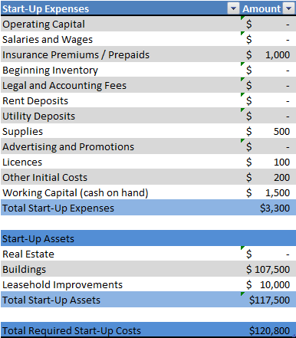

# Fuente y uso de fondos

The owners of REV received approximately $100,000 in inheritance and have access to liquidity to fund start up costs and meet operating shortfalls. However, they plan to invest a portion of these proceeds into additional rental income properties. Additional source of funds comes from both owners 'day jobs' - Steve Rogers owns his own house painting business and Linda Rogers is an elementary school math teacher at Franklin Elementary. The following table shows the proposed Source and Use of Funds:

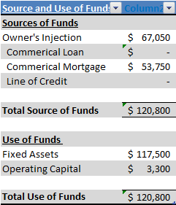

# Análisis de punto de equilibrio

The rental income property is expected to generate $1,300 in monthly rent or $15,600 annually. Break even rents required are $14,020 or approximately 10.78 months of revenue. The following chart depicts break-even analysis:

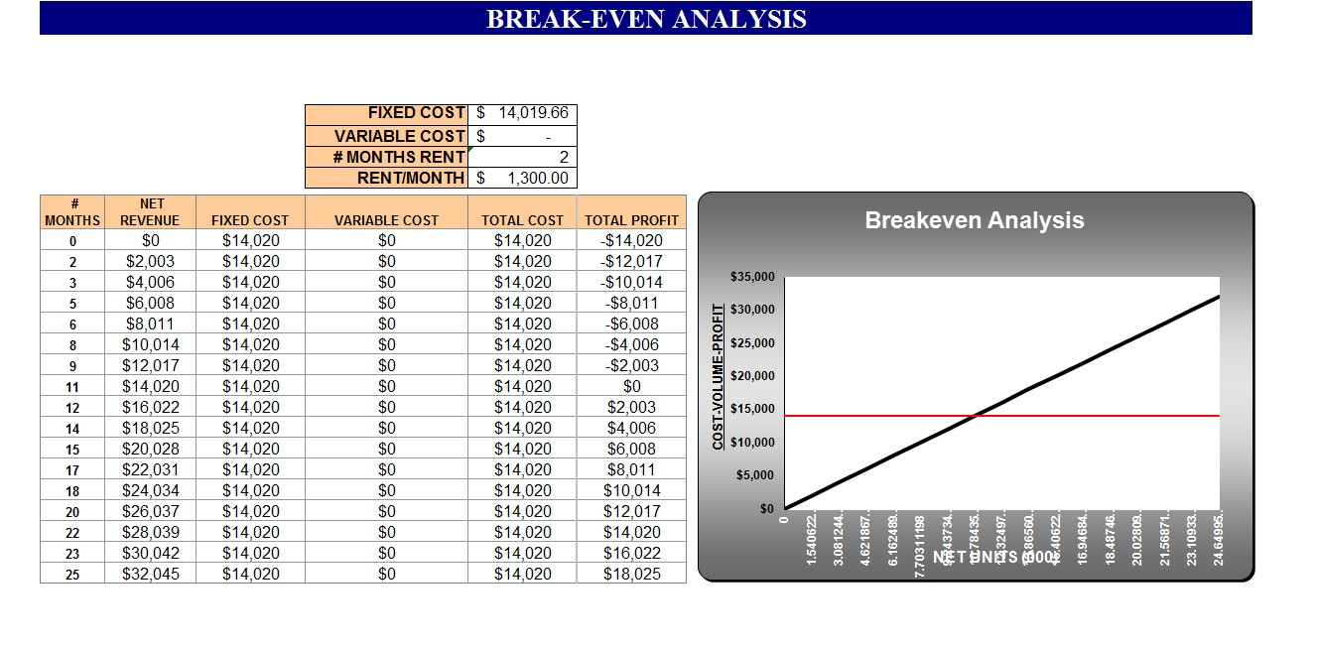

.

# Proyecciones

# Ganancias y pérdidas proyectadas

The proforma profit and loss is based on the initial 3 years associated with the subject property.

# Table 7.5.1 Pro Forma Profit and Loss

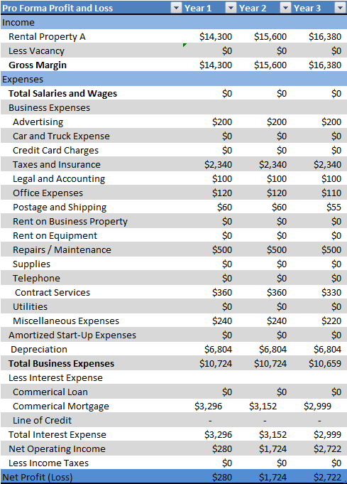

# Flujo de efectivo proyectado

The statement of cash flow shows the incoming and outgoing cash of the business.

# Table 7.5.2 Pro Forma Cash Flow

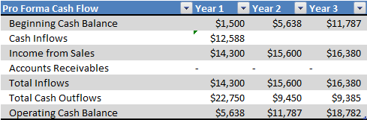

# Hoja de balance proyectada

**Table 7.5.3 Pro Forma Balance Sheet**

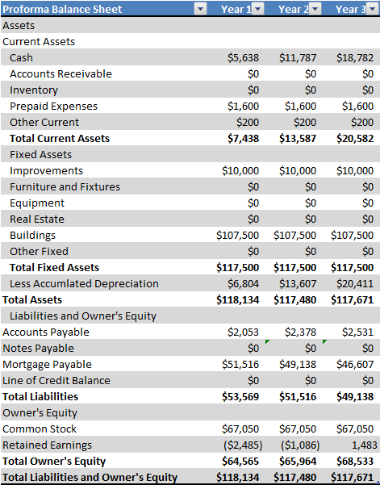

# 7.6 Business Ratios

The business ratios are based on NAICS code 531110. The ratios demonstrate that REV is well capitalized, has a low leverage position and has good liquidity. REV compares more favorably to its industry peers primarily due to the owner’s injection in equity.

# Table 7.6 Ratio Analysis

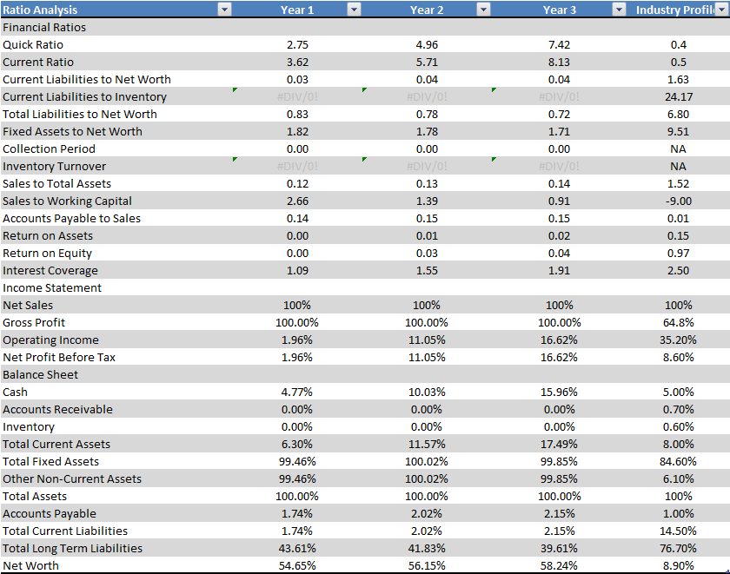

This business plan template can be downloaded at: <http://www.fastbusinessplans.com/business-plan-template.html>

Free sample business plans are available at: [http://www.fastbusinessplans.com/sample-business-plans.html.](http://www.fastbusinessplans.com/sample-business-plans.html)

Many articles to assist in guiding you through the writing of your business plan are available at: <http://www.fastbusinessplans.com/business-plan-guide.html>

**Crazy Ideas / Tasks**

4. Cuando logre mi primer millón de pesos donar 100,000 en buenas causas en personas que necesiten de verdad el dinero.

6. Buscar estimado precio por metro en DN

5. Buscar una propiedad en el distrito nacional en menos de 3 millones que se pueda dividir en 6 a 7 apartaestudios

1. Publicar 100 propiedades en corotos de supercasas, cuando alguien me llame interesado por una propiedad, contactarme con el agente que vende la propiedad y ganar comisiones por venta. 10 por sector en 10 sectores para comenzar, luego poner 20 anuncios por cada sector y conseguir 50/50 de comisión.

7. Luego de ganar 2,000,000 en comisiones, publicar anuncios falsos de propiedades de bajo costo para poder comprar a bajo costo y luego una vez comprada, subir el precio de los anuncios de los apartamentos del área comprada (de la competencia) así el valor de mi propiedad va a subir.

Publicar anuncios de apartamentos en corotos luego submit el link a google seach para quese indexe así cuando alguien busca algo pues le aparece en los resultados

Usar google adword para la publicidad por key word del area y bien ( es decir ejemplo evaristo morales apartamento )

Buscar el numero de telefono de un agento o compania en google para ver donde tiene su numero publicado (y sus propiedades)