AP – REVERSE A VOUCHER

PURPOSE: To reverse a voucher previously entered. A voucher may be reversed unless it has been paid. If vouchers are reversed for invoices created through “Convert PO to Voucher”, the material receipt is no longer available for you to re-convert. Vouchers reversed that need to be re-entered must be done in VOUCHER BY AMOUNT or VOUCHER BY ITEM. (See work instruction AP – VOUCHER BY AMOUNT). If you are rekeying a voucher for inventory items, be sure you use the G/L code for your inventory receipts clearing account instead of an expense G/L code when processing the replacement voucher.

1. ACCOUNTING BAND > ACCOUNTS PAYABLE > TRANSACTION > REVERSE VOUCHER
2. Enter the VOUCHER NUMBER. You may browse for the voucher number if needed, and can also browse for the vendor ID to narrow your search to vouchers for that vendor only.
3. The information for the voucher is displayed.

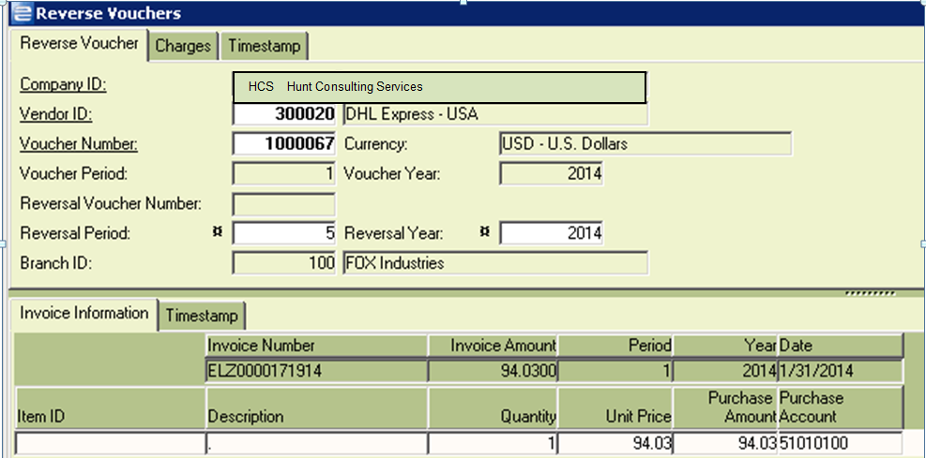

1. Review the REVERSAL PERIOD/YEAR to make sure you are reversing in the correct period. Edit, if needed.
2. Click SAVE. Voucher is reversed.