IT – CUSTOMER PART NUMBER MAINTENANCE

PURPOSE: To provide instruction for entering customer part numbers and assigning them to Item ID’s within Prophet 21. There are 2 ways to add a customer part number

ORDER ENTRY

1. Enter your customer order header information.
2. Enter the item ID for your line (or browse)
3. Once the line information populates the screen, press your RIGHT MOUSE BUTTON
4. Select option CREATE CUSTOMER PART NUMBER

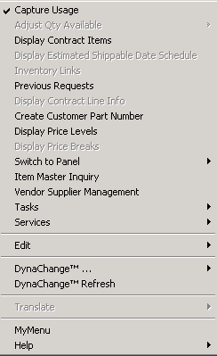

1. You will be prompted to enter the customer’s part number. Key the part number, then click SAVE.

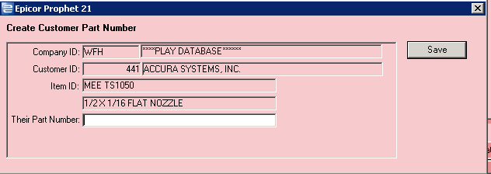

1. NOTE: If you use a customer master account for part numbers for a group of customers, be SURE you are setting up the part number for the correct customer ID. If you are not using the master customer ID for part numbers, do NOT set up the part number in order entry.

CUSTOMER PAR T NUMBER ENTRY

1. INVENTORY BAND > INVENTORY MGMT > MAINTENANCE > CUSTOMER PART NUMBER MAINTENANCE

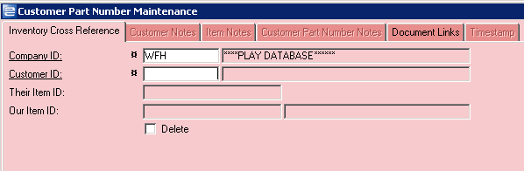

1. Enter the CUSTOMER ID or browse
2. Enter the CUSTOMER PART NUMBER in the field THEIR ITEM ID
3. Enter your item ID (or browse) in the field OUR ITEM ID
4. SAVE.
5. CAUTION: I f you are using a master customer ID to track part numbers for multiple customers, be sure you are using the correct customer ID when setting up your part number. This prevents having to maintain the same record multiple times.