**Sorbitol 95% - Spray Dried**

**Modeling and Evaluation with**

**SuperPro Designer®**

**INTELLIGEN, INC.**

*Simulation, Design, and Scheduling Tools*

*For the Process Manufacturing Industries*[**www.intelligen.com**](http://www.intelligen.com)

**Introduction**

This example analyzes the production of spray dried sorbitol. Sorbitol is a food and pharmaceutical ingredient produced in bulk quantities around the globe. Chemically speaking, sorbitol is hydrogenated glucose, and for this reason it is also called glucitol. **Figure 1** shows the difference between the molecules of glucose and sorbitol. Glucose, like many other hexoses, has a free aldehyde group (in Figure 1 it is shown at the top of the molecule). It is this free aldehyde group that makes glucose a reducing sugar, and gives it properties such as the ability to react with amino acids (Maillard reaction). If hydrogenated, the molecule’s carbonyl group becomes an alcohol, a non-reducing molecule.

Since sorbitol is produced from glucose and since glucose is usually derived from the hydrolysis of starch, it is very common for plants that produce starch to also produce sorbitol. Details on starch hydrolysis for the production of glucose syrups can be found in the **Corn Refinery** example of SuperPro. That example includes sections related to corn wet-milling (which produces starch and other coproducts) and hydrolysis of the starch to produce glucose and fructose syrups. In this example, the raw material for the production of sorbitol is glucose syrup that is 95% pure (on a dry solids basis).

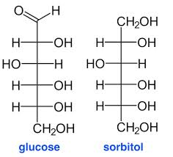

**Figure 1**: The chemical structures of glucose and sorbitol

As explained in the corn refinery example, glucose syrup 95% contains about 5% higher sugars, such as maltose, maltotriose, etc., due to the inevitably imperfect starch hydrolysis. These higher sugars are also reducing and since they are included in the raw material stream along with glucose, they get hydrogenated to produce maltitol (hydrogenated maltose), maltotritol (hydrogenated maltotriose) and higher polyols. Syrup with a specific sugar profile produces a similar polyol profile when it is hydrogenated. Therefore, when a 95% glucose stream is hydrogenated, the corresponding product is 95% sorbitol. This product is typically spray dried in order to produce the commercial form of sorbitol that is modeled in this example. Sorbitol is also sold in the form of syrup with a purity of around 70% on a dry solids (DS) basis. That form of sorbitol is typically produced by hydrogenating glucose syrups of lower purity.

There are several characteristics of polyols which render them useful ingredients in the food, pharmaceutical, and health care industries. All polyols are mildly sweet substances with sweetness lower than sucrose (sugar). Sorbitol in particular is about 60% as sweet as sucrose. Moreover, polyols are not readily metabolized by humans. As a result, from a nutritional point of view, they have lower caloric value than readily metabolized sugars such as sucrose, glucose, and fructose. Therefore they do not increase the glycemic index of a diet and they do not trigger production of large amounts of insulin to maintain blood sugar levels. This combination of properties makes them an ideal food ingredient for low sugar or low calorie sweet foods in general, and for foods consumed by people with diabetes in particular. Furthermore, polyols have many applications in pharmaceutical products, such as syrups containing active pharmaceutical ingredients. In these formulations, the syrup provides a pleasant sweetness without rendering the product unsuitable for people with diabetes. The fact that polyols are not easily metabolized by microorganisms also makes them useful in oral hygiene products, such as toothpastes and oral solutions (Bahndorf and Kienle, 2004). In addition, since sorbitol has a lower molecular weight than sucrose, it generates higher osmotic pressures, thereby extending the shelf life of food products such as jams and bakery products. Finally, crystalline polyols have a negative heat of solution, which creates a cooling sensation in the mouth. For this reason, they can be combined with mint and other flavors to sweeten low-calorie chewing gums (Hull, 2009).

Figure 2 displays the global sorbitol demand up to 2013, as well as a projection for the following years (source: Radiant Insights Inc.). The global production of sorbitol was around 1800 ktons in 2013. Cosmetic and health care end users consumed around 600 ktons (primarily for toothpaste manufacturing), while food industries consumed around 538 ktons. The global sorbitol market is expected to continue growing at an annual rate of around 3.6% in the coming years, partially due to the rising global awareness of good oral hygiene, which is expected to drive up the demand for toothpastes.

The sections that follow describe and analyze the sorbitol production process modeled in SuperPro Designer. The development of the model was based on data that is available in the patent and technical literature supported by our experience with related processes and our engineering judgment.

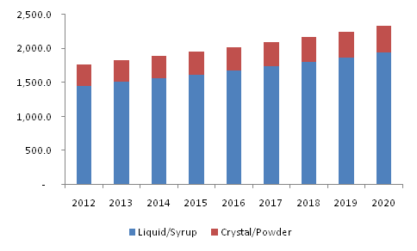

**Figure 2**: Global Sorbitol Market in ktons (Source:Radiant Insights Inc.)

**Process Description**

A 95% (dry solids basis) glucose solution enters the process in a feed tank (P-1 / V-101), where it is mixed with recycled water (S-113). Next, a custom mixer (P-2) adds more water in order to reach a final target water content of around 50%. Note that glucose syrup is commonly sold with an initial water content of 29%, with the remaining 71% being the dry solids (DS). A high DS percentage is undesirable for the hydrogenation reaction, which is why the syrup needs to be diluted to around 50% DS. In integrated processes, which co-produce 95% glucose syrup and sorbitol, the moisture content of the glucose syrup that is utilized for sorbitol production is adjusted directly using water from the final evaporator of the glucose syrup section. In contrast, in this flowsheet the moisture is adjusted by simply adding fresh water. The syrup then enters the hydrogenation reactor (P-3 / R-101), which operates in batch mode and includes the following operations:

* Pull-In Syrup
* Pull-In Hydrogen
* Heat
* React
* Cool
* Gas sweep
* Transfer Contents Out

In this procedure, initially the syrup is pulled into the reactor. Then part of the required hydrogen is pulled into the headspace of the reactor, pressurizing the vessel. The reaction utilizes Raney-Nickel catalyst which was modeled as a consumable. In order to initiate the reaction, the syrup is heated using steam to a temperature of around 80 ◦C. The hydrogenation of sugars is exothermic, and it is accelerated by high temperatures. This means that once the reaction starts it is self-catalyzed because of the generated heat.

As noted previously, there are several different sugars in the glucose syrup, with the predominant one being glucose at a concentration of about 95% on a DS basis, and the remaining 5% consisting of maltose (DP2), maltotriose (DP3), and higher sugars (DPn). All of these sugars get hydrogenated during the reaction. The molar stoichiometries of the reactions follow:

|  |  |
| --- | --- |
| **Reaction Name** | **Stoichiometry** |
| Glucose Hydrogenation | 1 Glucose + 1 H2 🡪 1 Sorbitol |
| Glucose Decomposition | 1 Glucose 🡪3Organic Acids |
| Maltose Hydrogenation | 1 Maltose + 1 H2 🡪 1 Maltitol |
| Maltotriose Hydrogenation | 1 Maltotriose + 1 H2 🡪 1 Maltotritol |
| Higher Sugars Hydrogenation | 1 DPn + 1 H2 🡪 1 Higher Polyols |

Since the combined reactions are exothermic, the feed rate of hydrogen into the reactor is limited to 50 kg/h (using a fed-batch feed), and cooling water is used to maintain a reactor temperature of around 120-130 ◦C. The pressure is maintained at around 60 bar. Approximately 0.2% of the glucose in the reactor is lost due to decomposition. The extents of reaction for the maltose, maltotriose, and higher sugar were set to 100% since there is typically a very small concentration of reducing sugars remaining at the end of the reaction (less than 0.1%). Once the reaction is complete, a cooling operation reduces the temperature to 80 ◦C. In parallel, all the remaining unreacted hydrogen in the overhead of the reactor is removed with nitrogen gas sweep. Finally the converted syrup is transferred to an intermediate storage tank (P-4 / V-102).

The hot syrup is subsequently precooled to approximately 57 ◦C in a heat exchanger (P-5 / HX-101), which exchanges heat with the outlet stream of the ion exchangers. Then the syrup is cooled to 52 ◦C (P-6) and sent into the ion exchangers (P-7 / INX-101), which operate in batch mode. Almost all salts bind to the resin of the mixed bed ion exchangers. The ion exchangers contain the following operations:

* Loading of the syrup.
* Washing with water to recover the syrup contained in the bed volume.
* Regeneration of the cation resin with Hydrochloric acid. The acid is prepared in P-8.
* Regeneration of the anion resin with Sodium Hydroxide. The alkali is prepared in P-9.
* Washing the resin with water to remove salts. The water required by the ion exchangers is supplied by P-10.

After exiting the ion exchangers and passing through the heat exchanger (P-5), the syrup is fed into a buffer tank (P-11 / V-103), heated to 72 ◦C (P-12 / HX-103), and passed through a carbon column (P-13 / GAC-101) in order to remove color and odors. The syrup then enters a buffer tank (P-16 / V-104) which feeds the evaporator (P-17 / EV-101). There the syrup is concentrated to a water content of 29% and finally it is dried in a spray drier (P-18 / SDR-101) to a final moisture content of 5%.

The vapor condensate of the evaporator is recycled and reused as follows: it is collected in a mixer (P-19), pumped using a centrifugal pump (P-20), cooled in a cooler (P-21), and redistributed to units which require water (ion exchangers and the activated carbon column) via a custom splitter (P-22) and flow distributors (P-23, P-10, and P-15). The excess water is removed from the recycle loop via the stream named “Water Purge” which exits the custom splitter (P-22). This stream is sent to the Receiving Storage Unit named “Waste Water Receiving Tank”.

**Economic Evaluation**

This plant processes 5 MT/h of 95% glucose syrup with an assumed uptime of 8208 hours per year. Based on these inputs, the plant produces around 31,000 metric tons of spray dried 95% sorbitol per year. Various assumptions were made for the costs of raw materials, heat transfer agents, wastewater treatment, equipment purchase costs, labor, *etc*. Based on these resource costs and the mass and energy balances, SuperPro Designer calculates the capital (CAPEX) and operating (OPEX) expenses, the production cost, and the profitability of the project. The results can be found in the Economic Evaluation (EER), Cash Flows Analysis (CRF), Itemized Cost (ICR), and Excel Custom reports.

**Table 1**, which was extracted from the ERR, provides information on equipment sizes and purchase costs. SuperPro’s built-in cost models were used for estimating the purchase cost of most of the equipment. For estimating the purchase cost of the spray dryer and the feed/buffer tanks, user-defined cost models were created. **Table 2**, which was also extracted from the ERR, provides an estimate of the direct fixed capital cost, which is around $28 million for a plant of this capacity.

**Tables 3a, b, and c** provide information on the assumed unit costs and the calculated annual amounts and costs for a) raw materials, b) labor, and c) utilities. The total annual cost of raw materials was calculated to be around $12.4 million per year. The cost of labor is around $2.1 million per year. Based on the utility requirements shown in **Table 3c**, the steam consumption by the process can be easily calculated to be about 3.6 tons per hour, which corresponds to one ton of steam per ton of product. The main users of steam are the evaporator and the dryer. A unit cost of $30/MT was assumed for steam. **Table 3c** shows that the annual expense for utilities is around $1.7 million.

|  |  |  |  |  |
| --- | --- | --- | --- | --- |
| **1. MAJOR EQUIPMENT SPECIFICATION AND FOB COST (2016 prices) (Table 2 in EER)** | | | | |
| **Quantity/**  **Standby/**  **Staggered** | **Name** | **Description** | **Unit Cost ($)** | **Cost ($)** |
| 1 / 0 / 0 | R-101 | Stirred Reactor | 1,540,000 | 1,540,000 |
|  |  | Vessel Volume = 28.80 m3 |  |  |
| 1 / 0 / 0 | V-101 | Receiver Tank | 56,000 | 56,000 |
|  |  | Vessel Volume = 34.09 m3 |  |  |
| 1 / 0 / 0 | V-102 | Receiver Tank | 71,000 | 71,000 |
|  |  | Vessel Volume = 40.75 m3 |  |  |
| 1 / 0 / 0 | HX-101 | Heat Exchanger | 34,000 | 34,000 |
|  |  | Heat Exchange Area = 12.44 m2 |  |  |
| 1 / 0 / 1 | INX-101 | INX Column | 60,000 | 120,000 |
|  |  | Column Volume = 605.96 L |  |  |
| 1 / 0 / 0 | V-103 | Receiver Tank | 72,000 | 72,000 |
|  |  | Vessel Volume = 41615.48 L |  |  |
| 1 / 0 / 0 | HX-103 | Heat Exchanger | 8,000 | 8,000 |
|  |  | Heat Exchange Area = 0.19 m2 |  |  |
| 1 / 0 / 1 | GAC-101 | GAC Column | 86,000 | 172,000 |
|  |  | Column Volume = 1250.35 L |  |  |
| 1 / 0 / 0 | V-104 | Receiver Tank | 47,000 | 47,000 |
|  |  | Vessel Volume = 20828.39 L |  |  |
| 1 / 0 / 0 | EV-101 | Evaporator | 340,000 | 340,000 |
|  |  | Mean Heat Transfer Area = 5.15 m2 |  |  |
| 1 / 0 / 0 | HX-102 | Heat Exchanger | 8,000 | 8,000 |
|  |  | Heat Exchange Area = 0.71 m2 |  |  |
| 1 / 0 / 0 | SDR-101 | Spray Dryer | 1,212,000 | 1,212,000 |
|  |  | Dryer Volume = 127.46 m3 |  |  |
| 1 / 0 / 0 | HX-104 | Heat Exchanger | 31,000 | 31,000 |
|  |  | Heat Exchange Area = 10.64 m2 |  |  |
| 1 / 0 / 0 | PM-101 | Centrifugal Pump | 9,000 | 9,000 |
|  |  | Pump Power = 0.05 kW |  |  |
|  |  | Unlisted Equipment |  | 930,000 |
|  |  |  | TOTAL | 4,649,000 |

|  |  |  |
| --- | --- | --- |
| **2. FIXED CAPITAL ESTIMATE SUMMARY (2016 prices in $) (Table 3 in EER)** | | |
| **2A. Total Plant Direct Cost (TPDC) (physical cost)** | | |
| 1. Equipment Purchase Cost | 4,649,000 | |
| 2. Installation | 1,909,000 | |
| 3. Process Piping | 1,627,000 | |
| 4. Instrumentation | 1,860,000 | |
| 5. Insulation | 139,000 | |
| 6. Electrical | 465,000 | |
| 7. Buildings | 2,092,000 | |
| 8. Yard Improvement | 697,000 | |
| 9. Auxiliary Facilities | 1,860,000 | |
| TPDC | 15,297,000 | |
|  | | |
| **2B. Total Plant Indirect Cost (TPIC)** | | |
| 10. Engineering | | 3,824,000 |
| 11. Construction | | 5,354,000 |
| TPIC | | 9,178,000 |
|  | | |
| **2C. Total Plant Cost (TPC = TPDC+TPIC)** | | |
| TPC | | 24,475,000 |
|  | | |
| **2D. Contractor's Fee & Contingency (CFC)** | | |
| 12. Contractor's Fee | | 1,224,000 |
| 13. Contingency | | 2,448,000 |
| CFC = 12+13 | | 3,671,000 |
|  | | |
| **2E. Direct Fixed Capital Cost (DFC = TPC+CFC)** | | |
| DFC | | 28,147,000 |

|  |  |  |  |  |  |  |  |  |  |  |
| --- | --- | --- | --- | --- | --- | --- | --- | --- | --- | --- |
| **3a. MATERIALS COST - PROCESS SUMMARY (Table 5 in EER)** | | | | | | | | | | |
| **Bulk Material** | | **Unit Cost ($)** | | | **Annual Amount** | |  | **Annual Cost ($)** | | **%** |
| Air | | | 0.00 | | 52,185,678 | | kg | 0 | | 0.00 |
| DPn | | | 0.40 | | 79,330 | | kg | 31,732 | | 0.25 |
| Glucose | | | 0.40 | | 27,853,288 | | kg | 11,141,315 | | 89.50 |
| HCl (20% w/w) | | | 0.03 | | 279,067 | | kg | 7,702 | | 0.06 |
| Hydrogen | | | 2.00 | | 358,200 | | kg | 716,400 | | 5.75 |
| Maltose | | | 0.40 | | 693,290 | | kg | 277,316 | | 2.23 |
| Maltotriose | | | 0.40 | | 508,774 | | kg | 203,510 | | 1.63 |
| NaOH (20% w/w) | | | 0.03 | | 950,568 | | kg | 26,236 | | 0.21 |
| Nitrogen | | | 0.00 | | 854,466 | | kg | 0 | | 0.00 |
| Soluble Protein | | | 0.40 | | 3,488 | | kg | 1,395 | | 0.01 |
| Solubles | | | 0.40 | | 1,765 | | kg | 706 | | 0.01 |
| Water | | | 2.00 | | 21,260 | | MT | 42,520 | | 0.34 |
| TOTAL | | |  | |  | |  | 12,448,833 | | 100.00 |
|  | | | | | | | | | | |
| **3b. LABOR COST - PROCESS SUMMARY (Table 4 in EER)** | | | | | | | | | |
| **Labor Type** | **Unit Cost**  **($/h)** | | | **Annual Amount**  **(h)** | | **Annual Cost**  **($)** | | | **%** |
| Operator | 69.00 | | | 31,009 | | 2,139,610 | | | 100.00 |
| TOTAL |  | | | 31,009 | | 2,139,610 | | | 100.00 |

|  |  |  |  |  |  |
| --- | --- | --- | --- | --- | --- |
| **3c. UTILITIES COST (2016 prices) - PROCESS SUMMARY (Table 8 in EER)** | | | | | |
| **Utility** | **Unit Cost**  **($)** | **Annual**  **Amount** | **Ref.**  **Units** | **Annual Cost**  **($)** | **%** |
| Std Power | 0.10 | 3,625,802 | kW-h | 362,580 | 21.21 |
| Steam | 30.00 | 29,365 | MT | 880,939 | 51.54 |
| Cooling Water | 0.05 | 9,312,624 | MT | 465,631 | 27.24 |
| TOTAL |  |  |  | 1,709,151 | 100.00 |
|  | | | | | |

**Figure 3** provides a breakdown of the total annual operating costs. Clearly raw materials, facility-dependent costs (annualized fixed capital investment, maintenance etc.), labor, and utilities have the highest contributions to the total annual operating costs. Raw materials in particular account for 54% of the total operating cost.

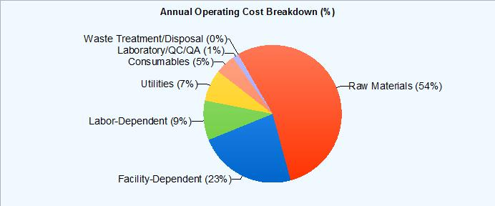

**Figure 3**: Annual Operating Cost Breakdown (%)

Finally, **Table 4** provides an executive summary. The total CAPEX required was estimated to be about $31 million. For a selling price of $0.85 per kg of sorbitol, the expected payback time is around 6.7 years.

|  |  |  |
| --- | --- | --- |
| **4. EXECUTIVE SUMMARY (2016 prices) (Table 1 in EER)** | | |
| Total Capital Investment | 30,984,000 | $ |
| Capital Investment Charged to This Project | 30,984,000 | $ |
| Operating Cost | 22,999,000 | $/yr |
| Revenues | 26,249,000 | $/yr |
| Cost Basis Annual Rate | 30,881,681 | kg MP/yr |
| Unit Production Cost | 0.74 | $/kg MP |
| Net Unit Production Cost | 0.74 | $/kg MP |
| Unit Production Revenue | 0.85 | $/kg MP |
| Gross Margin | 12.38 | % |
| Return On Investment | 14.92 | % |
| Payback Time | 6.70 | years |
| IRR (After Taxes) | 7.89 | % |
| NPV (at 7.0% Interest) | 1,650,000 | $ |
| MP = Total Flow of Stream 'Sorbitol 95%' | | |

**Miscellaneous Modeling Tips**

**Batch Unit Procedures in Continuous Processes**

SuperPro Designer handles modeling of batch processes, continuous processes, and combinations of batch and continuous. If a process involves several batch procedures that require inter-procedure scheduling links as well as a few continuous procedures, then the flowsheet’s Mode of Operation should be set to “Batch” (under **Tasks⮊Set Mode of Operation**). If a mostly-continuous process includes a few batch (cyclical) procedures that do not require inter-procedure scheduling, then the flowsheet’s Mode of Operation should be set to “Continuous”. More information on units operating in batch mode within a continuous flowsheet, on units operating in **Staggered Mode,** and related concepts can be found in the **Corn Refinery** example. These concepts were used in this Sorbitol example to model the reactor, the ion exchanger and the activated carbon column.

Note that continuous procedures in a SuperPro Designer flowsheet are assumed to operate at “steady state”, meaning they contain a single operation whose operating parameters are constant through time. In contrast, batch procedures may contain operations with parameters (such as flows, temperatures, pressures, etc.) which change through time. An example of such a procedure is the hydrogenation reactor, which operates in batch mode. As mentioned in the process description section, the hydrogenation procedure includes the following operations:

* Pull-In Syrup
* Pull-In Hydrogen
* Heat
* React
* Cool
* Gas sweep
* Transfer-out

During the first operation the vessel is vented to the atmosphere and the charged syrup displaces an equal volume of air. For this reason the pressure in the vessel remains equal to atmospheric. Then the vent valve is closed and the pressure increases as Hydrogen is fed into the vessel. Following the addition of Hydrogen, the vessel contents are heated in order to facilitate the reaction. This heating also increases the pressure. The vent valve is opened at the end of the reaction and the excess hydrogen is removed from the vessel with nitrogen Gas-Sweep. All these changes in equipment contents, pressure, and temperature that occur during each batch of the Hydrogenation procedure can be visualized in SuperPro Designer. Figure 4 displays the contents of the Hydrogenation reactor (R-101) during a typical batch (at the start of the batch and after each operation). This table is generated by right-clicking on the Hydrogenation procedure icon and selecting **Equipment Contents ⮊** **During P-3.**

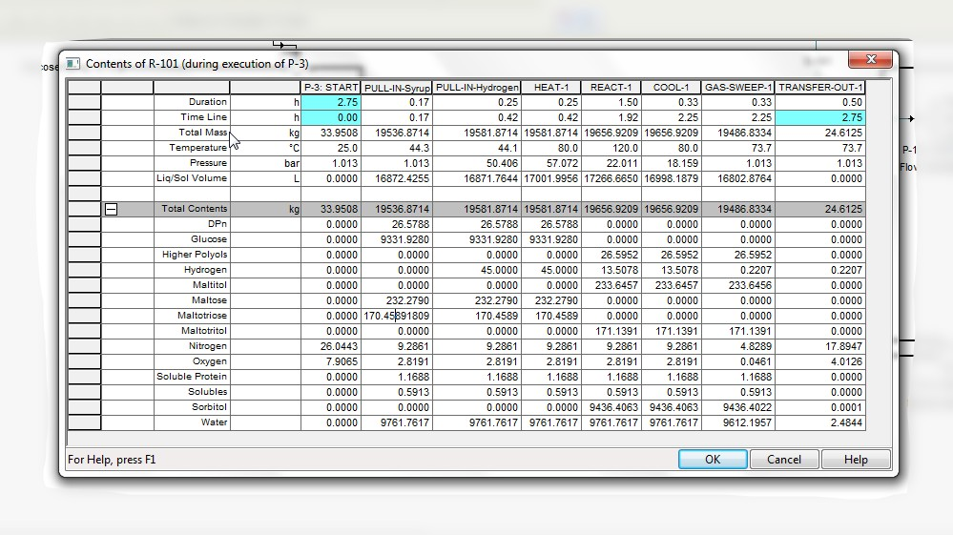

**Figure 4:** The contents of the hydrogenation reactor (R-101)

**Summary**

As indicated in the preceding analysis, a manufacturing plant producing 31,000 MT/year of spray dried 95% sorbitol from 95% glucose syrup requires a total CAPEX of around $31 million and has annual operating expenditures of around $23 million. The glucose syrup raw material is the most important operating cost (50% of total), followed by the facility-dependent cost which accounts for the depreciation of the fixed capital investment and the maintenance of the plant. This clearly indicates that depreciated facilities can have a considerably lower production cost. Moreover, the integration of sorbitol production lines within a corn refinery which includes glucose syrup production can result in synergies which can improve profitability further.

**References**

Bahndorf D. and Kienle U., 2004, World Market of Sugar and Sweeteners, International Association for Stevia Research

BeMiller J. and Whistler R., 2009, Starch Chemistry and Technology, Elsevier, Oxford, UK

Johnson L.A. and May J.B, 2003, “Wet milling: the basis for corn biorefineries”, in Corn: chemistry and technology, Edited by White P.J and Johnson L.A, AACC, St Paul, Minnesota

Hobbs L., 2009, “Sweeteners from Starch: Production, Properties and Uses”, pp 797-832 in Starch: Chemistry and Technology, Edited by BeMiller J. and Whistler R, 3rd edition, Elsevier, Oxford, UK

Hull P., 2010, Glucose Syrups Technology and Applications, Wiley Blackwell, Oxford, UK

Raquel de Pinho Ferreira Guine and Paula Maria dos Reis Correia, 2014, Engineering Aspects of Cereals and Cereal-based Products, CRC Press, Taylor & Francis Group, New York

Serna-Saldivar S.O., 2010, Cereal Gains: Properties, Processing and Nutritional Attributes, CRC Press, Taylor & Francis Group, New York