WORK INSTRUCTIONS

PUR – PO REQUIREMENTS GENERATION

PURPOSE: To provide instruction on using the PO Requirements Generation (referred to as PORG by Prophet 21) to create supplier purchase orders for inventory replenishment

1. INVENTORY > PURCHASING > TRANSACTION > PO REQUIREMENTS GENERATION

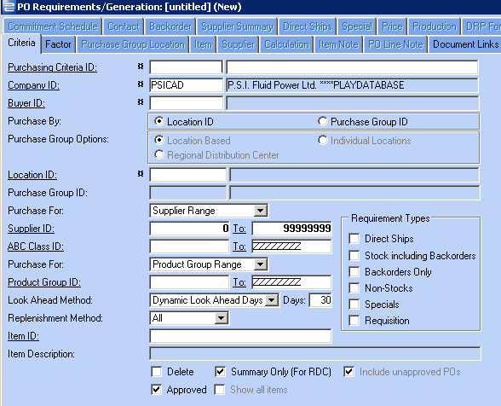

Hunt Consulting Services

Location 123 – stock and backorders

1. If you have already created and saved purchasing criteria, proceed to step #5
2. To create a new purchasing criteria:
   1. In the long white box on the PURCHASING CRITERIA ID row, key a description for the criteria you want to create. Be specific so that everyone knows the purpose of the criteria when they browse.
   2. BUYER ID - enter your buyer ID, or browse
   3. PURCHASE BY: Your choices are LOCATION ID (1 location only) or PURCHASE GROUP ID (a group of locations). Click the radio button beside the one you plan to use
   4. LOCATION ID: If you are purchasing by location id, key the location ID number (or browse). If you are purchasing by purchase group, key the location ID where the PO will be created and received for all of the locations in the group.
   5. PURCHASE GROUP ID will require an entry if you are purchasing by Purchase Group.
   6. PURCHASE FOR: This defaults to SUPPLIER RANGE. If you want to review all suppliers with stock/backorder requirements, leave as defaulted. Your other choice is SUPPLIER LIST. This option allows you to select specific suppliers for the report instead of using a range.
   7. ABC CLASS: Leave as defaulted unless you have a range of ABC classes you want to use.
   8. PURCHASE FOR: The default is PRODUCT GROUP RANGE. Leave as defaulted unless you want to select PRODUCT GROUP LIST and enter specific product groups to be reviewed.
   9. LOOK AHEAD DAYS: Change to DYNAMIC LOOK AHEAD DAYS and set the days to 30
   10. REQUIREMENT TYPES: For typical stock replenishment, check the following checkboxes:
       1. STOCK INCLUDING BACKORDERS
       2. NON STOCKS
3. SAVE your requirement. The system will generate a criteria ID for you to use. Once saved, bring the criteria number back up on the criteria tab.
4. Double check your criteria to make sure you are purchasing for the correct group/location ID and that your settings for supplier range/list, look ahead days, etc., are correct.
5. Click GENERATE REQUIREMENT
6. The list of items that require replenishment display on your screen

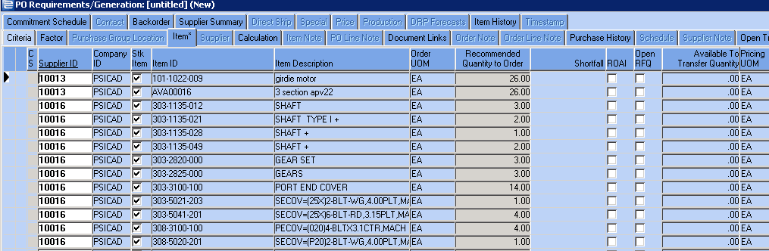

1. For each item reviewed, scroll to the right to find PURCHASE ITEM checkbox. Once you check the checkbox, the recommended quantity populates the QUANTITY TO PURCHASE field along with the unit price (which is actually unit cost)
2. On the far left if a column CS – if there is a “C” beside the item, this indicates you have customer backorders. If there is an “S” beside the item, this indicates you have a “critical shortage”. Use the tabs provided to review purchase history, sales history, usage, item notes, stock card calculation, open transfers and backorders. You may also use your F2 key to go to Item Master Inquiry to review the item.
3. Once your purchase requirements are made for your supplier, click the SUPPLIER TAB

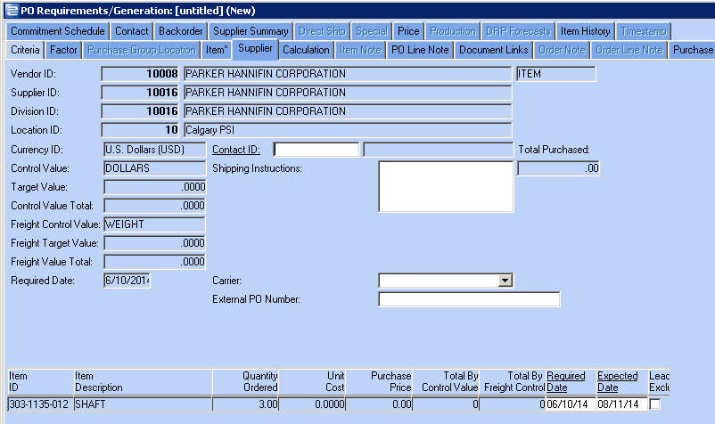

1. The SUPPLIER TAB provides the TOTAL PURCHASED value and advises if you are meeting any target values or freight target values that are set up for the supplier. The items you are buying will display at the bottom.
   1. SHIPPING INSTRUCTIONS – key the shipping instructions you want to print on the PO
   2. CARRIER – if you use carrier information, use drop down arrow to select correct carrier ID. NOTE: Carrier instructions and shipping instructions should match. You should not have a carrier ID set to FedEx, for example, and shipping instructions that state to ship UPS.
   3. REQUIRED DATES and EXPECTED DATES for the items may be edited as needed.
2. Once you have reviewed your supplier tab and made any necessary changes, click back on the ITEMS tab and review items for your next supplier. Repeat steps 8 through 11 for as many suppliers as you have on your PORG.
3. When all suppliers have been reviewed, click SAVE.
4. You will be prompted “WOULD YOU LIKE TO CREATE THE RFQ/PURCHASE ORDERS?”. Click YES
5. If you have made purchases for suppliers that do not exceed target values, you will get one more opportunity to review the total PO and either cancel that supplier or continue.
6. The list of PO’s that will be generated display, along with options for method of transmission.

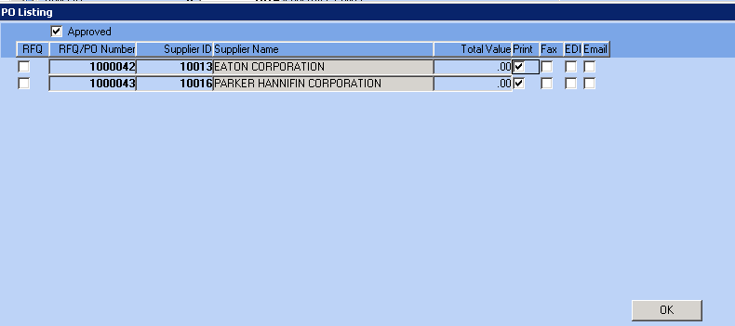

1. Check or uncheck methods of transmission so that you are sending the PO in your preferred method, such as Fax, Email, or Print. Click OK.
2. You will get popup boxes for printer options, fax cover sheets, or email for any suppliers that you selected for these types of transmissions. For fax and email, be sure to click the RECIPIENT TAB and confirm the fax number or email address is correct. If you printed the PO, be sure you manually transmit to the supplier from the printed copy.