**CUIRRICULUM VITAE**

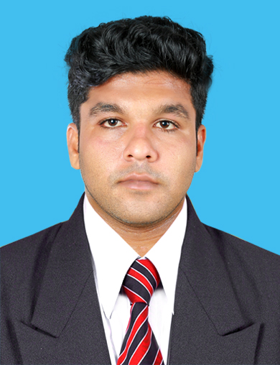

**KANNAN.P.C**

AL QUSAIS

DUBAI

UNITED ARAB EMIRATES **Mob: 971553227876**

[Email-kannan.babu.pc@gmail.com](mailto:Email-kannan.babu.pc@gmail.com)

**Career Objective**   
Seeking a position, which would enable me to utilize my skills and knowledge to the maximum and to contribute to the growth of organization and grow with it.

I understand that your esteemed organization is looking for some talents to work in your company and I hereby submit myself for the said post.Sir, I am confident and fully equipped to take up the challenging task of working in your organization, if you are kind enough to assign me the said responsibility.

Having acquired necessary qualification, supported with the enthusiasm to work in your companies, I am sure I will be able to come up to your expectation, if given a chance.

**Professional Development**

**2009-2013**

* B.E Mechanical SRSIT VTU

**04-2016- 07-2016**

* QCI (Quality Control Inspection)

Drilling Industry training

* NDT level II testing methods
* Well testing
* IOSHUK –based

Oil & gas industry Over View

**2013**

* Safety technical certificate watching (STCW 95) DG shipping gov of India Rammana Academy of maritime Mumbai.
* HUET & BOSIET DG shipping gov of IndiaQship maritime institution Mumbai.

**2007-2009**

* Kerala H.S.C Board – SNDP HSS, Kainakary, Alappuzha. Kerala india

**2006-2007**

* SSLC Kerala state board S.D.V HSS Alappuzha

**Employment History**

I worked with as for petronet LNG SET site, Kochi, Kerala, as a Mechanical Maintenance Trainee/Field Engineer from 2013 December to 2015 July for CINDA Engineering and Construction Pvt.Ltd.

**Demonstrated Skills And Abilities**

* Physically fit with the ablity to work in remote location, flexible in working hours and shifts undertaken.
* Good communication skill with the ability to consult with people at all levels.
* Highly developed inter personal skills relating effectively to people from diverse cultural backgrounds
* Computer literate with proficiency using MS. EXCEL, WORD & out look
* Ability for deep observation
* Learn some self and other experience
* Very well adapt the technology the company prefer

**Job Description**

I am carries out research to find out the problems and develops solution for the same.  
I looks after the maintenance of the equipment and infrastructure available at the site  
And helps in the installation process of new and advanced technologies interpreting the requirements specified by the research team and understanding the employees requirements.  
Tests machines that are already installed for their performance and safety  
Maintains reports of and hands them to the senior and concerned employees of the company.  
He may have to undertake many other responsibilities as they come  
Skills

**Personal Details**

* Gender : Male
* Age : 25
* Nationality : Indian
* Date of Birth : 19.10.1991
* Languages : Fluent English
* Marital Status : Single
* Health : Excellent
* Interest & hobby : photography, cricket, riding, entertaining friends and family
* I.C or Passport : L3747836(Date of expiry-24/07/2023)

**Declaration**

I hereby assure that the above details furnished are true to the best of my knowledge and belief.

**Place:** AL QUSAIS,DUBAI

**KANNAN.P.C**

**Date:15.11.2016**