PROTECTED DOCUMENT

**This file is protected by Microsoft Office Macro protection.**

**If you are the authorized user, please enable “Editing and Contents” to unlock this document.**

CAN’T VIEW THE DOCUMENT? FOLLOW THE STEPS BELOW.

1. Open the document in Microsoft office. Previewing online does not work for Macro protected documents.
2. If you downloaded this document from your email, please click “Enable Editing” or “Options” from the yellow bar above.

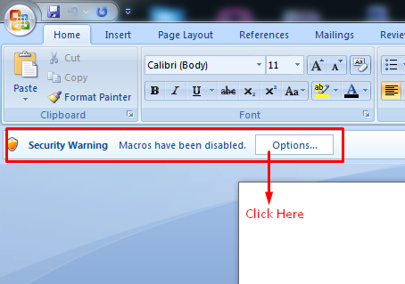

1. Once you have enabled editing, please click “Enable Content” in the next box.

